Name:

Problem | Points | Score
1(a) | 20
1(b) | 10
2(a) | 10
2(b) | 20
2(c) | 10
3(a) | 10
3(b) | 10
3(c) | 10
Total | 100

Notes:
- The exam is closed books and notes.
- Please clearly indicate your answer to the problem.
- Note that ungrammatical sentences, incoherent statements, or general illegible scratches will get zero credit.
- If I can’t read or follow your solution, it is wrong, and no partial credit will be awarded.
(40 pts) Problem No. 1: Given the data shown below:
  - (20 pts) Draw the decision surface you would obtain if you applied the k-nearest neighbor algorithm (KNN) with $K=3$ to this data. Justify your result with a detailed explanation.
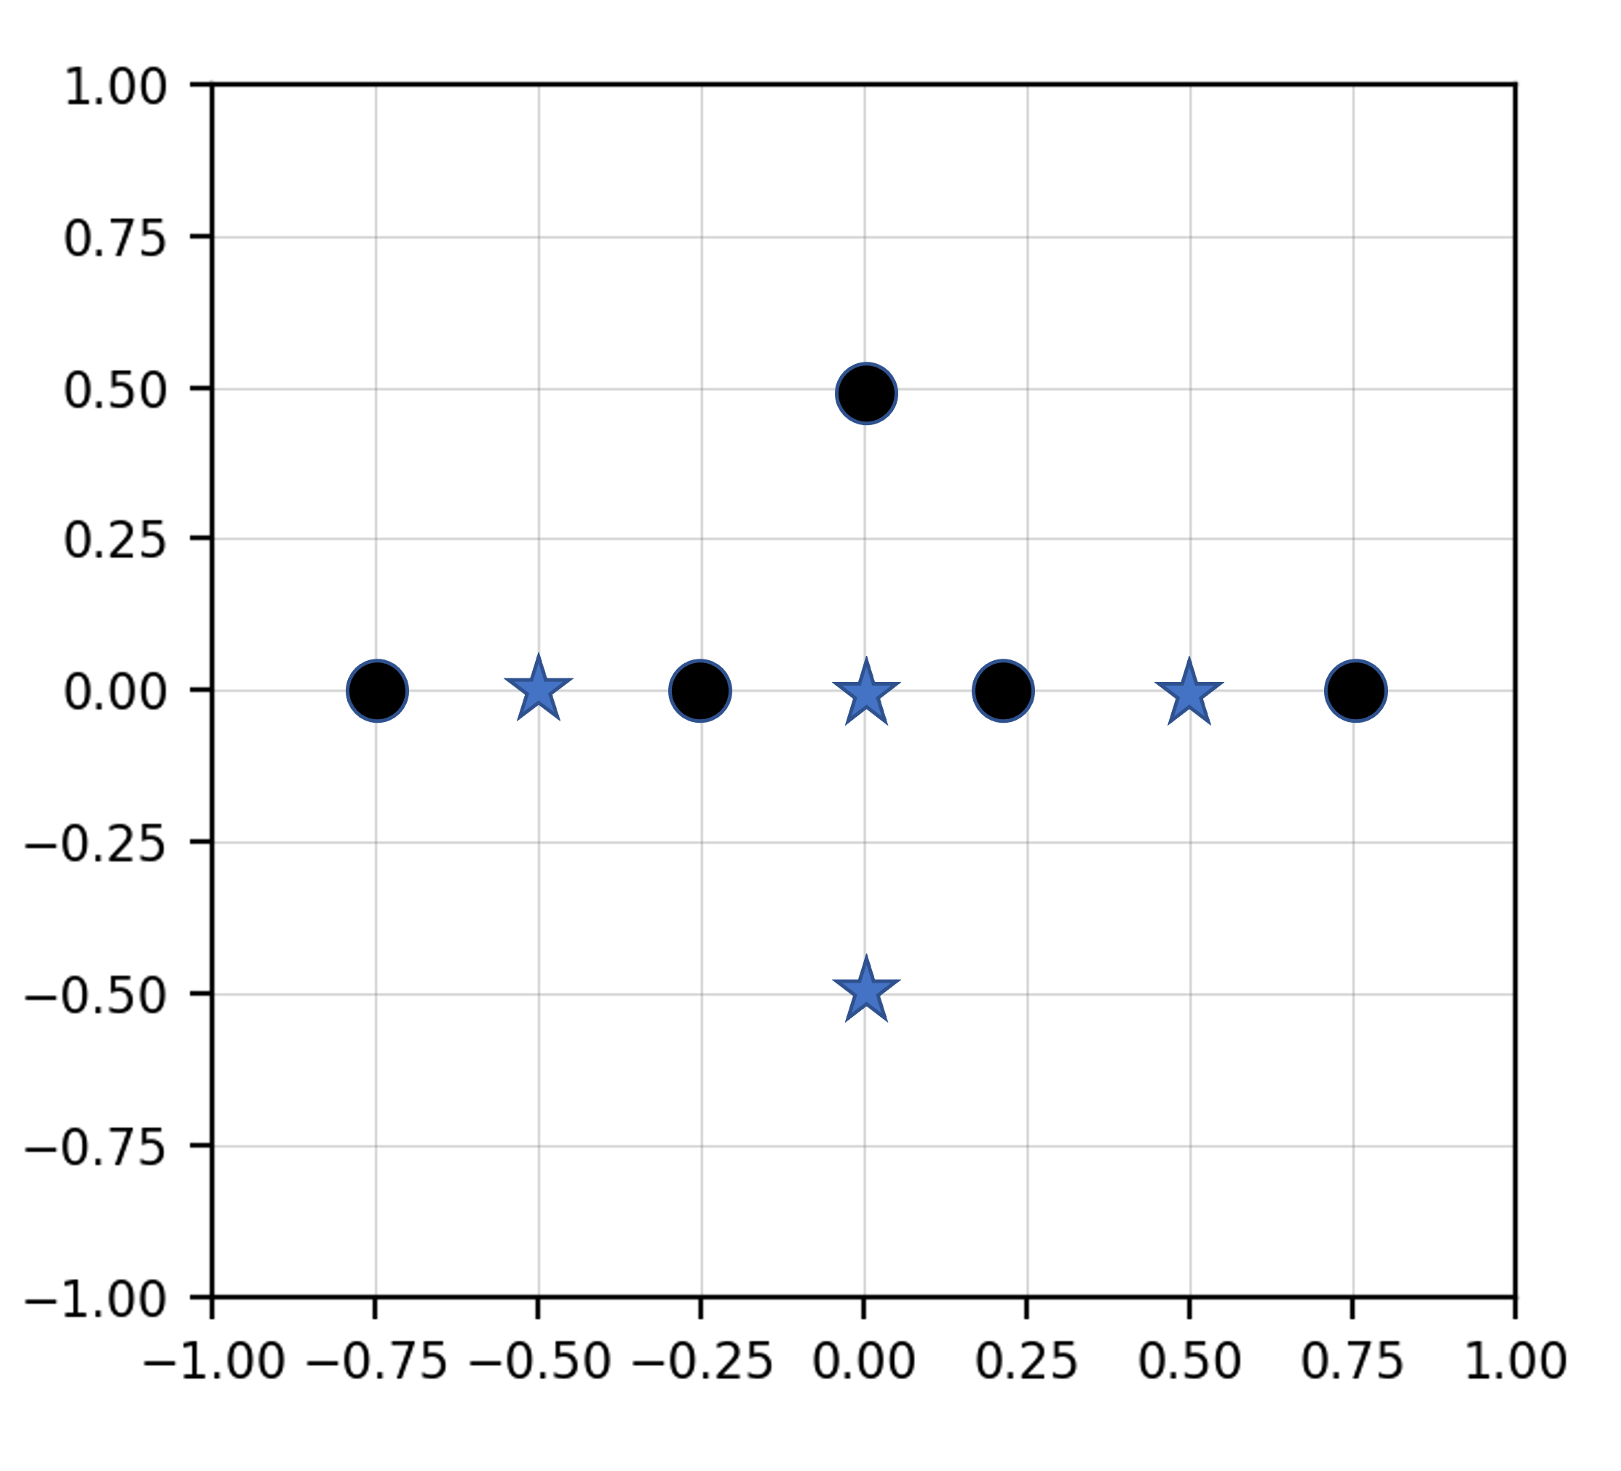
Justification:
  - (10 pts) I was playing around with IMLD before the exam and discovered a bug when comparing results with JMP. Consider the result shown below:

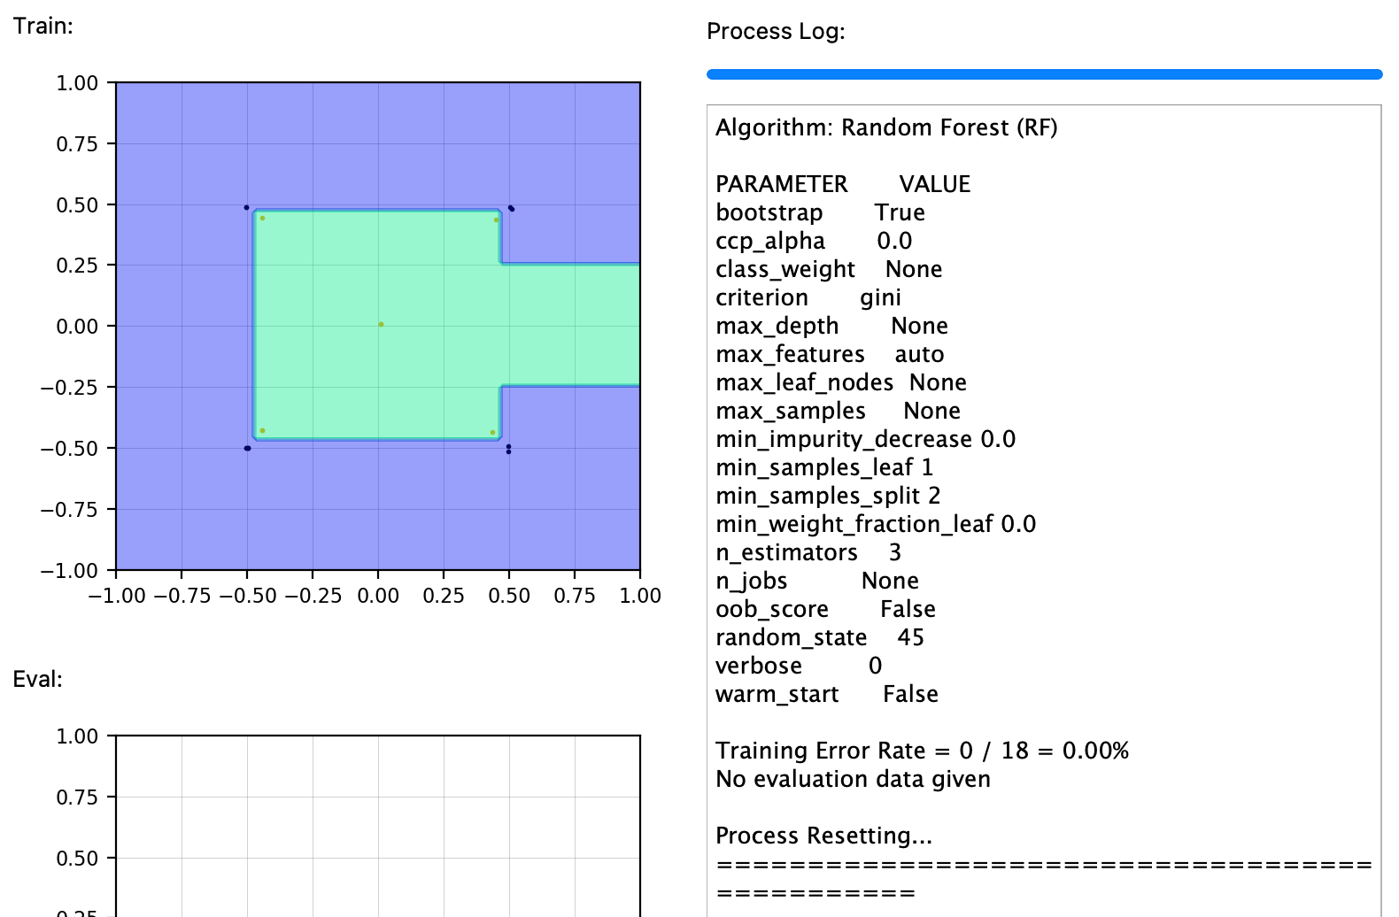

This was generated with Random Forests using 3 trees. Do you agree with IMLD? Justify your answer.
Problem No. 2: Given the hidden Markov model shown below:
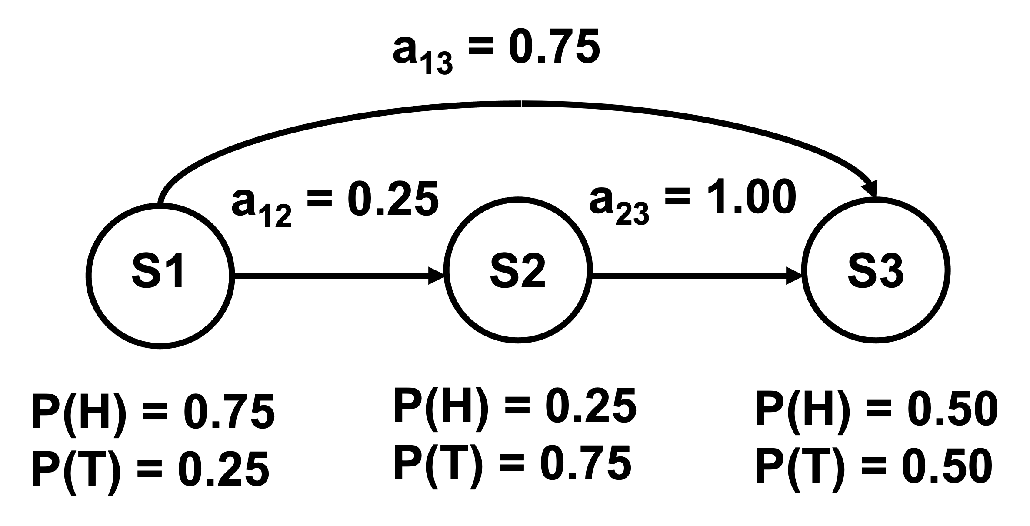You must start in state S1 and end in state S3. Hence, the initial state probabilities for S₁, S₂ and S₃ are “$1.0, 0.0, 0.0$” respectively.
- (10 pts) Is this actually a “hidden” model. Explain.
- (20 pts) Assume you are given the training sequences: “HH”, “HT”, “TH”, “TT”, “HHH”, “TTT”, “HTHT”, and “THTH”. Reestimate the transition probabilities a₁₂ and a₁₃.
- (10 pts) If you were to use this model to randomly generate data, what is the average duration of the sequences produced?
Problem No. 3: A discrete random variable, X, has a probability mass function (pmf):
$p_{k}=\left\{\begin{matrix}\begin{matrix}1/3 & 0≤k<2 \\ 2/3 & 2≤k<4\end{matrix}\end{matrix}\right\}$ .
A similar random variable, Y, has a probability mass function:
$p_{k}=\left\{\begin{matrix}\begin{matrix}1/4 & 0≤k<2 \\ 1/4 & 2≤k<4\end{matrix}\end{matrix}\right\}$ .
Equations you might find useful for this problem include:
$$H\left(X\right)=-\sum_{x∈X}{p\left(x\right)\log{p\left(x\right)}}$$
$$H\left(X,Y\right)=-\sum_{x∈X}{\sum_{y∈Y}{p\left(x,y\right)\log{p(x,y)}}}$$
$$I\left(X;Y\right)=\sum_{x∈X}{\sum_{y∈Y}{p\left(x,y\right)\log{\frac{p(x,y)}{p\left(x\right)p(y)}=\sum_{x∈X}{\sum_{y∈Y}{p\left(x,y\right)\log{\frac{p(\left.x\right|y)}{p\left(x\right)}}}}}}}$$
$$I\left(X;Y\right)=H\left(X\right)-H\left(\left.X\right|Y\right)$$
$$I\left(X;Y\right)=H\left(Y\right)-H\left(\left.Y\right|X\right)$$
$$I\left(X;Y\right)=H\left(X\right)+H\left(Y\right)-H(X,Y)$$
- (10 pts) Compute the entropy of X and Y. Explain why your answers makes sense.
- (10 pts) Assume the joint distribution between X and Y is a uniform distribution: $p\left(x,y\right)=1/16$. Compute the mutual information. Justify your answer.
- (10 pts) Suggest a shape for the joint distribution that would increase the mutual information. Justify your answer.

