Name:

Problem | Points | Score
1 | 40
2 | 40
3 | 20
Total | 100

Notes:
- The exam is closed books and notes except for one double-sided sheet of notes.
- Please indicate clearly your answer to the problem.
- If I can’t read or follow your solution, it is wrong and no partial credit will be awarded.
(40 pts) Problem No. 1: In this problem, you will design several neural networks:
- Design a network that accepts binary data in the form of a 3-tuple (e.g., “101”) and implements (or approximates as well as possible) the mapping shown to the right. Comment on the complexity of your network and how well it approximates this mapping. For the nonlinear unit at each node, use a hard limiter whose output is either 0 or 1.
Input | Output
000 | 0
001 | 1
010 | 1
011 | 0

- Compute the output of your network for previously unobserved patterns of “111”, “110” and “100”. Do these outputs make sense?
- Suppose you eliminate the third symbol in the input and disconnect whatever nodes you implemented to use that information. Suppose you apply “01”, “10”, “00” and “11” to this reduced network. Does it behave in a predictable manner? Explain (don’t just tell me what the outputs are, explain why or why not the make sense).
- Suppose you replaced the hard limiter in the nonlinear unit with a sigmoid function. How would that change the system’s ability to model this data?
(40 pts) Problem No. 2: You are given a single neural network node as shown to the right. Assume values of the weights are 1, and the hard limiter outputs a 1 if the input is greater than 0.5 and 0 otherwise. Assume two inputs (x₁ and x₂).
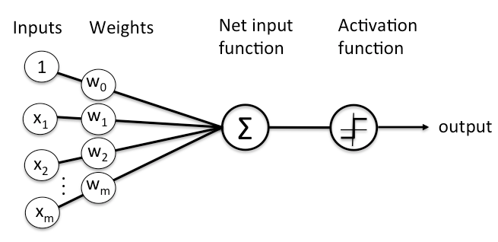
(a) Use backpropagation to update the weights based on the input “(0.5, 0.5)”. Clearly state any assumptions or approximations that you make and the values of any constants needed (e.g., learning rate).
(b) Replace the hard limiter with a sigmoid: $f\left(x\right)=\frac{1}{1+e^{-x}}$. Again use backpropagation to update the weights.
(c) Repeat (b) for a network that consists of two nodes in the first layer and one node in the second layer that is connected to the outputs of these two nodes at the first layer.
(20 pts) Problem No. 3: We began the class discussing the problem of sorting two types of fish – sea bass and salmon. We discussed how you could implement a simple Bayesian classifier to classify data based on length and light intensity. Design a deep learning system to classify this data. Describe an experiment that you would construct to evaluate your model. Be very specific and account for all the necessary details (e.g., the amount and type of training data).

