ECE3512 – Quiz #07

2014 October 17

**Question** – Given the continuous time signal shown below is sampled at f = 2Hz. Draw the spectrum of the sampled signal. Does this violate the Sampling Theorem? Explain. (**Hint:** Recall how the Fourier Transform of the sampled signal relates to the Fourier Transform of the original signal.)

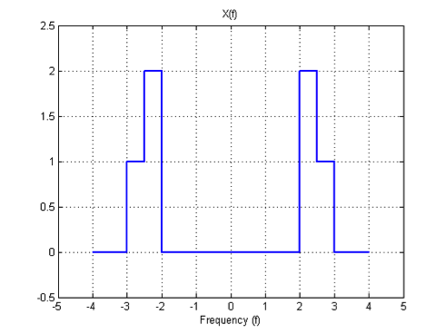

The signal here is given to use over the ranges of -4 Hz to +4 Hz, which suggests the bandwidth is 4Hz. Knowledge of the sampling theorem indicates that the number of samples to reconstruct the signal will be greater than or equal to twice the bandwidth [fs ≥ 2B]. The only part of the signal that contains data is between 2 Hz and 3 Hz, which can be collected from a 2 Hz sample rate. While the signal does appear to exist in multiple bands, the data is only in one specific range so the sampling theorem will allow for the signal to be reconstructed. This quiz is a demonstration of what is known as the Bandpass Sampling Theorem – Google it :)

Recall our expression for the spectrum of a sampled signal (which is periodic in frequency!):

$$X_{s}\left(e^{j2πf}\right)=\frac{1}{T}\sum_{k=-∞}^{∞}{X\left(e^{j\left(ω-k2πf_{s}\right)}\right)}$$

We originally learned that  for the signal to be able to be perfectly reconstructed with no loss of information. To construct the sampled signal’s spectrum, simply take the original spectrum and shift it 2 Hz to the right and left, and then add all these components together.

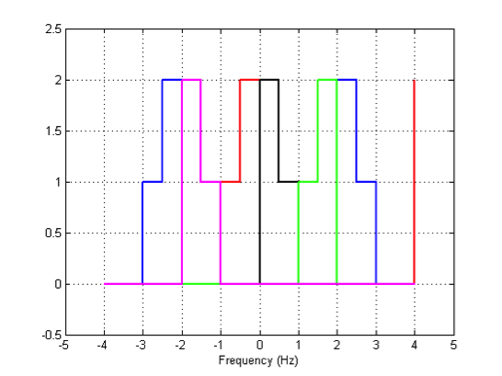

Overlaying all of samples from the first five samples turns the sampled signal into the above Technicolor® plot. The blue signal is the original and then the red and black signals are those shifted by one step of 2Hz. The magenta and green signals are those shifted by 4Hz, and of course this goes on along the entire spectrum from -∞ to +∞.

The overlays are a bit busy so below there is the sampled signal in blue compared to the original signal in black. The original signal fits snuggly inside the sampled signal and this should illustrate how the signal is being shifted through the frequency spectrum as it is sampled. Yet, what good is this now that the signal has been sampled, it just appears to take up the entire frequency spectrum.

The good part is that the signal now appears, among other places, tucked against the y-axis at *f = 0*. Using a low pass filter over the range of 0 Hz to 1 Hz will allow the continuous time signal to be brought out from the sampled signal. Imagine a filter, illustrated by the red plot against the signal in blue, which allows only the continuous time signal to pass out of the system. This provides access to the data stored in the signal.

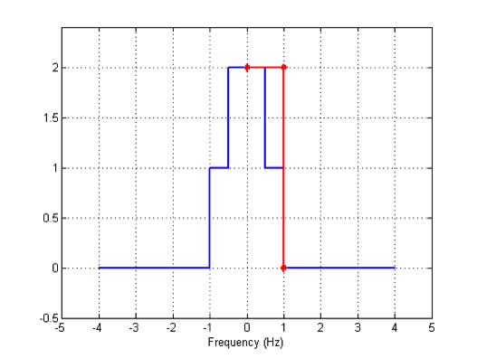

The baseband version of the signal (located from 0 Hz to 1 Hz) can be captured, or we could alternately use a bandpass filter from 1 Hz to 2 Hz to recover the original bandpass signal. Either way, it is important to note that the signal CAN BE sampled at 2 Hz and still recovered exactly. Hence, there is a little more to the Sampling Theorem than meets the eye.

There are some restrictions on the values of the upper and lower frequencies to make this work. You can read about these in the lecture notes.