Name:

|  |  |  |
| --- | --- | --- |
| Problem | Points | Score |
| 1(a) | 10 |  |
| 1(b) | 10 |  |
| 1(c) | 10 |  |
| 2(a) | 10 |  |
| 2(b) | 10 |  |
| 3(a) | 10 |  |
| 3(b) | 10 |  |
| 3(c) | 10 |  |
| 4(a) | 10 |  |
| 4(b) | 10 |  |
| Total | 100 |  |

Notes:

1. The exam is closed books and notes except for four double-sided sheet of notes.
2. Please indicate clearly your answer to the problem.
3. If I can’t read or follow your solution, it is wrong and no partial credit will be awarded.

**Problem No. 1**: Consider the LTCC difference equation: , where all coefficients are real numbers.

(a) Derive the conditions under which the system is stable.

(b) Assume b1 = 0. Derive an expression for the impulse response and explain the role a1 and a2 play in the shape of this impulse response. Be as specific as possible. For example, if the signal oscillates, write an equation for the frequency of oscillation in terms of the coefficients.

(c) Assume the system is stable and b1 ≠ 0. Plot the location of the poles and zeroes in the z-plane and explain how these influence the frequency response. (Hint: describe the relationship between the z-transform and the frequency response.)

**Problem No. 2**: Given the system shown:

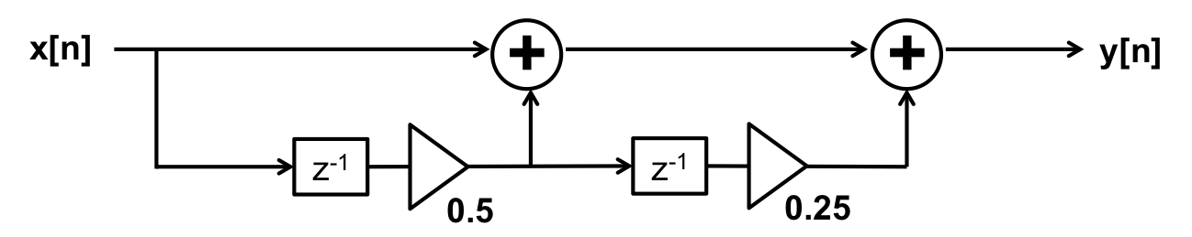

(a) Find the impulse response, h[n].

(b) Find the transfer function, H[z].

**Problem No. 3**: Given the signal x[n] = [0 1 0 2] represents a continuous-time signal sampled at 2 Hz.

(a) Find the frequency response, H(f), and sketch the magnitude as a function of frequency in Hz.

(b) Next, assume the signal is periodic with a period of 10 samples. Sketch the frequency response and explain the relationship between this answer and the answer to (a).

(c) How would your answer to (b) change if the period was 5 samples rather than 10 samples?

**Problem No. 4**: The impulse response to a linear time-invariant system is given by:



(a) Draw a block diagram realization of the system (e.g, use delay lines, adders, and amplifiers).

(b) Suppose the input to this system is x[n] = [1 -1]. Compute the output.