Optimized Image Processing Pipeline
Yingting Wu
Electrical and Computer Engineering Department, Temple University, Philadelphia, PA, USA
yingting.wu@temple.edu

Abstract— Despite the success of Convolutional Neural Networks (CNNs) and Transformers across many computer vision tasks, computational cost remains a critical bottleneck. Accelerating image processing is a comprehensive problem that extends beyond algorithm design to include data structure optimization, I/O latency, and hardware limitations. To address these challenges, this paper explores a multi-threaded data access strategy and an optimized GPU implementation of a hybrid image analysis system. We focus on developing an efficient image-processing pipeline that integrates several operations, including windows shifting, converting grayscale, Gaussian blurring, Fast Fourier Transforms (FFT), and log magnitude spectrum histograms. Keywords— image processing, GPU Acceleration, spectral histograms, computational cost.

Introduction
The rapid advancement of imaging technology has led to significantly higher image resolutions. Various strategies have been proposed to manage this computational load without sacrificing quality. One approach involves spatial decomposition, such as utilizing local spectral histograms [1] or the patch-based inference methods common in deep learning [2]. While effective at reducing peak memory, patch-based methods risk accuracy loss, a trade-off explored by models like Saccader [3]. A second, parallel approach focuses on domain transformation and reduction, such as downsampling [4], [5], or shifting operations into the Fourier domain to exploit the efficiency of Fast Fourier Transforms (FFT)[6]. By converting spatial convolution into spectral multiplication, these methods can significantly accelerate filtering operations on large inputs.
In this paper, we focus on optimizing an image-processing pipeline that integrates multiple spatial- and frequency-domain techniques into a cohesive workflow. The system performs local information extraction, converting grayscale, Gaussian smoothing, and spectral analysis via FFT to calculate the global mean and standard deviation of histograms. Our goal is to evaluate how acceleration strategies, such as multi-threading, GPU acceleration, and data batching, influence computational efficiency and memory overhead. By balancing spatial resolution preservation with computational cost, we determine an efficient strategy for computing the mean and standard deviation of histograms across large image datasets.

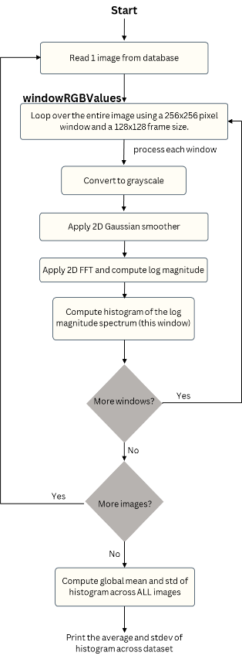
Methodology
Figure 1. A block diagram of the system
The dataset consists of 3,505 images. I processed each image sequentially to calculate the global mean and standard deviation of the spectral histograms (Figure 1). This algorithm implemented five stages, including window shifting, converting grayscale, Gaussian smoothing, FFT, and logarithmic scaling.
To characterize the global intensity distribution of the dataset, we compute the global histogram mean and standard deviation over all image data. The global mean and standard deviation are computed by aggregating local window histograms. This method relies on maintaining a consistent bin range throughout the entire dataset. By fixing the bin centers$c_{i}$, we allow the frequency counts $h_{i}$ from local windows to be summed directly.
$$Global Histogram H_{i}=\sum_{ω=1}^{W}{h_{i}^{(ω)}}$$
This enables the calculation of precise global statistics from local data streams without storing the full spectral map in memory. Then the global expected value (mean) is computed as:
$$μ_{global}=\sum_{i}{c_{i}*p_{i}= \sum_{i}{c_{i}*\frac{H_{i}}{number of pixels} }}$$
The global standard deviation is defined as:
$$σ_{global}=\sqrt{\sum_{i}{{(c_{i}-μ)}^{2}*p_{i}}}$$

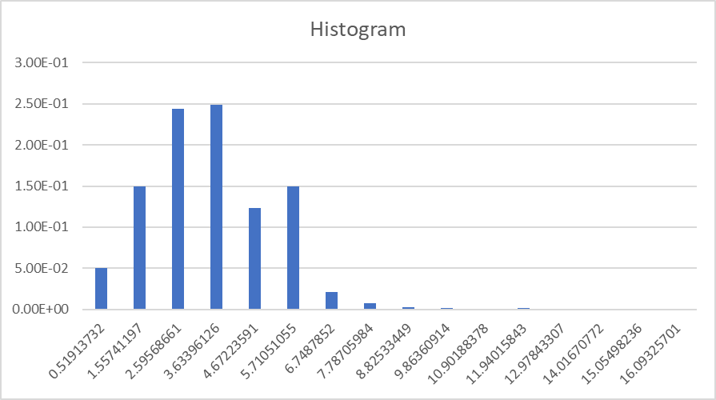
Since spatial frequency depends on brightness variation rather than color, the FFT spectrum is independent of the individual RGB channels. Therefore, converting each color image to grayscale allows us to reduce the number of Gaussian blurring and FFT computations from three channels to one, while preserving the structural frequency information.
Figure 2. Histogram of the magnitude spectrum for 100 testing data.
The normalized 7x7 2D Gaussian kernel used for smoothing is defined as:
$$G\left(x,y\right)= \frac{exp⁡(-\frac{x^{2}+y^{2}}{2σ^{2}})}{\sum_{u=-3}^{3}{\sum_{v=-3}^{3}{exp⁡(-\frac{u^{2}+v^{2}}{2σ^{2}})}}}$$
Gaussian blurring is applied before the FFT to suppress high-frequency noise and smooth pixel-level variations. As a low-pass filter, it effectively band-limits the spectrum, preserving the dominant spatial structures that are important for frequency-domain analysis.
The FFT converts the image from the spatial domain into the frequency domain. Instead of representing pixel intensities at specific locations, the FFT represents the image as a combination of sinusoidal frequency components. By transforming the image into its frequency spectrum, we can analyze and process its structural patterns more efficiently. In this project, the FFT is implemented using PyTorch library to perform fast and GPU-accelerated computations.
To manage the high dynamic range of the magnitude spectrum, we apply a logarithmic transformation. We specifically use the log(1+x) formulation to avoid the mathematical singularity at zero. This ensures numerical stability and prevents floating-point noise from artificially inflating the histogram's standard deviation.

Result
The evaluation was conducted on the nedc_012 node, utilizing 4 GPUs and 12 CPU threads for parallel image I/O. The pipeline utilized a 256×256 spatial window with a 128×128 stride. Processing was batched, with 64 windows executed in parallel across the GPU cluster. To initialize the algorithm, I first determined the necessary histogram range by randomly selecting 20 images and calculating their spectral extrema (minimum and maximum values) and then applied to the full execution.
The histogram (Figure 2) resembles a bell curve, which implies that the majority of the spectral energy is concentrated around the central values are few pixels with high frequency. The global mean of the histogram is 3.48599, the standard deviation is 1.65028 and the average processing time of 23.97 seconds per image.
To address the bottleneck of memory transfer speeds and hardware limitations, I adopted a batch processing approach. To maintain a steady data stream, the CPU reads a buffer of window RGB values equal to 4* N into system RAM. The GPU then processes this buffer in subsets of size N. The batch size is adjustable, allowing the system to balance memory constraints against the need to reduce kernel launch overhead.

Conclusion
This study discusses an approach to accelerate the image processing pipeline and addresses the trade-off between computational cost and analytical accuracy in spectral image analysis. This pipeline, which includes window shifting, grayscale conversion, Gaussian blurring, FFT, logarithmic scaling, and data batching, utilizes multi-threaded and GPU-accelerated protocols to provide computational and memory efficiency for analyzing large SVS pathology images. Implementing this pipeline revealed critical insights regarding hardware optimization. Batch sizes must be carefully tuned to the available resources. A batch size that is too large risks memory exhaustion or degrades concurrency benefits. Results demonstrate that these strategies significantly reduce memory usage while maintaining statistical precision. This pipeline offers a scalable solution for extracting texture features from high-resolution databases, proving effective even in resource-constrained environments.

Reference
[1] X. Liu and D. Wang, “Image and Texture Segmentation Using Local Spectral Histograms,” IEEE Trans. Image Process., vol. 15, no. 10, pp. 3066–3077, Oct. 2006, doi: 10.1109/TIP.2006.877511.
[2] J. Lin, W.-M. Chen, H. Cai, C. Gan, and S. Han, “MCUNetV2: Memory-Efficient Patch-based Inference for Tiny Deep Learning,” Apr. 03, 2024, arXiv: arXiv:2110.15352. doi: 10.48550/arXiv.2110.15352.
[3] G. F. Elsayed, S. Kornblith, and Q. V. Le, “Saccader: Improving Accuracy of Hard Attention Models for Vision,” Dec. 07, 2019, arXiv: arXiv:1908.07644. doi: 10.48550/arXiv.1908.07644.
[4] L. Yang, Y. Han, X. Chen, S. Song, J. Dai, and G. Huang, “Resolution Adaptive Networks for Efficient Inference,” May 18, 2020, arXiv: arXiv:2003.07326. doi: 10.48550/arXiv.2003.07326.
[5] P. Burt and E. Adelson, “The Laplacian Pyramid as a Compact Image Code,” IEEE Trans. Commun., vol. 31, no. 4, pp. 532–540, Apr. 1983, doi: 10.1109/TCOM.1983.1095851.
[6] M. Mathieu, M. Henaff, and Y. LeCun, “Fast Training of Convolutional Networks through FFTs,” Mar. 06, 2014, arXiv: arXiv:1312.5851. doi: 10.48550/arXiv.1312.5851.

