GPU-Accelerated SVS Image Processing
S. Mohammed
Computer Fusion Lab, Temple University, Philadelphia, Pennsylvania, USA
sarker.mohammed@temple.edu

Abstract— This paper presents a GPU-accelerated pipeline for processing large SVS images by streaming small patches through Gaussian smoothing, 2D Fourier transform, and histogram analysis. The pipeline emphasizes memory efficiency and high GPU occupancy by batching data. Experimental results show strong scaling when moving from one to two GPUs, reducing per-image runtime from 91.75 to 42.19 seconds. Future improvements focus on multi-process I/O loaders to further alleviate the I/O bottleneck and push the system toward fully GPU-bound performance.
Keywords— GPU Accelerations, SVS Images, CUDA

Introduction
Digital pathology workflows rely on extremely large SVS images, which are difficult to process on conventional CPU systems. Operations such as convolution and Fourier transform become computational bottlenecks and naively loading entire images into memory is infeasible. To address these challenges, we develop a GPU-accelerated pipeline that streams small patches through Gaussian smoothing, FFT computation, and histogram generation. By combining batching, concurrency, and GPU-CPU coordination, the pipeline significantly improves throughput for large-scale spectral analysis.

Methodology
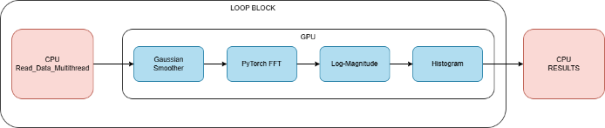
To efficiently process large SVS images, we implement a streaming, GPU-accelerated pipeline that moves image data through a sequence of spectral and statistical transformations. Each slide is first partitioned into 256×256 regions, which are small enough to fit comfortably in GPU memory while still preserving meaningful spatial structure. These patches are loaded incrementally in batches rather than all at once, allowing the system to keep stable memory use. They are immediately placed into a GPU-bound queue where a CUDA kernel applies a Gaussian smoothing filter, a 2D filter used to blur images by weighing pixels according to a normal distribution. The key advantage of the Gaussian filter is that it is separable, meaning 2D operation can be decomposed into two sequential 1D operations. This reduces the complexity from O(k²) to O(2k), significantly accelerating the smoothing stage.
Figure 1: Single I/O - GPU Pipeline
After smoothing, each patch is passed into a PyTorch-based 2D FFT module, where the Fourier transform is computed over the spatial dimensions. From the complex FFT output, we compute the magnitude and then apply a logarithmic transformation to compress the range. Empirically, the resulting log-magnitude values fall between -5 and 10. These values are then binned into a 16-bin histogram using a custom CUDA kernel. Each processed batch produces a partial histogram, which is accumulated directly into a global distribution stored on the GPU. In multi-GPU configurations, each device maintains its own histogram, and these distributions are merged on the CPU once all batches have been processed.
By iterating this sequence in a continuous streaming fashion, the system minimizes idle time and maintains high GPU occupancy. This architecture allows very large slides to be analyzed without exceeding memory limits, all while still leveraging the advantages of GPU-accelerated smoothing, FFT computation, and histogram generation.

Thread Management and Proposed Concept
Although the computational stages of our pipeline are highly parallel and well optimized, the overall performance is fundamentally constrained by how quickly the image data can be supplied to the GPU. In early profiling, we observed that the system is predominately I/O-bound, meaning that disk reads and host-device transfer dominate the total runtime. A GPU cannot maintain high occupancy unless patches are prepared and delivered at a rate that matches the speed of the CUDA computations. For that reason, the design of the CPU-side thread management system is as important as the GPU kernels themselves.
Graph 1: Read_Data_Multithread Speedup Ratio

By default, the given program for retrieving the image and conducting the windows to create patches utilizes 12 threads. After testing, when compared with a single thread, we notice that we can achieve similar results with 6 threads.
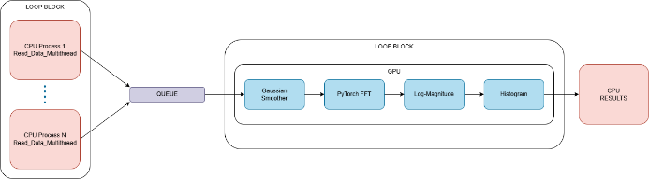
While not completed in this report due to time constraints and code error, we suggest that each GPU has multiple dedicated I/O processes. Instead of a single 12-threaded process reading a single image, two 6-threaded processes can read two images, helping combat the I/O-bound issue. Having multiple processes push into a queue allows the program to go from a I/O-bound problem to a GPU-bound problem. Finding a balance will give an optimized solution.
Figure 2: Multi-I/O Loader - GPU Pipeline

Results
Across more than one hundred SVS images, the pipeline shown in Figure 1 achieved consistent and stable performance when operating in streaming mode. This demonstrates that the pipeline maintains high GPU occupancy as long as the input queue remains sufficiently populated Using two GPUs, the system processed each image in an average of 42.19 seconds, a significant improvement in runtime observed with a single GPU. This result confirms that batched-based loaders provide efficient processing of SVS images.
Table 1: Results
Number of GPUs | Wall Time (per Image)
1 | 91.75
2 | 42.19
4 | 21.00 (Estimated)
The scaling behavior of the pipeline generally follows a near linear trend. Although only one and two GPUs were available for direct testing, extrapolation would suggest that 4 GPUs would reduce the per-image processing to approximately 21 seconds.

Conclusion and Future Work
In this work, we developed a GPU-accelerated pipeline for processing large SVS images and demonstrated that streaming batches enables efficient large-scale spectral processing. Our results showed strong scaling from one to two GPUs, reducing average per-image runtime from 91.75 to 42.19 seconds, and future testing on a four-GPU configuration is needed to validate the projected 21-second runtime. A key direction for future improvement is implementing and evaluating the multi-loader design outlined in Figure 2, shifting the system from I/O-bound to GPU-bound to allow the GPUs to operate closer to peak capacity. Further optimizations of asynchronous transfers and batch sizes will help refine the pipeline for efficient analysis in digital pathology.

