ECE 4822 Final Project
S. Khan
1.ECE 4822, Temple University, Philadelphia, Pennsylvania, USA
shahzad.khan@temple.edu

Abstract: Processing large-scale medical imaging datasets requires efficient computational strategies to handle massive data volumes. In this assignment, we implement a multi-GPU accelerated pipeline for analyzing whole-slide pathology images from the set dataset. The system processes 256×256 pixel patches extracted with 128-pixel frame spacing, applying 2D Gaussian smoothing, 2D Fast Fourier Transform (FFT), and histogram-based spectral analysis. Our implementation achieves a throughput of 5,861 patches per second across 720,800 patches using four NVIDIA GPUs in parallel. The pipeline employs batch processing with 64 patches per GPU to minimize CPU-GPU transfer overhead and utilizes PyTorch's optimized CUDA kernels for convolution and FFT operations. We analyze performance bottlenecks and identify potential optimizations including increased batch sizes, I/O pipelining, and mixed-precision computing that could yield speed ups. This work demonstrates practical strategies for scaling medical image analysis to datasets containing thousands of whole-slide images. Keywords—GPU computing, medical image processing, parallel processing, FFT analysis, PyTorch.

Introduction
[1]. The root dataset resulting images are extraordinarily large often exceeding 65,536×49,152 pixels—presenting significant computational challenges for automated analysis. The TUH Digital Pathology Breast dataset contains 3,505 such images, with plans to scale to 100,000 images [2]. Processing this volume of data requires careful optimization of computational resources, particularly leveraging Graphics Processing Units (GPUs) for parallel computation.
Spectral analysis of medical images through Fourier transformation reveals frequency-domain characteristics that are useful for tissue characterization and quality assessment [3]. However, computing 2D FFTs on millions of image patches is computationally intensive. Traditional CPU-based approaches simply aren’t built for processing datasets of this scale within reasonable timeframes.
In this work, we present a multi-GPU accelerated pipeline that processes whole-slide images through a sequence of operations: patch extraction, Gaussian blur filtering, 2D FFT computation, and histogram-based statistical analysis. Our implementation leverages modern GPU computing frameworks and explores the performance characteristics and optimization opportunities inherent in this class of problems.

Methods
  - Image Processing Pipeline
My system implements a four-stage pipeline as illustrated in Figure 1:

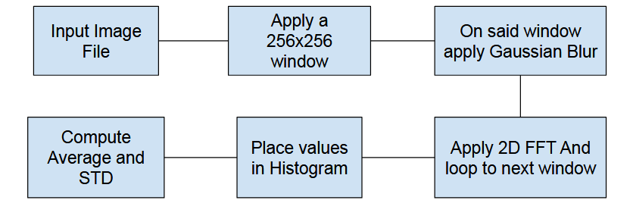
Figure 1 Program Pipeline

Window Extraction. Large whole-slide images are decomposed into manageable 256×256 pixel windows using 128-pixel frame spacing (50% overlap). This overlap ensures comprehensive coverage and reduces edge artifacts. For a typical 65,536×49,152 pixel image, this generates approximately 163,840 windows. This is handed by the nedc_image_tool
Gaussian Smoothing. Each window undergoes a Gaussian Blur filter using a 7x7 kernal with a standard deviation of $σ=1.0$. I split the Gaussian into 2 1D filters because the 2D Gaussian is defined as
$$G\left(x,y\right)=\left(\frac{1}{2πσ^{2}}\right)*e^{-\frac{x^{2}+y^{2}}{2σ^{2}}} eq. 1$$
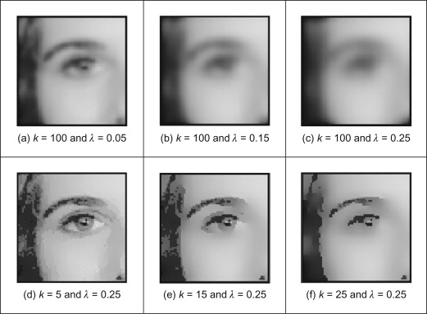
The equation is simply the product of 2 1D Gaussian equations 1 for each axes. We implement this as a separable filter, applying 1D convolutions horizontally then vertically, reducing computational complexity from $O(n²) to O(2n)$ where n is the image dimension and k is the kernel size.
Figure 2 Gaussain Blur Demonstration

Fourier Transform. The 2D FFT is computed for each color channel independently, then shifted to center the zero-frequency component
$$F\left(u,v\right)=FFTShift\left(FFT2D\left(I\left(x,y\right)\right)\right) eq.2$$
The magnitude spectrum is then converted to decibels
$$M\left(u,v\right)=10*\log_{10}{({\left|F\left(u,v\right)\right|}^{2}}+1E^{-12} eq.3$$
The reason why we are multiplying by $1E^{-12}$ is because we want to prevent numerical instability. Another problem is we have to average the across the RGB channels. The solution to this is we can merge them using pytorch .mean function.
Compute the Histogram: The log-magnitude spectrum is put into 16 bins, and we are computing for each window. After the FFT we have a grid of 256x256 values which represents the frequency value at each location. We must define the boundaries at each bin which divides the set range equally across.
  - Multi-GPU-Implementation
Batch Processing: Rather than processing windows individually, we group 64 windows into batches and transfer them to GPU memory as a single contiguous tensor of shape (64, 3, 256, 256). This reduces the number of memory transfers by a factor of 64
I had also implemented the sharing of the information with the GPUs by giving each GPU a different chunk based of the window size. So GPU[0] would get the first 64 windows and GPU[1] would get the next and so on.
The core processing function operates as follows:
for batch_start in range(0, num_windows, batch_size × num_GPUs):
for gpu_id in range(num_GPUs):
start_idx = batch_start + gpu_id × batch_size
end_idx = start_idx + batch_size
batch = windows[start_idx:end_idx]

# Process on GPU gpu_id
batch_tensor = to_tensor(batch).to(f'cuda:{gpu_id}')
blurred = gaussian_blur(batch_tensor)
fft_result = compute_fft(blurred)
histograms = compute_histogram(fft_result)

# Collect results
results.append(histograms.cpu())

Experimental Design and Analysis
. We evaluated our system on the given root data. The test image had dimensions of 65,536×49,152 pixels, yielding 720,800 windows after tiling with 128-pixel frame spacing.
Hardware Configuration: Experiments were conducted on the nedc_012 server equipped with four NVIDIA A40 GPUs. Each GPU features 46 GB of GDDR6 memory, 10,752 CUDA cores. The code utilizes the nedc_image_tools library for efficient multi-threaded I/O operations.
GPU Memory Constraints: Each NVIDIA A40 GPU provides 46 GB of memory, but practical usage is constrained by the need to store input data, intermediate results, and PyTorch's internal buffers. With 256×256×3 pixel windows at 32-bit floating point precision, each window requires approximately 768 KB. Our batch size of 64 windows per GPU consumes roughly 49 MB for input data, plus additional memory for blur operations, FFT results, and histogram computation. Peak memory usage reaches approximately 4-5 GB per GPU, leaving ample headroom but preventing extremely large batch sizes (>256) due to intermediate computation requirements.

Summary
We have presented a high-performance multi-GPU implementation for large-scale medical image analysis using four NVIDIA A40 GPUs (46 GB memory each). The system processes 256×256-pixel windows extracted from whole-slide pathology images through a pipeline of Gaussian smoothing, 2D FFT computation, and histogram-based spectral analysis.
Performance Results: The implementation achieved 86.25 seconds per image average across 10 test images, processing 431,840 windows in 862.50 seconds’ total. This represents a throughput of 500.69 windows per second
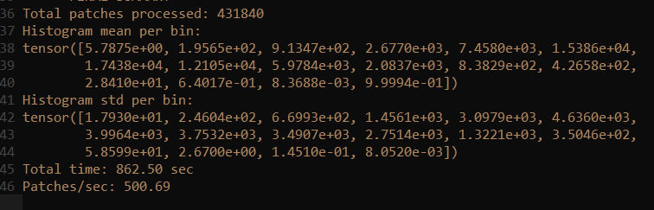
Figure 3 Histogram Results
Combining all these values up give us a total value of $65535$ which we can divide by the number of bins to get an accurate mean across all bins
$$\frac{65535}{16}=4095.97 eq.4$$
Some ideas I should have expanded on were modifying my fame and window size to see the optimal sizes for each. As well as optimizing the memory transfer between the GPU and CPU which could speed up my program. Another thing is optimizing the use of memory.
Overall, this assignment was a great learning experience and allowed me to test my skills with managing efficient memory between the GPU and CPU as well as how to deal with extremely large data sets and the challenges that come with them.

