Gpu image processing
Massimo Graham
massimo.graham@temple.edu

Abstract
This paper describes a GPU-accelerated system for computing the distribution of log-magnitude spectra over a large database of pathology images. The system applies Gaussian smoothing, two-dimensional FFTs, and histogram-based statistics over sliding image windows. Performance is evaluated using wall-clock runtime and statistical outputs.

1. Introduction
Spectral analysis is widely used in image processing to characterize spatial frequency content. In the context of image processing, it allows us to see the amount of high and low frequency content in an image. In this project, we focus on efficiently computing spectral statistics over thousands of large histopathology images. The objective is to use the tools provided to us and the knowledge gained from lectures to produce the fastest gpu code that we can.

2. Processing Pipeline
Each image is processed using a sliding 256×256 window with a 128×128 step size which provides a 50% overlap between each window. A 7×7 Gaussian filter is applied to each window to reduce high-frequency noise. Then, A two-dimensional FFT is computed on the window, and the magnitude spectrum is converted to a logarithmic scale. Then the magnitudes of each window was placed into a histogram of 16 bins ranged from -6 to 6 with an interval of 0.75
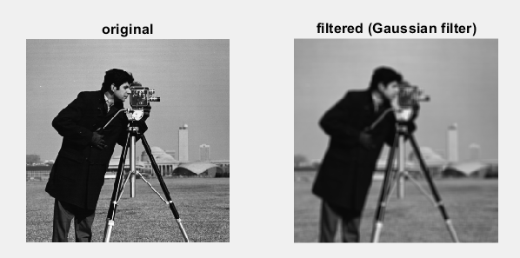
Figure 1: the effects of applying a gaussian filter
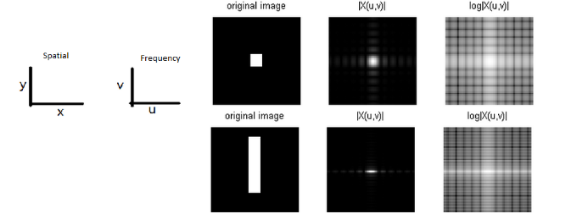
Figure 2: Visualizing a 2D fast Fourier transform

3. GPU Implementation
The system was first implemented in Python to verify correctness and then ported to GPU execution. In order to port this code to the gpu, pytorch was used, which allowed the conversion of windows to tensors to be processed by the gpu. Preprocessing such as loading the files and batching them to be ported to the gpu was done on the cpu. The most computationally expensive operations, including Gaussian filtering and FFT computation, were executed on the GPU. Image tiles were processed in batches to improve memory efficiency and reduce kernel launch overhead.

4. Experimental Results
System performance was measured using wall-clock time on the target platform. The average and standard deviation of the log-magnitude spectrum histogram were computed over the full dataset. A little too late into the project, I realized that I was only computing the first 2000 windows of each image which is a small amount of data compared to most of the images, which was a leftover from my previous testing. I know this is pretty bad on my end but what I found interesting is that the data is pretty consistent between the first 2000 windows and the whole image. I realize that this is also on a smaller data set at (10/80) images instead of 3505 but it still seems representative of the major trend.
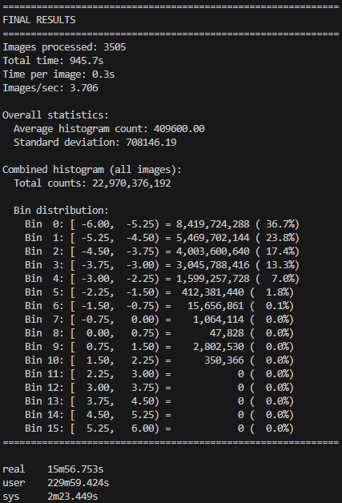
Figure 3: results of first 2000 windows all 3505 images
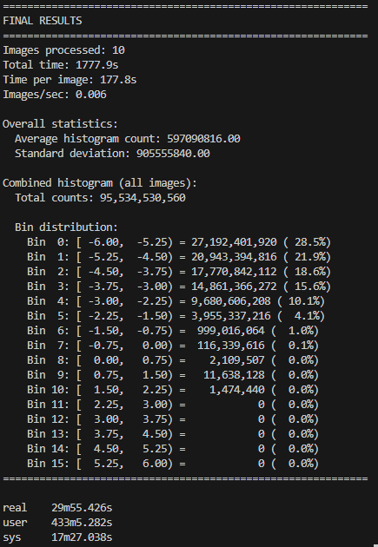
Figure 4: results of image analysis using 10 images

5. Discussion
When originally done in python, the program was running about about 9 minutes per image, which is relatively slow. When I ran my first gpu program with limited window numbers and collected data I was averaging about 3 seconds per image. When I ran my second gpu program, I was averaging about 3 minutes per image. Utilizing the GPU provided a massive speedup. In the case of only scanning the first: 2000 windows; gaussian filtering provides a strong low pass filter over the data which might be a reason for why the data of only a fraction of the image is consistent with the data of the entire image.

6. Conclusion
GPUs can provide massive speedup for real life digital signal processing, which seems to be the basis for societies reliance for faster communication and computation. Even though the full dataset wasn’t covered, we see the general trend of how gaussian filtering effects images

