ENGR Computation IV: Final Project and Discussion
K. Frazer
1. Neural Engineering Data Consortium, Temple University, Philadelphia, Pennsylvania, USA
tur37868@temple.edu

Abstract— Given a very large data set of SVS files, this paper will present a GPU approach to compute a Gaussian Blur and 2D FFT histogram in a reasonable time. By reading the SVS files in frame sizes of a small window and batching out the 2D Gaussian Blur and 2D FFT to the GPUs, there is a high speed up that can be observed over native CPU code. When five files were tested on the GPUs, the average time observed was 102.6869 seconds per image, which shows a major speed up compared to CPU code where it takes over three minutes for one image. This approach will show the pros and cons of using GPU code in processes like this and discusses how this can be optimized even further.
Keywords— GPU, SVS Images, Gaussian Blur, FFT, Histogram

Introduction
As technology in the image processing field develops, there needs to be more efficient ways to process images. Typical CPU operations can work fast in these operations, however it quickly bottlenecks as the number of cores for these operations quickly fill in. Fortunately, the rapidly advancing field of GPU programming has allowed this field to flourish quickly as operations like Gaussian Blur and FFT’s make the amount of computation time trivial. In this case, processing large SVS files become a small task for properly optimized GPU code rather than CPU code.
This paper will go into detail about the four methods used to complete the task, the results of this, and any future improvements. First, loop over the full image of an SVS file using the provided code. Second, create a 2D Gaussian smoother that’s 7x7 taps to read the data easier. Third, compute the 2D FFT and convert each value to a magnitude of the smoothed image. Finally, compute a histogram of the values and print the average and stdev if the histogram.

Methodology
As mentioned previously, there are a lot of steps required to do this project, let’s look a bit deeper into what is going on here.
Starting off from the top left of the image, we have a frame size of 128x128 within a sub-window that is 256x256. The purpose for this is to be able to easily read the RGB values associated with each frame from the image. This way, the data from each frame can be easily sent into the GPUs for computation since the data pool within each frame isn’t large. Interestingly, PyTorch handles most of the computation where torch sends the code through CUDA into the NVIDIA GPUs and will queue the process in the GPU’s memory. This way the CPU code can continue without waiting on the GPU and the GPU will not be idol because it will always have computations in queue.
After each window is processed, it will then be sent through a 2D Gaussian Smoother with a sigma ($σ$) of 1.2. This smooths out the high-frequency switches between white and another color being used, getting rid of massive DC spikes. Fortunately, Torch can parallelize these tasks the same way as previously mentioned. Something worth noting here is sigma can be any value, however the higher the value of sigma, the more blur that will be applied. This can be powerful and dangerous if the value for sigma isn’t considered properly. When working with small data points, typically between 1 to 1.5 will work.
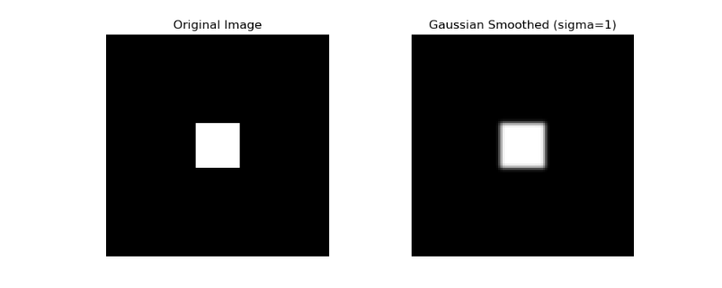
Figure 1: 2D Gaussian Smoothed Square
Once this is completed, each smoothed sub-window will then get sent into a Torch FFT, which will then return the value of the magnitude. The value of the FFT is required here because we need to know how much energy is at a certain frequency such that the histogram can find the mean and stdev. The way Torch does this is by calling the cuFFT library and sending the code off to the GPUs. There is a very nice feature that Torch has is the ability to deal with the memory allocation by using torch allocator which is highly optimized GPU allocation code.
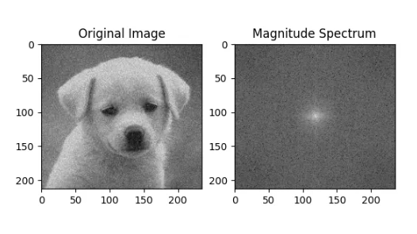
Figure 2: FFT on Dog Image
From here, a histogram is then created and computed with 16 bin range values. Each bin has its own range of RGB values, but the sum of them should equal the original number of window inputs. From there, Torch has functions that directly calculate the mean and the stdev.

Results
The results I received are as follows from image /data/isip/data/tuh_dpath_breast/deidentified/v3.0.0/svs/eval/00006695_aaaaaadg/s000_2015/breast/00006695_aaaaaadg_s000_0hne_0000_a002_lvl003_t000.svs:
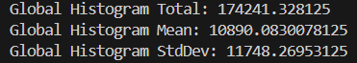
From top to bottom, the histogram total is the approximate number of windows that have been received and processed. The histogram mean is the mean from the histogram, this can be explained by the following equation:
$$mean=\frac{histogram_{total}}{bins}$$
Where the bins, as discussed above, is where each range of the RGB values exist within said bins. Since the number of wanted bins is 16 here, the equation returns the following:
$$mean=\frac{174231}{16}=10980$$
This follows a reasonable expectation however it is also worth noting that the histogram total is off by around 30, it’s not enough to be noticeable in the final output though. Another thing to note here is that the histogram can be returned as an array based on the number of bins given to it. The following shows the outputs for each bin using the same SVS file:
When running this code using five SVS files, I receive an average of 102.6869 seconds per image.

Disscusion
Overall, this project was a great learning experience, where I fully understood a lot of concepts that I didn’t fully grasp before such as using python for GPU code over CUDA/C. However, there are a few things I would like to improve next time. The first example I will go into is I/O. I didn’t really touch optimizations for bringing the files over to read, there were a few ways I could have went about that such as batching a list of files in at a time. Another example of this is the use of multiple GPUs over using one. This should be a simple task using Torch since there is a function call that can detect multiple GPUs. However, I was unable to get it to run the way I wanted it to run, so I eventually had to leave the idea behind.

Summary
To summarize, we have created a program that can loop over an image that creates a frame size through a larger window size. Computed a Gaussian Blur to be able to see a smoother transition between high and low frequencies on an image. Ran that through an FFT to compute the magnitude of each frequency. Then computed a histogram of the values after the processing is finished.

