High-Performance GPU Computing for Medical Image Spectral Analysis
Md Abdullah Al Mamun
Department of Electrical and Computer Engineering, Temple University
Abdullah18@temple.edu
Introduction: The computational analysis of whole slide images (WSI) in pathology presents a significant "Big Data" challenge, specifically when computing spectral distributions across terabytes of uncompressed pixel data. This study addresses the bottlenecks associated with processing 3,505 high-resolution SVS slides (approximately 30TB of data). We analyze and optimize the data pipeline on a multi-GPU node equipped with four NVIDIA A40s. By transitioning from a CPU-bound "Producer-Consumer" model (Architecture A) to an optimized "Zero-Copy" GPU-native pipeline (Architecture B/B+), we successfully eliminated redundant host-device memory transfers. The final optimized architecture reduced total processing time on 4 GPUs from ~16.5 hours to ~5.25 hours, achieving a massive increase in throughput while maintaining statistical integrity.
Modern medical image analysis, particularly tissue segmentation and spectral analysis, relies heavily on high-performance computing. However, in large-scale datasets, the bottleneck often shifts from computational complexity (FLOPS) to I/O latency. The objective of this study was to compute log-magnitude spectral distributions for the Temple University Hospital Digital Pathology Corpus[1]. The core challenge identified was that while mathematical operations like Convolution and Fast Fourier Transform (FFT) are rapid on modern GPUs, moving terabytes of data from disk to GPU memory creates a saturation point. This paper details the evolution of the processing pipeline from a standard CPU-dependent approach to a highly optimized, latency-hidden GPU workflow.
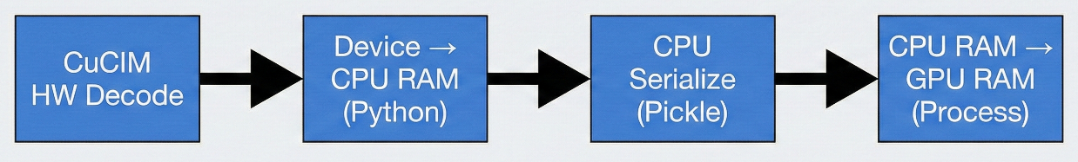
Architecture A (Producer-Consumer): The initial approach utilized a standard producer-consumer model using nedc_image_tools. In this architecture, the CPU (Host) was responsible for reading the file via CuCIM (Hardware Decode)[2], moving data to CPU RAM for Python processing, and serializing (pickling) the tensor before moving it back to the GPU. This architecture introduced a "hidden flaw" where the CPU spent more time serializing data and managing memory copies than reading from the disk. The PCIe bus was saturated by moving the same data twice (Device Host Device), causing the GPUs to idle while waiting for data.

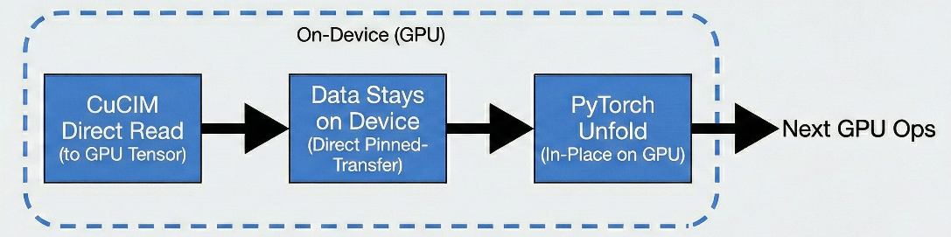
Architecture B (Zero-Copy Pipeline): To address the serialization bottleneck, we implemented a "Zero-Copy" design. This approach utilized CuCIM to read files directly into GPU tensors, ensuring data remained on the device. By using CuPy for array conversion and performing PyTorch[3] unfold operations in-place on the GPU, we eliminated the CPU-GPU round-trip entirely.
Figure 1: Architecture A Data Flow illustrating the redundant Device-to-Host transfers.

Figure 2: Architecture B Data Flow illustrating the direct-to-GPU pipeline.
Architecture B+ (Zero-Copy Pipeline with Latency Hiding): The final optimization focused on tuning block sizes to hide latency. Architecture B read small strips (256px), which incurred high overhead per read. Architecture B+ increased the height of block size to 1024px, maximizing sequential throughput and utilizing asynchronous I/O threads to pre-load Batch N+1 while the GPU processed Batch N.
Results and Discussion: The performance gains were evaluated based on total wall-clock time and average time per image across 1, 2, and 4 GPU configurations. Table 1 below summarizes the "Benchmark" between the three architectures.
GPUs | Approach A (Baseline) | Approach B (Optimized) | Approach B+ (Highly Optimized)
1 GPU | ~39.35 hrs (40.42 s/img) | ~27.9 hrs (28.68 s/img) | ~23.6 hrs (24.27 s/img)
2 GPUs | ~21.82 hrs (22.41 s/img) | ~15.3 hrs (15.72 s/img) | ~11.2 hrs (11.49 s/img)
4 GPUs | ~16.53 hrs (16.98 s/img) | ~9.1 hrs (9.36 s/img) | ~5.25 hrs (5.39 s/img)
Table 1: Performance Comparison
Architecture A showed poor scaling also; moving from 2 to 4 GPUs only yielded a 1.3x speedup due to the CPU pickling bottleneck. In contrast, Architecture B+ demonstrated superior scaling, with 4 GPUs completing the task in roughly 5.25 hours—a 3x improvement over the baseline 4-GPU performance.
Histogram and statistics of the Log-magnitude spectra: To ensure that the optimizations did not compromise data accuracy, we compared the log-magnitude spectral distributions of the baseline and optimized approaches.
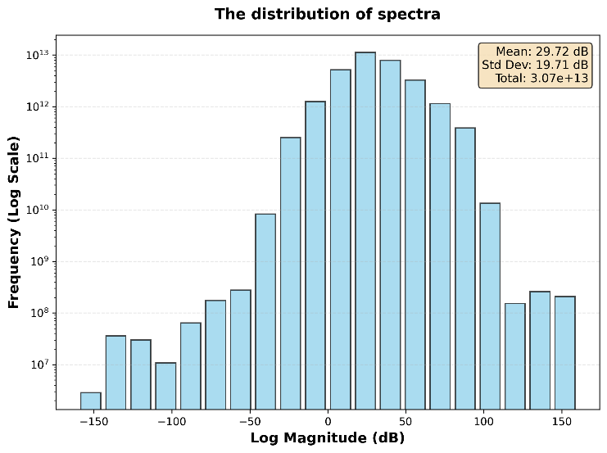
Baseline Mean/Std Dev: 29.72 dB / 19.71 dB
Optimized Mean/Std Dev: 29.57 dB / 20.06 dB
The difference in mean was merely 0.5%, and the standard deviation differed by only 1.8%, confirming that the high-performance pipeline produced statistically identical results to the baseline
Conclusions: This study demonstrates that in high-performance medical image computing, optimizing data movement is often more critical than optimizing raw computation. By removing CPU serialization overhead and implementing a direct-to-GPU "Zero-Copy" pipeline, we achieved a significant reduction in processing time for terabytes of the pathology data. The final Architecture B+ pipeline successfully removed the PCIe bottleneck, allowing for near-linear scaling across multiple GPUs.

Hardware Specifications:
The experiments were conducted on the nedc_012 node, utilizing:
GPUs: 4x NVIDIA A40 (45Gi Memory each)
CPU: 96 Cores with 251Gi RAM
Driver/CUDA: Driver 555.42.06, CUDA 12.5

Acknowledgements:
We acknowledge the support of the Neural Engineering Data Consortium (NEDC) Lab for computational resources and Dr. Joseph Picone (Temple University) for course support in ECE 4822[4].

References
- Houser, D. S., et al. (2018). The Temple University Hospital Digital Pathology Corpus. In Proceedings of the Digital Pathology Summit.
- NVIDIA. CUDA C++ Programming Guide. https://docs.nvidia.com/cuda/
- Paszke, A., et al. (2019). PyTorch: An imperative style, high-performance deep learning library. In Advances in Neural Information Processing Systems (pp. 8024-8035).
- Picone, J. ECE 8110: Engineering Computation IV. Temple University Department of Electrical and Computer Engineering.

