Vaughn Wiernicki

ECE 3522: Stochastic Processes in Signals and Systems

Department of Electrical and Computer Engineering, Temple University, Philadelphia, PA 19122

# Problem Statement

The purpose of this computer assignment was to examine various signals as well as their autocorrelations and the matching Power Spectral Density. The Power Spectral Density is the Fourier Transform of the Autocorrelation function. In terms of ECE 3412, the Fourier Transform of a signal gives us the frequency response of that signal, or a plot of which frequencies contain the most energy. This is also called the Spectral Density of a signal. If we were to plot the power of the Spectral Density we would then get the Power Spectral Density. The inverse Fourier Transform of this function would result in an Autocorrelation function.

# Approach and Results

Our first signal was simple Gaussian white noise. When plotted we received a signal that had a variety of amplitudes. If a histogram was taken we would see a Gaussian distribution of amplitude values. Then using MATLAB’s “autocorr” function the autocorrelation was taken with the specified number of lags. In this example our specified value was 20. We can see from Figure 1 below that our Autocorrelation starts off at 1 and then quickly falls to zero and then hovers around going back and forth between small values of direct and indirect correlation. Using “fft” on our autocorrelation gave us the Fourier Transform. When the magnitude of the Fourier Transform was taken we received the third plot for the Power Spectral Density as seen below.

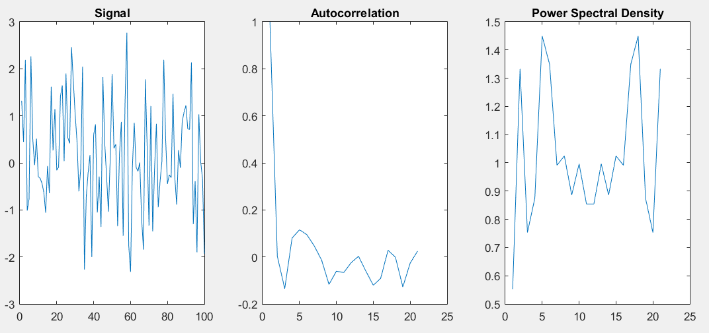

Figure : Results for a Gaussian White Noise Signal

We can see that the power Spectral Density has spikes in various locations in the frequency, but the magnitude for all of these values is very small. While there is frequency content in the signal, it’s not strong enough to amount to anything majorly significant. With enough time however, Gaussian White Noise would have frequency content for all values of frequency.

Our second signal was an impulse signal. Using the value of one for the first point and all zeros afterwards. Then taking the autocorrelation of the signal we see that the plot drops to zero after the first point and stays flat at zero for the rest of the 20 lags. This makes sense as there is never a value like the first value in the function, hence there is no correlation within itself. The Power Spectral Density then illustrates that the Fourier Transform is similar to a constant. This has to do with the duality principle to the Fourier Transform. When the signal gets closer to being narrow in the time domain, we get a function that is wider in the frequency domain.

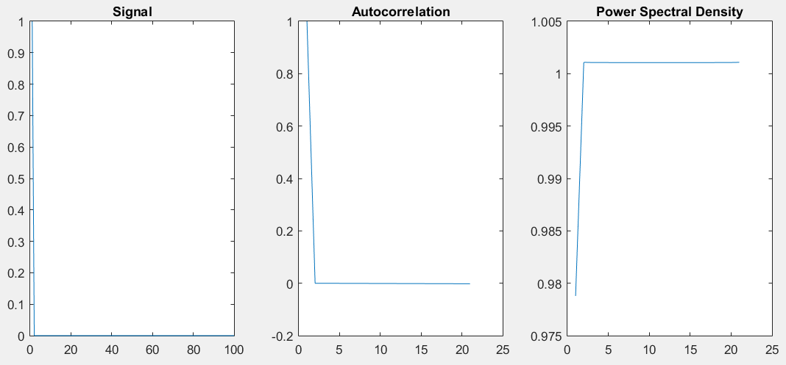

Figure : Results for an Impulse Signal

We then followed this plot with an Impulse Train with a periodicity of 20 samples as our signal. We can see that the autocorrelation oscillates between zero and impulse showing the autocorrelation to be closer to one, but not quite there. The reason for the decreasing amplitude in the spikes can be attributed to the zeros in between the impulses. The Power Spectral Density is also rich with harmonics of the frequency for the impulses.

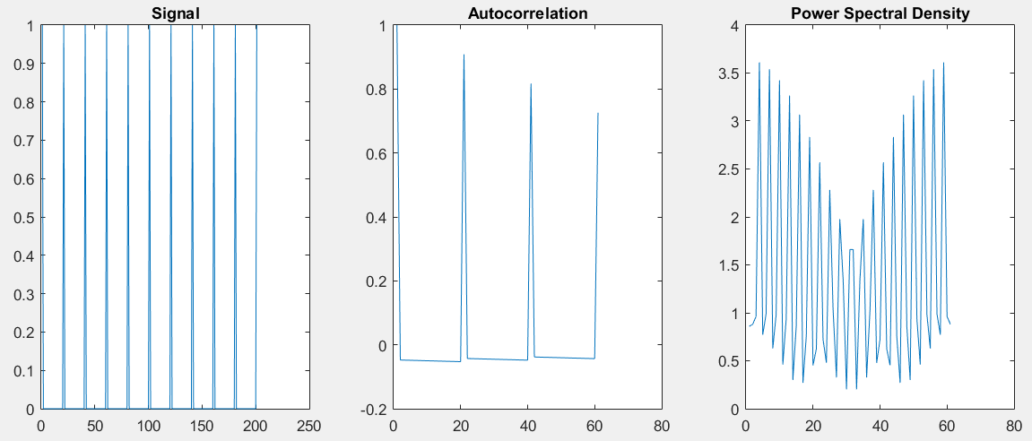

Figure : Results for an Impulse Train

We then move to the series of Sine waves for all of the figures involved in part 4 and 5 of the assignment. In Figure 4 below we look at a signal of a sine wave with a period of 20. The signal looks nothing like a sine wave, but that is a result of having only 200 points. When more points were added the sine wave would have a shape more characteristic of a periodic function. We then see that the autocorrelation function shows a periodic behavior as well. The autocorrelation goes back and forth between being directly and indirectly correlated. The Power Spectral Density is then characteristic of a periodic function where there is a lot of energy on the frequency of the signal, 20 Hz, and then there are smaller spikes of energy for the harmonics of the signal.

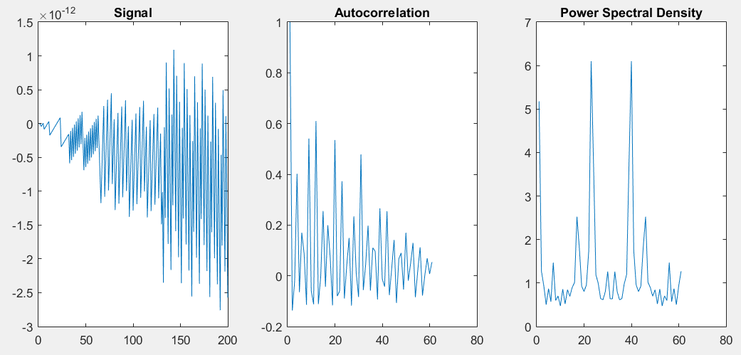

Figure : Results for a Sine wave

Now we are redoing the same sine wave, but changing the number of lags we’re using for the autocorrelation. Below is the data for only 14 lags as opposed to the above 60 lags.

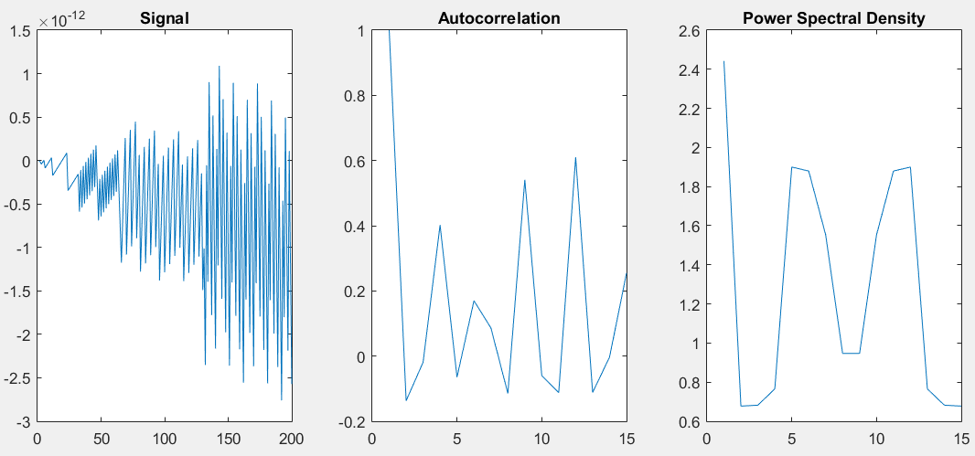

Figure : Results for a Sine with 14 Lags

We then look at the plot for 17 lags:

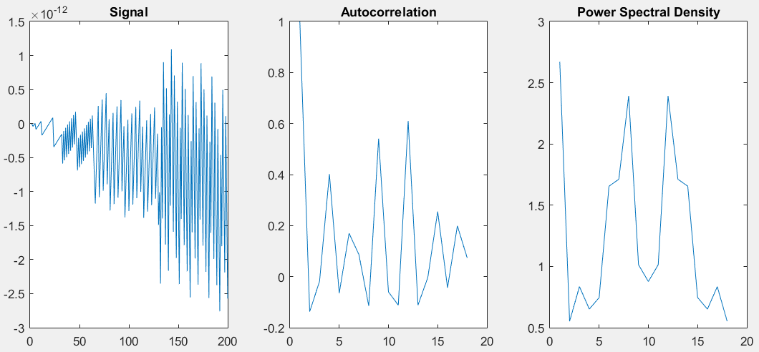

Figure : Results for a Sine with 17 Lags

A plot for 20 lags:

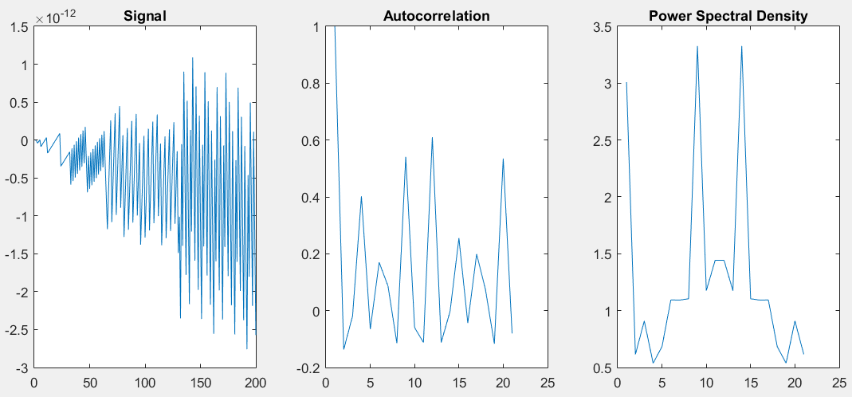

Figure : Results for a Sine with 20 Lags

A plot for 23 lags:

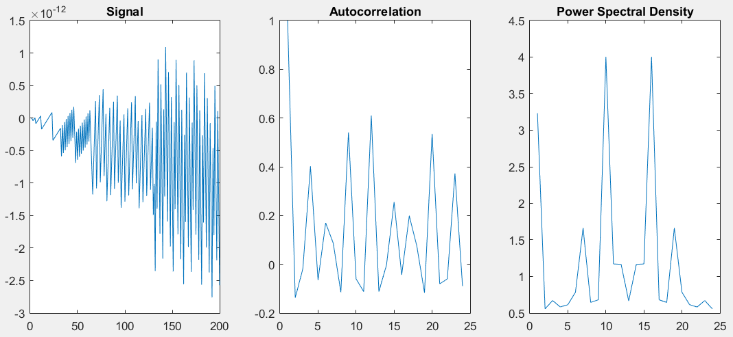

Figure : Results for a Sine with 23 Lags

And finally a plot for 26 lags:

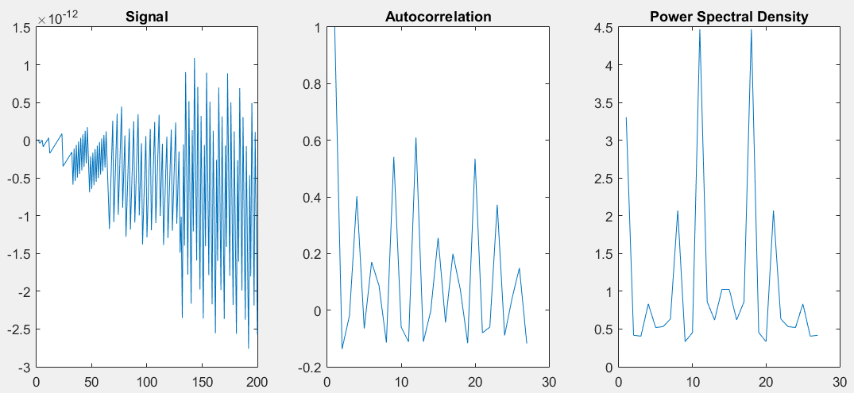

Figure : Results for a Sine with 26 Lags

So we can see that as we increase the number of lags our signal stays the same, as we would expect. The number of lags has nothing to do with the signal being plotted. We then look at the autocorrelation and see that as we increase the number of lags, there isn’t any more definition to the plot, but there is more data being tacked on to the end of the plots. The oscillations of the autocorrelation are similar to the figure with 60 lags and show that the function is periodic. We can then see that as we increase the number of lags the Power Spectral Density becomes more and more defined with peaks at the frequency of the sine wave and smaller peaks at harmonics of the frequency.

Our last signal is the same sine wave used in part 4 combined with the Gaussian White Noise from the first signal. We give the signal a Signal-Noise Ratio of 10 dB so we expect to have a fair amount of the sine wave present in relation to the noise and have a sine wave like structure to the autocorrelation. The following plot cannot illustrate the signal well enough due to the low number of points and proportional low resolution of the sine wave. The Power Spectral Density still has peaks at its base frequency. The Plot was redone and placed in figure 11 to give a more accurate representation.

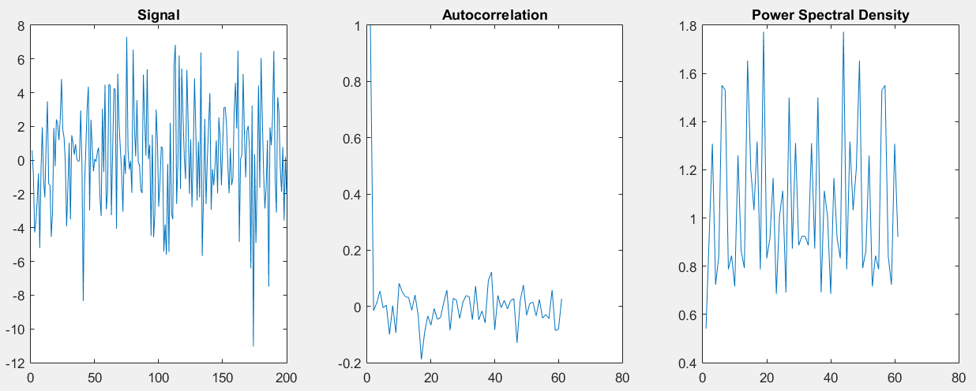

Figure : Results for a Sine wave with 10 dB Signal-Noise Ratio

With a factor of one hundred extra points we can see more clearly that the autocorrelation has a more sinusoidal tendency. We can also see that the power spectral density has strong peaks at its frequency just as we would expect.

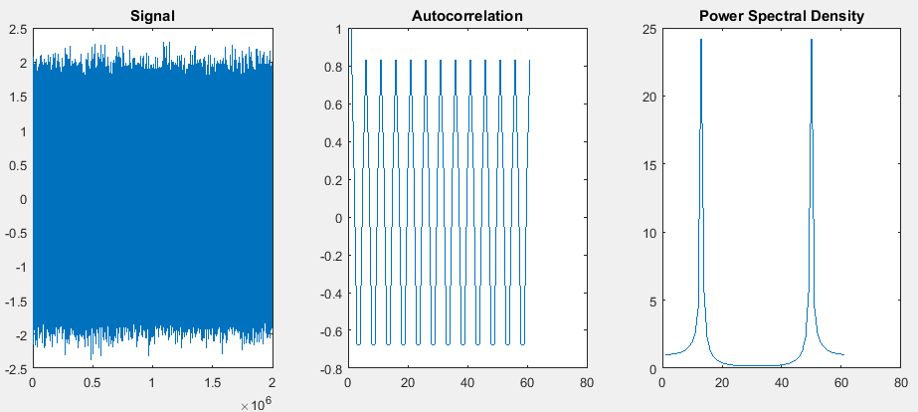

Figure : A Clearer Representation of Figure 10

# MATLAB Code

clear; clc; clf; close all;

%% Signal 1:

N = 100;

M = 20;

sig = wgn(1, N, 1);

Asig = autocorr(sig, M);

Fsig = abs(fft(Asig));

figure(1);

subplot(1, 3, 1);

plot(sig);

title('Signal');

subplot(1, 3, 2);

plot(Asig);

title('Autocorrelation');

subplot(1, 3, 3);

plot(Fsig);

title('Power Spectral Density');

%% Signal 2:

N = 100;

M = 20;

sig = zeros(1, N);

sig(1, 1) = 1;

Asig = autocorr(sig, M);

Fsig = abs(fft(Asig));

figure(1);

subplot(1, 3, 1);

plot(sig);

title('Signal');

subplot(1, 3, 2);

plot(Asig);

title('Autocorrelation');

subplot(1, 3, 3);

plot(Fsig);

title('Power Spectral Density');

%% Signal 3:

N = 200;

M = 60;

sig = zeros(1, N+1);

for i = 1:20:N+1

sig(1, i) = 1;

end

Asig = autocorr(sig, M);

Fsig = abs(fft(Asig));

figure(1);

subplot(1, 3, 1);

plot(sig);

title('Signal');

subplot(1, 3, 2);

plot(Asig);

title('Autocorrelation');

subplot(1, 3, 3);

plot(Fsig);

title('Power Spectral Density');

%% Signal 4:

T = 20;

w = 2*pi*T;

N = 200;

M = 60;

sig = zeros(1, N);

for t = 1:1:N

sig(1, t) = sin(w*t);

end

Asig = autocorr(sig, M);

Fsig = abs(fft(Asig));

figure(1);

subplot(1, 3, 1);

plot(sig);

title('Signal');

subplot(1, 3, 2);

plot(Asig);

title('Autocorrelation');

subplot(1, 3, 3);

plot(Fsig);

title('Power Spectral Density');

%% Signal 5:

T = 20;

w = 2*pi*T;

N = 200;

M = [14, 17, 20, 23, 26];

sig = zeros(1, N);

for a = 1:1:N

sig(1, a) = sin(w*a);

end

for b = 1:1:length(M)

Asig = autocorr(sig, M(b));

Fsig = abs(fft(Asig));

figure(b);

subplot(1, 3, 1);

plot(sig);

title('Signal');

subplot(1, 3, 2);

plot(Asig);

title('Autocorrelation');

subplot(1, 3, 3);

plot(Fsig);

title('Power Spectral Density');

end

%% Signal 6:

T = 20;

w = 2*pi*T;

N = 200;

M = 60;

A = zeros(1, N);

for t = 1:1:N

A(1, t) = sin(w*t);

end

sig = awgn(A, -10);

Asig = autocorr(sig, M);

Fsig = abs(fft(Asig));

figure(1);

subplot(1, 3, 1);

plot(sig);

title('Signal');

subplot(1, 3, 2);

plot(Asig);

title('Autocorrelation');

subplot(1, 3, 3);

plot(Fsig);

title('Power Spectral Density');

# Conclusions

In conclusion we can see that the Power Spectral Density has a lot to do with the number of lags used for the autocorrelation. More or less lags dictate more or less resolution for the plot of the Power Spectral Density. The plots for the Power Spectral Density also look very similar to the Fourier Transform we would expect to see for all of the functions used. With the autocorrelation we can gain knowledge of what the power of the frequency response would look like.