Emilie Doyle

ECE 3522: Stochastic Process in Signals and Systems

Department of Electrical and Computer Engineering, Temple University, Philadelphia, PA 1912

# Problem Statement

The objective of this assignment is to learn more about the autocorrelation function and the power spectral density of various types of signals. The signals that were assigned for this task are; Gaussian white noise (1), an impulse function (2), a periodic impulse train with period of 20 samples (3), a sinewave with period of 20 samples (4), a sinewave with various sample sizes (5), and the combination of signals 1 and 4 ( sinewave and GWN) (6). The data that is given to us involved the number of samples and the number of points for the autocorrelation to take place upon. Additionally, the general form for the autocorrelation function is provided for a reference. For signal 6, the signal to noise ratio is also given for analysis. The goal of this assignment is to determine the autocorrelation function of each of the given signals and then to use the Fourier Transform on the autocorrelation values in order to calculate the power spectral density for each signal.

# Approach and Results

I first started by coding all of the signals into MATLAB and calculating the autocorrelation for each signal. The first signal was just Gaussian white noise, so I used the wgn function to create the signal. This function was fed a signal to noise ratio of 0 dB, thus resulting in solely noise. The number N was also provided, as the number of points. I then used the autocorrelation function, autocorr, to determine the values for this signal by supplying the function with the signal and the number of points used in the autocorrelation. . I then plotted the autocorrelation function for good measure.

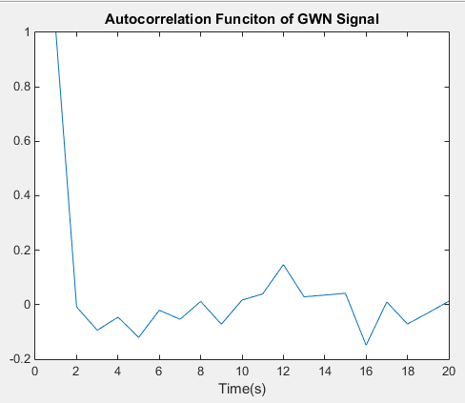

Figure : Autocorrelation of Gaussian White Noise Signal

The second function was an impulse function so I created this by concatenating a1 x 1 matrix of content 10e5, with a matrix formulated from the command ‘zeros’. It is crucial that the impulse function have an extremely tall height. Ideally it would be infinite, but that is not really practical in MATLAB. Again, I used the autocorrelation command to determine the values and plotted it again.

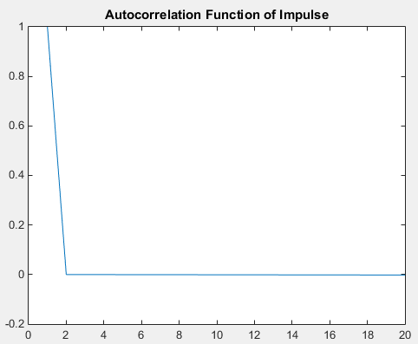

Figure : Autocorrelation of Impulse Function

The third function was an impulse train. I created this by concatenating a 1x1 matrix of content 10e5 with a array of zeroes. This concatenation spanned one cycle of the train. Then I concatenated that resulting array with itself many times over until it stretched to the length of the given desired size. I also plotted this autocorrelation function.

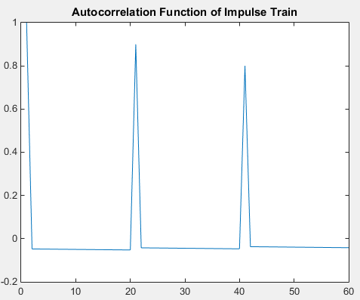

Figure : Autocorrelation of Impulse Train Function

The fourth function was a sine wave of specified period/frequency. I just used the sin function in order to create it. The time values I used came from a linear spacing between 1 and the total value with step size of the inverse of the period (frequency). I used the autocorrelation function again and plotted the results.

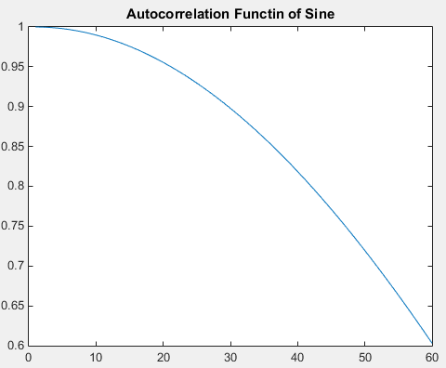

Figure : Autocorrelation of Sine-wave

For the fifth function, there were different values for the sample window. I put these values in an array, N, and then used a loop to cycle through the values. Within the loop, I set a time frame and then calculated a sine wave based off of that and calculated the autocorrelation function of that and stored it in an array. I plotted all of those autocorrelations.

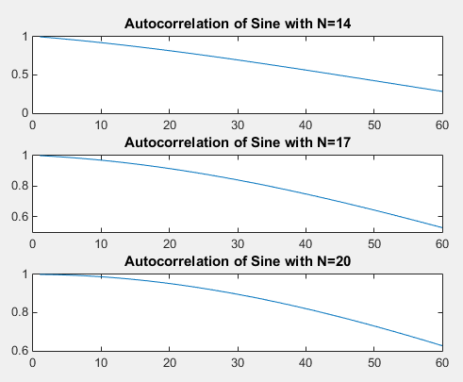

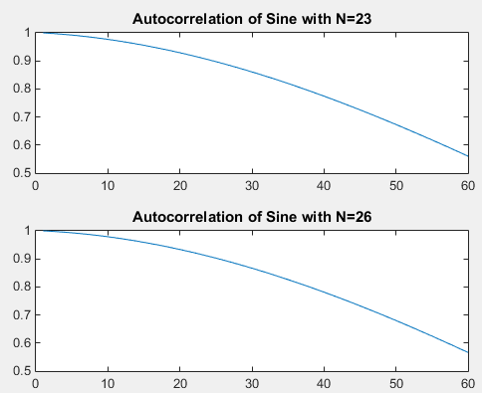

Figure : Autocorrelation Function of Sine with Various N Values

The last signal is the sine wave plus the Gaussian white noise. I just used the fourth signal and the add white Gaussian noise (awgn) command in order to add in the Gaussian white noise at the specified signal to noise ratio of 10 dB. Again, I plotted this.

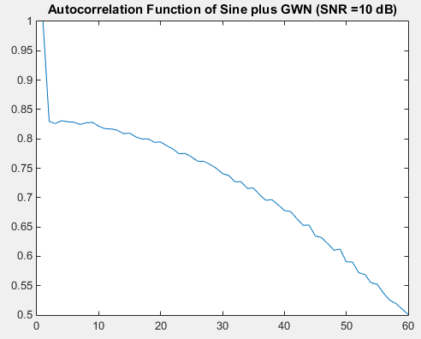

Figure : Autocorrelation of Sine and GWN at SNR=10dB

In order to determine the power spectral density of all of these signals, I took the fast Fourier Transform (fft) of all of the signals at 8192 points. When these are to be plotted, it is important to take the absolute value of the Fourier Transform in order to account for imaginary values.

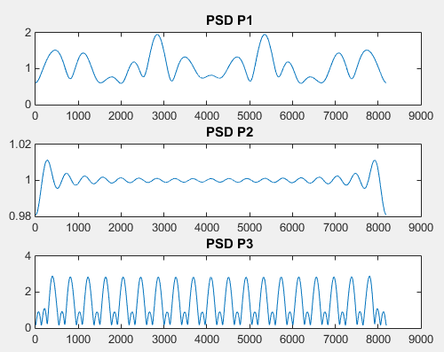

Figure : Power Spectral Densities of First Three Signals

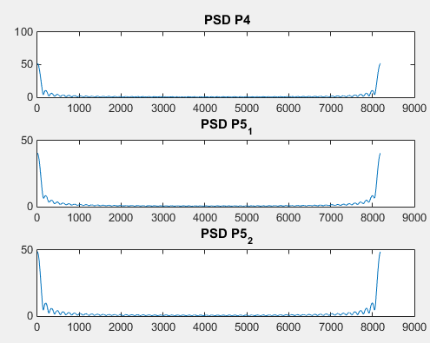

Figure : Power Spectral Densities of Signals 4- 6

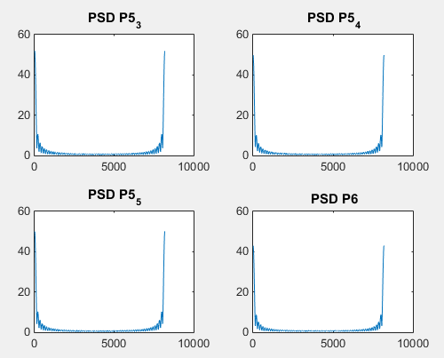

Figure : Power Spectral Densities of the last 4 signals

# MATLAB Code

%Stoch CA 11

clear;

%GWN

N= 100; M= 20;

y1= wgn(1, N ,0 );

acf1= autocorr(y1, M-1);

t= 1:20;

figure(1)

plot(acf1);

title('Autocorrelation Funciton of GWN Signal'); xlabel('Time(s)');

%Impulse Function

k= [10e5];

z= zeros(1, 99);

y2=[k, z];

acf2= autocorr(y2, M-1);

figure(2)

plot(acf2);

title('Autocorrelation Function of Impulse'); xlabel('Time(s)');

%Impulse Train

M= 60; N=200;

k= [10e5];

z= zeros(1, 19);

k= [k, z];

y3=[ k, k , k , k , k,k, k , k , k , k];

acf3= autocorr(y3, M-1);

t=1:M;

figure(3)

plot(acf3);

title('Autocorrelation Function of Impulse Train'); xlabel('Time(s)');

%Sine wave

T= 20;

f= 1/T;

t= 1:f:200;

y4= sin(2*pi*f*t);

acf4= autocorr(y4, M-1);

figure(4)

plot(acf4);

title('Autocorrelation Functin of Sine'); xlabel('Time(s)');

%4 Again

N= [14 17 20 23 26];

for i=1: length(N)

t= 1:f:N(i);

y5= sin(2*pi*f*t);

acf5(i, :)= autocorr(y5, M-1);

end

figure(5)

subplot(3, 1, 1)

plot(acf5(1, :));

title('Autocorrelation of Sine with N=14');

subplot(3,1,2)

plot(acf5(2, :));

title('Autocorrelation of Sine with N=17');

subplot(3,1,3)

plot( acf5(3, :));

title('Autocorrelation of Sine with N=20');

figure(6)

subplot(2,1,1)

plot(acf5(4, :));

title('Autocorrelation of Sine with N=23');

subplot(2,1,2)

plot(acf5(5, :));

title('Autocorrelation of Sine with N=26');

%Sine plus WGN

y6= awgn( y4, 10);

acf6= autocorr(y6, M-1);

plot(acf6);

title('Autocorrelation Function of Sine plus GWN (SNR =10 dB)');

%PSD

t=1:8192;

p1= fft(acf1, 8192);

p2= fft(acf2, 8192);

p3= fft(acf3, 8192);

p4= fft(acf4, 8192);

p5_1= fft(acf5(1,:), 8192);

p5_2= fft(acf5(2,:), 8192);

p5_3= fft(acf5(3,:), 8192);

p5_4= fft(acf5(4,:), 8192);

p5_5= fft(acf5(5,:), 8192);

p6= fft(acf6, 8192);

figure(7)

subplot(3,1,1)

plot(t, abs(p1)); title(' PSD P1');

subplot(3,1,2)

plot(t, abs(p2)); title(' PSD P2');

subplot(3,1,3)

plot(t, abs(p3)); title(' PSD P3');

figure(8)

subplot(3,1,1)

plot(t, abs(p4)); title(' PSD P4');

subplot(3,1,2)

plot(t, abs(p5_1)); title(' PSD P5_1');

subplot(3,1,3)

plot(t, abs(p5_2)); title(' PSD P5_2');

figure(9)

subplot(2,2,1)

plot(t, abs(p5_3)); title(' PSD P5_3');

subplot(2,2,2)

plot(t, abs(p5_4)); title(' PSD P5_4');

subplot(2,2,3)

plot(t, abs(p5_5)); title(' PSD P5_5');

subplot(2,2,4)

plot(t, abs(p6)); title(' PSD P6');

# Conclusions

The autocorrelation for the Gaussian white noise makes sense because initially it may be similar, but then the sporadic nature of the white noise severely will limit the correlation between different portions of the signal. The power spectral density of this signal makes sense that there would be content across the spectrum. White noise means that there will be content for all frequencies, and then the Gaussian aspect means that it will follow some sort of Gaussian model. In this plot we can see aspects of Gaussians, and definitely the presence of content at all frequencies.

The autocorrelation for the impulse function also makes sense because as the autocorrelation function progresses the frame for the comparison will continually progress away from the actual value at t=0. Because so many of the values literally have zero content, it would make sense that the autocorrelation would converge to zero as well. The power spectral density seems to fluxuate greatly around 0, which seems to correspond with the high zero content of the impulse signal. It also has frequency content to correspond to the impulse. Due to the duality of time and frequency we can tell that it will have a wide range of content.

Similarly, the autocorrelation function of the pulse train would be similar to that of single pulse. However, the periodic element of if prevents it from truly converging to zero as quickly as that of the single pulse. The periodic pulses pull back up the autocorrelation, but it is important to note that the magnitudes of the successive pulses are smaller because of the zero elements between them. The periodic aspect of the pulse train is very obvious in the power spectral density. It has a great many bumps to correspond with the periodic elements and signal content again due to duality.

The autocorrelation function of the sine wave appears to be a portion of the sine wave. This makes sense because of the periodic and symmetrical aspects of the sine wave. Additionally, the autocorrelations of the successive versions of the sine wave that have different values of N are nearly identical. This makes sense because, again, the signal is periodic and so symmetrical.. This essentially removes the time/phase element of the situation. The sine wave is periodic, but it has a given frequency, so it makes sense to only really see content on the power spectral density at that frequency and multiples of it, but other than that it has relatively low frequency content. The power spectral densities for all of the forms of the sine wave also reflect this.

Within the autocorrelation of the sine and Gaussian white noise, we can see elements from both the Gaussian white noise and the sine wave correlation values. The sine wave portion seems more prevalent in this graph, which makes sense because the signal to noise ratio is 10 dB, so the signal will have prevalence, yet the other is still present. Because the sinewave is so prevalent in the autocorrelation, it makes sense that the power spectral density would appear to reflect more of the sine wave characteristics. It appears to match that of the normal sine waves where is has real magnitude at the frequency of the sinewave, with low content elsewhere.