John Lee

ECE 3512: Signals – Continuous and Discrete

Department of Electrical and Computer Engineering, Temple University, Philadelphia, PA 19121

# Problem Statement

For this experiment, we will be working with visualizing the PDF plots at specific parameters. As we understand the manipulation of 3D data plots with the joint PDF calculated, we were able to produce multiple covariance 3D plots to obtain a detailed plot of the specified conditions to plots these data sets. The main key is to maintain the covariance matrices within a 2x2 set and to visualize all of the concepts we recently applied during lecture time.

# Approach and Results

In order to generate a basic bar plot of a data set of our choice. These values can determine the quality of the data obtained after inputting specific plots. We will require a set of “for loop statements to produce a multiple set of bar graphs plots for each X and Y PDF value sets. These will be place on a 3D function set that will take care of producing the joint PDF of the both data sets. **Figure 1** display the bar graph plot of the PDF values for the data sample [1:10000]. If we increase the number of samples the probability of the X and Y values should be able to read to 0.01.

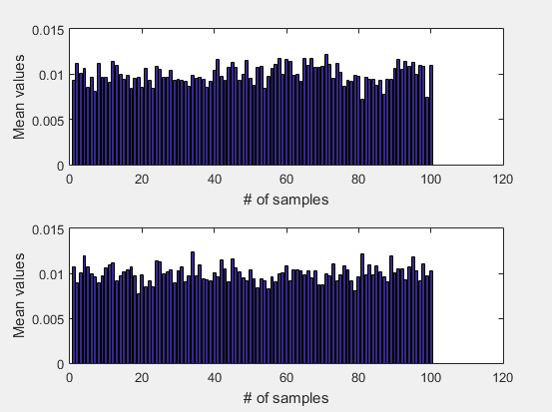

**Figure 1** Autocorrelation plot at t = [0.9, 3]

Once we obtain the data sets of both PDF (X & Y) values, we can generate a mesh plot of the 3D perspective of both PDF sets. We manipulated around the [X Y Z] positions for the best suited display of the joint PDF. We can observe that there are oscillations within the probability values, this occurs due to the lack of samples inputted into the system. If we include more samples, not only the system is consuming memory on the computer, but it should display a smooth sheet-like plot, with low noise.

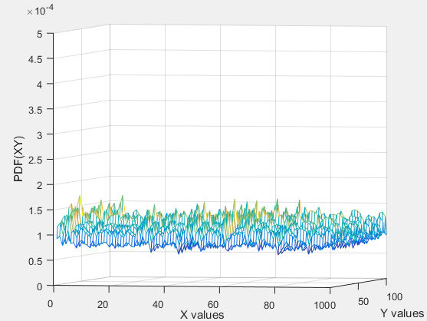

**Figure 1** Autocorrelation plot at t = [0.9, 3]

The second portion of this experiment requires us to plot multiple covariance’s 3D plots to observe and compare these results. We need to take note that all these data matrices are within 2x2. **Figures 2 – 5** displays all the Covariance results under specific matrix values sets. Manipulating the values of the 2x2 set, we can increase or decrease the join PDF by changing the matrix structure.

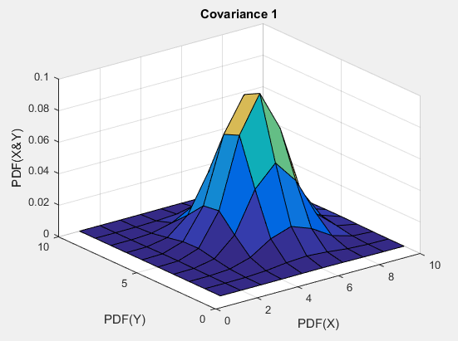

**Figure 2** Covariance #1 plot

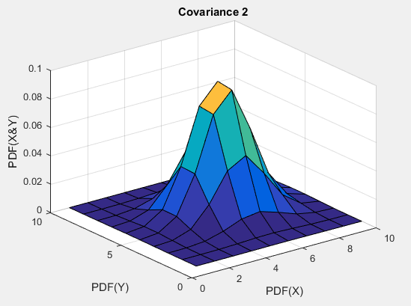

**Figure 3** Covariance #2 plot

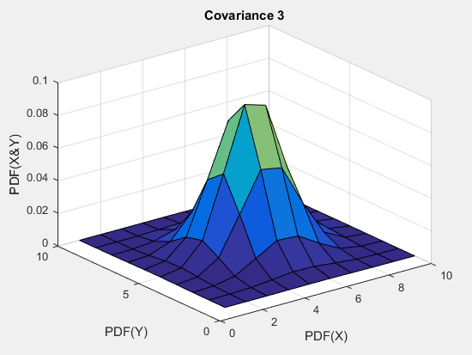

**Figure 4** Covariance #3 plot

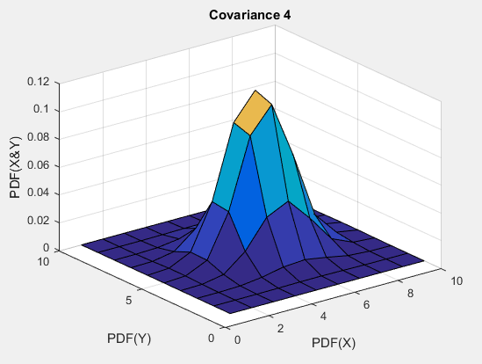

**Figure 5** Covariance #4 plot

# MATLAB Code

**Part 1**

clear;

clc;

clf;

close all;

% Creating the sample set loop

for X = 1:10000

x(X,:) = rand(1,2);

end

numbin = 100;

PDF1 = histcounts(x(:,1),numbin , 'Normalization', 'Probability');

PDF2 = histcounts(x(:,2),numbin ,'Normalization', 'Probability');

% PDF plot of X and Y

figure(1)

subplot(2,1,1)

bar(PDF1)

xlabel('# of samples');

ylabel('Mean values of samples');

title('PDF(X)');

subplot(2,1,2)

bar(PDF2)

xlabel('# of samples');

ylabel('Mean values of samples');

title('PDF(Y)');

% Joint PDF 3D plot

figure(2)

[x_mesh, y_mesh] = meshgrid(PDF1, PDF2);

PDmesh = x_mesh .* y_mesh;

[X, Y] = meshgrid(1:1:length(PDmesh), 1:1:length(PDmesh));

mesh(X,Y,PDmesh)

axis([0, 100, 0, 100, 0 , 0.0005])

xlabel('Probability of X');ylabel('Probability of Y');zlabel('Joint PDF');

title('Joint PDF of X and Y');

**Part 2**

clear;

clc;

clf;

% Defining values

N = 4;

Case = 10^N;

numbin = 10^(4/N);

mean = [6 6];

cov1 = [1 0 ; 0 1];

cov2 = [5 0 ; 0 2];

cov3 = [1 0.5 ; 0.5 1];

cov4 = [5 0.5 ; 0.5 2];

% Plotting Covariance 1

figure(1)

A = mvnrnd(mean, cov1, Case);

X1 = histcounts(A(:,1),numbin,'Normalization','Probability');

X2 = histcounts(A(:,2),numbin,'Normalization','Probability');

%B = mvnpdf(A, mean, cov1);

[x_mesh,y_mesh] = meshgrid(X1,X2);

B = x_mesh.*y_mesh;

[A,Y_mesh] = meshgrid(1:1:length(B), 1:1:length(B));

surf(A, Y_mesh, B)

xlabel('PDF(X)');

ylabel('PDF(Y)');

zlabel('PDF(X&Y)');

title('Covariance 1');

% Plotting Covariance 2

figure(2)

A = mvnrnd(mean, cov2, Case);

X1 = histcounts(A(:,1),numbin,'Normalization','Probability');

X2 = histcounts(A(:,2),numbin,'Normalization','Probability');

%B = mvnpdf(A, mean, cov2);

[x_mesh,y_mesh] = meshgrid(X1,X2);

B = x_mesh.*y_mesh;

[A,Y_mesh] = meshgrid(1:1:length(B), 1:1:length(B));

surf(A, Y_mesh, B)

xlabel('PDF(X)');

ylabel('PDF(Y)');

zlabel('PDF(X&Y)');

title('Covariance 2');

% Plotting Covariance 3

figure(3)

A = mvnrnd(mean, cov3, Case);

X1 = histcounts(A(:,1),numbin,'Normalization','Probability');

X2 = histcounts(A(:,2),numbin,'Normalization','Probability');

%B = mvnpdf(A, mean, cov3);

[x_mesh,y_mesh] = meshgrid(X1,X2);

B = x_mesh.*y_mesh;

[A,Y_mesh] = meshgrid(1:1:length(B), 1:1:length(B));

surf(A, Y_mesh, B)

xlabel('PDF(X)');

ylabel('PDF(Y)');

zlabel('PDF(X&Y)');

title('Covariance 3');

% Plotting Covariance 4

figure(4)

A = mvnrnd(mean, cov4, Case);

X1 = histcounts(A(:,1),numbin,'Normalization','Probability');

X2 = histcounts(A(:,2),numbin,'Normalization','Probability');

%B = mvnpdf(A, mean, cov4);

[x_mesh,y_mesh] = meshgrid(X1,X2);

B = x_mesh.*y_mesh;

[A,Y_mesh] = meshgrid(1:1:length(B), 1:1:length(B));

surf(A, Y_mesh, B)

xlabel('PDF(X)');

ylabel('PDF(Y)');

zlabel('PDF(X&Y)');

title('Covariance 4');

# Conclusions

The use of the “histcounts” command helps us organize and display the desired number of sample sets. The more sample sets, it can display a better and less noisy plots. When working under 3D plots, we also need to keep in mind that generating the position of the desired sample set, could be troublesome, as the proper set up helps us display our results. Since the given 2x2 matrices were mostly used to determine location of the points and the other axes took care of the height and width of the system plot. The covariance’s 3D plots displays a variety of sample sets that look similar to a Gaussian plot.