Marc Jurchak

ECE 3522: Stochastic Processes in Signals and Systems

Department of Electrical and Computer Engineering, Temple University, Philadelphia, PA 1912

# Problem Statement

We will generate the joint pdf of two uniformly distributed random variables and plot in 3D. We will also plot the joint pdf of two Gaussian random vectors, given a covariance matrix and mean. We will vary the covariance matrix and see what affect this has on the 3D plot.

# Approach and Results

Since we know that the two uniformly distributed random variables are uncorrelated, we can multiply their pdfs to get their joint pdf. We generate two random vectors from 0 to 1 with 1e6 data points each, and plot their pdfs as normalized histograms shown in figures 1 and 2.

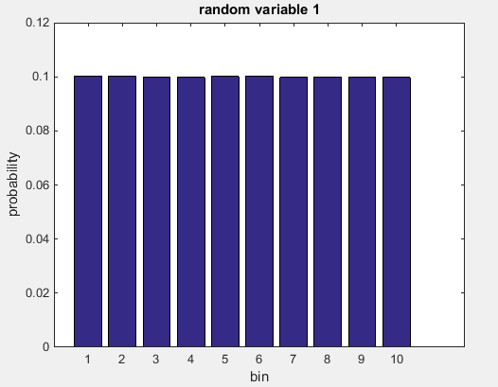

Figure : Random variable 1PDF

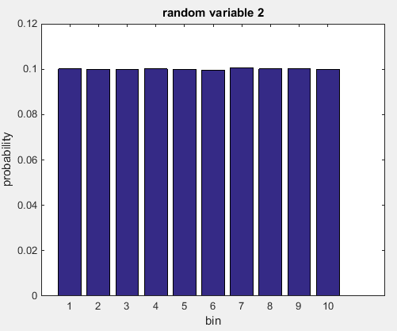

Figure : Random variable 2 PDF

Next we multiply these together and plot using “surf”. This is shown in figure 3.

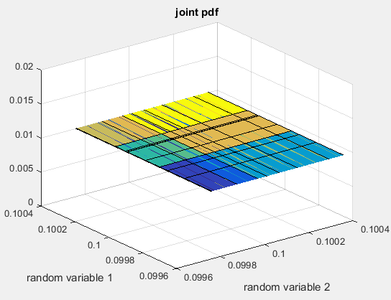

Figure : joint pdf of uniform random variables

Next we plot the joint distribution of two Gaussian random variables. We will use the “mvnpdf” function to generate the Gaussian random numbers and “surf” to plot the result. We will also use “contour” to have a better view of the support region. Our average matrix will be [6 6], and we will use a variety of covariance matrices. Results are shown below.

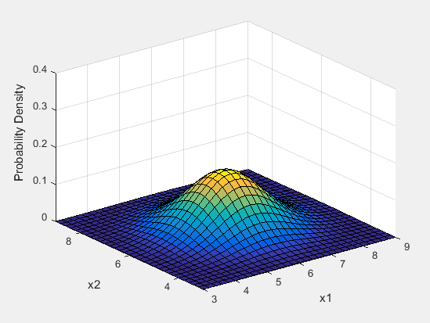

Figure : Joint pdf with covariance matrix [1 0 : 0 1]

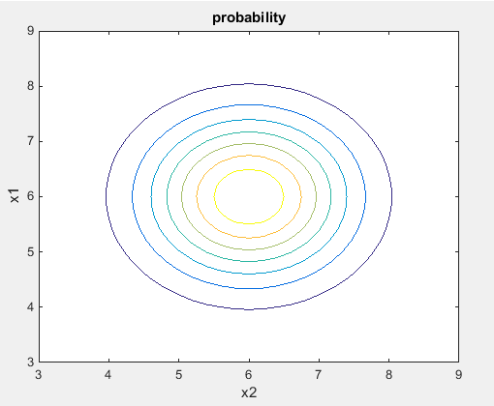

Figure : Joint pdf contour plot with covariance matrix [1 0 : 0 1]

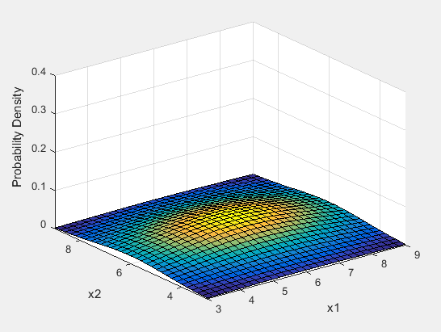

Figure : Joint pdf with covariance matrix [5 0 : 0 2]

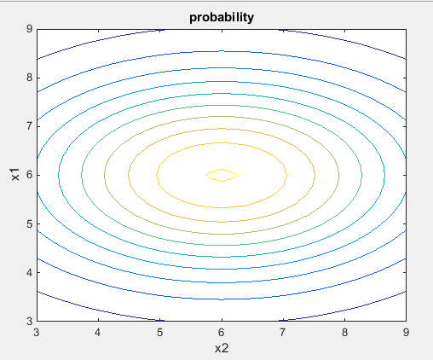

Figure :Joint pdf contour plot with covariance matrix [5 0 : 0 2]

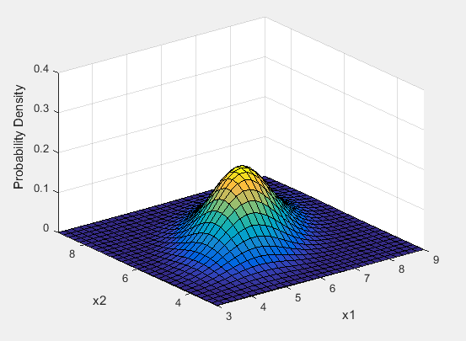

Figure :Joint pdf with covariance matrix [1 .5 : .5 1]

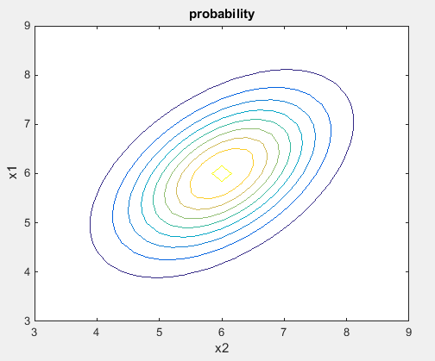

Figure :Joint pdf contour plot with covariance matrix [1 .5 : .5 1]

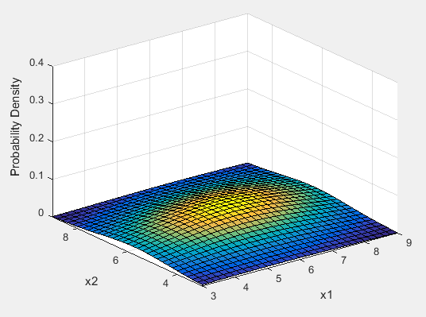

Figure : Joint pdf with covariance matrix [5 .5 : .5 2]

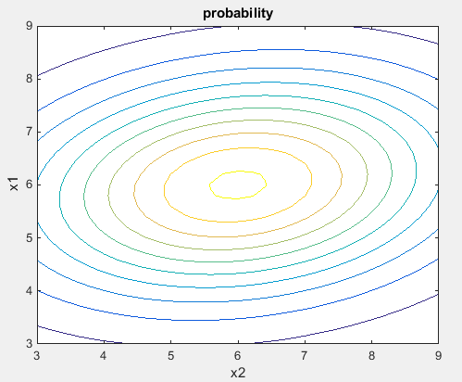

Figure : Joint pdf contour plot with covariance matrix [5 .5 : .5 2]

# MATLAB Code

**Part 1**

clear;

clc;

N = 1000000;

% generate uniform random variables

X = zeros(1,N);

for i = 1:N

X(i) = rand;

end

Y = zeros(1,N);

for i = 1:N

Y(i) = rand;

end

% generate histograms

B = 10;

histogram = histcounts(X,B);

PMF_X = histogram ./ length(X);

histogram = histcounts(Y,B);

PMF_Y = histogram ./ length(Y);

figure(1)

bar(PMF_X)

title('random variable 1')

ylabel('probability')

xlabel('bin')

figure(2)

bar(PMF_Y)

title('random variable 2')

ylabel('probability')

xlabel('bin')

[x,y] = meshgrid(PMF_X,PMF_Y);

% z is the joint pdf

z = x.*y;

figure(3)

surf(x,y,z)

axis([0.0996 .1004 0.0996 .1004 0 .02])

title('joint pdf')

ylabel('random variable 1')

xlabel('random variable 2')

**Part 2**

clear;

clc;

% average

mu = [6 6];

% covariance matrix

Sigma = [1 0; 0 1];

%Sigma = [5 0;0 2];

%Sigma = [1 .5;.5 1];

%Sigma = [5 .5;.5 2];

% coordinates

x1 = 3:.2:9; x2 = 3:.2:9;

[X1,X2] = meshgrid(x1,x2);

% generates random numbers

F = mvnpdf([X1(:) X2(:)],mu,Sigma);

F = reshape(F,length(x2),length(x1));

surf(x1,x2,F);

axis([3 9 3 9 0 .4])

xlabel('x1'); ylabel('x2'); zlabel('Probability Density');

figure(2)

contour(x1,x2,F)

title('probability')

ylabel('x1')

xlabel('x2')

# Conclusions

From the first part we can see how the shape of the distribution informs the joint pdf, especially when the data is uncorrelated. The joint pdf is a “tabletop” because we are multiplying a mostly constant distribution by another constant distribution. We can see in the Gaussian joint distributions how the random variables are correlated. When the covariance matrix is the identity matrix, [1 0; 0 1], we can see we have a circular cross section of the joint pdf, as seen in figures 4 and 5. As the covariance matrices change, we can see that the random variables are correlated in different ways. Looking at the joint pdf from the “side”, we can see what the marginal pdf looks like. When variables are uncorrelated, their distributions look like normal Gaussian distributions, but they are skewed when they are correlated.