Tyler Castelli

ECE 3512: Signals – Continuous and Discrete

Department of Electrical and Computer Engineering, Temple University, Philadelphia, PA 1912

# Problem Statement

In this assignment, we were asked to create visual plots of multivariate random distributions. The first task was to generate these random numbers over a uniform distribution, estimate the pdf, then plot it. Similarly, for the second task we were asked to perform the same operation on several multivariate normal distributions, each with a mean vector of [6 6] and different covariance matrices. These covariance matrices are:

$$cov1=\left[\begin{matrix}1 & 0 \\ 0 & 1\end{matrix}\right] cov2= \left[\begin{matrix}5 & 0 \\ 0 & 5\end{matrix}\right] cov3=\left[\begin{matrix}5 & 0 \\ 0 & 2\end{matrix}\right] cov4=\left[\begin{matrix}1 & 0.5 \\ 0.5 & 1\end{matrix}\right] cov5=\left[\begin{matrix}5 & 0.5 \\ 0.5 & 2\end{matrix}\right]$$

# Approach and Results

For the first ask I created matrix of size 100000x2, with each entry containing a random number generated based on a uniform distribution. I then made two linearly spaced vector from 0 to 1, with a spacing of 0.01 to create 100 bins that will be used in finding the pdf. From here I made a histogram, took the values and normalize them to estimate the pdf, and plotted using the mesh function. The result is shown in figure 1.

Figure 1: Multivariate Uniform PDF

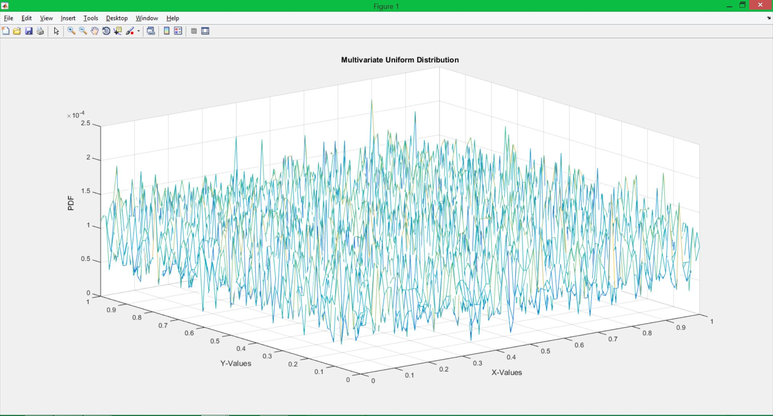

In the second task, the method was essentially the same. However, I did not make an initial matrix containing the normally distributed values. Instead, I made two normal random vectors that have each have a mean of 6 then used those to create a multivariate normal pdf using the mvnpdf() function. I generated one data set, and used different covariance matrices to get different plots. These plots are below in figures 2 through 6.

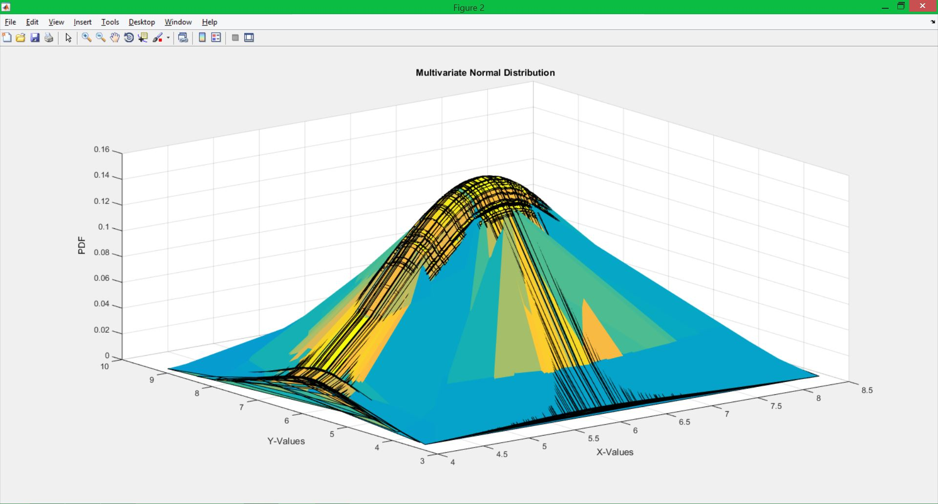

Figure 2: MVN PDF using cov1

Figure 3: MVN PDF using cov2

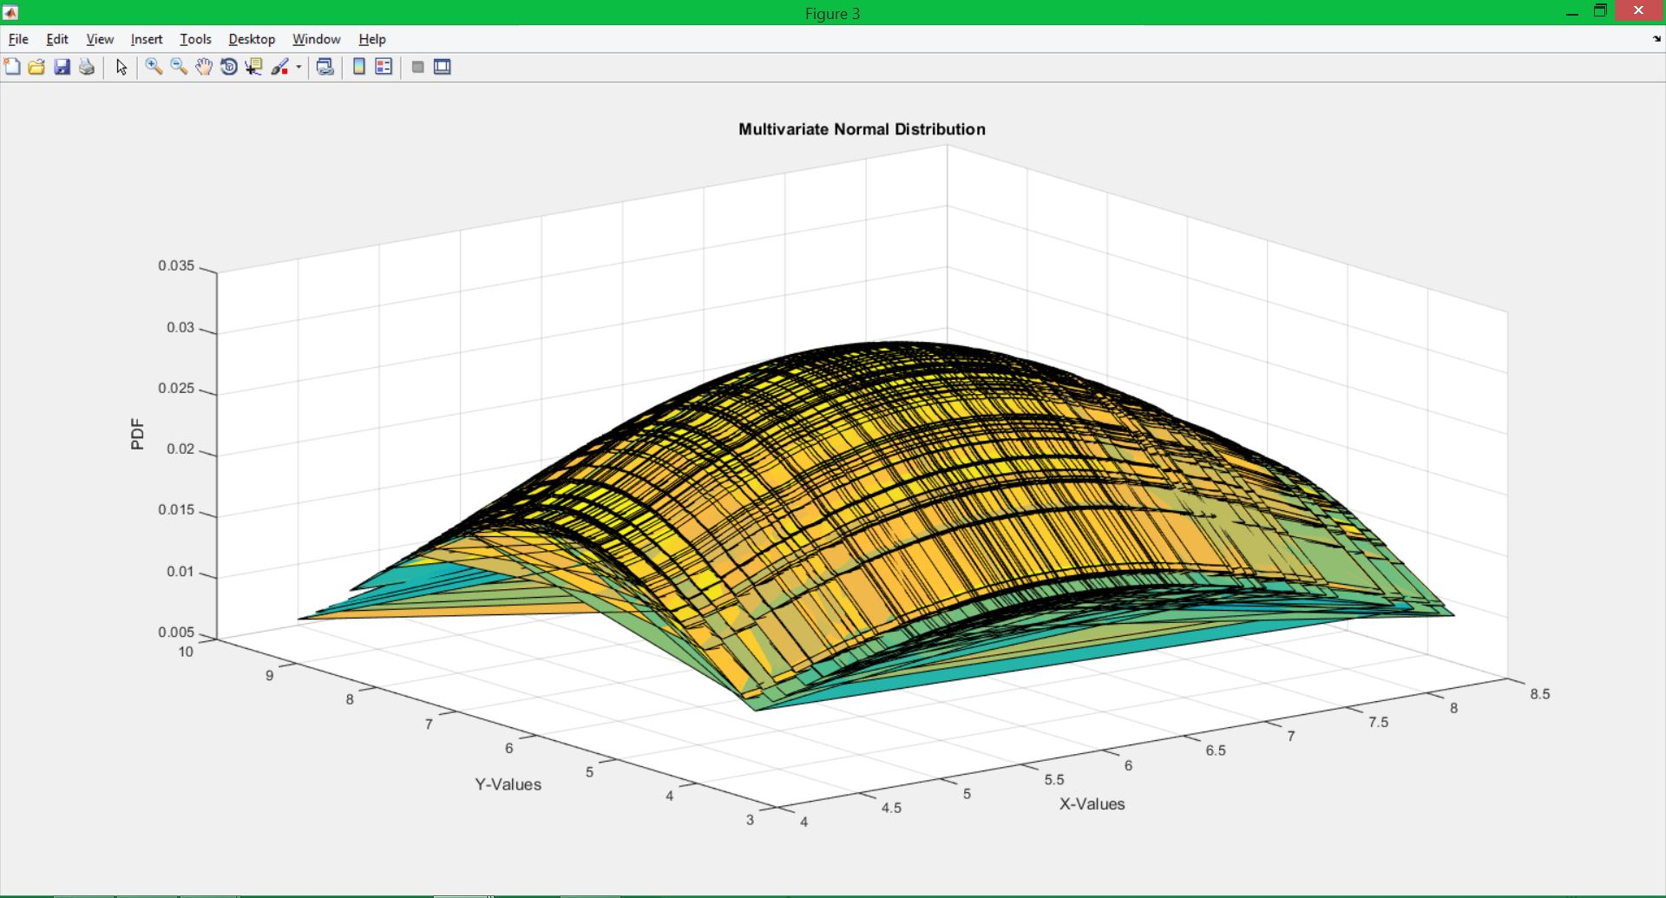

Figure 4: MVN PDF using cov3

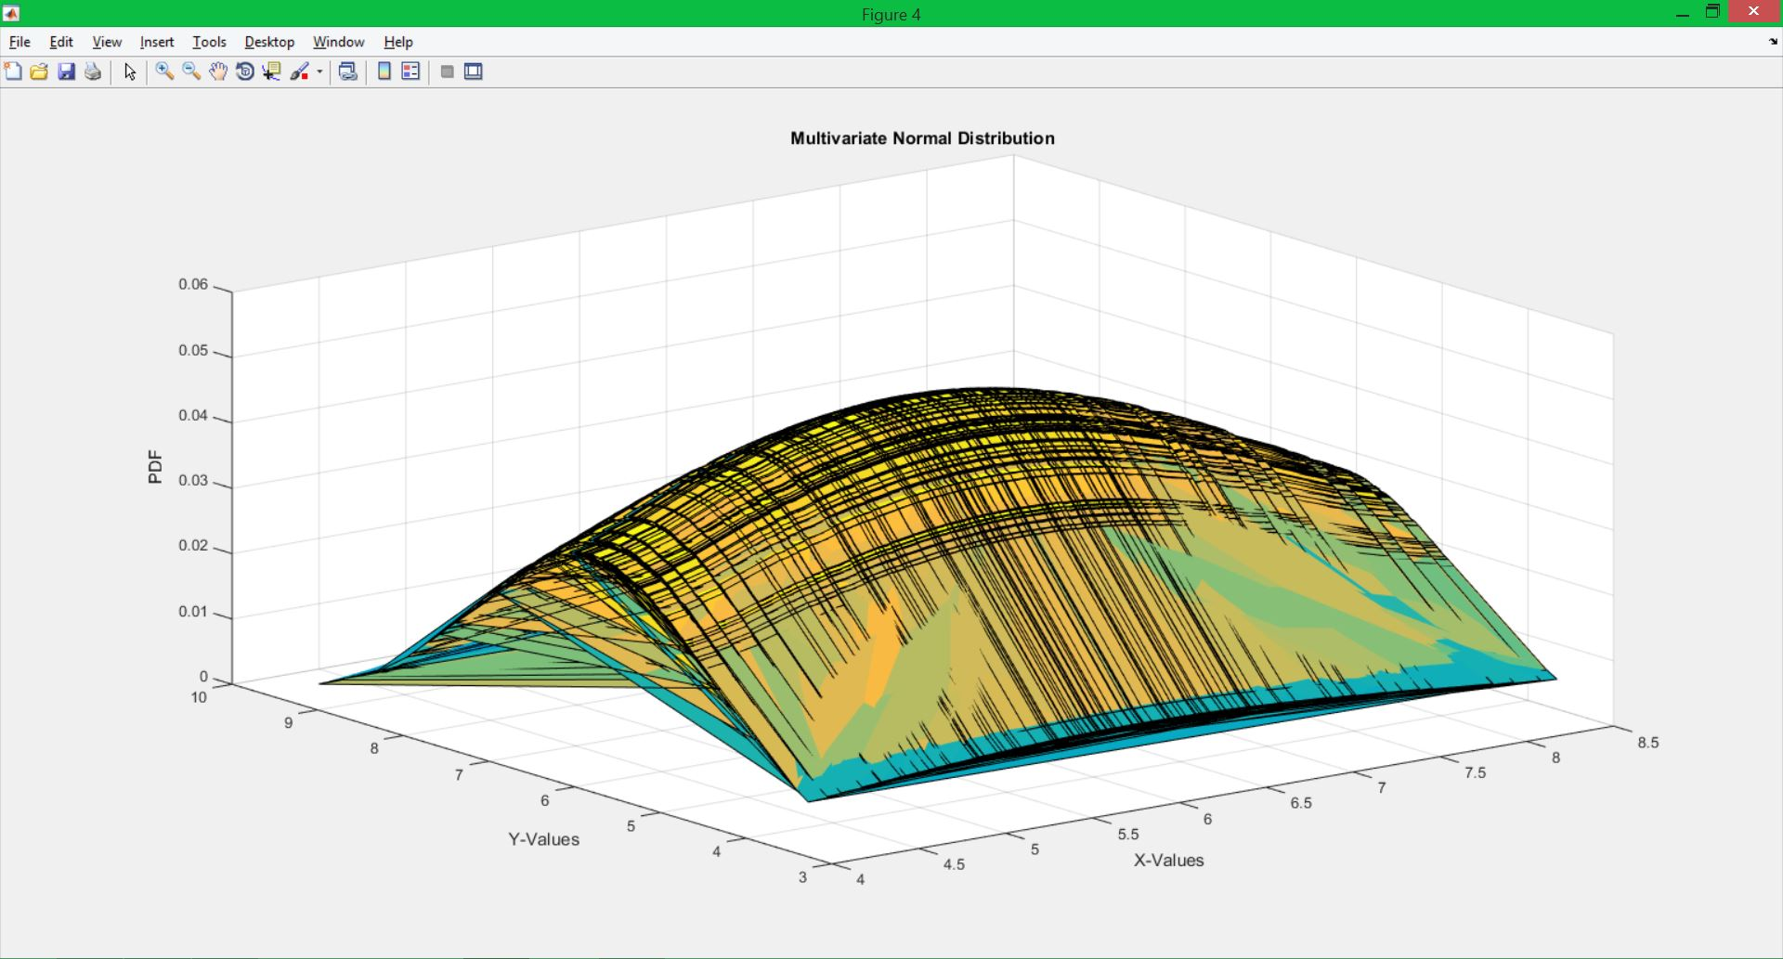

Figure 5: MVN PDF using cov4

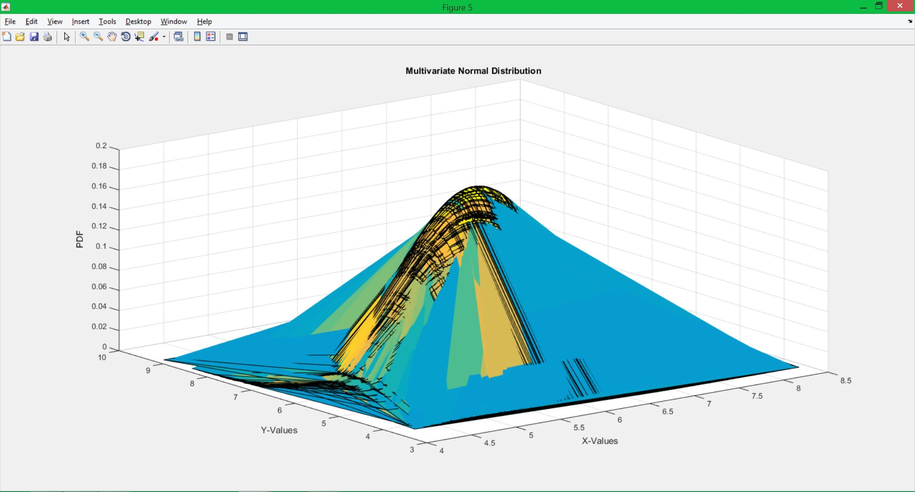

Figure 6: MVN PDF using cov5

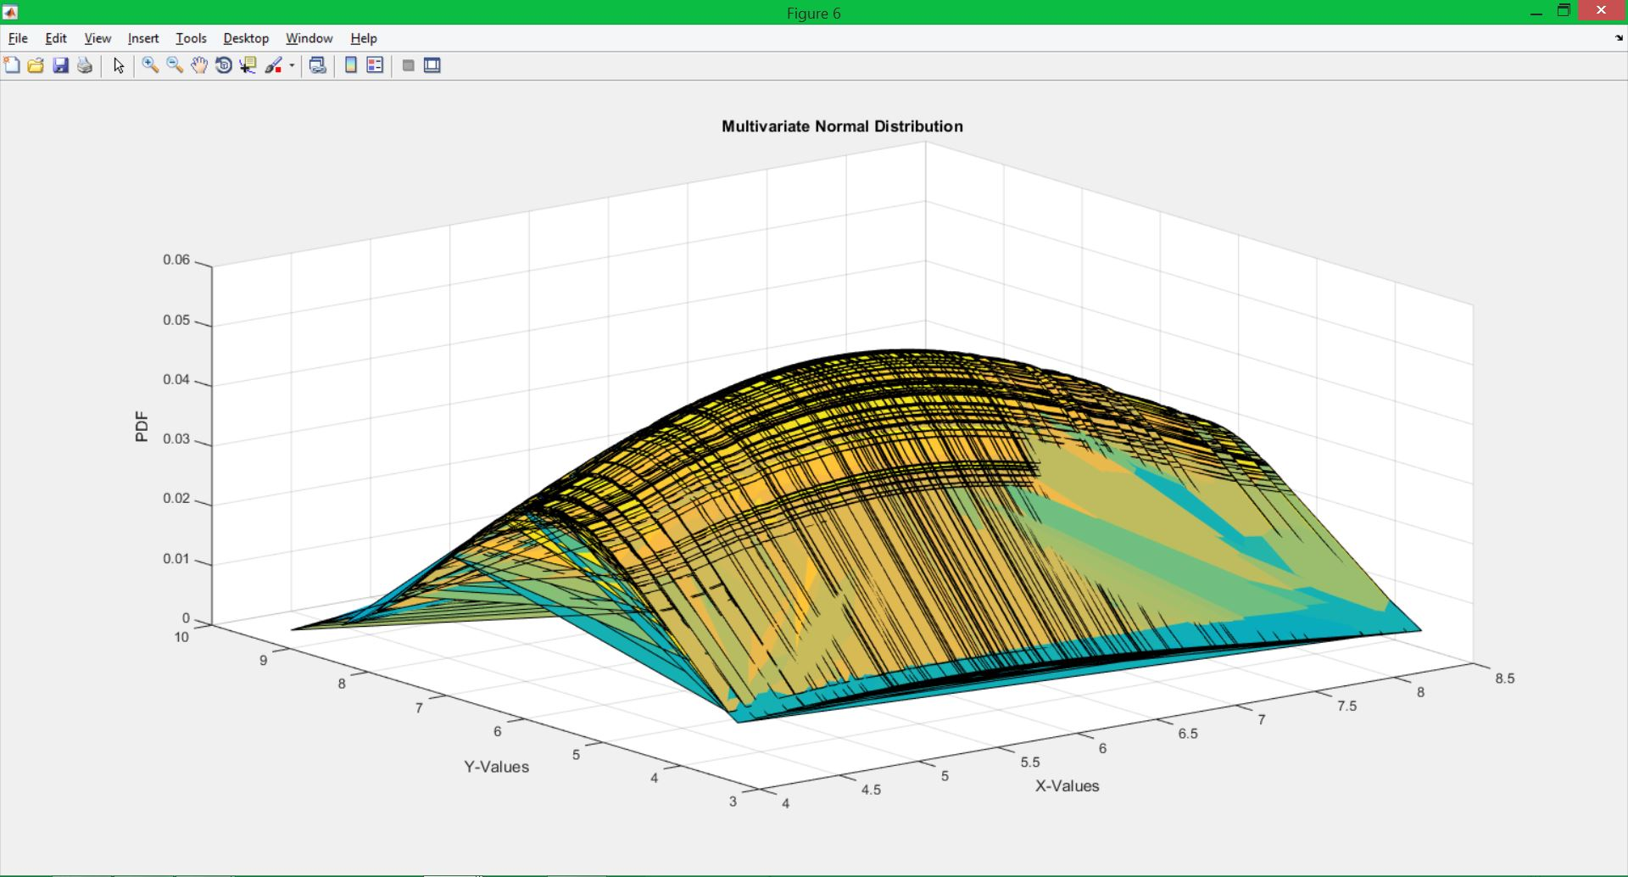

# MATLAB Code

%%

clear all;

close all;

clc;

%Initialize vector to hol uniform random numbers

xn = zeros(100000,2);

for i = 1:length(xn)

xn(i,:) = rand(1,2);

end

%create axis vectors and make sed meshgrid

%to make a grid for plotting in 3D

x = 0:0.01:1;

y = 0:0.01:1;

[X,Y] = meshgrid(x,y);

%make a 3D histogram and normalize it to estimate the pdf

%plot usig mesh

h1 = hist3(xn,[101 101]);

pdf = h1./(length(xn));

mesh(X,Y,pdf);

title('Multivariate Uniform Distribution');

xlabel('X-Values');

ylabel('Y-Values');

zlabel('PDF');

**In this section of code we find the multivariate pdf of the multivariate uniform distribution. Here I initialized a vector, created a grid matrix to plot over, and made a histogram and normalized the values to create the pdf.**

%%

%initialize mean vector and covariance matrices

mu = [6 6];

cov2(:,:,1) = [1 0;0 1];

cov2(:,:,2) = [5 0;0 5];

cov2(:,:,3) = [5 0;0 2];

cov2(:,:,4) = [1 0.5;0.5 1];

cov2(:,:,5) = [5 0.5;0.5 2];

%create normally distributed random vectors use create a grid for 3D

%plotting

x2 = 6 + randn(1,100);

y2 = 6 + randn(1,100);

[X2,Y2] = meshgrid(x2,y2);

%for each covariace matrix, find the multivariate normal pdf of the data

%set and plot

for i = 1:length(cov2)

F = mvnpdf([X2(:),Y2(:)],mu,cov2(:,:,i));

F = reshape(F,length(y2),length(x2));

figure(i+1);

surf(x2,y2,F);

caxis([min(F(:))-.5*range(F(:)),max(F(:))]);

title('Multivariate Normal Distribution');

xlabel('X-Values');

ylabel('Y-Values');

zlabel('PDF');

end

**This section of code is again very similar to the previous code. The only difference being that no initial matrix is created to hold the random numbers. The numbers are contained within their own respective vectors, and the pdf is found using a function rather than a histogram.**

# Conclusions

This assignment enforced the visualization of multivariate random distributions and their pdf’s. From this assignment we can see that the pdf’s are 3-dimensional surfaces with the Z-axis representing the pdf values. In the first task the shape that is generated is similar to a square. This can be expected as the univariate graph of a uniform pdf is a square. The graph shows that the numbers will all have similar probabilities (notice the small scale of the z-axis). This again expected because in a univariate case, all the numbers will have the same if not very similar probabilities. Since the z-axis represents the probabilities, the height for each number will be close, resulting in the rectangular prismatic shape.

In the second task, we again get the results we’d expect from analyzing the univariate normal distribution. The covariance matrix defines the support region for each Gaussian curve. The support region is the ellipse found by plotting the probabilities of numbers with the same probability, given that covariance matrix. This gives the altered shape to each curve.