Marc Jurchak

ECE 3522: Stochastic Processes in Signals and Systems

Department of Electrical and Computer Engineering, Temple University, Philadelphia, PA 1912

# Problem Statement

We will plot the covariance and correlation at different samples of an audio signal. We will plot the statistical correlation between 240 samples of an audio signal with the same number of samples shifted by “k”. We do this for two different parts of the audio signal. Next we will perform a similar operation, this time plotting the covariance matrix of the 240 samples, but this time we will shift two signals, giving us a 3D plot. We also do this for various parts of the signal.

# Approach and Results

To plot the statistical correlation, we use the following equation:

$$\frac{\sum{x\left[n\right]y[n]}}{\sqrt{\sum{{x\left[n\right]}^{2}\sum{{y[n]}^{2}}}}}$$

Where x[n] is the original 240 samples and y[n] is another 240 samples shifted by “k”. We shift 512 times. Figures 1 and 2 show the results starting at .9 seconds and 3 seconds.

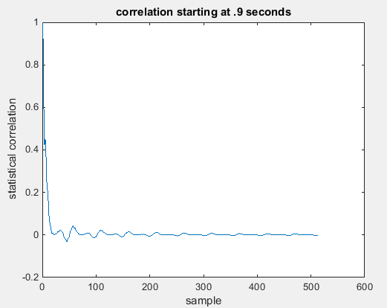

Figure : Correlation starting at .9 seconds

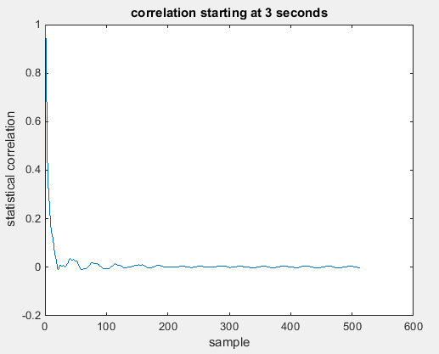

Figure : Correlation starting at 3 seconds

Next we look at the original signal to see what this signal looks like at .9 and 3 seconds.

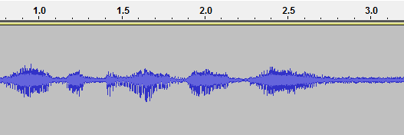

Figure : Audio signal to see .9 and 3 seconds

We notice that there is a sound signal at .9 seconds, but only noise at 3 seconds.

Next we will compute and plot the covariance matrix at 1 second and 2.9 seconds. We pick 16 samples, and compare the covariance around 240 samples ending at these 16 points. We use the following formula:

$$x\left[i,j\right]=\frac{1}{N}\sum_{n=0}^{N-1}{x\left[n-i\right]x[n-j]}$$

Where N is the 240 samples, x is the element of the 16 samples, and x[i, j] is the covariance matrix. The matrices are plotted in figures 4 and 5.

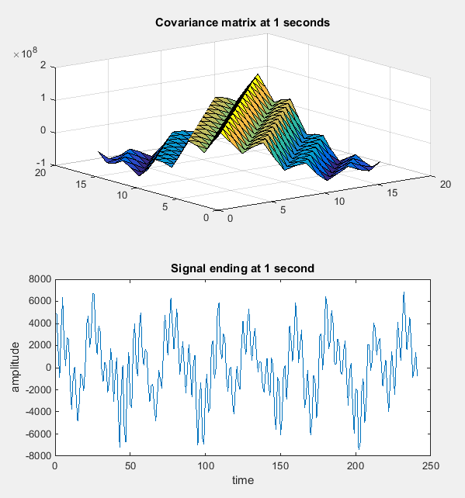

Figure : Covariance matrix and signal at 1 second

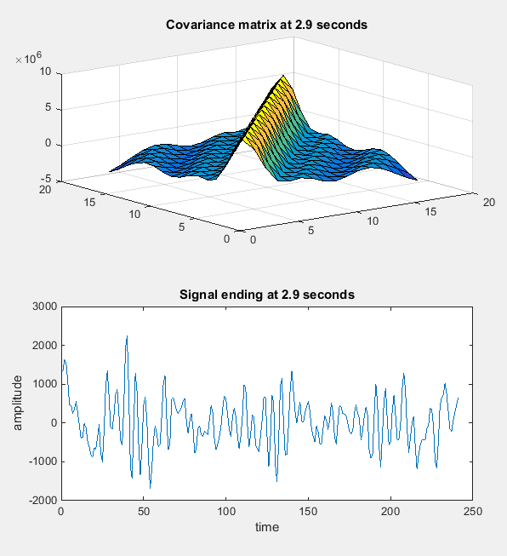

Figure :Covariance matrix and signal at 2.9 second

# MATLAB Code

**Part 1**

clear;

clc;

% compute correlation. Arguments: (starting second, samples to be included,

% times shifted)

correlation_1 = statistical_correlation(.9, 240, 512);

correlation_2 = statistical_correlation(3, 240, 512);

figure(1)

plot(correlation_1)

title('correlation starting at .9 seconds')

ylabel('statistical correlation')

xlabel('sample')

figure(2)

plot(correlation_2)

title('correlation starting at 3 seconds')

ylabel('statistical correlation')

xlabel('sample')

**statistical_correlation function**

function [correlation] = statistical_correlation(start_second, length_of_sample, length_of_correlation )

fp = fopen('rec_01_speech.raw','r');

speech = fread(fp,inf,'int16');

fclose(fp);

start_element = start_second / (1.25e-4);

correlation = zeros(length_of_correlation,1);

x = zeros(length_of_sample,1);

y = zeros(length_of_sample,1);

x = speech((start_element):(start_element + length_of_sample));

sum_yy = 0;

sum_xx = 0;

sum_xy = 0;

%Correlation calculation done here

for k = 0:length_of_correlation

y = speech((start_element + k):(start_element + length_of_sample) + k);

for i = 1:length_of_sample

sum_yy = sum_yy + y(i)^2;

sum_xx = sum_xx + x(i)^2;

sum_xy = sum_xy + (y(i) * x(i));

end

correlation(k + 1) = sum_xy / sqrt((sum_xx) * (sum_yy));

end

end

**Part 2**

clear;

clc;

clf;

fp = fopen('rec_01_speech.raw','r');

speech = fread(fp,inf,'int16');

fclose(fp);

% start times

time1 = .9;

time2 = 1;

time3 = 2.9;

second_pt9 = time1;

second_1pt1 = time2;

second_3 = time3;

%calculate the starting element of the vector

start_pt9 = second_pt9 / (1.25e-4);

start_1pt1 = second_1pt1 / (1.25e-4);

start_3 = second_3 / (1.25e-4);

% Inputs (starting time in seconds, length of covariance matrix, length of sample)

[cov_pt9, sig_pt9] = covariance_matrix_v01(time1, 16, 240);

[cov_1pt1, sig_1pt1] = covariance_matrix_v01(time2, 16, 240);

[cov_3, sig_3] = covariance_matrix_v01(time3, 16, 240);

% plot

figure(1)

subplot(2,1,1)

surf(cov_pt9)

title('starting at .9 seconds')

subplot(2,1,2)

plot(speech((start_pt9 - 240):start_pt9));

title('starting at .9 seconds')

figure(2)

subplot(2,1,1)

surf(cov_1pt1)

title('Covariance matrix at 1 seconds')

subplot(2,1,2)

plot(speech((start_1pt1 - 240):start_1pt1));

title('Signal ending at 1 second')

ylabel('amplitude')

xlabel('time')

figure(3)

subplot(2,1,1)

surf(cov_3)

title('Covariance matrix at 2.9 seconds')

subplot(2,1,2)

plot(speech((start_3 - 240):start_3));

title('Signal ending at 2.9 seconds')

ylabel('amplitude')

xlabel('time')

**Covariance_matrix_v01**

function [covariance_matrix, x] = covariance_matrix_v01(start_second, length_of_sample, num_samples )

fp = fopen('rec_01_speech.raw','r');

speech = fread(fp,inf,'int16');

fclose(fp);

% calculate start element

start_element = start_second / (1.25e-4);

covariance_matrix = zeros(length_of_sample,length_of_sample);

x = zeros(length_of_sample,1);

x = speech((start_element):(start_element + length_of_sample - 1));

sum = 0;

% calculation of covariance matrix

for i = 0:(length_of_sample - 1)

for j = 0:(length_of_sample - 1)

for k = (start_element + i): (start_element + i + num_samples - 1)

first_index = k - i;

second_index = k - j;

sum = sum + speech(first_index)*speech(second_index);

end

covariance_matrix(i+1,j+1) = sum * (1/length_of_sample);

sum = 0;

end

end

# Conclusions

We found that in both calculations, the correlation and covariance plots mirrored the sinusoidal nature of the speech signal to various degrees. When computing correlation in part 1, we see that since the signal oscillates like a sinusoid, and when the signal is “out of phase” the correlation is low, while when it is “in phase” the correlation is high. This is why there are peaks in the plots, these are the places where the “humps” are in phase. We can also see that they decay overall in correlation, since when k = 0 we are comparing the same signal to itself, but as k increases we move further and further from the samples we are comparing it to. We notice that even though the signal starting at 3 seconds is part of the noise as seen in figure 2, this noise is still somewhat sinusoidal. As result the plot in figure 1, which takes the signal around .9 seconds, has a better defined correlation plot that shows its sinusoidal shape. A similar effect happens for the covariance matrix. The plot in figure 4 appears like a damped sinusoid shape since it is taken from a part of the signal where a word is spoken. The plot in figure 5 is smoother because it is taking in a noisy part of the signal where the signal cannot be “in phase” with itself in any way. We notice that all areas where “i” = “j”, the covariance is nearly equal. This is because we are shifting the signal the same amount for both calculations.