Joe DeMarco CA_05

Original Signal at 0.9 sec

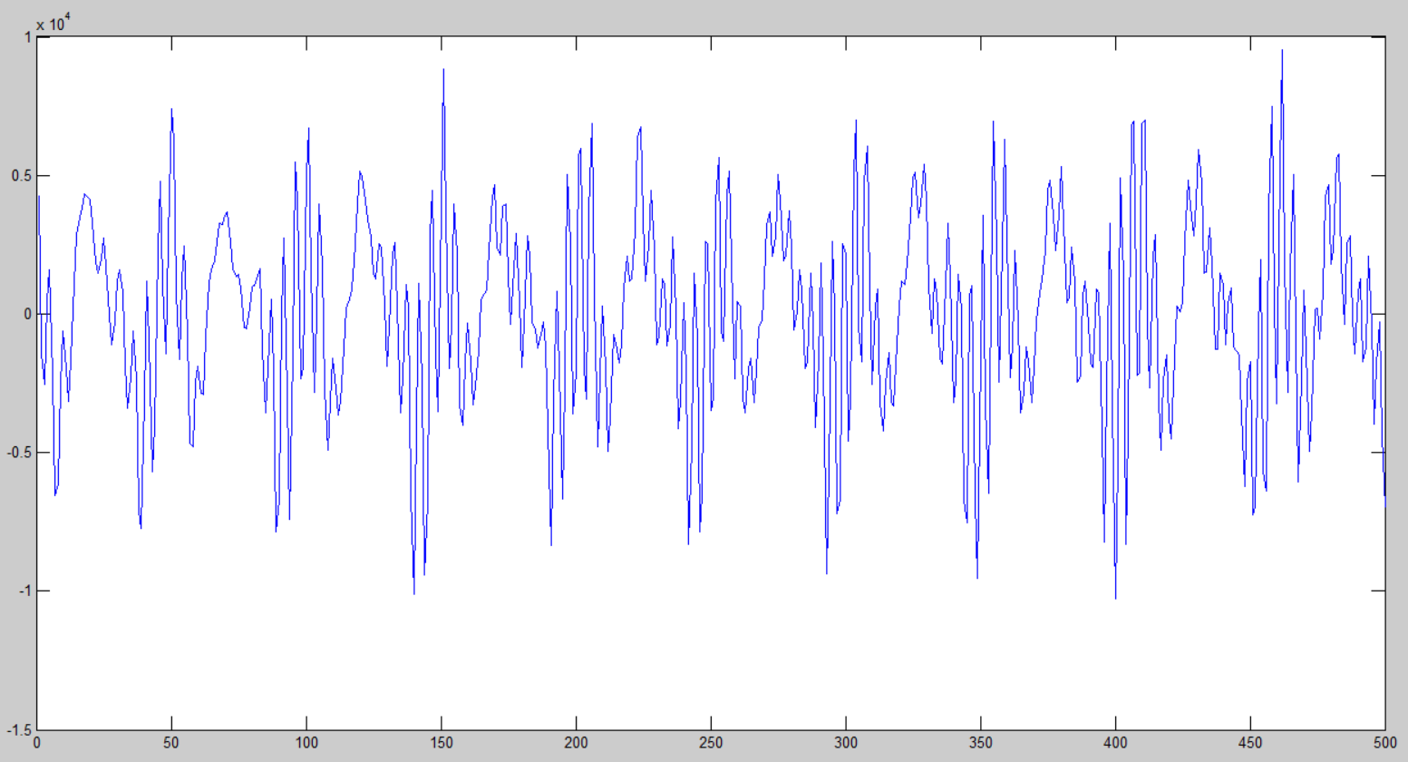

Autocorrelation at 0.9 sec

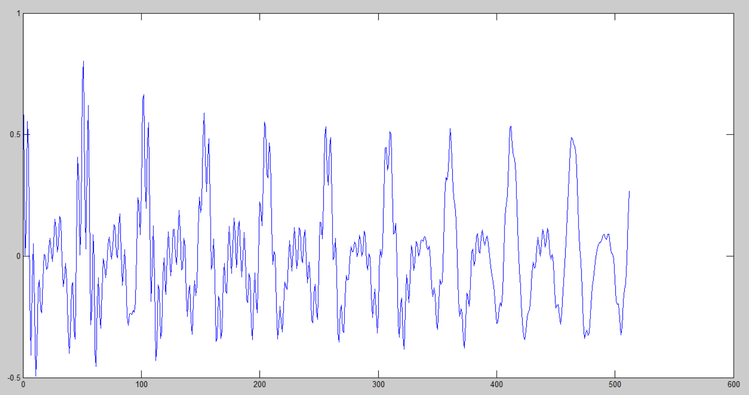

I think that because the signal at this time point is periodic it makes sense that the correlation would be periodic too.

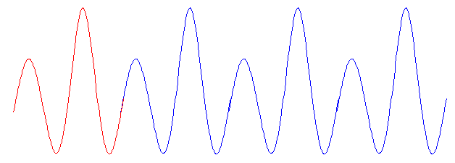So if there is no offset between the x and y samples, the signal perfectly overlaps and the correlation is 1.

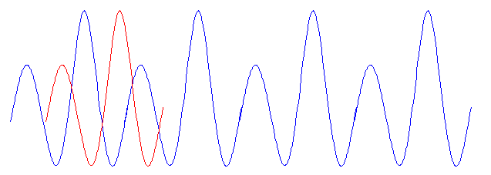But as we increase the offset the signals start not to overlap as well.

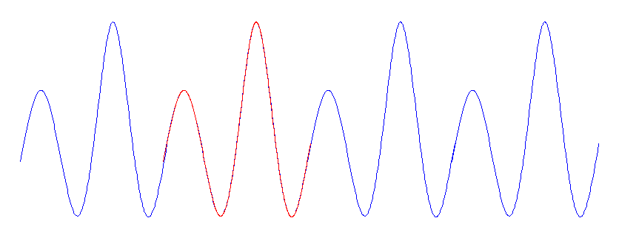

Until we get to the second period, where the signal repeats.

Original signal at 3 sec

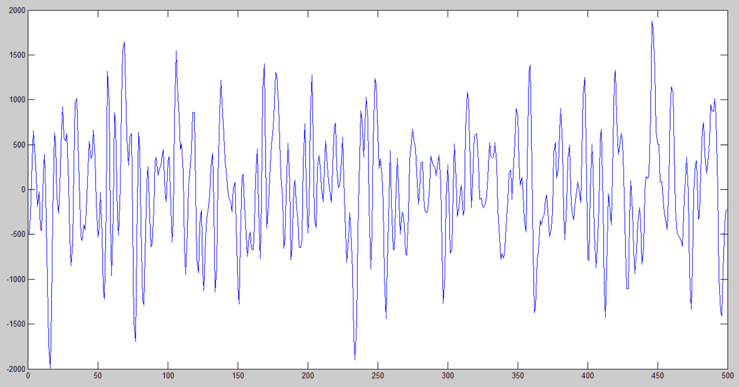

Autocorrelation at 3 sec

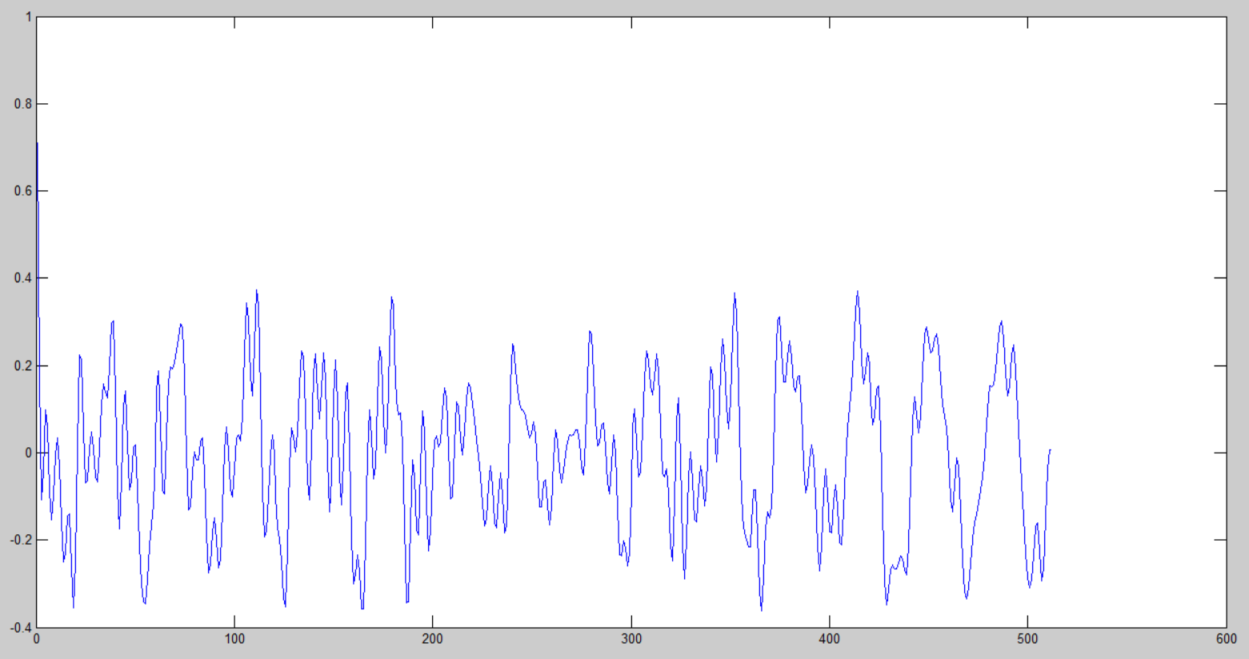

The signal at 3 seconds is not periodic. Since the signal never repeats it makes sense that the correlation would be 1 at the start and drop quickly as we start to offset the signal sample.

Covariance at 0.9 sec

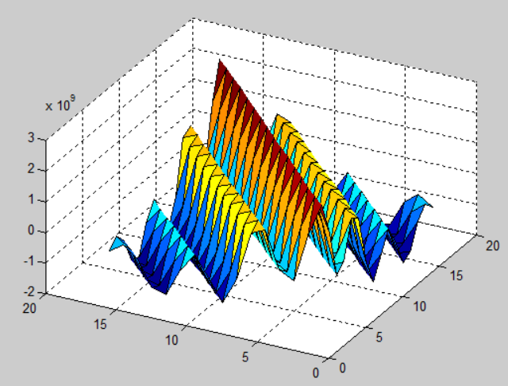

Covariance at 1.1 sec

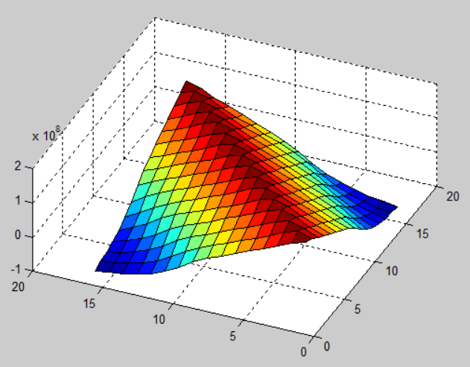

Covariance at 3 sec

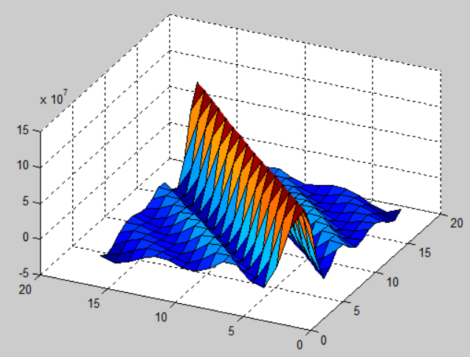

I think the covariance plots are showing more generally the same thing as the correlation plot. In these we see a wider range of starting values, and how the points around them are related. I think that the correlation is like a single slice of these covariance plots.

So we can see that the first plot is of the periodic section of the original signal, the second plot is of a somewhat less correlated section of the signal, and the third plot looks like there is no correlation at all.

Part1 code

fp = fopen('rec_01_speech.raw','r');

data = fread(fp,inf,'int16');

fclose(fp);

strt=24000;

xdat = data(strt:strt+239);

tp=0;

bp1=0;

bp2=0;

for k=1:512

ydat=data(strt+k:strt+239+k);

xdatm=mean(xdat);

ydatm=mean(ydat);

for i=1:240

tp=tp+((xdat(i)-xdatm)*(ydat(i)-ydatm));

bp1=bp1+(xdat(i)-xdatm)^2;

bp2=bp2+(ydat(i)-ydatm)^2;

end

r(k)=tp/(sqrt(bp1)*sqrt(bp2));

tp=0;

bp1=0;

bp2=0;

end

t=1:512;

plot(t,r)

part2 code

%%

clc;clear;

fp = fopen('rec_01_speech.raw','r');

data = fread(fp,inf,'int16');

fclose(fp);

strt=7200;

xdat = data(strt:strt+15);

xmat=0;

for i=1:16

for j=1:16

mat(i,j)=sum(data((strt-i):(strt+239-i)).*data((strt-j):(strt+239-j)));

end

end

surf(mat)