**Computer Assignment 3:**

John Lee

ECE 3522: Stochastic Processes in Signals

Department of Electrical and Computer Engineering, Temple University, Philadelphia, PA 1912

# Problem Statement

On this computer assignment, we will be continuing our work with using both files, Google stock data and Speech data, to understand its variance as they affect the results of real-time streaming data. We would need to perform a number of experiments to observe the line behavior of the variances obtained from MATLAB. These values will be plotted to compare them from one another in different types of settings, as we change its sample/window values.

# Approach and Results

The first part of this experiment relates to the comparison of two variances. Both files will need to execute their variances and plot them to observe the statistical data behavior of the line variance. **Figure 1** shows us that the variance of the first data file, representing an increase of variance from data values [1,2] and a decrease of variance from data value [2,3]. It also displays it high/low values [1.633,1.603]. **Figure 2** displays the variance of the speech data file, although we had trouble to obtain the proper variance plot of the second file, MATLAB seems to display a generalized plot of the variance plot. We can observe that a square point is plotted at [1,0] meaning there is generalized variance value on the graph.

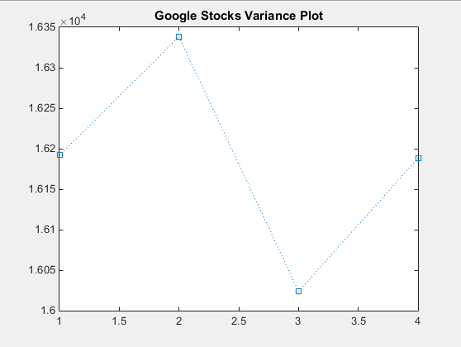

**Figure 1.** Google Stocks data, variance plot.

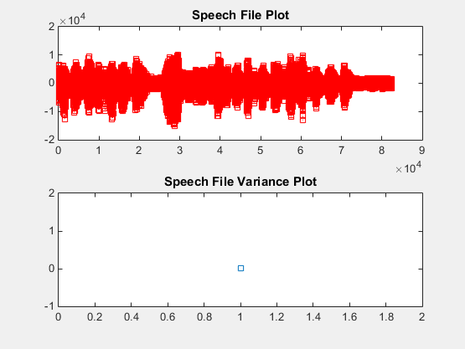

**Figure 2.** Speech file data, variance plot.

The second part of the assignment consists of plotting both data’s by generating a simple “for loop” instruction that plots the variances at specific samples. These samples will give us the variances as we increment these samples by one, until it reaches the data limit from the file. We can observe that on **Figure 3** it represents the variance taken when we start at 10 samples and slowly increased them by one. Note that the increase of sample will more likely increase the values of the variance.

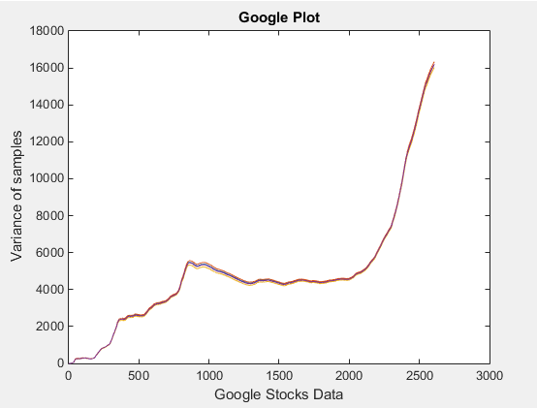

**Figure 3.** Google Stocks data, variance plot (Starting at 10 samples).

Our second plot, displays the results of the variance plot for the speech signal. Note that the increments of samples will likely give us a variance of 1.2-1. It will reach a plateau point as we add more sample to the speech signal.

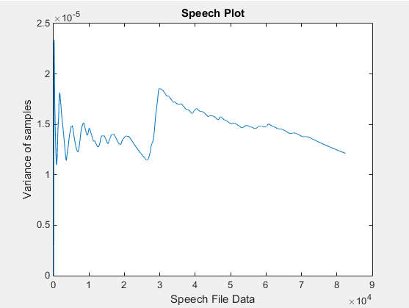

**Figure 4.** Speech file data, variance plot (Starting at 10 samples).

Finally our last part of the assignment, relates to using our old skills taken from previous computer assignments. We will need to use the frame/window sample method to obtain the variance at specific sample rates. Plot these values and observe the line behavior.

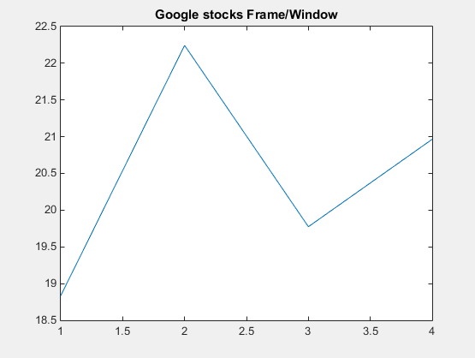

**Figure 5.** Google stocks Frame/Window based plot.

We can note that on **Figure 5** the google stocks plot displays the window plot set at a frame of 1 and a window duration of 30. Note that the y-axis determine the number of days for the window duration of the sample plot. The x-axis represents the variance taken at 0.5 frames. This graph is quite similar to the first **Figure 1**, since we were given a set number of frames/window duration, our graph will not display an overall look of the plot like **Figure 1**, and instead we will obtain the variance of a specific area.

# MATLAB Code

On **Figure 6,** we can observe the code sample for the first part of the assignment. We first need to load the data files into MATLAB and normalize the second audio file. Taking the variance of both files, we simply plot these values into MATLAB.

The second part of the assignment, shows us that on **Figure 7**, once we load both data files. We would need to create a for loop statement that takes the variance of an incrementing data sample. We start with the first 10 samples and they increase by one. Then we would need to generate a plot of the incrementing variance values and compare the line behavior displayed on MATLAB.

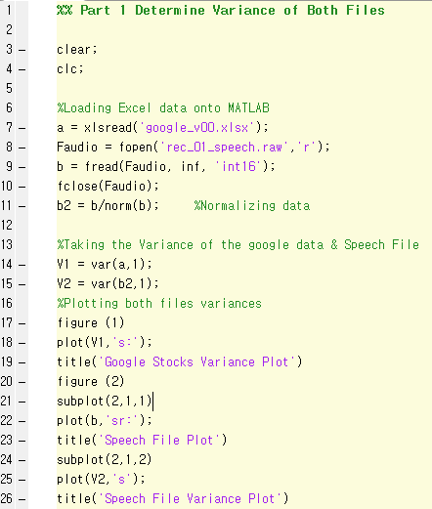

**Figure 6.** Part 1 Code.

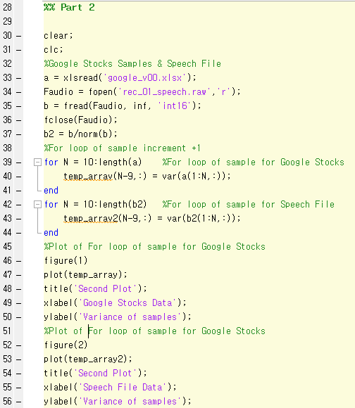

**Figure 7.** Part 2 Code.

Our last set of codes, represents the plot of both given files. **Figure 7-8** display the use of old codes taken from the first computer assignment. By simply taking the variance of the first set of data from either given files, we simply plotting those value s for the final results. We need to make sure we include the frame/duration value inside the variance. This way we can limit the variance range between the data set. Unfortunately, our second set of codes for the speech signal was not producing any plot for the variance of the data set. Even normalizing the data or using a different approach did not help us come out with any results. We suspect that the issue comes from the core code taken from last computer assignment.

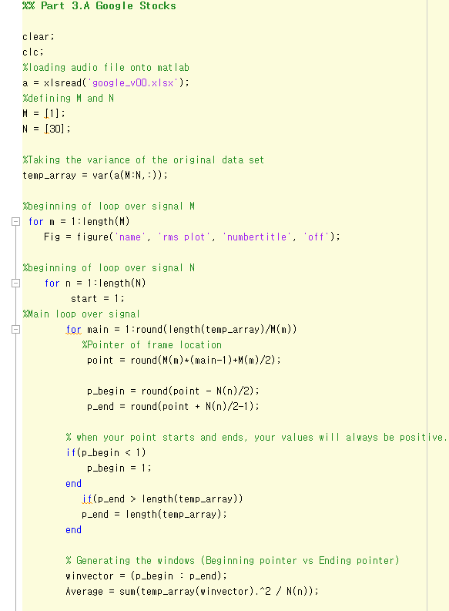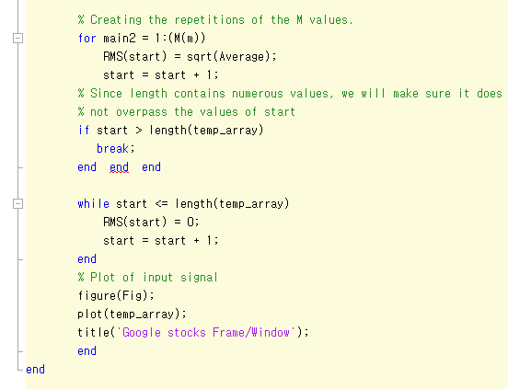

**Figure 8** Google stocks Frame/Duration code

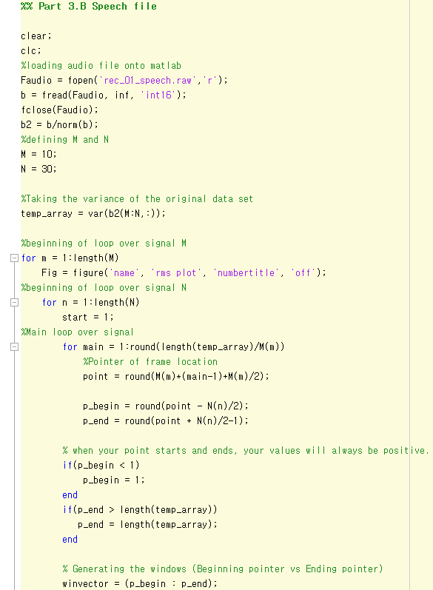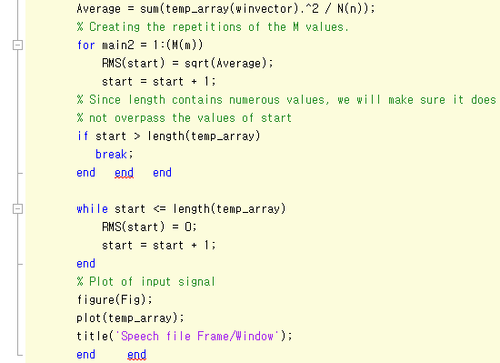

**Figure 9** Speech file Frame/Duration code

# Conclusions

We can reflect that taking the variance plot with the use of different methods, can help us getting a better understanding of the data itself. These methods can be used to focus on studying specific areas and observe the difference between the variance as it is being affected by the increment of data samples. Although we experienced some difficulties obtaining the correct data, we suspected that the old set of codes used for the last computer assignment could’ve been the issue of not obtaining specific plots from certain data sets.

.V. MATLAB CODE II

**Part 1**

%% Part 1 Determine Variance of Both Files

clear;

clc;

%Loading Excel data onto MATLAB

a = xlsread('google_v00.xlsx');

Faudio = fopen('rec_01_speech.raw','r');

b = fread(Faudio, inf, 'int16');

fclose(Faudio);

b2 = b/norm(b); %Normalizing data

%Taking the Variance of the google data & Speech File

V1 = var(a,1);

V2 = var(b2,1);

%Plotting both files variances

figure (1)

plot(V1,'s:');

title('Google Stocks Variance Plot')

figure (2)

subplot(2,1,1)

plot(b,'sr:');

title('Speech File Plot')

subplot(2,1,2)

plot(V2,'s');

title('Speech File Variance Plot')

**Part 2**

clear;

clc;

%Google Stocks Samples & Speech File

a = xlsread('google_v00.xlsx');

Faudio = fopen('rec_01_speech.raw','r');

b = fread(Faudio, inf, 'int16');

fclose(Faudio);

b2 = b/norm(b);

%For loop of sample increment +1

for N = 10:length(a) %For loop of sample for Google Stocks

temp_array(N-9,:) = var(a(1:N,:));

end

for N = 10:length(b2) %For loop of sample for Speech File

temp_array2(N-9,:) = var(b2(1:N,:));

end

%Plot of For loop of sample for Google Stocks

figure(1)

plot(temp_array);

title('Google Plot');

xlabel('Google Stocks Data');

ylabel('Variance of samples');

%Plot of For loop of sample for Google Stocks

figure(2)

plot(temp_array2);

title('Speech Plot');

xlabel('Speech File Data');

ylabel('Variance of samples');

**Part 3**

%% Part 3.A Google Stocks

clear;

clc;

%loading audio file onto matlab

a = xlsread('google_v00.xlsx');

%defining M and N

M = [1];

N = [30];

%Taking the variance of the original data set

temp_array = var(a(M:N,:));

%beginning of loop over signal M

for m = 1:length(M)

Fig = figure('name', 'rms plot', 'numbertitle', 'off');

%beginning of loop over signal N

for n = 1:length(N)

start = 1;

%Main loop over signal

for main = 1:round(length(temp_array)/M(m))

%Pointer of frame location

point = round(M(m)*(main-1)+M(m)/2);

p_begin = round(point - N(n)/2);

p_end = round(point + N(n)/2-1);

% when your point starts and ends, your values will always be positive.

if(p_begin < 1)

p_begin = 1;

end

if(p_end > length(temp_array))

p_end = length(temp_array);

end

% Generating the windows (Beginning pointer vs Ending pointer)

winvector = (p_begin : p_end);

Average = sum(temp_array(winvector).^2 / N(n));

% Creating the repetitions of the M values.

for main2 = 1:(M(m))

RMS(start) = sqrt(Average);

start = start + 1;

% Since length contains numerous values, we will make sure it does

% not overpass the values of start

if start > length(temp_array)

break;

end end end

while start <= length(temp_array)

RMS(start) = 0;

start = start + 1;

end

% Plot of input signal

figure(Fig);

plot(temp_array);

title('Google stocks Frame/Window');

end

end

**Part 4**

%% Part 3.B Speech file

clear;

clc;

%loading audio file onto matlab

Faudio = fopen('rec_01_speech.raw','r');

b = fread(Faudio, inf, 'int16');

fclose(Faudio);

b2 = b/norm(b);

%defining M and N

M = 10;

N = 30;

%Taking the variance of the original data set

temp_array = var(b2(M:N,:));

%beginning of loop over signal M

for m = 1:length(M)

Fig = figure('name', 'rms plot', 'numbertitle', 'off');

%beginning of loop over signal N

for n = 1:length(N)

start = 1;

%Main loop over signal

for main = 1:round(length(temp_array)/M(m))

%Pointer of frame location

point = round(M(m)*(main-1)+M(m)/2);

p_begin = round(point - N(n)/2);

p_end = round(point + N(n)/2-1);

% when your point starts and ends, your values will always be positive.

if(p_begin < 1)

p_begin = 1;

end

if(p_end > length(temp_array))

p_end = length(temp_array);

end

% Generating the windows (Beginning pointer vs Ending pointer)

winvector = (p_begin : p_end);

Average = sum(temp_array(winvector).^2 / N(n));

% Creating the repetitions of the M values.

for main2 = 1:(M(m))

RMS(start) = sqrt(Average);

start = start + 1;

% Since length contains numerous values, we will make sure it does

% not overpass the values of start

if start > length(temp_array)

break;

end end end

while start <= length(temp_array)

RMS(start) = 0;

start = start + 1;

end

% Plot of input signal

figure(Fig);

plot(temp_array);

title('Speech file Frame/Window');

end end