Below are plots of the closing price for google stock. The original plot shows a data point for every day.

Original data plot

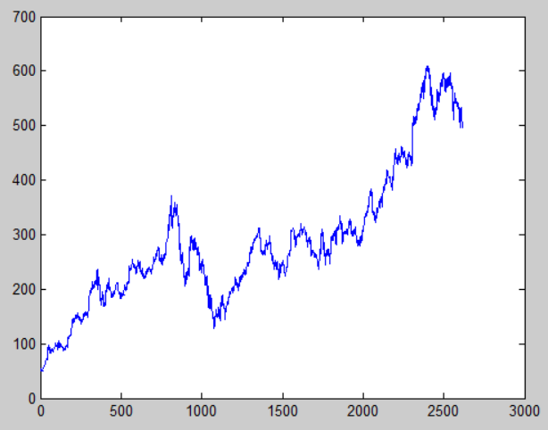

When the window is small and the frame is small the plot looks almost identical. But as we increase the frame size we start losing information. There are gaps in the data we are using when the frame size is larger than the window size. As a result the plots start to look more jagged.

Window 7, frame 1

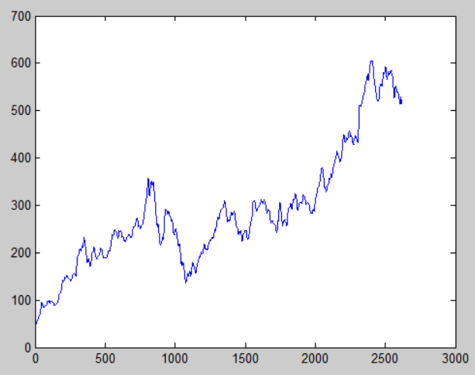

Window 7, frame 7

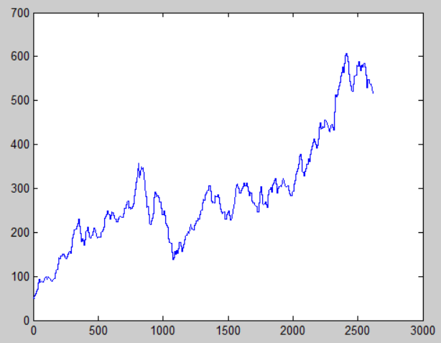

Window 7, frame 14

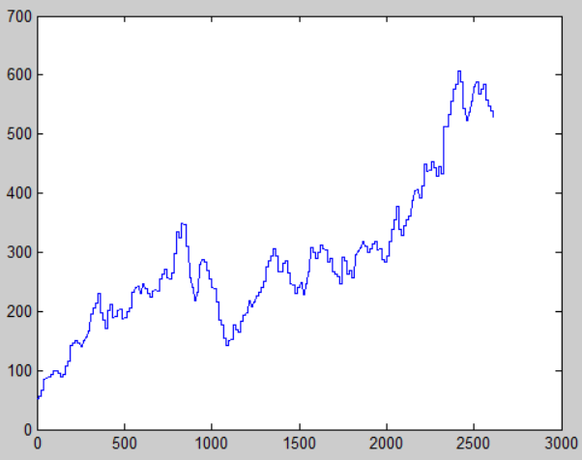

Window 7, frame 30

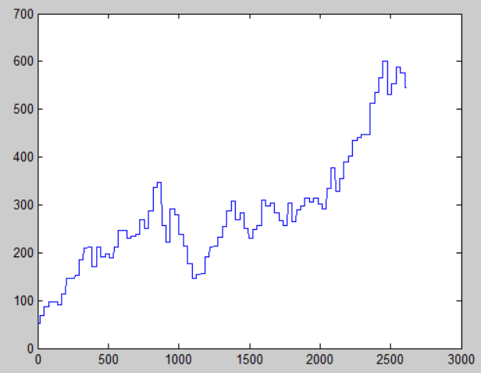

Alternatively, when we make the window size very large and the frame size very small, there is a smoothing of the graph.

Window 30, frame 1

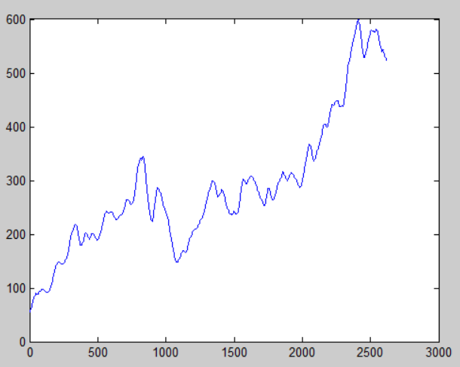

Window 30, frame 7

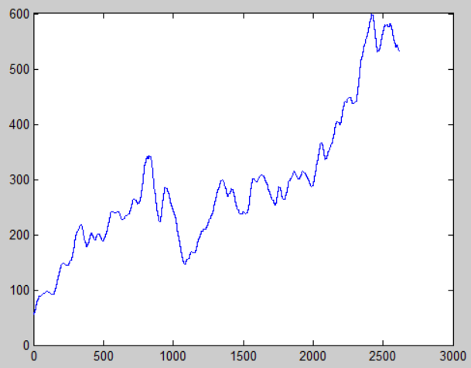

Window 30, frame 14

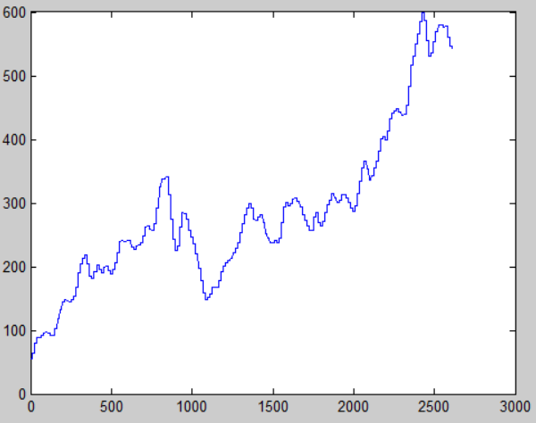

Window 30, frame 30

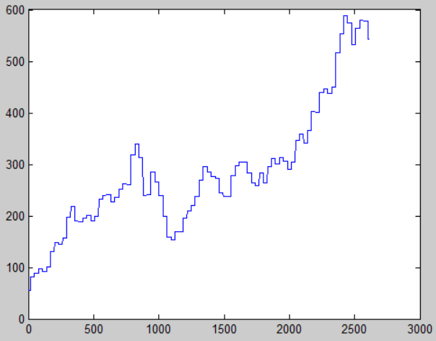

If I were going to try to predict the price of google stock in the future I think I would choose a large window and a small frame. I think the overall trend of the stock price is more important than the day to day changes. Maybe a better way to predict the value would be to vary the frame and window size to weight the data near the end more, since it is more recent data. I think to do this we would make the windows smaller toward the end.

Matlab code

clc;

%overall values

high = max(Close1);%highest value

low = min(Close1);%lowest value

med = median(Close1);%median value

mea = mean(Close1);%average value

vari = var(Close1);%Variance

len = length(Close1);

ind = 1:len;

%plot(ind,Close1);

w=7;%window 7,30

f=100;%frame 1,7,14,30

newLen=floor((len-w)/f);

newHigh=zeros(1,newLen);

newLow=zeros(1,newLen);

newMed=zeros(1,newLen);

newMea=zeros(1,newLen);

newVari=zeros(1,newLen);

c=1;

sig = Close1;

for i=1:newLen

wdat=Close1(c:c+w);

% newHigh(i)=max(wdat);

% newLow(i)=min(wdat);

% newMed(i)=median(wdat);

newMea(i)=mean(wdat);

% newVari(i)=var(wdat);

c=c+f;

end

%hold on;

ind2=1:newLen;

figure;

str=interp1(1:numel(newMea),newMea,linspace(1,numel(newMea),2616),'nearest');

plot (ind,str)

Below are plots of the audio signal ‘rec_01_speech.raw’

Again, when the window is small and the frame is small the plot looks almost identical. But as we increase the frame size we start getting a more jagged looking plot. When the window is large and the frame is small the plot gets smoothed out.

Original signal

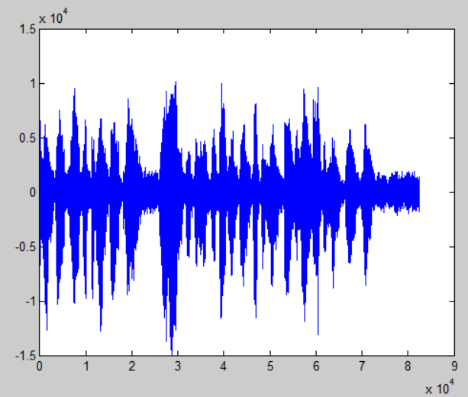

Window 160, frame 40

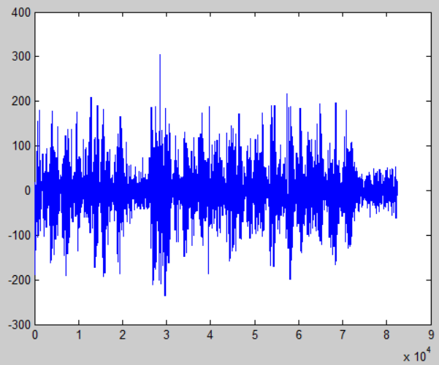

Window 160, frame 80

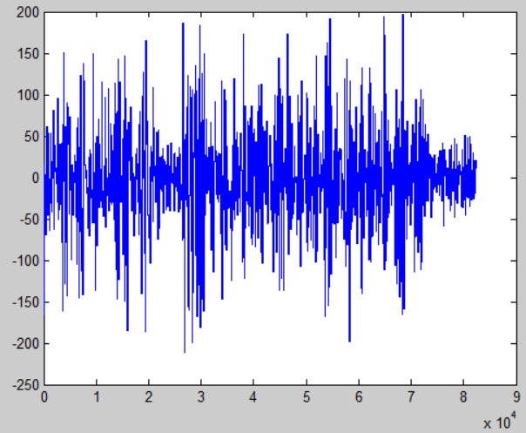

Window 160, frame 160

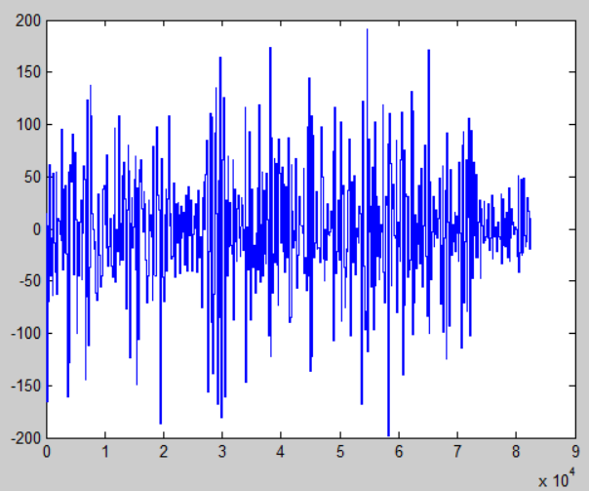

Window 240, frame 40

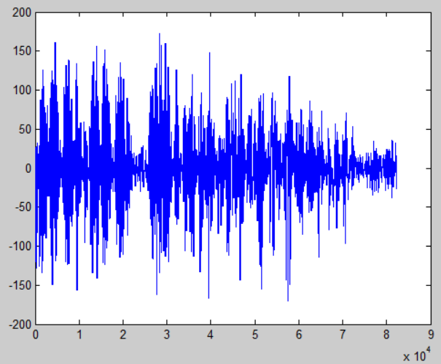

Window 240, frame 80

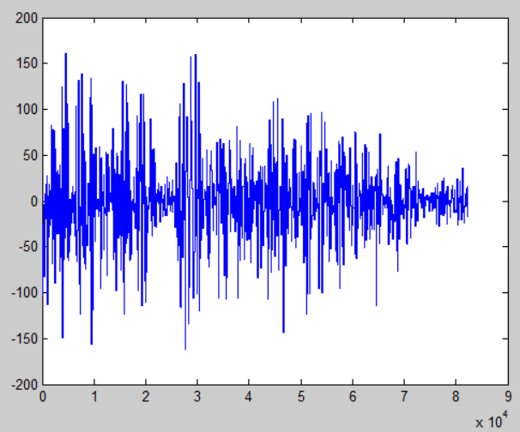

Window 240, frame 160

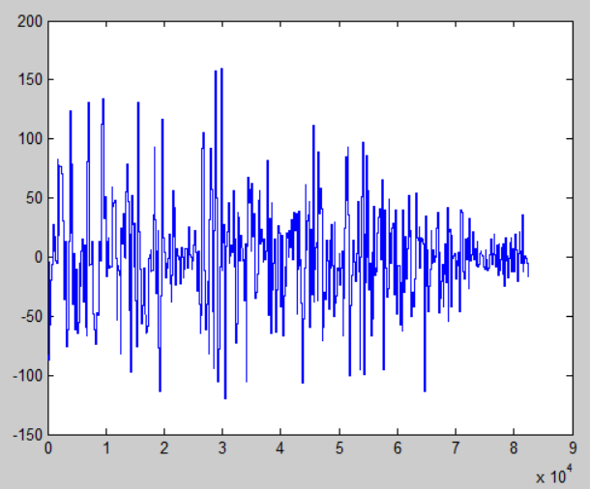

Matlab Code

clc;clear;

%overall values

fp = fopen('rec_01_speech.raw','r');

Close1 = fread(fp,inf,'int16');

fclose(fp);

high = max(Close1);%highest value

low = min(Close1);%lowest value

med = median(Close1);%median value

mea = mean(Close1);%average value

vari = var(Close1);%Variance

len = length(Close1);

ind = 1:len;

%plot(ind,Close1);

w=240;%window 160 (20 msec), 240 (30 msec)

f=160;%frame 40 (5 msec), 80 (10 msec), 160 (20 msec)

newLen=floor((len-w)/f);

newHigh=zeros(1,newLen);

newLow=zeros(1,newLen);

newMed=zeros(1,newLen);

newMea=zeros(1,newLen);

newVari=zeros(1,newLen);

c=1;

sig = Close1;

for i=1:newLen

wdat=Close1(c:c+w);

% newHigh(i)=max(wdat);

% newLow(i)=min(wdat);

% newMed(i)=median(wdat);

newMea(i)=mean(wdat);

% newVari(i)=var(wdat);

c=c+f;

end

%hold on;

ind2=1:newLen;

figure;

str=interp1(1:numel(newMea),newMea,linspace(1,numel(newMea),length(Close1)),'nearest');

plot (ind,str)