[Robert Irwin]

ECE 3512: Stochastics

Department of Electrical and Computer Engineering, Temple University, Philadelphia, PA 1912

# Problem Statement

In this assignment we are introduced to the process of analyzing noisy signals. This is a critical part of engineering because every physical system will have some degree of Gaussian white noise. In this assignment we will be generating a sine wave with a degree of noise defined by a specified signal to noise ratio. We will then compute the autocorrelation of these signals sampled at 8000Hz. We will then compute a 8192 point Fourier Transform and plot the magnitude spectrum for [0 4000] Hz. We will then observe and comment on the differences between the two plots generated.

This signals will then be passed through a digital filter of the form y[n] = .5y[n-1]+x[n]. We will compute and plot the autocorrelation of y, and plot the magnitude spectrum squared of y[n].

# Approach and Results

The first thing we had to do was generate a sine-wave that contained Gaussian white noise. The Gaussian white noise was produced using the box-muller-transform discussed in the previous assignment. The amplitude of the Gaussian distribution is defined by the signal to noise ratio, which is

$$snr=20\log_{10}{\frac{signal energy}{noise energy}}, Equation 1$$

We know that the energy of a sine wave is $\frac{{\left|A\right|}^{2}}{2}$, so we can solve Equation 1 for the energy of the noise. As energy is the variance, we can multiply the Gaussian by the desired noise energy and simply add the noise signal to the sine wave. The noisy signal created is shown below. It has a signal to noise ratio of 10dB.

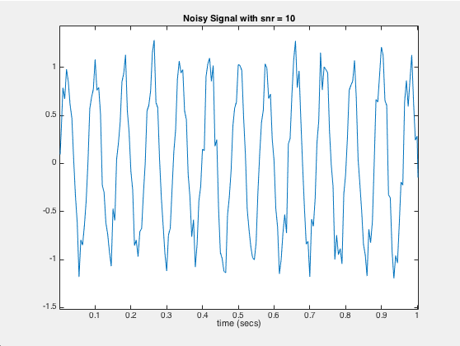

*Figure 1: Noisy Sine Wave, SNR = 10dB*

Now that we have verified that we are in fact creating a noisy signal, we proceed with the deliverables specified in the problem statement. The figure below shows the autocorrelation functions corresponding to the desired signal to noise ratios.

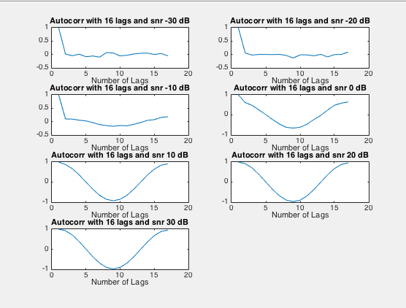

*Figure 2: Autocorrelation Functions*

We see that as the signal to noise ratio increases, the autocorrelation function approaches the respected result of a cosine function. This makes sense because with a low signal to noise ratio, i.e. -30dB, the autocorrelation function, because of the large unbiased random noise component, should be 0. As the signal to noise ration increases, i.e. the amplitude of the sin is large compared to the amplitude of the noise, the signal is more deterministic. We also see the autocorrelation begins to be affected by the noise at a 0 dB signal to noise ratio.

Now we will look at the Fourier Transforms of the noisy sine waves. The plots of these functions are shown below.

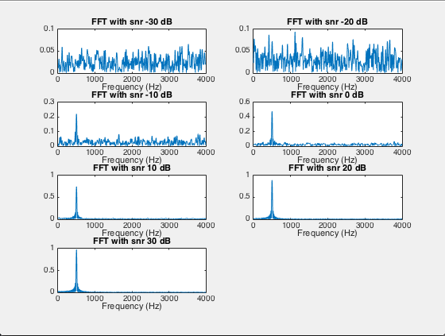

*Figure 3: Fourier Transforms of the Noisy Signals at Different SNRs*

The Fourier Transforms above agree with the results presented in Figure 2. With a law signal to noise ratio, we see almost equal energy at all frequencies. This is in fact what we expect because the Gaussian white noise is dominant in these signals and Gaussian white noise has equal energy at all frequencies. Also, when the signal to noise ratio becomes large, we notice that the Fourier Transform begins to have energy only at one frequency, namely 500Hz. A pure sine wave only has energy at its frequency of oscillation, so if the sine wave is the dominant part of the signal, we expect there to only be energy at the frequency of the sine wave.

We will now view the results of the filtered signal y[n] at a signal to noise ratio of 30dB.

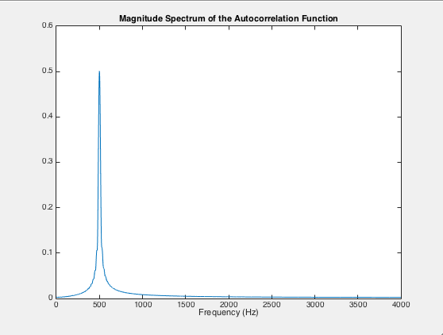

*Figure 4: Magnitude Spectrum of Autocorrelation Function of Filtered Signal (Power Spectral Density)*

As we have said before, the magnitude spectrum of a sine wave is a cosine, and the Fourier Transform of either function is a pulse at the sine or cosine’s frequency of oscillation. When we filter the noisy sine wave, compute the autocorrelation function, and find the Fourier Transform, we get the Fourier Transform of a cosine! We also know because the amplitude of our signal is basically 1, we expect a power of .5W. This is what we see above. This result tells us that our filter did a fairly good job of filtering the noise from the signal.

Now we look at the square of the magnitude spectrum of the signal y[n].

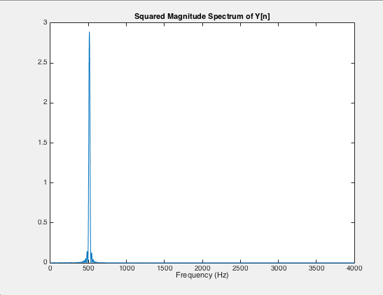

*Figure 5: Square of Magnitude Spectrum of the Filtered Signal*

When we compute the square of a magnitude, it is essentially the power spectral density of the stochastic process. We have also proven that the Fourier Transform of the autocorrelation function is the power spectral density. As we can see by comparing Figures 4 and 5, we have almost exactly the same plot. The only difference is the amplitudes of the two spectra and the degree of oscillation around 500Hz. The amplitude of the spectrum in Figure 5 oscillates much more at frequencies around 500Hz compared to the amplitude of the frequency of Figure 4.

# MATLAB Code

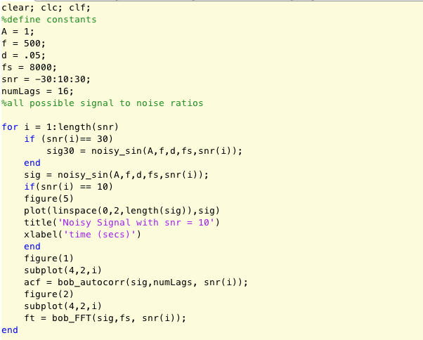

*Figure 6: Main Script for Signal Generation, Autocorrelation Calculation and Fourier Transform*

Above is the main script that generates the noisy signal, and computes and plots the Autocorrelation functions and the Fourier Transform. This script contains three user defined functions: noisy_sin(), bob_autocorr(), and bob_FFT(). These will be shown and explained subsequently. It is important to note that in this code, we are generating a signal, computing the autocorrelation function, and the Fourier Transform for every signal to noise ratio defined in snr.

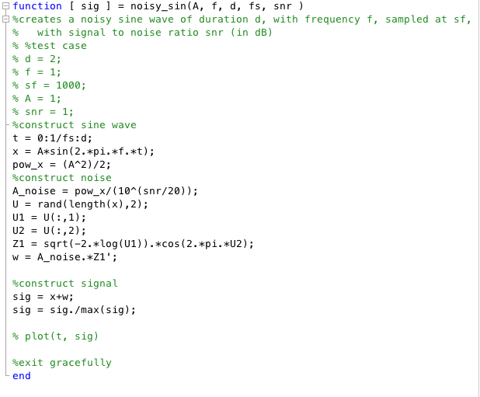

*Figure 7: Function: noisy_sin*

In this function we first define a time vector, t, based off the sampling frequency, and duration. The sample frequency and duration are both inputs to the function. Based off this we generate a clean sine wave with amplitude A. We next have to generate the noise signal, but before we can do this we need to figure the appropriate energy level of the noise signal. Algebraic manipulation of Equation 1 yields the equation assigned to A_noise. We then use the box-muller-transform to generate Gaussian noise. This signal is then multiplied by A_noise which essentially gives it the desired energy for the proper signal to noise ratio. We then normalize the signal for plotting purpose.

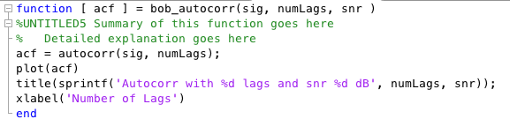

*Figure 8: Function: bob_autocorr*

This is essentially the same function as Matlab’s autocorr function. The only difference is it outputs a plot with a title based off the number of lags and the signal to noise ratio of the signal it is working with. This function was made to work with the subplot function shown in the main script.

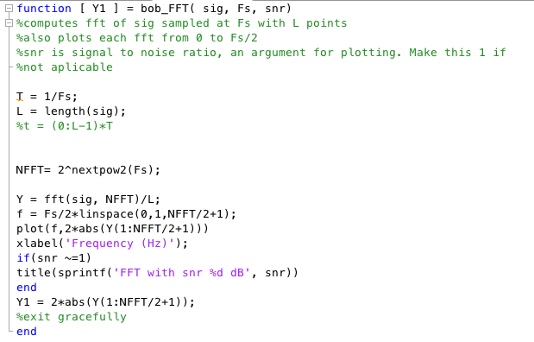

*Figure 9: Function bob_FFT*

The function above does a Fast Fourier Transform with the number of points of the output being equal to the closest power of two to the sampling frequency. This function also plots the FFT from [0 Fs/2] Hz. The output of this function is the values of the magnitude spectrum.

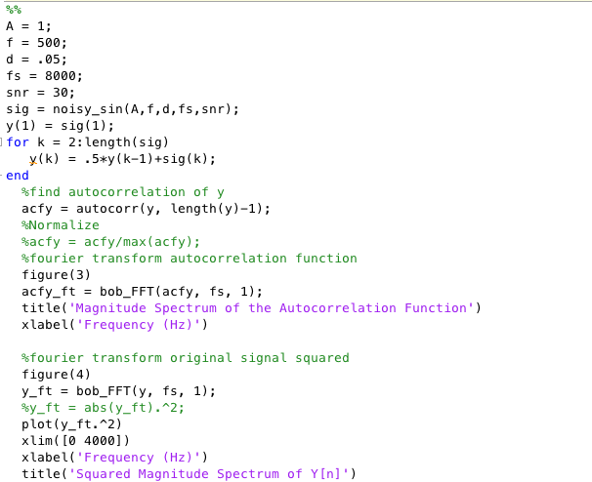

*Figure 10: Main Script that Deals with the Filtered Signal*

In this part of the code we generate the noisy sine wave with a signal to noise ratio of 30dB. This signal is then filtered according to the equation found in the Problem Statement. Once the signal is filtered, we find the power spectral density by using the functions described above to compute the autocorrelation function, and find the Fourier Transform of this function. Then, using the same functions, we compute the Fourier Transform of the filtered signal, square the magnitude spectrum, and plot the results.

# Conclusions

In this experiment we found that the autocorrelation function essentially filters signals. When the signal to noise ratio was extremely low, we saw the autocorrelation function was 0. Because the signal is mostly noise, which has a mean of 0, the autocorrelation was basically 0. The same argument can be made for when the signal to noise ratio was extremely high. Because the signal was predominantly a sine wave, the autocorrelation function was a cosine. We also saw that the Fourier Transform of a autocorrelation function tells how much power we have at each frequency. This is why the magnitude of Figure 4 at 500 Hz was .5. We know the power of a sine wave with amplitude of 1 is .5. Again, Figure 4 corresponds to a signal to noise ratio of 30dB, so the signal barely has noise. The Fourier Transform of the autocorrelation is .5 when f = 500.

Another interesting phenomena is that when we square the magnitude of the Fourier Transform we end up with essentially the power spectral density.