[Your Full Name Goes Here]

ECE 3512: Signals – Continuous and Discrete

Department of Electrical and Computer Engineering, Temple University, Philadelphia, PA 19122

# Problem Statement

In this assignment we will a better understanding about what covariance means in terms of the shape of a pdf. We rely heavily on MATLAB’s 3D visualization tools with two random variables. Firstly, we need to generate a large number of random vectors of dimension 2 consisting of two independent uniformly distributed random numbers over the range [0,1]. Then estimate the pdf and plot in 3D using MATLAB’s functions like surf, mesh or the equivalent. Secondly, we need to generate a set of Gaussian random vectors that have a 2x2 covariance matrix, estimate the pdf, and plot in 3D. A pdf function of two random variables is a 3D surface where the third dimension represents the value of the pdf. Correlation implies these functions are skewed. In the case of a Gaussian, the function will be circularly symmetric if the function has no correlation structure. Correlation, which shows up as the off-diagonal components of the covariance matrix, skews the shape so that its support is an ellipse.

# Approach and Results

1)

Firstly, we create two randomly generated uniform variables between 0 and 1 using MatLab’s random number generator. Then use MatLab’s function ‘hist3’ to find the histogram of the 2 variables. Therefore we generate 100,000 vectors and sum all the results so to guarantee our output produces accurate results.

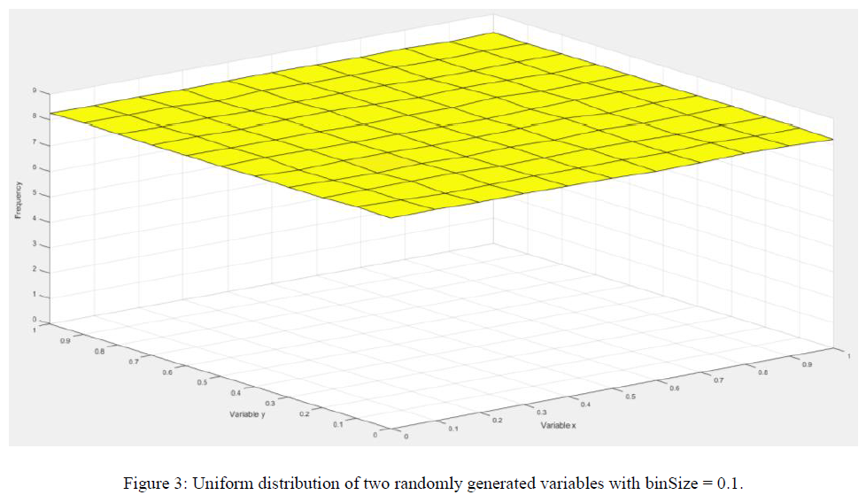

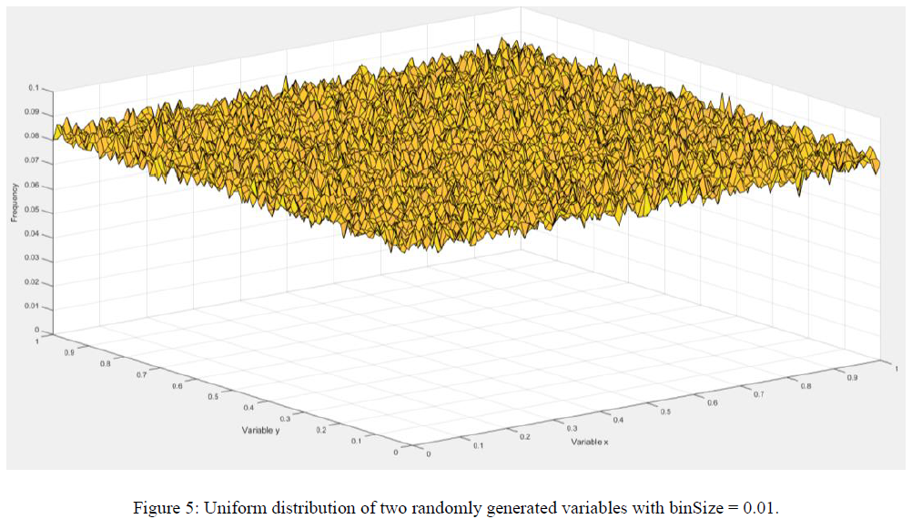

The plot above is the overall histogram. In the previous assignment we emphasized and proved how the number of samples you take can influence whether your data reaches your expected output. Figure 4 showcases our resulting plot which matches our expectations. If we decrease the binSize to 0.01 we will observe a less uniform appearing plot as seen in Figure 5. However, both plots demonstrate the same set of data. We can see the same characteristics where each bin has approximately the same frequency of resulting a uniform distribution between the two plots.

2)

Next we move onto changing our covariance matrices so that are data is not normal. First we take the covariance matrix that matches the identity and thus should produce a normal 3D PDF. For all these following results we again take 100,000 sample vectors.



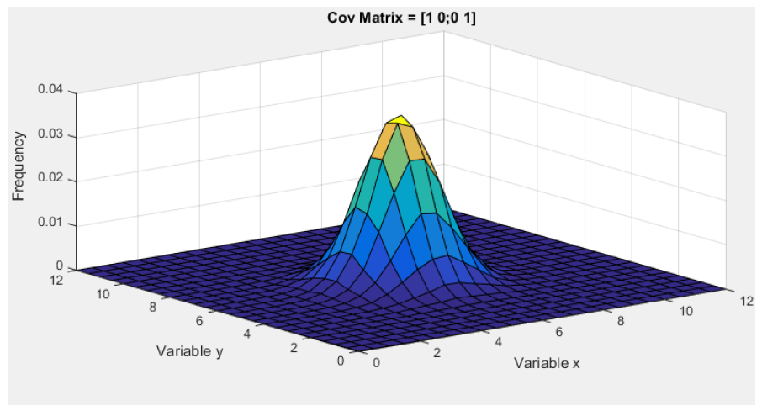



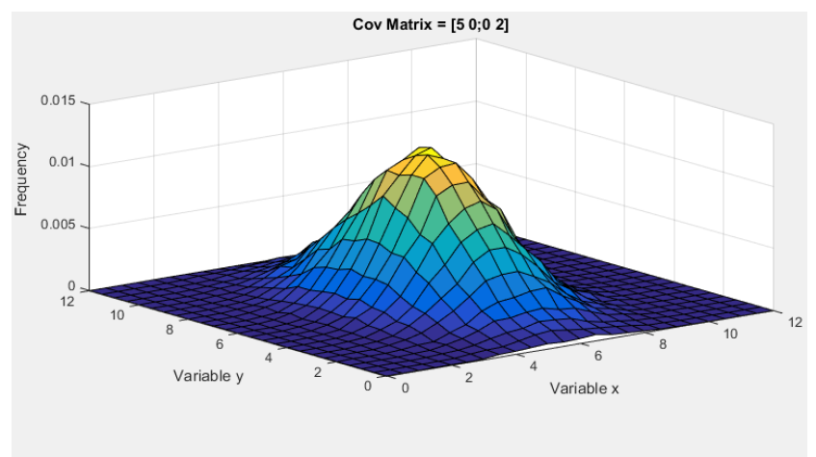



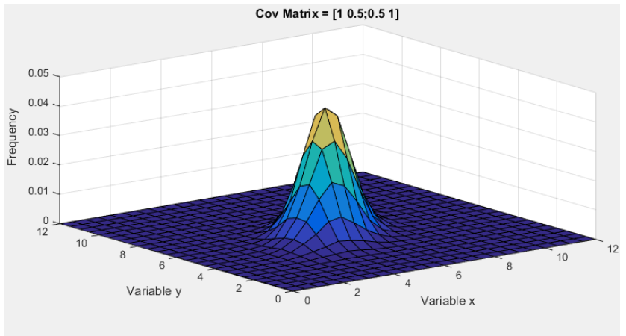



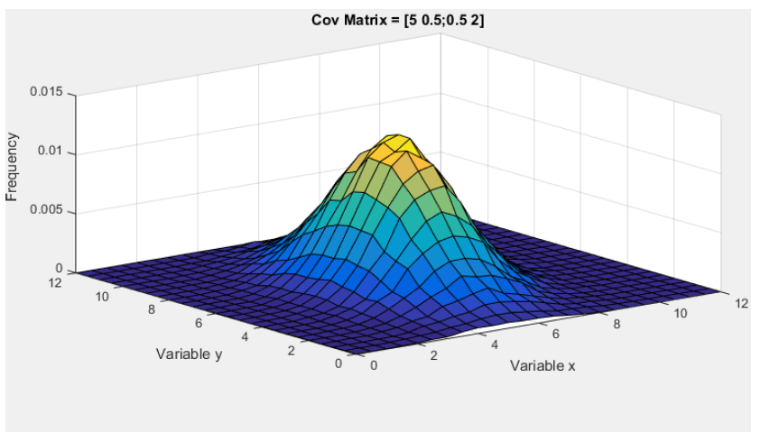

From the 5 different plots above we can see the effects of the covariance matrices relating to the 3D plot. In the first example our

matrix is 𝐶𝑜𝑣(𝑋,𝑌) = [5 0,0 2]. In this example there is correlation between X & Y since the diagonal is zero. The variance of X and Y are different where the variance for X values is 5 while for Y its only 2. Thus in the plot are X values take on a more spread of values compared to Y values which produces an ellipse support region.

In the first two cases, since both X and Y are built off the same variance values it appears that the two are correlated but they are not. Both X and Y were generated separately using MatLab’s random number generator

# MATLAB Code

1 To begin we setup some parameters that will define the characteristics of our random data set

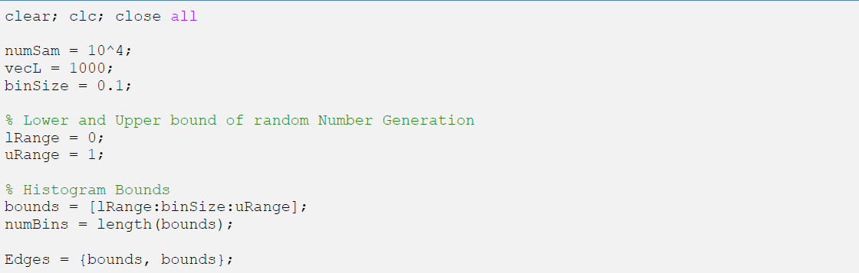

2 First we create a ‘numSam’ of random vectors and compute the histogram each time.

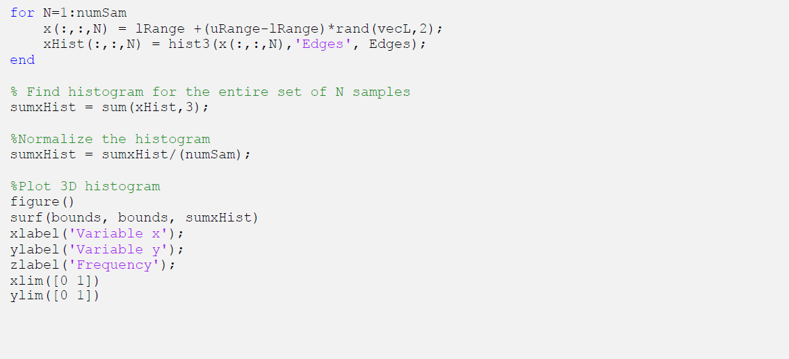

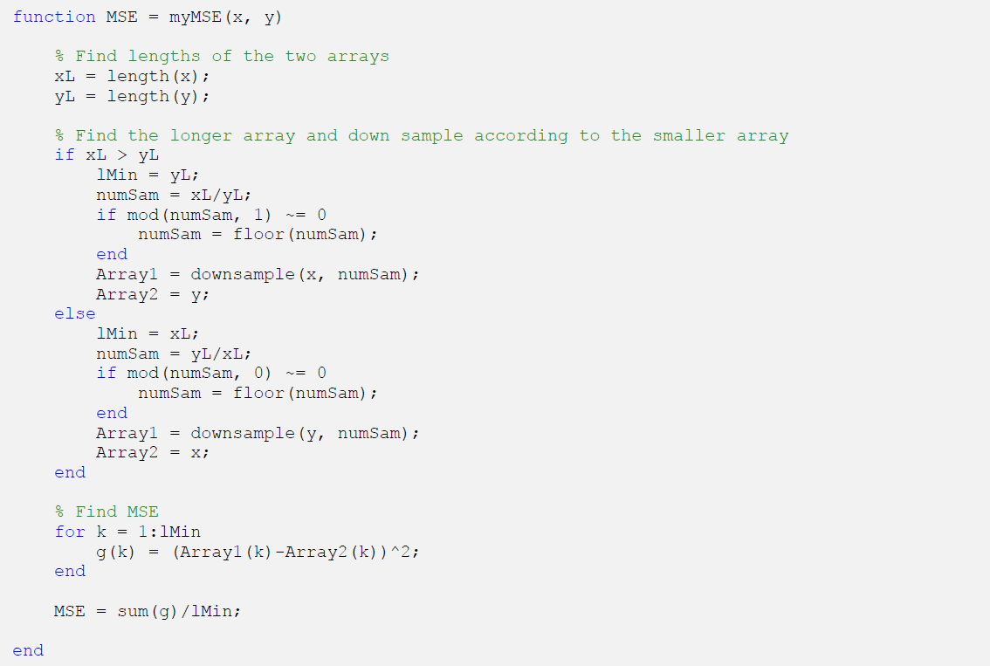

Moving onto Part 2 of the assignment we start with defining our function parameters. 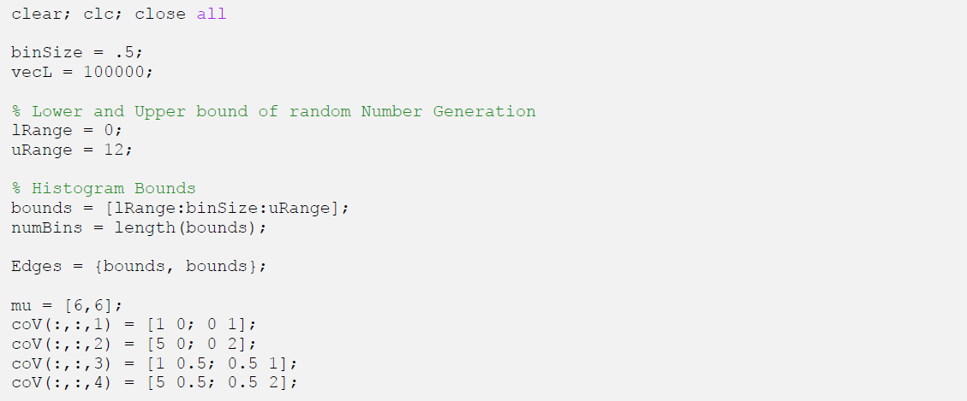

Using the ‘mvnrnd’ we are able to construct a multivariable random array given a set mean and covariance matrix.

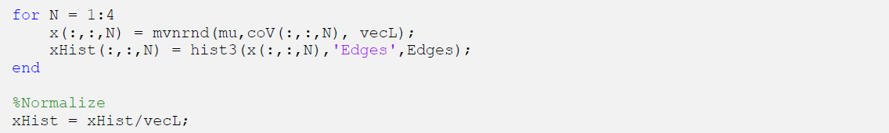

Lastly we plot our individual histograms for each covariance case.

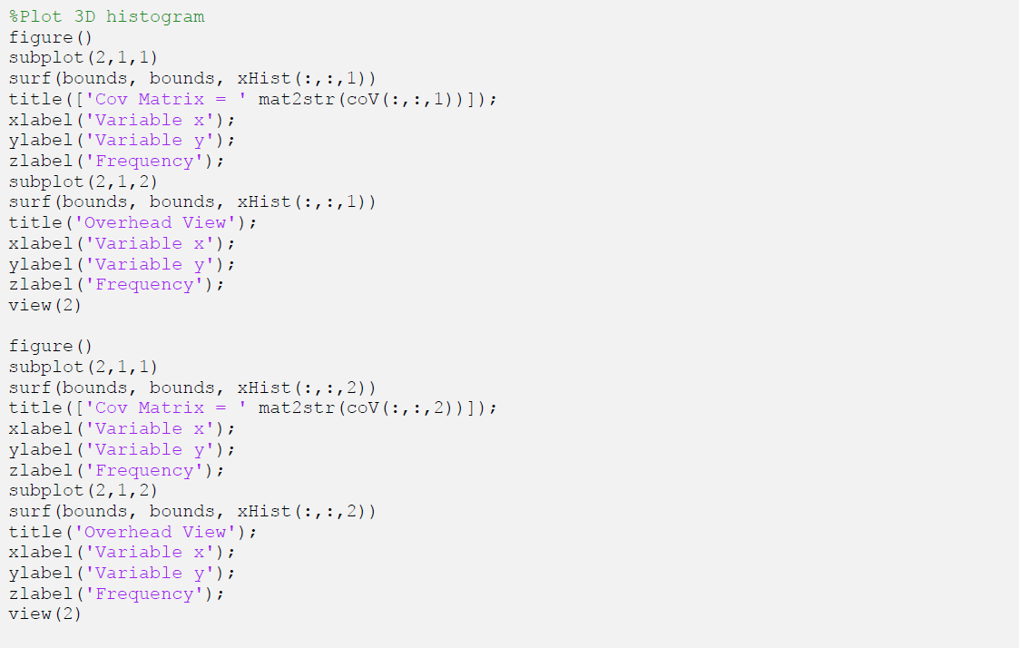

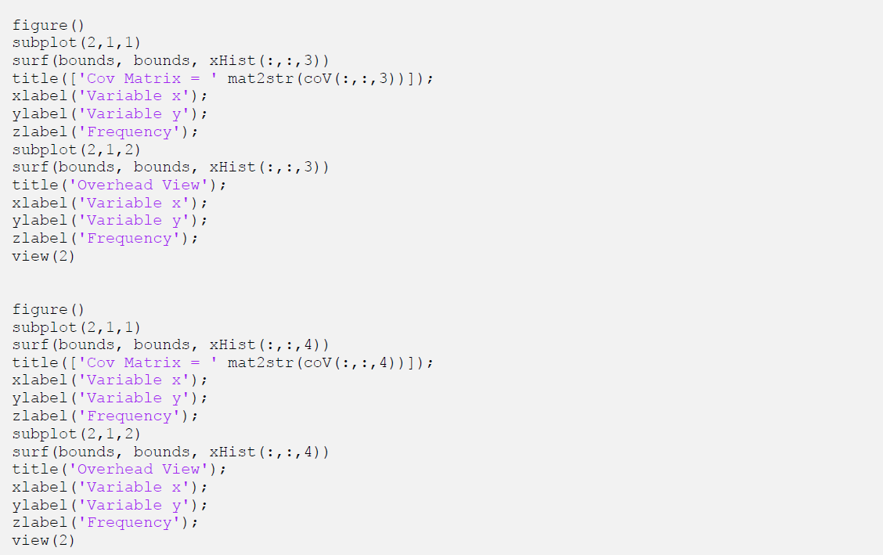

# Conclusions

The assignment helps us to better understand and visualize multivariable datasets. Firstly we focused on showing the PDF of a uniform distribution. What we developed was a flat plane that can clearly see how every combination of X and Y has the same frequency within the test case. Also, the assignment helps us understanding of the covariance matrix. Telling us that Knowing that we can analyze their corresponding PDFs by comparing the difference between the diagonal corresponds to the variance of our variables and the off diagonal. The support region of an identity covariance matrix is a circle showing the even distribution in all directions. In our third example we introduce a correlation of 0.5 between X and Y. The slight correlation introduces a skewness to our PDF. In the third example the variance of X and Y are equal so our PDF is skewed so our PDF is 45 degrees off the horizontal.