Miles A. Vendetti-Houser

ECE 3522: Stochastics

Department of Electrical and Computer Engineering, Temple University, Philadelphia, PA 1912

# Problem Statement

The goal of this assignment is use MATLAB to visualize covariance in terms of the shape of a pdf. Working with two random variables X and Y and MATLAB’s 3D visualization tools, we will discuss the topic of covariance and compare it with correlation.

# Approach and Results

The first task in this assignment is to generate a large number of random vectors with 2 dimensions. These will be independently and uniformly distributed random numbers over range of [0,1]. Using the combination of a for loop and the built-in rand() function, I created these vectors with length 10^6. Using MATLAB’s function histcounts(), I generated a PDF for X, and a separate one for Y. The pdfs for both of these are individually displayed below.

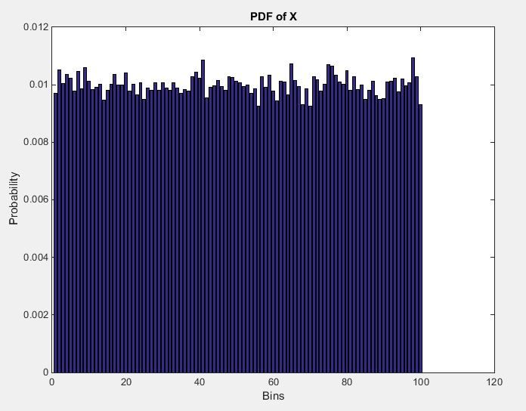

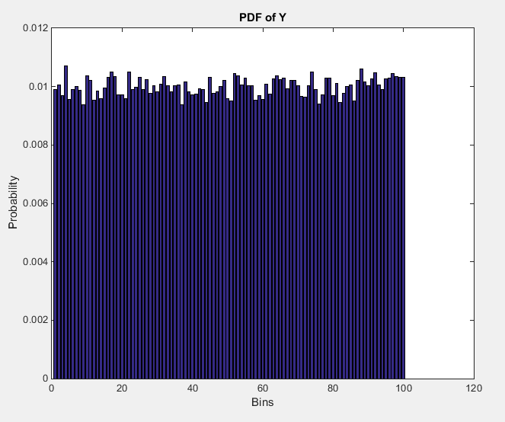

Now, in order to create the joint PDF of X and Y, we need to multiply their PDFs together to create the joint PDF. Using mesh() function, and creating matrix spaces to properly distribute the values, I create the following figure representing the joint PDF.

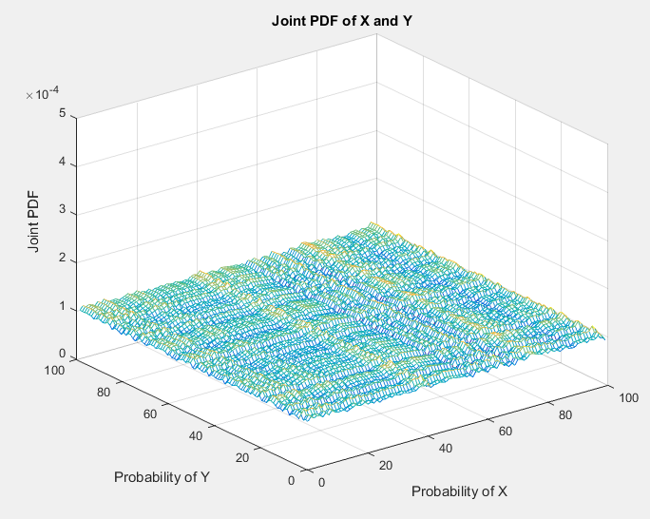

The joint PDF has a uniform distribution as well (being the product of two uniformly independent pdfs). The uniform value is 0.01 * 0.01 = 0.0001.

The second task is to generate a set of Gaussian random vectors with a mean of [6,6] and the supplied 2x2 covariance matrices listed below;



Before I show you the graphs, lets discuss a little about the definition of covariance and correlation..

Covariance is defined as follows;

$$Cov\left(X,Y\right)=E\left[\left(X_{n}-μ_{X}\right)\left(Y_{n}-μ_{Y}\right)\right]$$

Where this is analogous to how we find variance. Except now we have a joint PDF, and we want to find the variance of two random variables on the same space. Looking at this equation we can intuitively assume that…okay, we have a product, meaning that we are bringing information from X and stuff from Y and we wish to analyze how the vary together. We have X relative to it’s mean, and Y relative to it’s mean. Also, since if X is below its means implies Y is below its mean, we will have two negatives becoming positive and vice versa. Here are some properties;

$$Cov\left(X,Y\right)=Cov\left(Y,X\right)$$

$$Cov\left(X, X\right)=Var\left(X\right)$$

$$Cov\left(X, k\right)=0$$

$Cov\left(kX, Y\right)=k*Cov(X,Y)$

$$Cov\left(X, Y+Z\right)=Cov\left(X,Y\right)+Cov\left(X,Z\right)**$$

**

Where the latter two properties (**) use bi-linearity (fancy word for ‘treating one coordinate as fixed and treating the other coordinate, it looks like linearity’). Also, if X, Y are independent, then they are uncorrelated, i.e. Cov(X,Y) = 0. However, the converse if false. If Cov(X,Y)=0, then they may or may not be independent.

Mathematically, correlation is defined by covariance. Where

$$Corr\left(X,Y\right)=\frac{Cov\left(X, Y\right)}{SD(X)SD(Y)}=Cov(\frac{X-μ_{X}}{SD\left(X\right)},\frac{Y-μ_{Y}}{SD\left(Y\right)} )$$

Or in other words, the correlation is the standardization of covariance (more on this is the conclusion).

So, when we have a covariance matrix of say [1 0 ; 0 1], we find that the diagonal represents the var(X), var(Y), and other spots are the Cov(X_i, Y_j) and since they are 0, we can conclude that X and Y are in fact independent. When they are dependent of each other, we start to see the shape of the joint Gaussian PDF begin to skew and rotate in different ways. We set the covariance equivalent to that of sigma_1 and plot its pdf shown on next page.

$$σ_{1}=\left[\begin{matrix}1 & 0 \\ 0 & 1\end{matrix}\right]$$

$$σ_{2}=\left[\begin{matrix}5 & 0 \\ 0 & 2\end{matrix}\right]$$

$$σ_{3}=\left[\begin{matrix}1 & 0.5 \\ 0.5 & 1\end{matrix}\right]$$

$$σ_{4}=\left[\begin{matrix}5 & 0.5 \\ 0.5 & 2\end{matrix}\right]$$

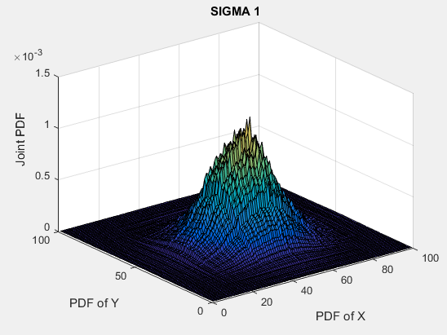

Here we can see that the resulting PDF is Gaussian, centered in the middle as a circle. If we look at the top view of is pdf and compare it to say, sigma_4. We can visualize what the ellipse will do as we go from a joint pdf with no covariance to a joint pdf with a covariance of 0.5 and a variance of X and Y individually of 5 and 2.

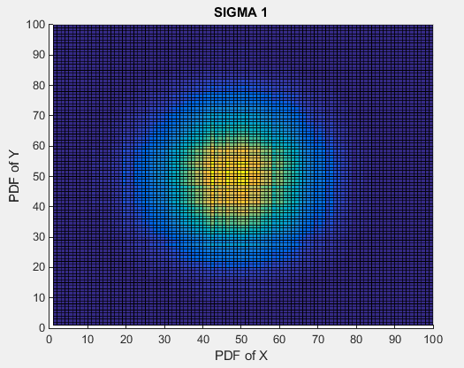

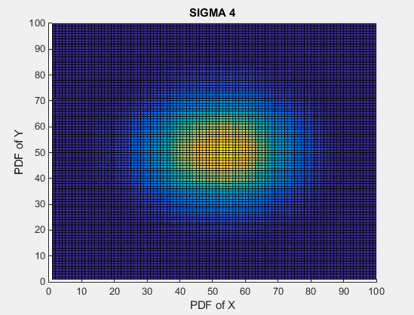

We see that the first plot has a more circular yellow region centered in the middle, whereas sigma_4 contains an ellipse with wider width than its height. This means that covariance matrices that are not identity, come from joint PDFs with dependent values. The following plots resemble the joint PDFs of sigma_2 through sigma_4. I spend more time discussing the relationship between sigma_1 and sigma_4 due to larger differences for the covariance matrices and the resulting figures.

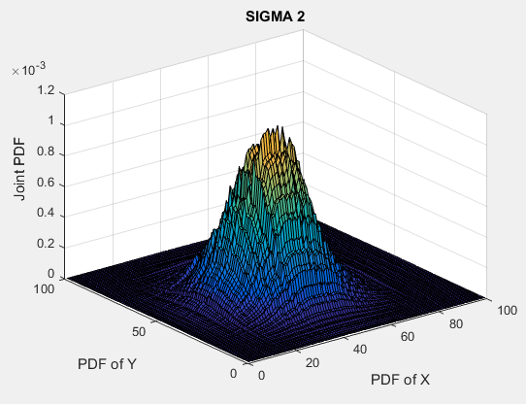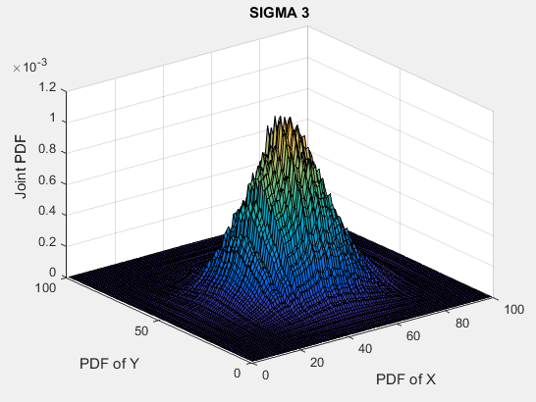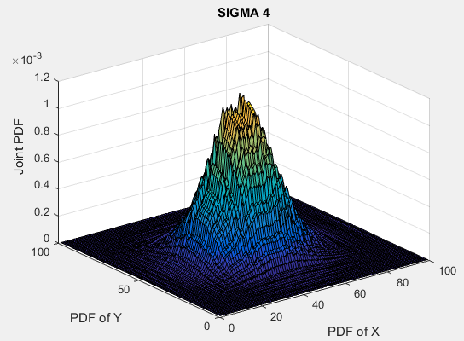

# MATLAB Code

% Computer Assignment 07

% Stochastics [ECE 3522] Dr. Picone

%

clear;clc;clf;close all;

% Generate a large number of random vectors

for n = 1:100000

x(n,:) = rand(1,2);

end

bin = 100;

pd1 = histcounts(x(:,1),bin , 'Normalization', 'probability');

pd2 = histcounts(x(:,2),bin ,'Normalization', 'probability');

figure(1)

bar(pd1)

xlabel('Bins');ylabel('Probability');

title('PDF of X');

figure(2)

bar(pd2)

xlabel('Bins');ylabel('Probability');

title('PDF of Y');

figure(3)

[x_mesh, y_mesh] = meshgrid(pd1, pd2);

pd_n = x_mesh .* y_mesh;

[X, Y] = meshgrid(1:1:length(pd_n), 1:1:length(pd_n));

mesh(X,Y,pd_n)

axis([0, 100, 0, 100, 0 , 0.0005])

xlabel('Probability of X');ylabel('Probability of Y');zlabel('Joint PDF');

title('Joint PDF of X and Y');

%% Part 2

clear;clc;clf;close all;

MU = [ 6 6 ];

SIGMA1 = [ 1 0 ; 0 1 ];

SIGMA2 = [ 5 0 ; 0 2 ];

SIGMA3 = [ 1 0.5 ; 0.5 1 ];

SIGMA4 = [ 5 0.5 ; 0.5 2 ];

N=4;

cases = 10^N;

bin = 10^(N/2);

figure(1)

X = mvnrnd(MU, SIGMA2,cases);

H1 = histcounts(X(:,1), bin, 'Normalization', 'probability');

H2 = histcounts(X(:,2), bin, 'Normalization', 'probability');

F = mvnpdf(X, MU, SIGMA1);

[x,y] = meshgrid(H1, H2 );

F = x.*y;

[X, Y] = meshgrid(1:1:length(F) , 1:1:length(F));

surf(X, Y, F)

xlabel('PDF of X');ylabel('PDF of Y');zlabel('Joint PDF');

title('SIGMA 1');

figure(2)

X = mvnrnd(MU, SIGMA2,cases);

H1 = histcounts(X(:,1), bin, 'Normalization', 'probability');

H2 = histcounts(X(:,2), bin, 'Normalization', 'probability');

F = mvnpdf(X, MU, SIGMA2);

[x,y] = meshgrid(H1, H2 );

F = x.*y;

[X, Y] = meshgrid(1:1:length(F) , 1:1:length(F));

surf(X, Y, F)

xlabel('PDF of X');ylabel('PDF of Y');zlabel('Joint PDF');

title('SIGMA 2');

figure(3)

X = mvnrnd(MU, SIGMA2,cases);

H1 = histcounts(X(:,1), bin, 'Normalization', 'probability');

H2 = histcounts(X(:,2), bin, 'Normalization', 'probability');

F = mvnpdf(X, MU, SIGMA3);

[x,y] = meshgrid(H1, H2 );

F = x.*y;

[X, Y] = meshgrid(1:1:length(F) , 1:1:length(F));

surf(X, Y, F)

xlabel('PDF of X');ylabel('PDF of Y');zlabel('Joint PDF');

title('SIGMA 3');

figure(4)

X = mvnrnd(MU, SIGMA2,cases);

H1 = histcounts(X(:,1), bin, 'Normalization', 'probability');

H2 = histcounts(X(:,2), bin, 'Normalization', 'probability');

F = mvnpdf(X, MU, SIGMA4);

[x,y] = meshgrid(H1, H2 );

F = x.*y;

[X, Y] = meshgrid(1:1:length(F) , 1:1:length(F));

surf(X, Y, F)

xlabel('PDF of X');ylabel('PDF of Y');zlabel('Joint PDF');

title('SIGMA 4');

# Conclusions

The video recording of lecture 21 for Harvard University’s Statistics 110 class discussing covariance and correlation contains a lot of useless information regarding this topic. Correlation means, standardize them first, then take covariance. Covariance has annoying property when dealing with interpretation of units. For example, if X and Y represent distances, and one person measures in millimeters, another measures in light years, the result will be completely different answers. So, getting a result, say ‘73’, we don’t know what that means. Is that in millimeters or light years? So, by taking the correlation, we can standardize the random variables, X and Y, to get a dimension-less / unit-less result giving us a proper answer to compare.

This was one of my favorite computer assignments so far due to the capabilities of visualizing the data. We need more like this. ☺