[Tyler Olivieri]

ECE 3512: Stochastic Processing in Signals and Systems

Department of Electrical and Computer Engineering, Temple University, Philadelphia, PA 1912

# Problem Statement

The purpose of this computer assignment is to visualize a joint pdf. Also to create a visualization of covariance in terms of the shape of the pdf. Given a uniform random joint pdf, a 3d plot will be made in MATLAB. Then a set of Gaussian random vectors will be generated with a 2x2 covariance matrix. A 3d pdf will be estimated and plotted in 3d. Visualizing the covariance will give insight to the shape of the pdf.

# Approach and Results

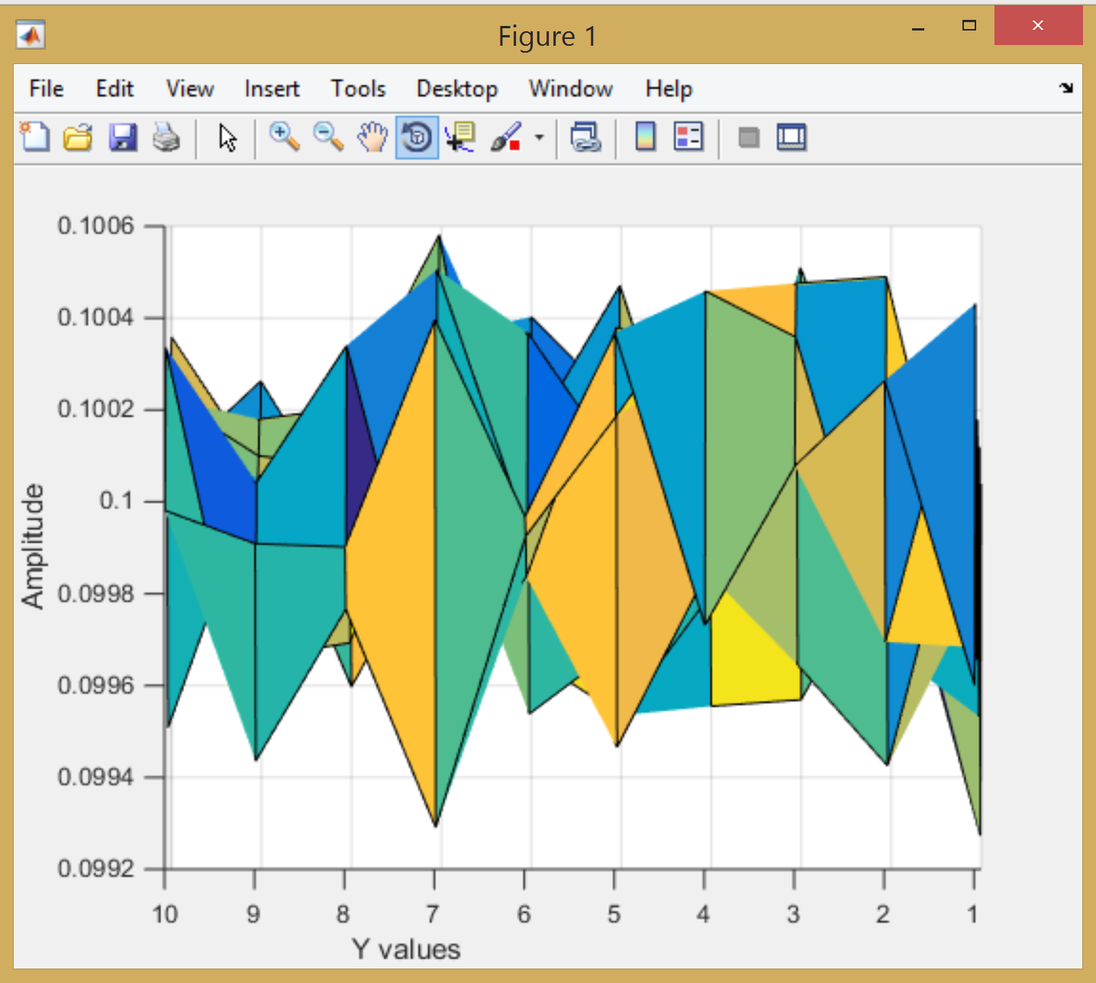

Figure 1: uniform joint pdf

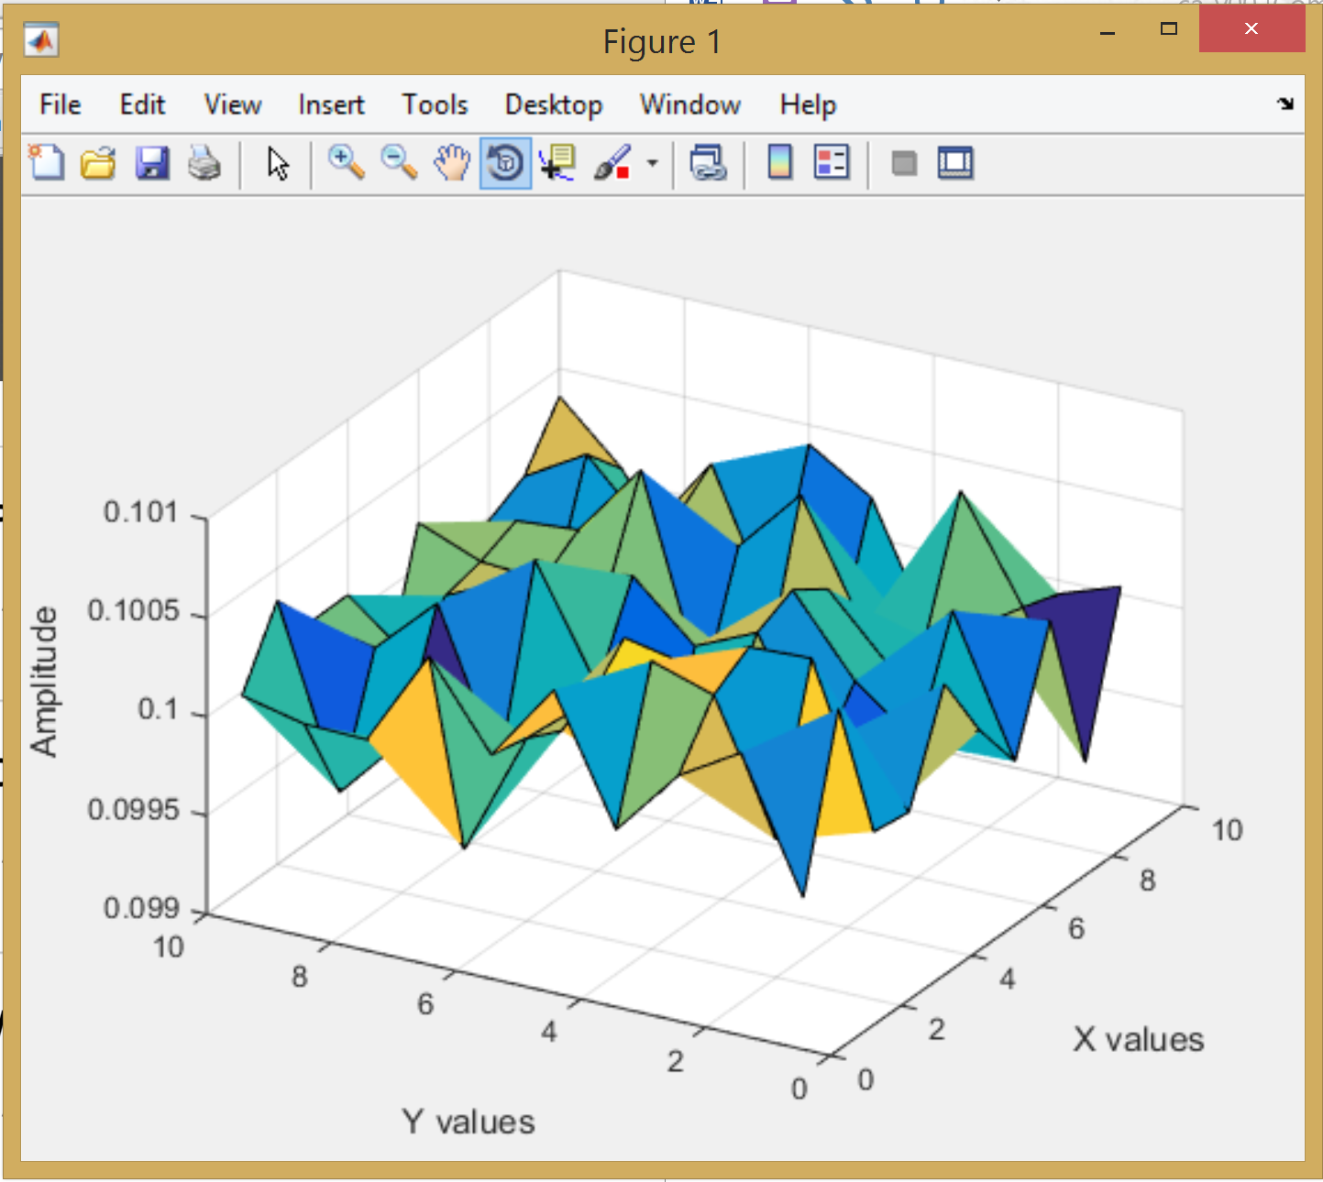

Figure 2: different view; joint uniform pdf

In Figure 1, the joint pdf can be seen for a joint uniform distribution. The marginals were generated randomly. The plot does not appear uniform at first glance. However, the amplitude axis has very small intervals. The range around the distribution is .0992 to .1006 which is uniform. I created a 3d histogram for each set of marginals and summed the output of all the histograms. Creating more sets of marginals would make the distribution even more uniform. So would increasing the size of the marginals.

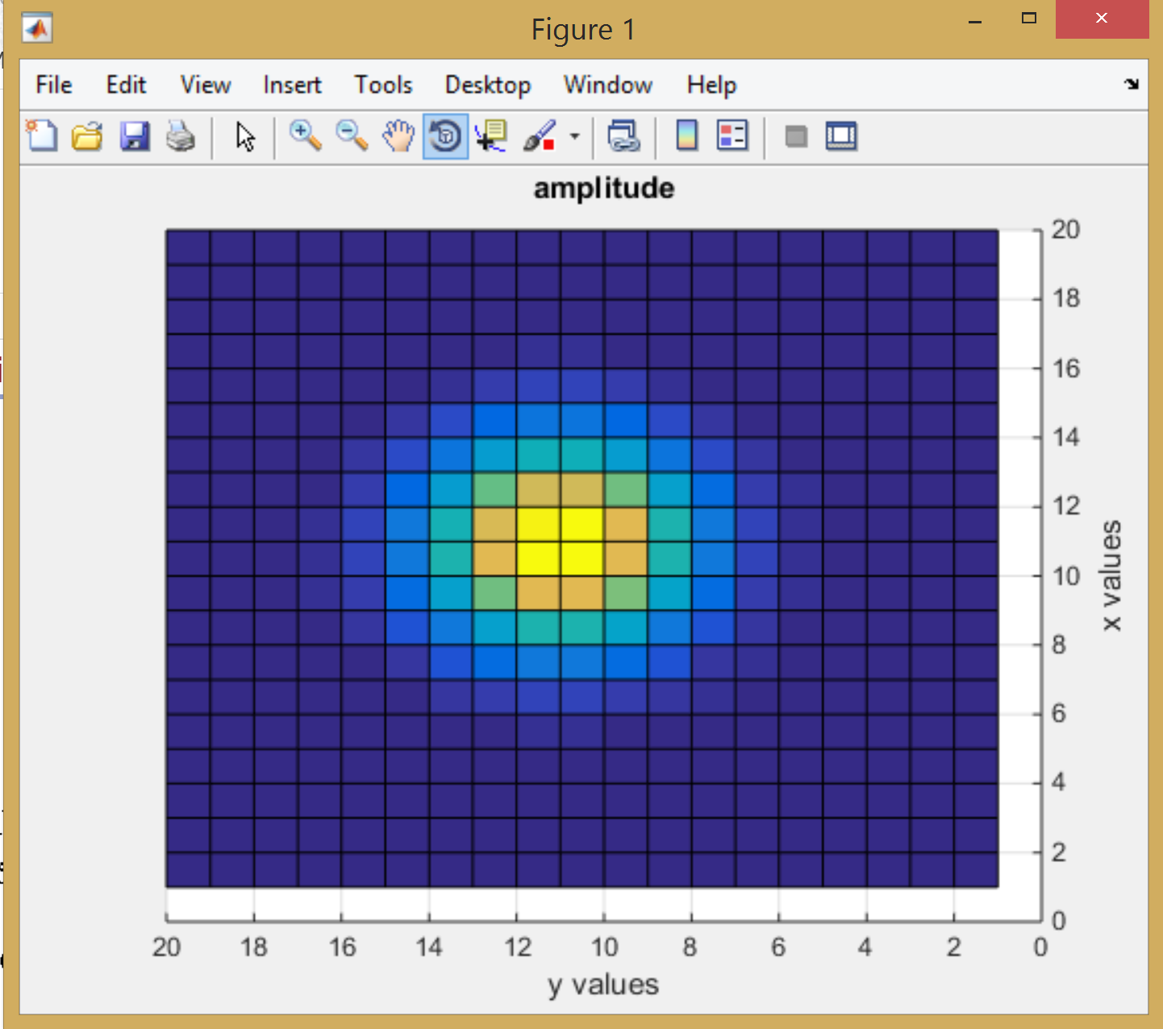

Figure 3: Cov matrix [1 0; 0 1] top view

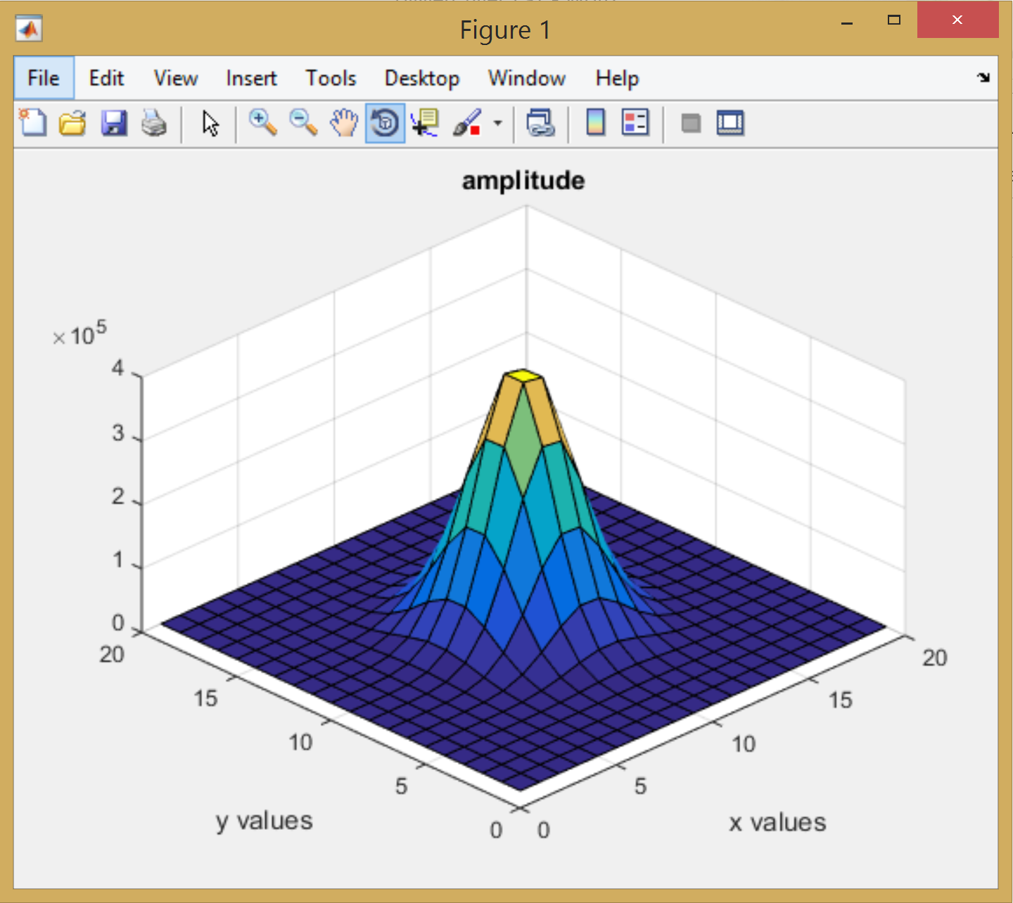

Figure 4: cov matix [1 0; 0 1]

In Figure 3 and Figure 4 the Gaussian can be seen with the covariance matrix [1 0; 0 1].

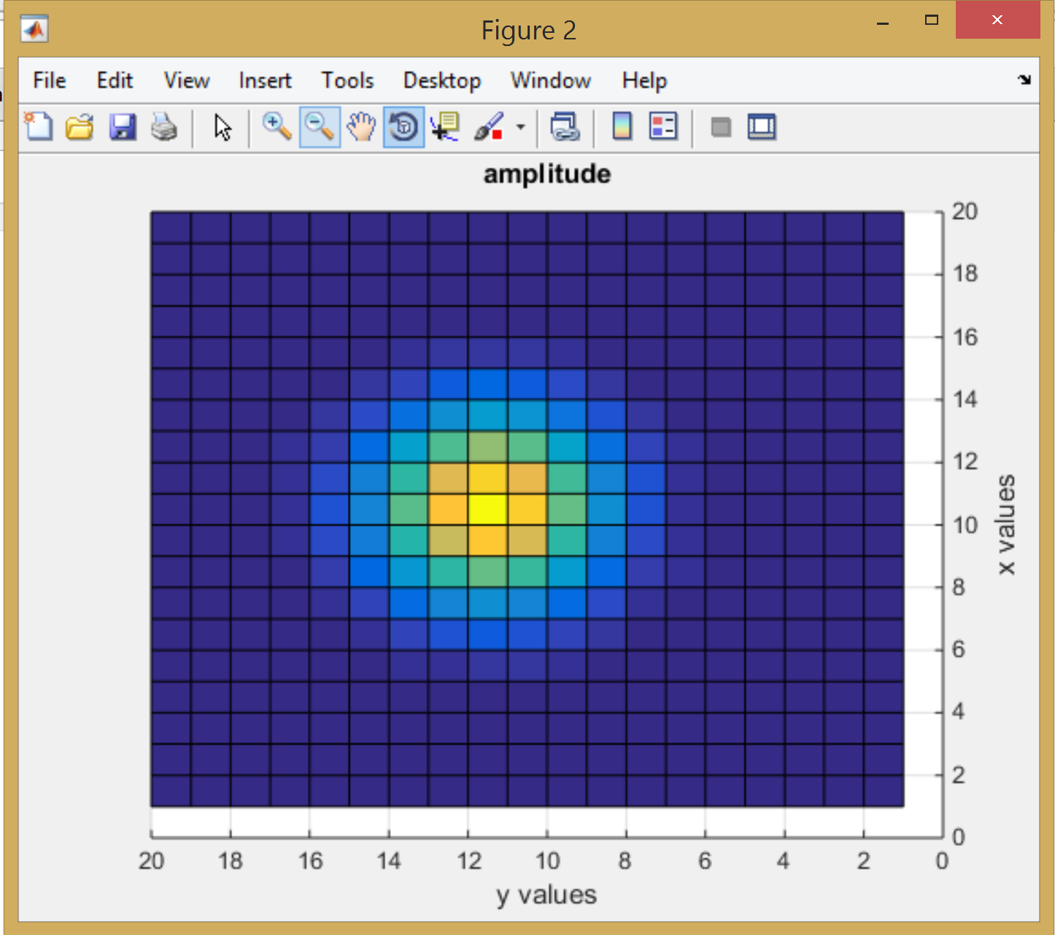

Figure 5: cov matrix [5 0; 0 2] top view

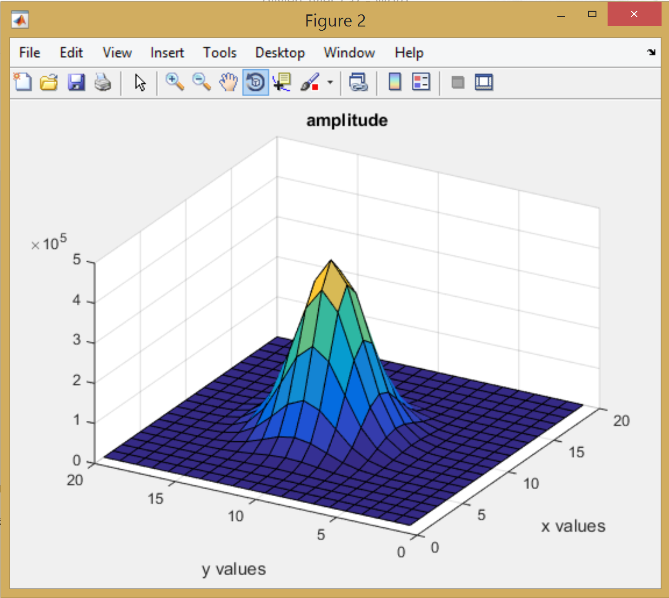

Figure 6: cov matrix [5 0; 0 2]

In Figure 5 and Figure 6 the Gaussian can be seen with the covariance matrix of [5 0; 0 2].

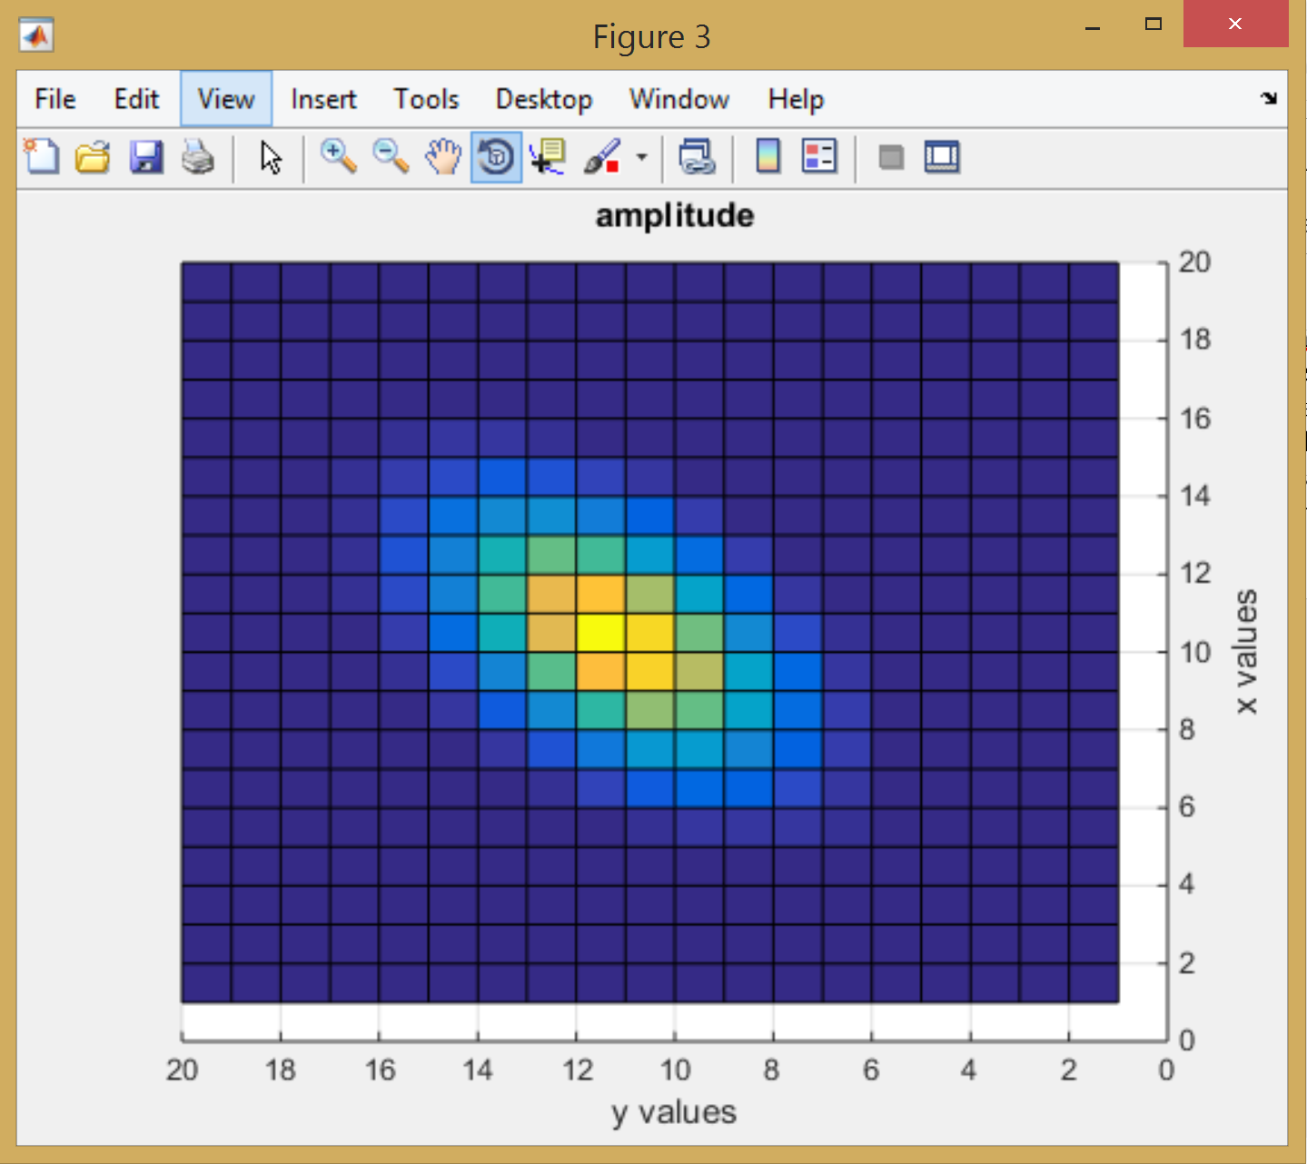

Figure 7: cov matrix [1 .5; .5 1] top view

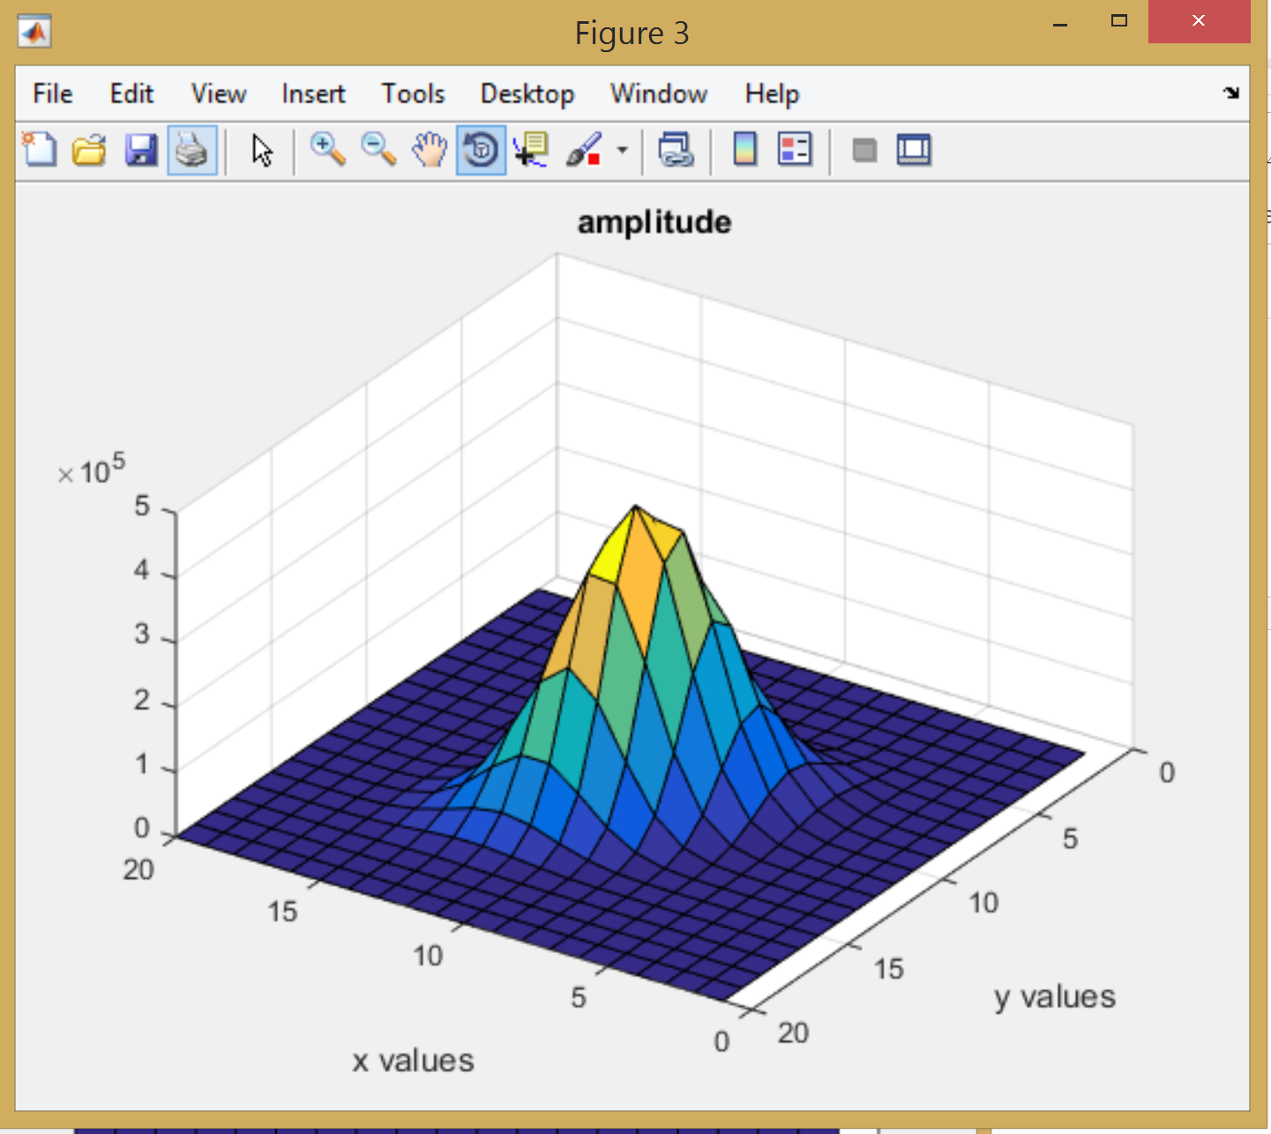

Figure 8: cov matrix [1 .5; .5 1]

In Figure 7 and Figure 8 the Gaussian can be seen for the covariance matrix of [1 .5; .5 1].

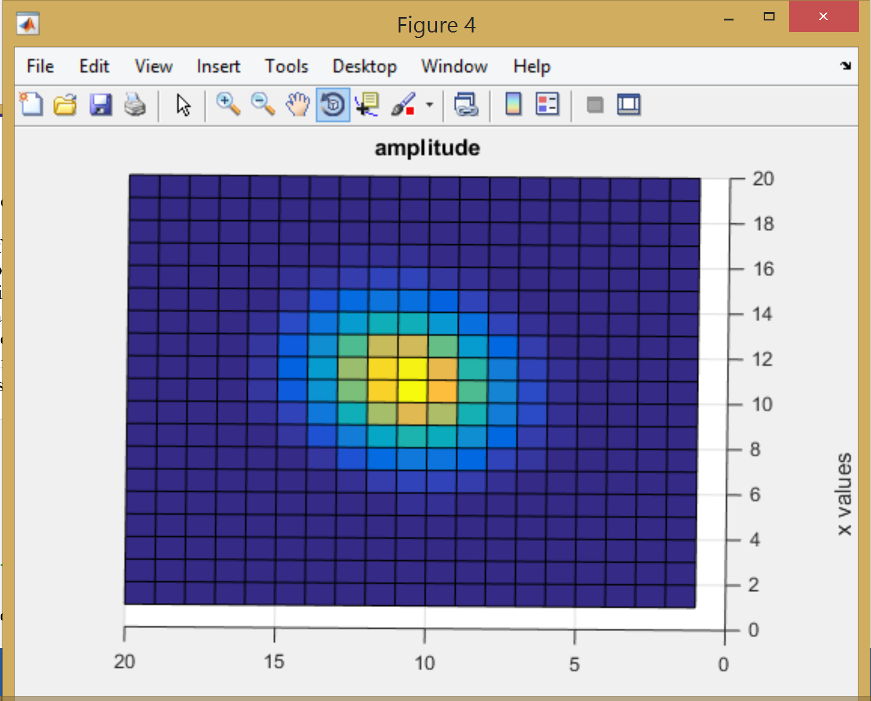

Figure 9: cov [5 .5; .5 2] top view

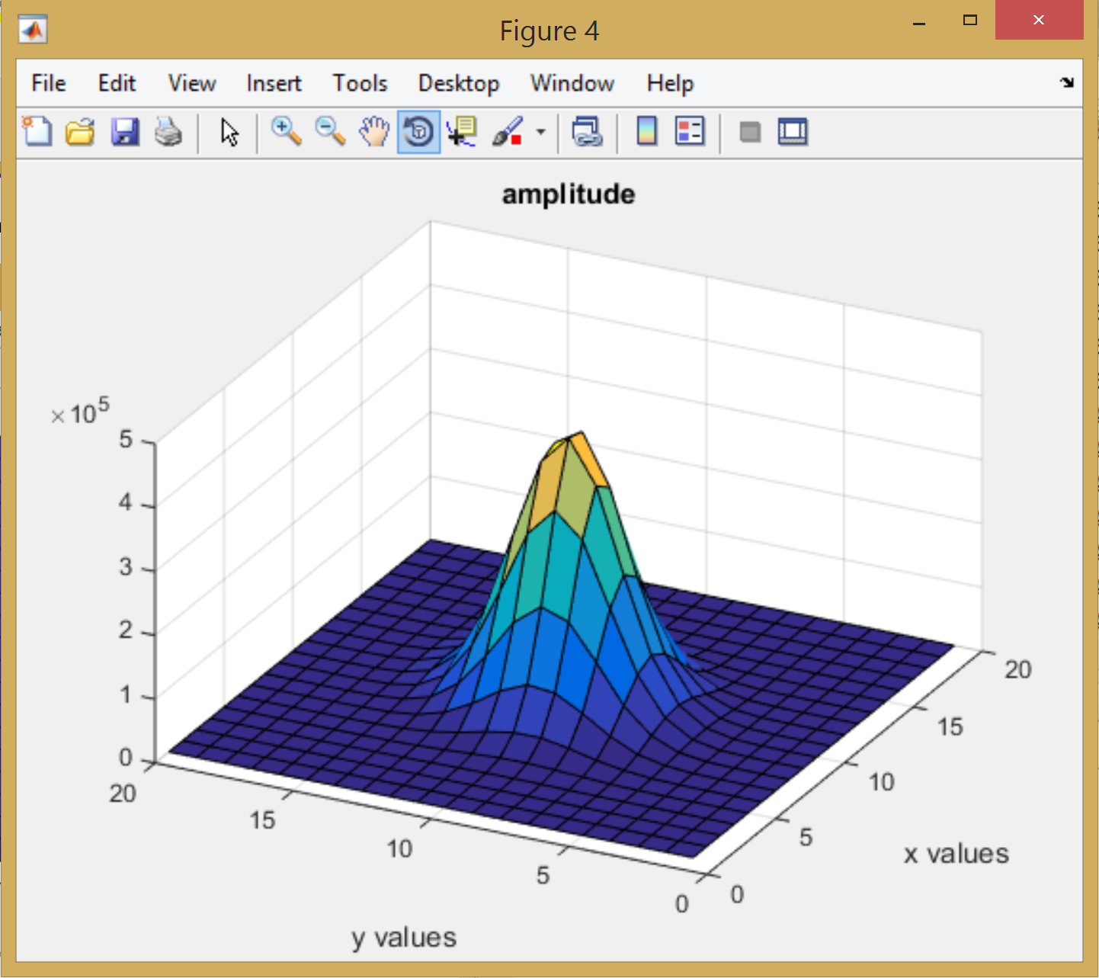

Figure 10: cov [5 .5; .5 2]

In Figure 9 and Figure 10 the 3d plot of the Gaussian can be seen with the covariance matrix of [5 .5; .5 2].

# MATLAB Code

In the first part, a set of N marginals are created. N is usually large number but can vary. A large number of marignals will create a more uniform distribution. The size of the marginals could also be changed by changing the first parameter of the rand function. x is the variable that holds all the sets of marginals. A 3d histogram is created using hist3 on each set of x. Now there is a set of histograms for each set of marginals inside the variable h. Then an algorithm is used to sum h(1,1,:),h(1,2,:), etc. Essentially each row column spot is summed for all histograms. This leaves a final histogram that needs to be normalized by the number of histograms or number of vectors. The normalized histogram(pdf) is then visualized in 3d using surf.

In part 2, a vector was created for the means. The mean for each marginal was set to be 6 so the vector turns out to be [6 6]. Then all covariance matrices were entered. MATLAB has a convenient function called mvnrnd that takes the input of the mean vector and the covariance matrix. It then outputs the marginals of the joint pdf. Hist3 was used to create a 2x2 matrix of the gaussian. Then surf was used to make the plot smoother.

%%Tyler Olivieri  
%CA7  
%  
clc;clear;  
  
%creating edges vector for hist3 parameter  
bound = 0:.1:1;  
edges = {bound bound}  
  
for N = 1:100000  
 N  
 x(:,:,N)= rand(10,2);  
 h(:,:,N) = hist3(x(:,:,N), 'Edges', edges);  
end  
  
  
hsum = zeros(10, 10);  
for i = 1:10  
 for j = 1:10  
 %%parse through h and sum each block  
 hsum(i,j) = sum(h(i,j,:));  
 end  
end  
hsum = hsum./N; %pdf(normalizing)  
  
surf(hsum)  
xlabel('X values')  
ylabel('Y values')  
zlabel('Amplitude')

%% Part 2

clc;clear;

n = 10000000;

bins = [20 20];

mean = [6; 6];

cov = [1 0; 0 1];

cov2 = [5 0; 0 2];

cov3 = [1 .5; .5 1];

cov4 = [5 .5; .5 2];

r = mvnrnd(mean,cov, n);

r1 = mvnrnd(mean,cov2, n);

r2 = mvnrnd(mean,cov3, n);

r3 = mvnrnd(mean,cov4, n);

h = hist3(r,bins);

h1 = hist3(r1,bins);

h2 = hist3(r2,bins);

h3 = hist3(r3,bins);

figure(1);

surf(h)

title('amplitude')

xlabel('x values')

ylabel('y values')

figure(2);

surf(h1)

title('amplitude')

xlabel('x values')

ylabel('y values')

figure(3);

surf(h2)

title('amplitude')

xlabel('x values')

ylabel('y values')

figure(4);

surf(h3)

title('amplitude')

xlabel('x values')

ylabel('y values')

# Conclusions

The joint pdf was visualized successfully in part 1. The expected joint pdf of a uniform distribution is a flat plane. The joint pdf that was plotted (Figure 1) shows an almost flat plane. With more vectors the pdf could become flatter as N increases. However, the pdf can be deduced to be uniform by inspection. The Gaussians in part 2 were also plotted with success. Each 3d representation looked Gaussian with the Gaussian centered around the point (6,6) as expected. This was expected because the Gaussian peaks at the mean of each marginal. The covariance matrix sets tells the energy of each marginal on the main diagonal and tells the correlation on the off diagonal. When the off diagonal is 0 and 0, the two marginal are independent. If they are independent a cross sectional view of the Gaussian will be square with the x and y axis. With correlation, the cut out plane will be rotated. If the energy of one marginal is larger than the other, an elliptical shape will be seen. With the covariance matrix of [1 0; 0 1] a circular cross section is expected. This can be confirmed in Figure 3. With a covariance matrix of [5 0; 0 2], an elliptical cross section is expected and not rotated along the x-y plane. This can be confirmed in Figure 5. I would have expected the cross section to be more elliptical but it slightly hard to see with it being just a top down view. The intensity of the orange shows an elliptical shape not rotated so that is good. It can be compared with Figure 3. With the covariance matrix of [1 .5; .5 1] an elliptical shape is expected rotated 45 degrees which can be seen in Figure 7. With a covariance matrix of [5 .5; .5 2], an elliptical rotated shape can be observed in Figure 9. The support regions are not quite a cut out plane and just a top down view but the top down views compared favorably to the support regions seen in the powerpoint.