Anton LeKang

ECE 3522: Stochastic Processes in Signals and Systems

Department of Electrical and Computer Engineering, Temple University, Philadelphia, PA 1912

CA7

# Problem Statement

The objective of this computer assignment is to build on the visualization of the Gaussian curve, but this time with two random variables. From computing the Gaussian of two random vectors a 3D plot can be looked at, and the energy can be observed. In the first part of this lab two sets of random larger numbers are generated, and then the Gaussian is taken from the data. This plot will look uniform when there are enough points, if there is a small sample of data, the plot will not look as uniform. In the second part of this lab, the energy of two random variables are looked at with respect to a covariance matrix. Depending on the value of the covariance, the Gaussian will show if the data is statistically independent, and the energy of the plot. This computer assignment will use the random number generator, and the 3D plot on MATLAB to observe to build on the fundaments of the Gaussian curve.

# Approach and Results

Part 1: Estimate PDF and plot in 3D

The first part of the computer assignment looks at the 3D plot of the estimate of two larger random vectors. Figure 1 shows the 3D plot with 1,000 data values, and Figure 2 uses 100,000 data values. The data values are random variables between 0 and 1. When the plot is taken with not a “large” number of values, the 3D estimate does not look that uniform. On the other hand when 100,000 values were plotted, the data looked much more uniform and had the shape of a cube.

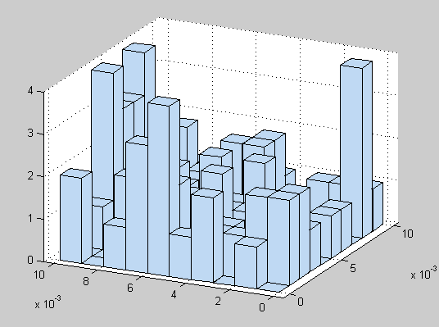Figure 1 – Uniform distribution with 1,000 data values

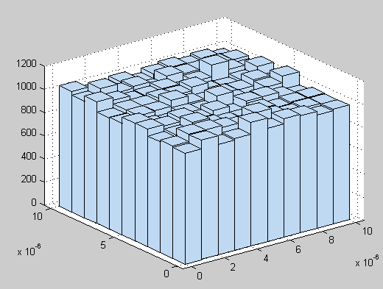Figure 2 – Uniform distribution with 100,000 data values

Part 2: Gaussian with different covariance values

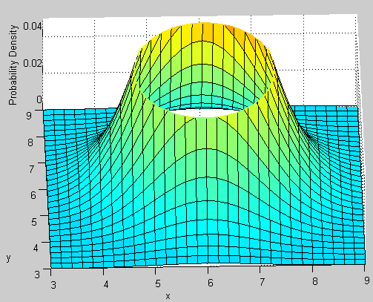Figure 3 – Cov with 1,1 on the diagonals

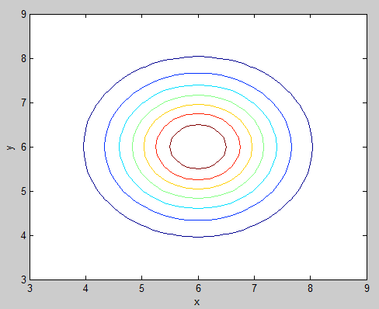Figure 4 – Slice of Gaussian from figure 3

This first part of the second activity of this computer assignment looks at the 3D Gaussian when the diagonal covariance of the matrix is 1, 1 and the other two values are 0. When this happens the Gaussian produces an even mountain upward and has an even circle on the XY axis. Since the X11, and the X22 value both equal 1, they have the same energy, thus creating an even circle. Also they are statistically independent of each other because the other diagonal values are 0, 0.

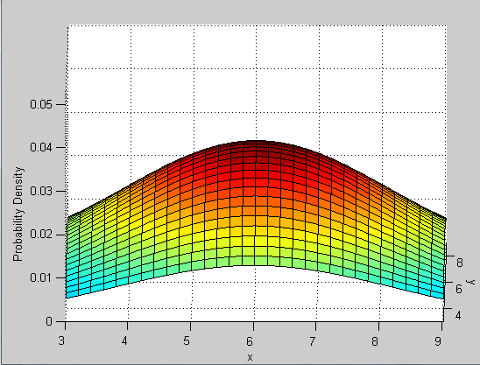Figure 5 – Cov with 5,5 on the diagonals

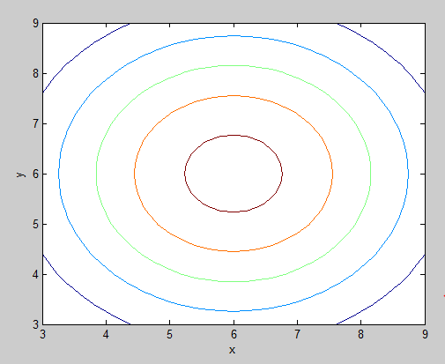Figure 6 – Slice of Gaussian from figure 5

This second part of the second activity of this computer assignment looks at the 3D Gaussian when the diagonal covariance of the matrix is 5, 5 and the other two values are 0. When compared to figures 3 and 4, this energy is much larger. As seen in figure 6, the circles are father apart from each other and have larger values. These are also statistically independent.

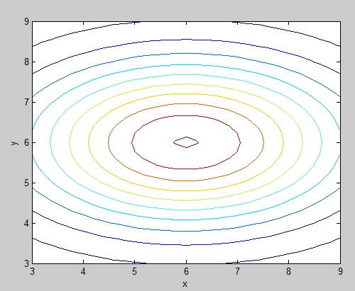Figure 8 – Slice of Gaussian from figure 5

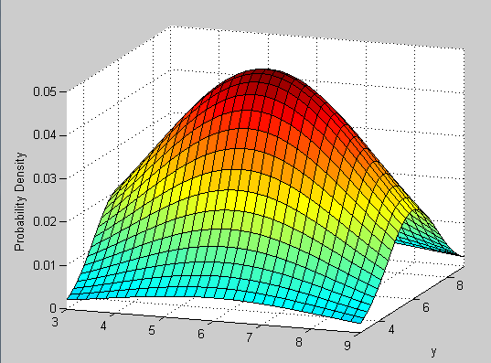Figure 7 – Cov with 5, 2 on the diagonals

This third part of the second activity of this computer assignment looks at the 3D Gaussian when the diagonal covariance of the matrix is 5, 2 and the other two values are 0. In this example the energy is not the same between the covariance values. As seen from figure 8, the shape is not perfectly circular, and it favors the side with the larger energy. Values are still statistically independent.

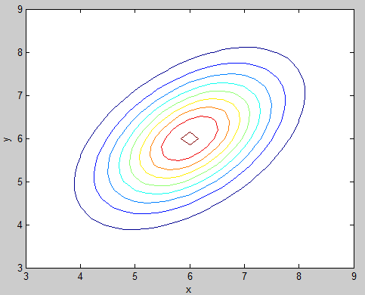Figure 10 – Slice of Gaussian from figure 9

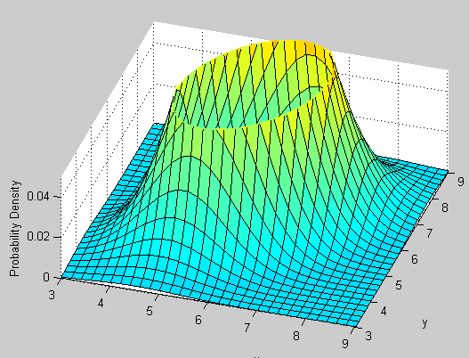Figure 9 – Cov with 1,1 on main diagonal and .5, .5 on other diagonal

This fourth part of the second activity of this computer assignment looks at the 3D Gaussian when the covariance has 1, 1 on the main diagonal, and .5, .5 on the other diagonal. In this section of the activity, there are not 0, 0 values on the other diagonal of the matrix, so it is skewed or angled off of the XY axis. As seen in figure 10, the shape is about 45 degrees off.

Figure 11 – Cov with 5,2 on main diagonal and .5, .5 on other diagonal

Figure 12 – Slice of Gaussian from figure 11

This fifth part of the second activity of this computer assignment looks at the 3D Gaussian when the covariance has 5, 1 on the main diagonal, and .5, .5 on the other diagonal. In this section of the activity, there are not 0, 0 values on the other diagonal of the matrix, so it is skewed or angled off of the XY axis. As seen in figure 10, the shape is about 9 degrees off.

# MATLAB Code

Part 1:

function CA_7_1

size = 10e4;

B = rand(size, 2);

B = B/size;

hist3(B, [15, 15]);

end

Part 2:

function CA_7_2

%covariance matricies

con1 = [1 0; 0 1];

con2 = [5 0; 0 5];

con3 = [5 0; 0 2];

con4 = [1 0.5; 0.5 1];

con5 = [5 0.5; 0.5 2];

%graph 3D plots of each covariance matrix

surf_pdf(con4)

end

%calculates and plots multivariate normal pdf

%plots contour lines from top view

function surf_pdf(Sigma)

%mean

mu = [6 6];

%mesh grid

x1 = 3:.2:9; x2 = 3:.2:9;

[X1,X2] = meshgrid(x1,x2);

%calculate pdf

F = mvnpdf([X1(:) X2(:)],mu,Sigma);

F = reshape(F,length(x2),length(x1));

%3d plot

figure(1)

surf(x1,x2,F);

caxis([min(F(:))-.5*range(F(:)),max(F(:))]);

axis([3 9 3 9 0 0.05])

xlabel('x'); ylabel('y'); zlabel('Probability Density');

%top view contour

figure(2)

mvncdf([0 0],[1 1],mu,Sigma);

contour(x1,x2,F);

xlabel('x'); ylabel('y');

line([0 0 1 1 0],[1 0 0 1 1],'linestyle','--','color','k');

end

These are the scripts for each of the parts in tis computer assignment. In the first part, hist3 is used to plot the 3D plot of the random values. The size can be changed and that is how figures 1 and 2 were plotted. The second script shows how the Gaussian 3D was plotted with respect to the different covariance matrices. Each of the covariance matrices are created, and then those are used within in the function surf_pdf. That function computes the Gaussian of the desired matrix picked.

# Conclusions

This computer assignment looked at the shape of a PDF in a 3D form. In the first part of the lab two random variables are looked at, and depending on the number of values, a uniform distribution will be seen. In the first figure, there are not enough values, so the plot does not look as uniform as figure 2. The second part of the lab looks at the estimate of the PDF with respect to difference covariance matrix values. The covariance can influence the 3D plot of the Gaussian dramatically and it is seen from figures 3 to 12. When 1, 1 is on the main diagonal of the covariance matrix, and 0, 0 is the other diagonal, the shape of the Gaussian is a circle. In the second part the main diagonal is increased to 5, 5, when this happens the energy is increased, and the values are larger. Still the other values of the covariance are 0, so they have zero energy, thus creating a circular shape again. As seen in the third part of this activity, if one of the values is larger than the other, the plot will not be circular anymore. In figure 7, the main diagonal is 5, 2, creating an off balance in the energy, and the shape is now an oval. In the fourth and fifth part of this activity there are values on the other diagonal of the covariance matrix. Since there is not zero energy there anymore, this effects the output of the 3D Gaussian plot. As seen in these parts, the plots are skewed, and angled off of the XY axis. In the first three activities, the circles and ovals stayed even on the XY axis. This lab was very informative, and showed good insight on the 3D plot of two random variables. It was also very valuable in showing the importance of the covariance matrix, and what effect is has on the overall distribution.