Dana Joaquin

ECE 3522: Stochastics

Department of Electrical and Computer Engineering, Temple University, Philadelphia, PA 19121

# Problem Statement

The purpose of this assignment is to see how the joint PDF of two independent random variables look by plotting the results on a 3D graph. The assignment also explores how the covariance effects the shape of the PDF, which will also be shown on a 3D plot and analyzing 5 different covariance matrix values by using a mean of [-6 6]. The 5 covariance matrices used in this assignment are:

$$1. cov\left(x, y\right)=\left[\begin{matrix}1 & 0 \\ 0 & 1\end{matrix}\right]$$

$$2. cov\left(x, y\right)=\left[\begin{matrix}5 & 0 \\ 0 & 5\end{matrix}\right]$$

$$3. cov\left(x, y\right)=\left[\begin{matrix}5 & 0 \\ 0 & 2\end{matrix}\right]$$

$$4. cov\left(x, y\right)=\left[\begin{matrix}1 & 0.5 \\ 0.5 & 1\end{matrix}\right]$$

$$5. cov\left(x, y\right)=\left[\begin{matrix}5 & 0.5 \\ 0.5 & 2\end{matrix}\right]$$

# Approach and Results

For the first part of the assignment, two random variables, X and Y were made using MATLAB’s rand function which generates uniformly distributed random numbers from 0 to 1. The size for both of these vectors is 1 x 1000. The reason both vectors are 1000 values long because 1000 is the largest number my computer was able to handle to compute the joint PDF of X and Y. Any values larger would take too much memory and cause MATLAB to crash. In order to get the joint PDF of X and Y, the marginal PMFs of X and Y were computed using the histogram function and extracting the probability from histogram’s variable “data,” which is a vector.

Since both X and Y are independent random variables, the joint PMF is simply the product of their marginal PMFs. Therefore, the vectors extracted from their respective histogram function, they were multiplied with each other, with one being transposed so the matrices can be multiplied. This resulted in a square matrix, which is desired since there are 1000 values in X and Y, therefore the joint PMF should be a 1000 by 1000 size square matrix. Figure 1a shows the PMF of random variable X and Figure 1b shows the PMF of random variable Y.

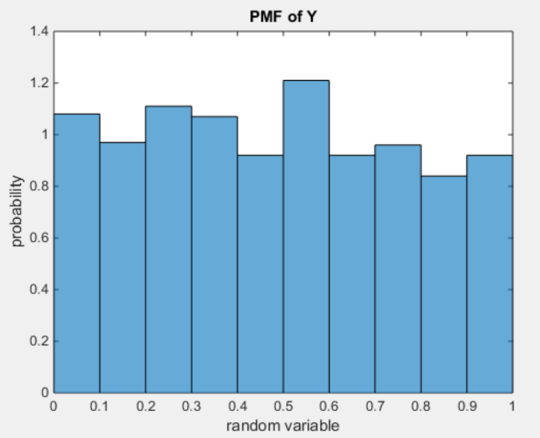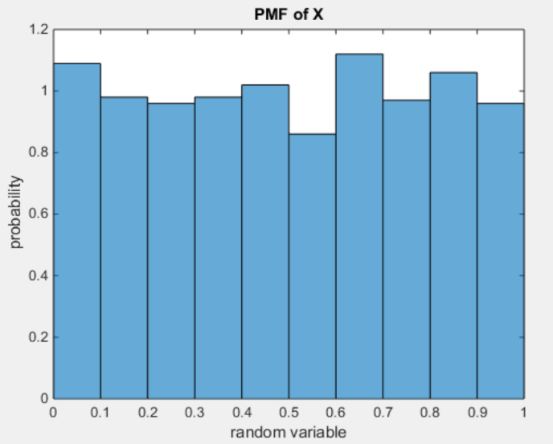

Figure 1a. PMF of random variable X. Figure 1b. PMF of random variable Y.

The resulting square matrix that contained the joint PMF values was then plotted using the waterfall plot function in MATLAB. Figure 2 displays the results. In figure 2, the results appear noisy and spikey, however, it generally appears to be a uniform distribution across all possible x and y value combinations. This makes sense since both the PMFs of the X and Y are uniform distributions and because they independent of each other, their joint PMF is simply the product of the two. Therefore, the product of two uniform distributions should result in a joint uniform distribution as well, which is what figure 2 appears to look like.

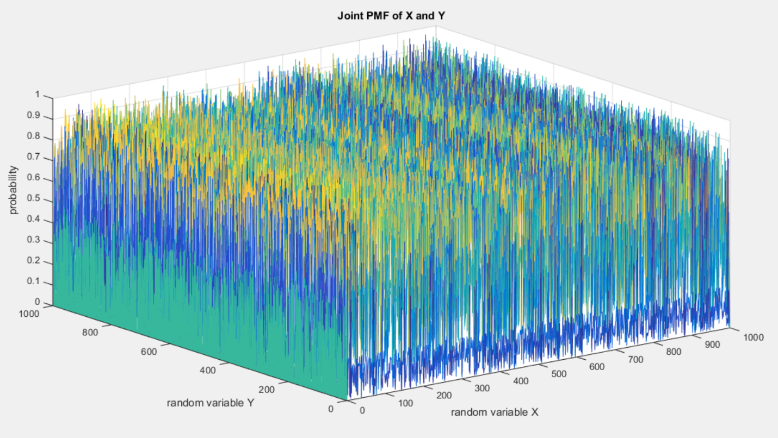

Figure 2. The joint PMF of random variables X and Y.

The second part of the assignment focused on showing how the covariance values effect the shape of the joint PMF of two random variables. This was done by using the mvnpdf MATLAB function and using the algorithm code provided on the MathWorks multivariate normal distribution webpage. For the first covariance matrix, it is the identity matrix. Therefore, this means the variance of the distribution is equal in all directions, and the shape of the support region is a circle. Figure 3 shows how the PMF looks with the first covariance matrix and its support region.

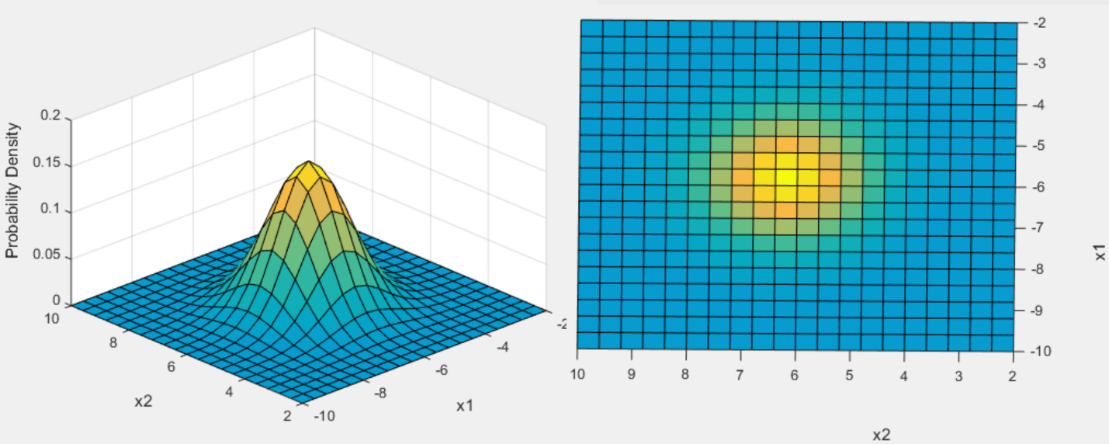

Figure 3. Joint PMF and support region with the first covariance matrix.

The second covariance matrix is essentially the same as the first covariance matrix, but scaled by 5. The result of this is that the joint PMF was smaller in amplitude, but its support region was larger than that of the first covariance matrix, which is displayed in Figure 4. This makes sense because the variance for the second covariance matrix was 5 times larger than the first one, meaning the values were more spread out. Since the second covariance matrix is a scaled identity matrix, the shape of the support region is circular as well, meaning the variance is the same in all directions too.

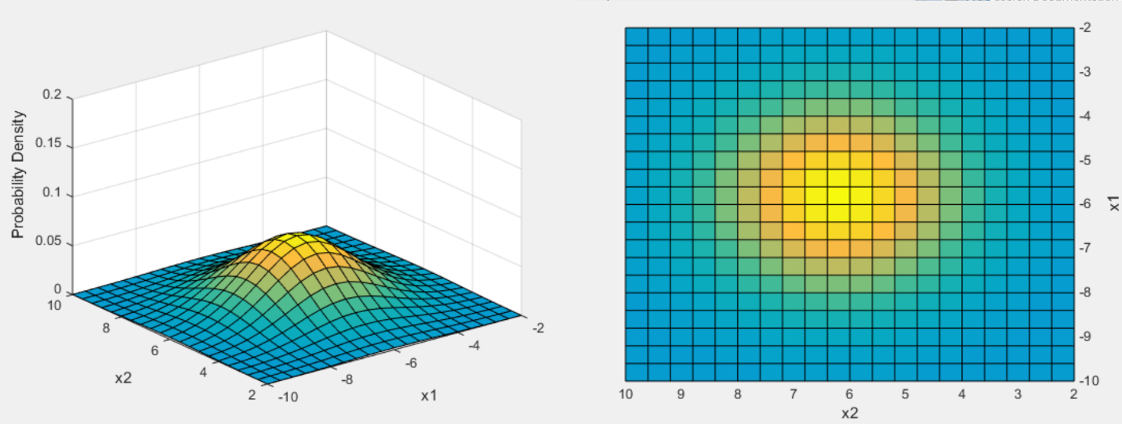

Figure 4. PMF and support region with the second covariance matrix.

The third covariance matrix is an unequal matrix but only the nonzero values are on the diagonal. What this did to the shape of the PMF is that it was more elongated in one direction, which can be seen clearly when observing the support region. The support region was no longer circular, but was elliptical. In Figure 5, it shows that the shape of the support region was elongated with respect to the x1 axis. Comparing it to an identical covariance matrix, the third covariance matrix shows that the variance is no longer equal in all directions which makes sense since the matrix is unequal. Along the x1 axis, the values are more spread out than the values along the x2 axis.

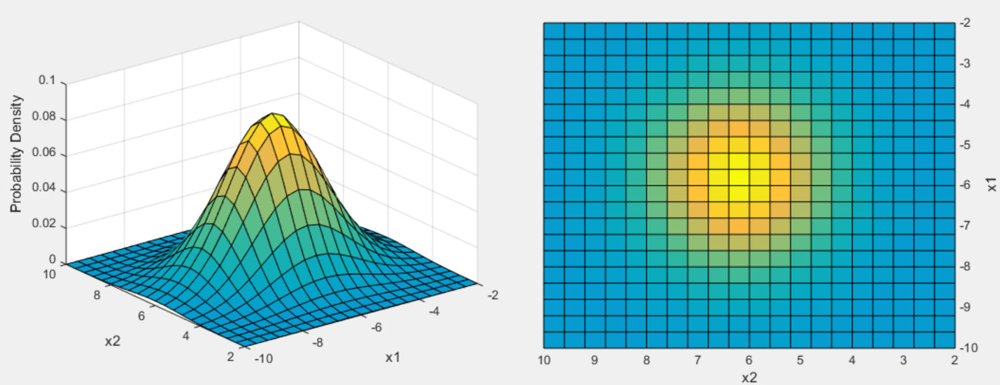

Figure 5. PMF and support region with the third covariance matrix.

Having nonzero values on the off diagonal positions of the covariance matrix makes the PMF and support region appear skewed. For the fourth covariance matrix, since the off-diagonal values were non zero, the PMF and the support region resulted in them being skewed. The PMF and support region is rotated with respect to the origin and how much it has rotated can be calculated using this equation:

$$\tan\left(θ\right)=\frac{({σ_{x}}^{2}-{σ_{y}}^{2})±\sqrt{{({σ_{x}}^{2}-{σ_{y}}^{2})}^{2}+{(-2σ_{xy})}^{2}}}{-2σ_{xy}}$$

Equation 1. Angle of Rotation

Since the diagonal values are 1, it is essentially a skewed PMF and support region version of results for the first covariance matrix and since it is skewed, the support region is elliptical shape. Figure 6 displays the PMF and support region results of the fourth covariance matrix.

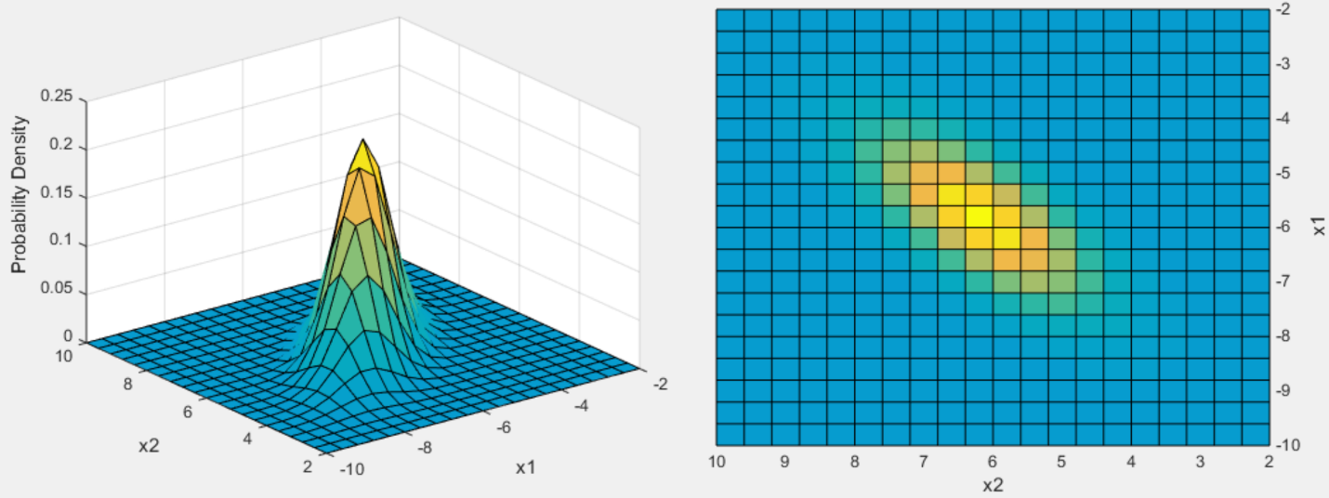

Figure 6. PMF and support region with the fourth covariance matrix.

The fifth covariance matrix is similar to the third one, except it has nonzero off diagonal values. Since the diagonal values are the same as the third one, therefore its overall spread and support region shape is larger than the fourth covariance matrix with its diagonal values being 1. Since it has nonzero off diagonal values, the PMF and support region are rotated, skewed on an angle, which is displayed in Figure 7. This angle of rotation can again be calculated using equation 1. It makes sense that the results of the fifth covariance matrix is similar to the third one since it has the same diagonal values.

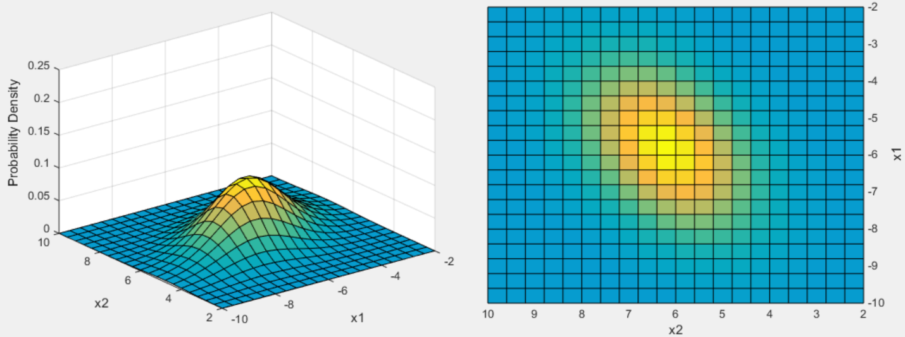

Figure 7. PMF and support region with the fifth covariance.

# MATLAB Code

|  |
| --- |
| % Dana Joaquin  % computer assignment 7    function ca07    clear; clc  close all    % ---------------- Part 1 ----------------  % parameters  M = 1; % # of rows  N = 1e3; % # of columns    x = rand(M, N); % create a RV vector x with dimensions M x N  y = rand(M, N); % create a RV vector y with dimensions M x N    % plot the pdf of RV X  figure(1)  histpdf1 = histogram(x, 'Normalization', 'pdf');  px = histpdf1.Data;  title('PDF of X')  ylabel('probability')  xlabel('random variable')    % plot the pdf of RV Y  figure(2)  histpdf2 = histogram(y, 'Normalization', 'pdf');  py = histpdf2.Data;  title('PDF of Y')  ylabel('probability')  xlabel('random variable')    % b/c independent RV, can multiply pdfs of X & Y to get joint PDF  jpdf = ((px.')*py); % need to tranpose one of them to get a square matrix  % that is N x N  figure(3)  waterfall(jpdf)  title('Joint PDF of X and Y')  ylabel('random variable Y')  xlabel('random variable X')  zlabel('probability')  % -----------------------------------------      % ---------------- Part 2 -----------------  % general parameters  a = 2; % x + y scale value  b = 10; % x + y scale value  mu = [-6 6]; % mean  ssize = 0.4; % step size for joint pdf plot    % covariance matrix 1  hh = 0.2; % height of z-axis  cov1 = [1 0; 0 1];  figure(4)  plot_jpdf(cov1, mu, a, b, ssize, hh);    % covariance matrix 2  hh = 0.2; % height of z-axis  cov2 = [1 0; 0 1];  figure(5)  plot_jpdf(cov2, mu, a, b, ssize, hh);      % covariance matrix 3  hh = 0.1  cov3 = [5 0; 0 2];  figure(6)  plot_jpdf(cov3, mu, a, b, ssize, hh);    % covariance matrix 4  hh = 0.25  cov4 = [1 0.5; 0.5 1];  figure(7)  plot_jpdf(cov4, mu, a, b, ssize, hh);    % covariance matrix 5  hh = 0.25  cov5 = [5 0.5; 0.5 2];  figure(8)  plot_jpdf(cov5, mu, a, b, ssize, hh);  % -----------------------------------------    end    % function name: plot_jpdf  % coded by Dana Joaquin  % input argument(s):  % (1) covarray: covariance array  % (2) i: scaling parameter value  % (3) j: scaling parameter value  % (4) ss: step size plot  % (5) h: max limit of z-axis  % output argument(s):  % plots the joint PDF  % objective:  % This function plots the joint PDF based on the inputted  % values of covarray and muu. The code that does this is taken  % from the multivariate normal distribution documentation page  % on the MathWorks website.  % url: http://www.mathworks.com/help/stats/multivariate-normal-distribution.html  %  function jointz = plot_jpdf(covarray, muu, i, j, ss, h)    % plot scaling parameters  % x-axis  m1 = i;  m2 = j;  % y -axis  n1 = -j;  n2 = -i;  % z-axis  hi = h;    % got this code from multivariate normal distribution documentation page  % on the Mathworks website  x1 = n1:ss:n2; x2 = m1:ss:m2;  [X1,X2] = meshgrid(x1,x2);  F = mvnpdf([X1(:) X2(:)],muu,sqrt(covarray));  F = reshape(F,length(x2),length(x1));  surf(x1,x2,F);  caxis([min(F(:))-.5*range(F(:)),max(F(:))]);  axis([n1 n2 m1 m2 0 hi])  xlabel('x1'); ylabel('x2'); zlabel('Probability Density');    end |

# Conclusions

Using two independent random variables with uniform distributions to compute and plot the joint PMF was a good way to understand how the resulting joint PMF would look like. Even without any computations or displays, one should be able to infer that since both random variables have uniform distributions, it would make sense that the joint PMF would have similar looking results as well. This was done easily since the two random variables are independent and getting their joint PMF was just the product of their individual PMFs. The purpose of the joint PMF is to show all the probabilities of all possible combinations of the random variables.

For the second part of this assignment, the covariance matrix effects the shape of the distributions, or can be seen as the matrix that holds the information on what the distribution looks like. For the first covariance matrix, the identity matrix resulted in an equally distributed joint PMF and supported region And if the identity covariance matrix is scaled, the variance of the distribution and size of the supported region will be scaled accordingly to such value, which is seen in the results of the second covariance matrix. However, when the diagonal value are not the same, one of the diagonal values corresponds to the variance of one dimension of the joint PMF while the other diagonal value corresponds to the other. This results is seen in the third covariance value, where the x1 dimension had a wider spread than the x2 dimension. When the off diagonal values are nonzero, that is when the PMF and supported regions are skewed on an angle, rotated along the PMFs distribution, which is shown in the results for both covariance matrices 4 and 5. Overall, the covariance matrix gives good insight and idea on what the distribution is expected to look like and behave.