[Robert Irwin]

ECE 3512: Stochastics

Department of Electrical and Computer Engineering, Temple University, Philadelphia, PA 1912

# Problem Statement

In this assignment we are interested in the visualization of joint pmfs. We will be using Matlab to compute an n x 2 matrix of random numbers. Then, we will compute the pmf of the random variable and obtain a visual using one of Matlab’s 3D plotting functions.

The next part of the assignment called for the generation of a matrix of n x 2 random numbers that had a mean of [6,6] and the covariance matrices shown below.

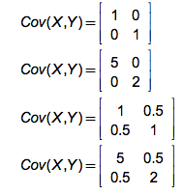

Then, using one of Matlab’s 3D plotting tools, we plotted the joint pmf of the random variables This producd the plots shown below.

# Approach and Results

In order to find the joint pmf we first had to generate the random numbers. The Matlab macro rand() was used to accomplish this. Then we passed these vectors to hist3, which created a joint pdf of the data. This pdf was thn passed to the Matlab macro surf(), which yields the plot shown in below in Figure 1.

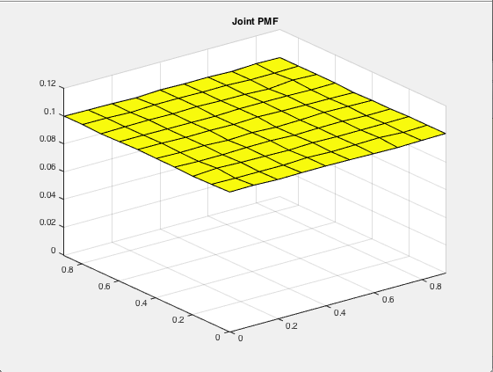

*Figure 1: Joint PMF*

In the figure above we can see that the joint pdf is completely uniform. We expect the plot to be uniform because the random number generator used is unbiased, as proven in the previous assignment. Because it is unbiased, when we take a large amount of samples, all possible numbers possible should come out an equal amount of times. This is what we see above.

This plot was computed by passing each n x 2 matrix of random numbers to hist3, and then adding up the corresponding rows and columns of the outputs. This was the normalized and passed to surf.

Now we look at the results from part 2, in which a Gaussian was computed from a mean and a covariance matrix.

For the first covariance matrix shown in the Problem Statement, we have the following results.

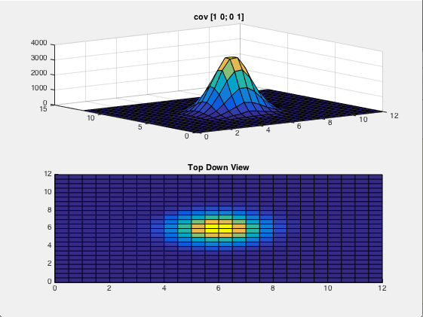

*Figure 2: Joint PDF Corresponding to Covariance Matrix 1*

We can see with the covariance matrix above, the joint pdf is symmetric about the mean. This makes sense because the 0’s in the off-diagonal positions represent the correlation between the two vectors. The 1’s in the diagonal represent the energy of the vectors. Because the vectors aren’t correlated, and they have equal energy, the joint pdf should be circular about the mean, which it is.

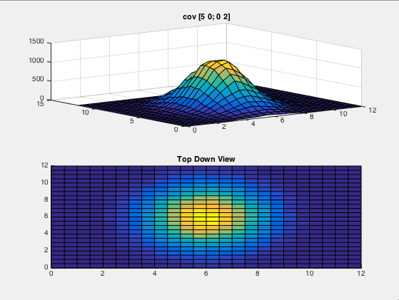

*Figure 3: Joint PDF Corresponding to Covariance Matrix 2*

In the figure above we see that the top-down view of the pdf is elongated in the y-direction. This makes sense as the top left matrix entry, which represents the variance, or energy, of the vector plotted along the y-axis. Because the variance is higher, it should be longer in that direction, which it is. We also notice that the pdf is also slightly elongated in the x direction in comparison to Figure 2.

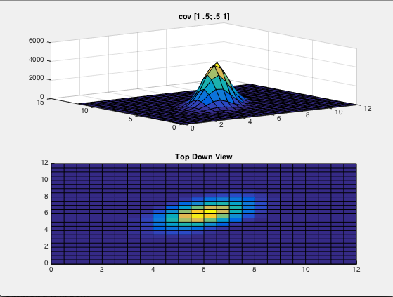

*Figure 4: Joint PDF Corresponding to Covariance Matrix 3*

This figure seems to be very similar to Figure 2, with a rotation. Notice that the variance of each individual vector is 1, but there is correlation between the two vectors. For this reason, the top down view shows a rotated version of the pdf seen in Figure 2.

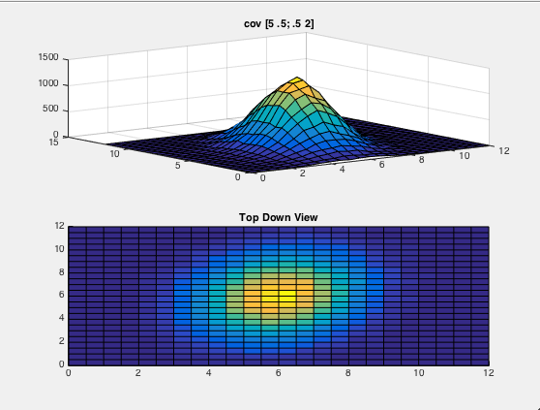

*Figure 5: Joint PDF Corresponding to Covariance Matrix 4*

In this plot, we see that it is a rotated version of the plot seen in Figure 3. This is because the 2 vectors have a correlation coefficient of .5. For the same reasons discussed above, this causes the pdf to be rotated about the mean.

# MATLAB Code

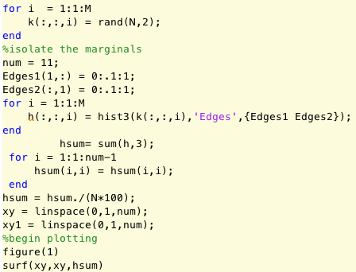

*Figure 6: Matlab Code for Part 1*

In this piece of code we are computing M, Nx2 matrices, where M is 1000 and N is 10,000/ We then take these vectors, one at a time, and pass them in to hist3. Hist3 does the job of counting how many of the random numbers fall within each window. We then add all of the corresponding rows and columns of each matrix. This creates an un-normalized pdf of the data. Then we simply normalize the data, and plot the normalized pdf using the surf() command.

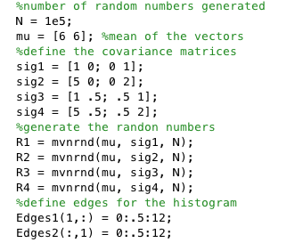

*Figure 7: Matlab Code for Part 2: Creating the Random Vectors*

In this code we define the covariance matrices and the mean of each of the vectors we wish to create. Then, using mvnrnd, we create the vectors that have dimension Nxlength(mu), which is Nx2. We then define our edges vectors that will dictate our bin sizes when we pass the data into hist3.

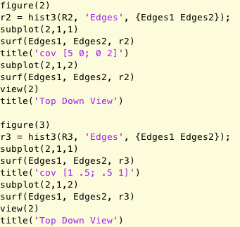

*Figure 8: Matlab Code for Part 2: Plotting*

Following the same procedure as above, we pass the vectors in to hist3 and plot the output, which is the data grouped in to bins, with surf. Then we plot the same thing, but specify a 2-dimensional view on the plot. This creates Figures 2-5.

# Conclusions

In this assignment I have found that the joint pdf of two independent variables will be uniform, if the vectors themselves are uniform. This conclusion can be drawn from Figure 1. In part 2 we saw what the covariance matrix means with respect to the variables it describes. The diagonal entries represent the variance of each of the random variables, and the off diagonal is a measure of the correlation between the random variables. These factors affect the shape of the joint pdf. We also saw that pdf is always shifted with about the mean of the two random variables.