Joe DeMarco

ECE 3522: Stocastics, CA07

Department of Electrical and Computer Engineering, Temple University, Philadelphia, PA 1912

# Problem Statement

For this computer assignment we are taking a look at joint PDF’s. The first part is to create two random sets of data and look at the joint of them. The second part of the assignment is to create two normally distributed sets of data and look at the joint of them.

# Approach and Results / Conclusion

First I generate the two sets of uniformly distributed random data. I then use them to populate a 3d histogram plot. From the plot it looks like the data sets are uncorrelated. There is no area where they appear to correlate together.

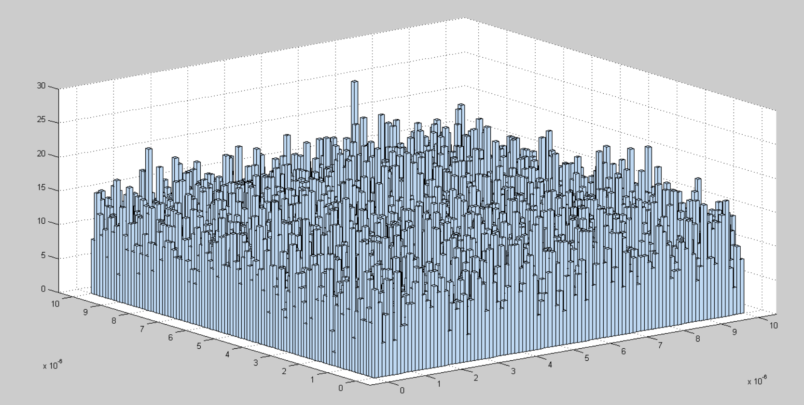

For part 2 again I am using the histograms to estimate the PDF. I create the normally distributed data sets and then create histograms for each. I then create a meshgrid to hold my values, and get the joint PDF by multiplying the two separate PDF’s. All of the 3d plots look about the same, so I will only include the first sigma plot. Also the individual PDF’s are very similar.

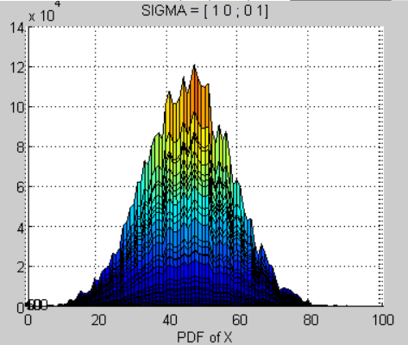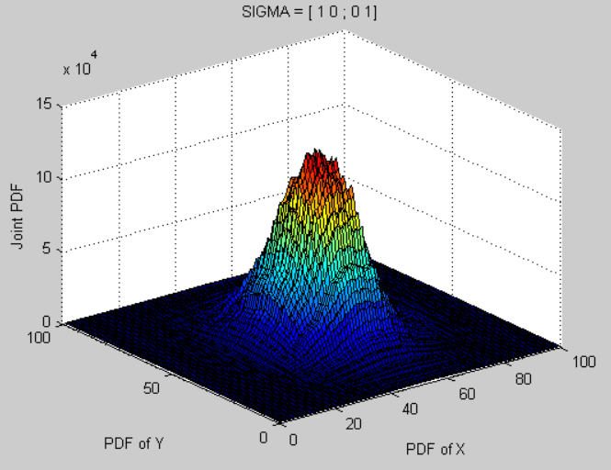

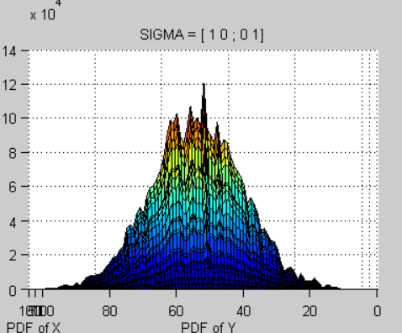

Because the plots are so similar I plot the overhead views next to each other here. I am generating new values for each figure, so I’m not 100% sure if the variations I am seeing are due to a variation in the set or a variation due to the different sigma values. However, I am going to assume the variations are due the sigma values.

The thing that stands out most to me is the shift of position between figure 1 and 2. It seems that those values are shifting the normal distribution of X to the right. It also seems like, in all cases the larger diagonal values cause a sharper peak in the joint PDF. It also seems like when there are non-zero values in the off-diagonal positions that the joint PDF is a little more spread out than otherwise.

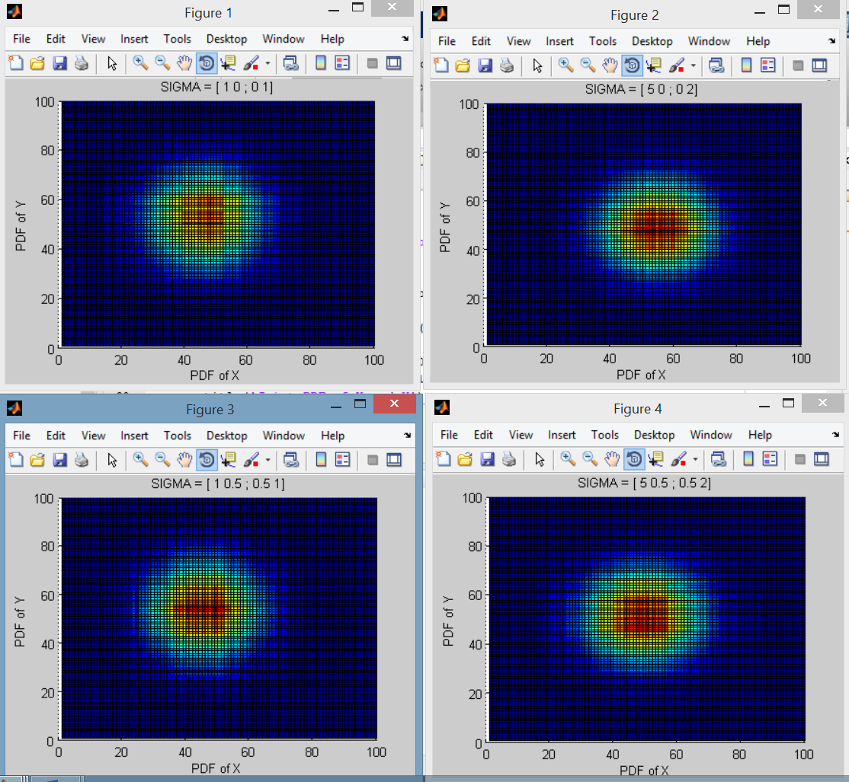

# MATLAB Code

Part1

clear;clc;close all;

N=100000;

n=2;

for i=1:N

for k=1:n

vect(i,k)=rand(1);

end

end

hist3(vect/N,[100 100])

part 2

clear;clc;clf;close all;

MU = [ 6 6 ];

SIGMA1 = [ 1 0 ; 0 1 ];

SIGMA2 = [ 5 0 ; 0 2 ];

SIGMA3 = [ 1 0.5 ; 0.5 1 ];

SIGMA4 = [ 5 0.5 ; 0.5 2 ];

N=4;

cases = 10^N;

bins = 10^(N/2);

figure

X = mvnrnd(MU, SIGMA1,cases);

h1=hist(X(:,1)./cases,bins);

h2=hist(X(:,2)./cases,bins);

[x,y] = meshgrid(h1, h2 );

F = x.*y;

surf(F)

xlabel('PDF of X');ylabel('PDF of Y');zlabel('Joint PDF');

title('SIGMA = [ 1 0 ; 0 1]');

figure

X = mvnrnd(MU, SIGMA2,cases);

h1=hist(X(:,1)./cases,bins);

h2=hist(X(:,2)./cases,bins);

[x,y] = meshgrid(h1, h2 );

F = x.*y;

surf(F)

xlabel('PDF of X');ylabel('PDF of Y');zlabel('Joint PDF');

title('SIGMA = [ 5 0 ; 0 2]');

figure

X = mvnrnd(MU, SIGMA3,cases);

h1=hist(X(:,1)./cases,bins);

h2=hist(X(:,2)./cases,bins);

[x,y] = meshgrid(h1, h2 );

F = x.*y;

surf(F)

xlabel('PDF of X');ylabel('PDF of Y');zlabel('Joint PDF');

title('SIGMA = [ 1 0.5 ; 0.5 1]');

figure

X = mvnrnd(MU, SIGMA4,cases);

h1=hist(X(:,1)./cases,bins);

h2=hist(X(:,2)./cases,bins);

[x,y] = meshgrid(h1, h2 );

F = x.*y;

surf(F)

xlabel('PDF of X');ylabel('PDF of Y');zlabel('Joint PDF');

title('SIGMA = [ 5 0.5 ; 0.5 2]');