John Lee

ECE 3512: Signals – Continuous and Discrete

Department of Electrical and Computer Engineering, Temple University, Philadelphia, PA 19121

# Problem Statement

For this experiment, we will be working with understanding the mean and variance plots as we set them at specific parameters within the data. We noticed that these samples will affect the results of our output data values from the plots, and the change of samples within a given formula could affect the plot behavior of the graph.

# Approach and Results

In order to begin creating the code, we are given a set of important values that will be used to generate the two plots for this experiment. For the first portion of the assignment, we are given a set of formulas that determine the values of the mean and variance. These two different set of formulas will help us deliver the output values at 1000 samples.

**Mean**: () **Variance**: () (Where N = # Samples.)

We are also given two additional formulas that pertains to the estimation of these values. As we are generating a random number of values with the rand() command on MATLAB, we are able to obtain the estimate of the 1000 sample points.

**E.Mean / E.Variance**: 

After, defining all the values with their corresponding formulas. We used the command semilogx() to use the semi logarithmic plot, as we are working with a log base 10 scale. With these random values generated on MATLAB, we managed to obtain the plot of the regular functin and the base 10 scale logarithmic plot from **Figure 1.**

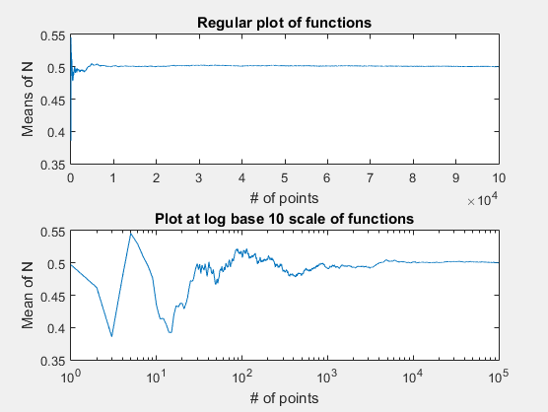

**Figure 1.** Regular plot / Log plot base 10 scale.

The plot displays the number of points used in the sample set, the mean of each samples a plotted into a graph. The plot from **Figure 1** shows that the mean distribution oscillates when the samples are beginning to be calculated, then it settles down to a plateau point by the mean of 0.5. Followed by another plot, it displays the base 10 scale logarithmic plot of the same sample sets. We can observe that the data is very noisy and later reaches to a settling point at the same mean of 0.5.

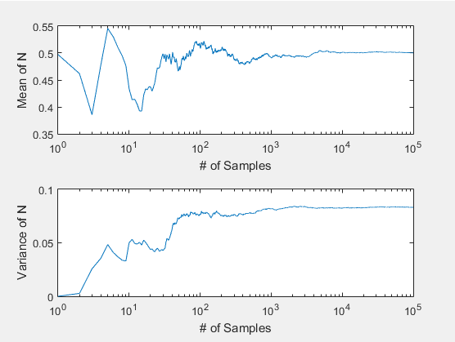

**Figure 2.** Estimate mean and Estimate variance plots.

Next, we continue plotting the estimate mean and estimate variances from **Figure 2**, where it displays the plot using the estimation formulas to observe and compare the logarithmic plot with the variance plots. We can observe that the variance plot deliver steady increase of variance values as the data sets are increased. The variance plot is less noisy than the logarithmic plot.

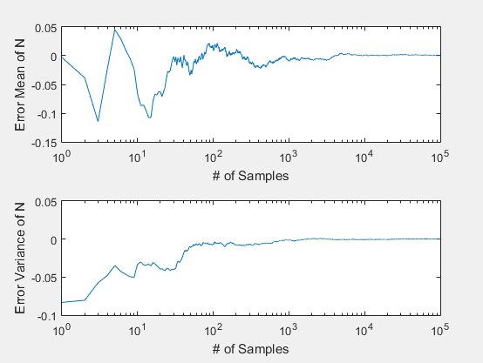

**Figure 3.** Error mean and Error variance plots.

Finally, the final plot of the first part of this assignment, **Figure 3**, relates to the error mean/variances of the formula given on the manual. As we choose our own data sets, we delivered a similar plot from the logarithmic plot, as we can observe that this plot contains a great number of oscillations within the man values and the variance plot displays a steady increase as more data sets.

The second portion of the experiment, introduces a new concept, the mean-square error (MSE) formula set. We used the same steps to generate the plots, but for this case we worked with plotting our pdf values as a bar graph. The MSE plot displays our results as we use a specific set of data sample points. We noticed that **Figure 4** displays all of these sample points as we used a for-loop to plot all three different data sets. As we continue generating a random set of numbers, we can observe that majority of these bin values are estimating their probability values around the 0.01 point mark. This is due, to the probability being close but not exactly to zero. The more set of bins, the more closer the probability values reach to zero.

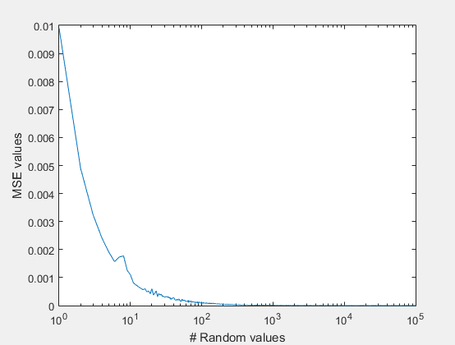

**Figure 4.** MSE plot

# MATLAB Code

**Part 1**

clear;clc;

clf;

close all;

% Setting scaling and random values for each variable

N = [1,10^5];

y = rand(N);

% Setting up given formulas into MATLAB

e_mean = 1/N(2) * sum(y);

e_var = 1/N(2) * sum((y - e_mean).^2);

mean1 = zeros(N);

mean2 = zeros(N);

variance1 = zeros(N);

variance2 = zeros(N);

errmean = zeros(N);

errvar = zeros(N);

for x = 1 : 10^5

if (x-1 <= 0)

mean1(x) = (1/x) * sum(y(:,1:x));

else

mean1(x) = ( (mean1(x-1)*(x-1)) + y(:,x)) * (1/x);

end

end

for x = 1 : 10^5

mean2(x)= 1/x * sum(y(:,1:x));

end

for x = 1 : 10^5

variance1(x)= 1/x * sum(( y(:,1:x) - e_mean).^2);

end

for x = 1 : 10^5

errmean(x) = mean2(x) - e_mean;

end

for x = 1 : 10^5

errvar(x) = variance1(x) - e_var;

end

% Plotting mean distribution

figure(1)

subplot(2,1,1)

plot(mean1)

title('Regular plot of functions');

xlabel('# of points');

ylabel('Means of N');

subplot(2,1,2)

semilogx(mean2)

title('Plot at log base 10 scale of functions');

xlabel('# of points');

ylabel('Mean of N');

% Plotting variance

figure(2)

subplot(2,1,1)

semilogx(mean2);

xlabel('# of Samples');

ylabel('Mean of N');

subplot(2,1,2)

semilogx(variance1)

xlabel('# of Samples');

ylabel('Variance of N');

% Plotting error distribution

figure(3)

subplot(2,1,1)

semilogx(errmean)

xlabel('# of Samples');

ylabel('Error Mean of N');

subplot(2,1,2)

semilogx(errvar)

xlabel('# of Samples');

ylabel('Error Variance of N');

**Part 2**

clear;

clc;

clf;

% Defining given values

K = 100000;

bsize = 0.01;

brange = 100;

sum = 0;

% Generating MSE plot

for X = 1: K

vec = [1,X];

sum = 0;

Y = rand(vec);

pdf = histcounts(Y , brange,'Normalization','Probability');

for x = 1:brange

sum = sum + ((pdf(x) - (1./brange)).^2);

end

MSE(X) = (1./brange) * sum;

end

figure(1)

semilogx(MSE)

xlabel('# Random values');

ylabel('MSE values');

# Conclusions

This assignment helps us understand the purpose of the mean/variance formula sets. As we plot our results with a given set of parameter values, we can observe that even generating a random set of values the probability of any cause could reach to zero, as we use a high number of sample points. The given formulas are shortcuts for us to obtain a statistical data plot of the random.