Emilie Doyle

Stochastics CA 6 Redo

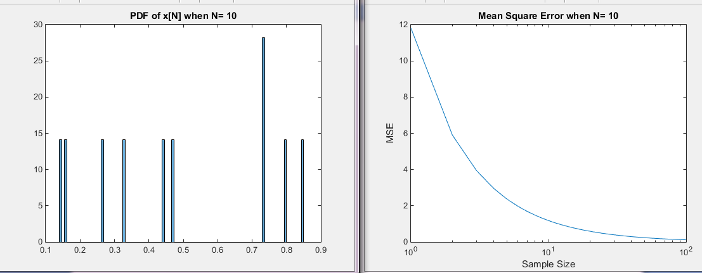

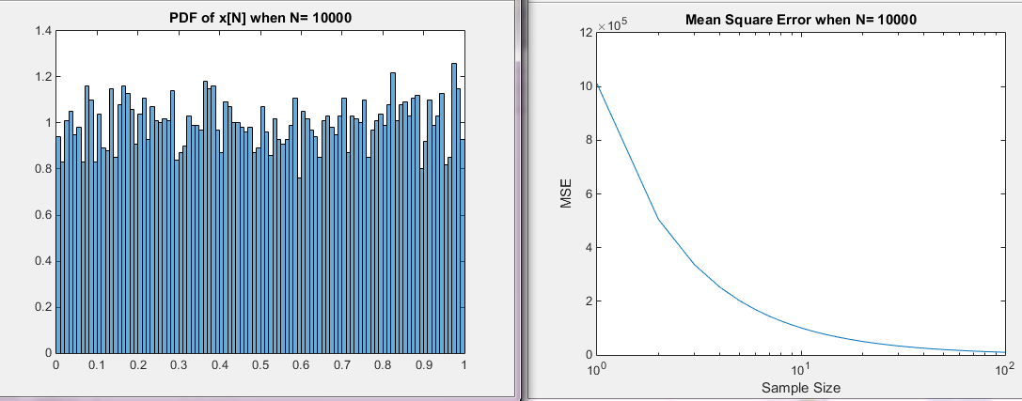

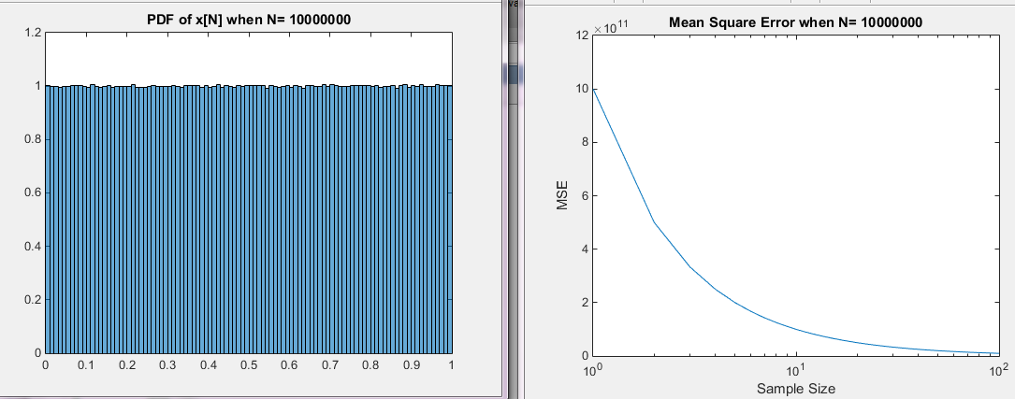

Code:

%StochCA6

K=[10, 10e3, 10e6];

for q=3:3

%Declare Variables

f=linspace(1,10);

N=linspace(1, K(q),10e3);

v=linspace(1, K(q),10e3);

MSE=linspace(1, 100,100);

VarErr=linspace(1, K(q),10e3);

MeanErr=linspace(1, K(q),10e3);

G=linspace(1,100,100);

x= rand(K(q),1);

Mean=mean(x);

Variance= var(x);

for i=1:length(x)

curMean= (1/i)\*sum(x);

x=x-0.5;

x=x.^2;

curVar=(1/i)\*sum(x);

MeanErr(i)=curMean-Mean;

VarErr(i)=curVar-Variance;

end

%Plot

figure(1)

semilogx(N,VarErr);

title('Variance Error');

xlabel('Sample Size');

ylabel('Magnitude of Error');

figure(2)

semilogx(N,MeanErr);

title('Mean Error');

xlabel('Sample Size');

ylabel('Magnitude of Error');

%2

figure(3)

histogram(x, 100, 'Normalization', 'pdf');

str1=sprintf('PDF of x[N] when N= %.0f', K(q));

title(str1);

[N,edge]=histcounts(x,100);

for i=1:length(N)

g=N-0.01;

g=g.^2;

MSE(i)=(1/i)\*sum(g);

end

p=(1:100);

figure(4)

semilogx(p, MSE);

str2=sprintf('Mean Square Error when N= %.0f', K(q));

title(str2);

xlabel('Sample Size');

ylabel('MSE');

end