John Lee

ECE 3512: Signals – Continuous and Discrete

Department of Electrical and Computer Engineering, Temple University, Philadelphia, PA 19121

# Problem Statement

For this experiment, we will be introduced to a new concept of covariance’s and correlations between data values. We will continue experimenting with the audio signal as it allows us to work at a specific rate of 8000Hz at a length of 240 samples. Our goal is to use the given formulas on the experiment’s manual to plot our results and observe the difference between both new concepts. All these plots will be developed under specific parameter to obtain a better plot view of our results.

# Approach and Results

First we will need to create a code that plots the correlation at times 0.9 and 3 seconds. When we input the time values of 0.9 seconds, we can observe that the oscillations between each wave for the first autocorrelation, contains high spikes of oscillations between the frequencies. The second autocorrelation displays the results at 3 seconds when we are working with 240 samples for this system, the plot shows a noisier with less high oscillation spikes. **Figure 1** shows that the autocorrelation at different times, affect the noise and the oscillation spike between the audio frequency data.

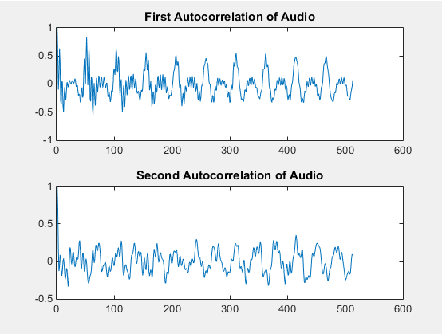

**Figure 1** Autocorrelation plot at t = [0.9, 3]

The second portion of this assignment consists on applying the covariance matrix formula using 240 samples. In order to plot the mesh data, a set of nested for loops are being used to implement the given formula on the manual. We can observe that **Figures 2-4** displays the plot results of the covariance and autocorrelation at specific times. We can notice that the increase of time values, helps shape the covariance plot to be smoother, assimilating a sinusoidal wave. A mesh plot is being used to display the plot of the given covariance formula of two vectors.

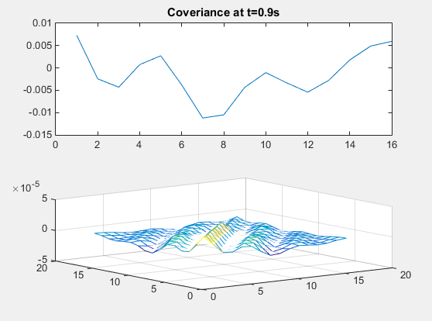

**Figure 2.** Covariance + Mesh plot at 0.9s

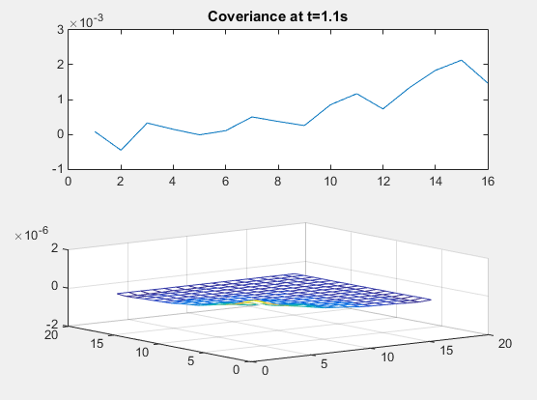

**Figure 3.** Covariance + Mesh plot at 1.1s

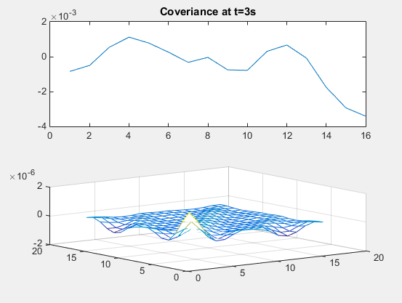

**Figure 4.** Covariance + Mesh plot at 3s

# MATLAB Code

**Part 1**

clear;

clc;

%Google Stocks Samples & Speech File

Faudio = fopen('rec_01_speech.raw','r');

b = fread(Faudio, inf, 'int16');

fclose(Faudio);

b2 = b/norm(b);

% Defining intergers

Frequency = 8000;

Length = 420;

% Time * Frequency

% Time + Length

Time1 = 0.9 * Frequency;

Time2 = 3 * Frequency;

Sum1 = Time1 + Length;

Sum2 = Time2 + Length;

% For loop for X, Y samples for First autocorrelation

for r = 0 : 512

x = b2(Time1:Sum1,:);

y = b2(Time1 + r : Sum1 + r, :);

Correlation1 (r+1,:) = corr(x,y);

end

% For loop for X, Y samples for Second autocorrelation

for r = 0 : 512

x = b2(Time2:Sum2,:);

y = b2(Time2 + r : Sum2 + r, :);

Correlation2 (r+1,:) = corr(x,y);

end

figure(1)

subplot(2,1,1);

plot(Correlation1)

title('First Autocorrelation of Audio')

subplot(2,1,2);

plot(Correlation2)

title('Second Autocorrelation of Audio')

**Part 2**

clear;

clc;

%Google Stocks Samples & Speech File

Faudio = fopen('rec_01_speech.raw','r');

b = fread(Faudio, inf, 'int16');

fclose(Faudio);

b2 = b/norm(b);

% Defining intergers

Frequency = 8000;

Length = 420;

% Time * Frequency

t1 = 0.9 * Frequency;

t2 = 1.1 * Frequency;

t3 = 3 * Frequency;

% Setting parameters between time/frequency points

x1 = b2(t1 : t1 + 15,:);

x2 = b2(t2 : t2 + 15,:);

x3 = b2(t3 : t3 + 15,:);

% Covariance plot for loop.

for i = 0:15

for j = 0:15

sum1= 0;

sum2= 0;

sum3= 0;

for k = 1:15+1;

if (k - j <= 0 || k - i <= 0)

value1 = 0;

value2 = 0;

value3 = 0;

else

value1 = x1(k-i) * x1(k-j);

sum1 = sum1 + value1

value2 = x2(k-i) * x2(k-j);

sum2 = sum2 + value2

value3 = x3(k-i) * x3(k-j);

sum3 = sum3 + value3

end

end

cov1(i+1,j+1) = (1/15) * sum1;

cov2(i+1,j+1) = (1/15) * sum2;

cov3(i+1,j+1) = (1/15) * sum3;

end

end

figure (1)

subplot(2,1,1)

plot(x1);

title('Coveriance at t=0.9s')

subplot(2,1,2)

mesh(cov1)

figure (2)

subplot(2,1,1)

plot(x2);

title('Coveriance at t=1.1s')

subplot(2,1,2)

mesh(cov2)

figure (3)

subplot(2,1,1)

plot(x3);

title('Coveriance at t=3s')

subplot(2,1,2)

mesh(cov3)

# Conclusions

To summarize our results, we concluded that the data plots for both covariances and autocorrelations, are dependent to the time variables. As we use these plots to determine the repetition of wave signals, we noticed that the increment of these given time variables, could affect the shape and form of the wave obtained from our plot displays. Determining the covariance and the autocorrelation of a given signal helps us determine its measurements of the periodic signals.