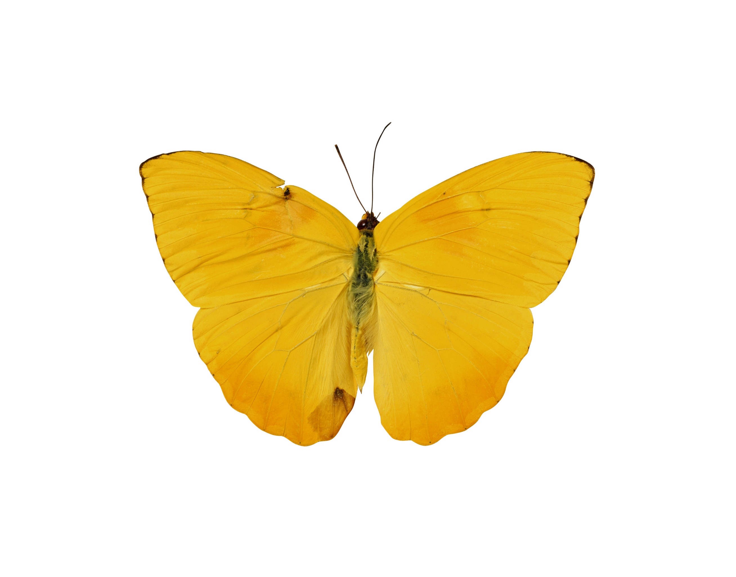

Zainab H. AlAli  
SPSS 3522  
Joseph Picone

Computer Assignment (5) Covariance and Correlation

# Image of butterfliesIntroduction:

In this computer assignment we are going to learn more about the covariance and correlation system. In this assignment we are going to work on two dependent tasks to introduce the covariance and correlation calculations.

# Problem Statement:

The Assignment asked us to do two tasks where we need to usie the audio signal which is sampled at 8000 Hz so that we can complete the tasks. Moreover, we need to define a vector, **x**, of length 240 (30 msec) that contains the 240 samples of the signal starting at t = 0.9 secs. Define a second vector, **y**, which also represents 240 samples, but consists of samples shifted by k samples. Plot the statistical correlation between **x** and **y** for k = 0, 1, ..., 512. And repeat this for t = 3.0 secs. Compare the two functions and relate them to properties of the audio signal. Then, start at t = 0.9 secs. Take the first 16 samples as a vector: **x** = [x1 x2 x3 ... x16]. Compute the covariance matrix using 240 samples. Each element in the matrix is governed by the equation:



where i is defined over the range [0, 15] and j is defined over the range [0, 15]. Do this for t = 1.1 secs and t = 3.0 secs. Compare the two matrixes and explain why they are different.

## Results:

Original Graph without any shift:

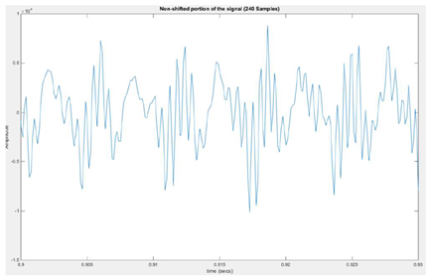 Figure (1)

When K=100

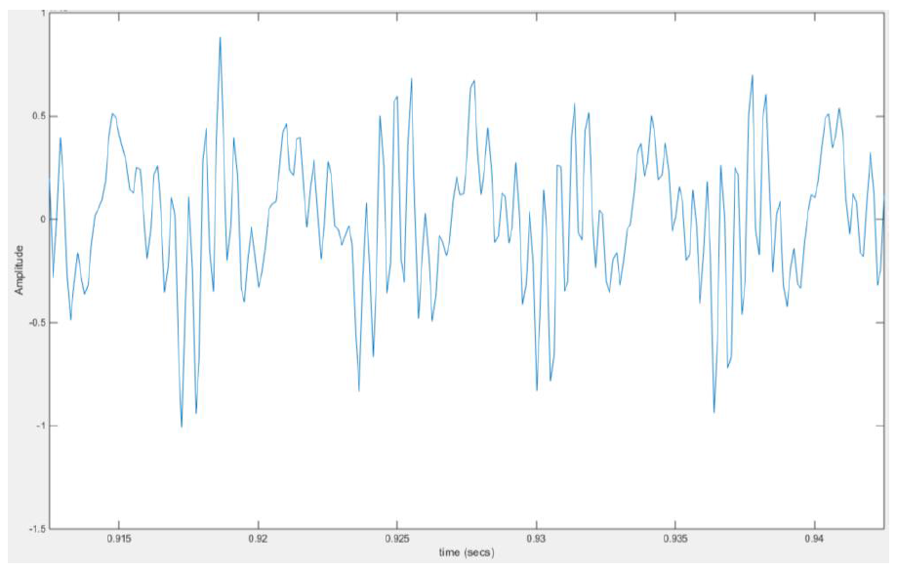Figure (2)

When K=60

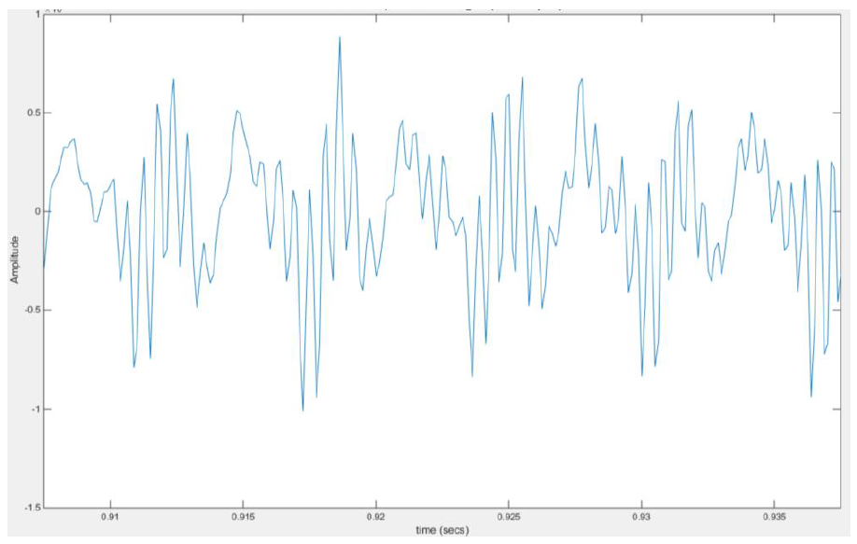Figure (3)

For the Above Graphs, we can see that figure (1) is basically represented and non-shifted signal at time = 0.9 sec where that range is between (-1,1), while in figure (2) the graph shows the plot when k=100 and figure (3) shows the graph when k=60 where the plot is pretty similar but different than the non-shifted plot according to the positive and negative swings.

### Correlation Part:

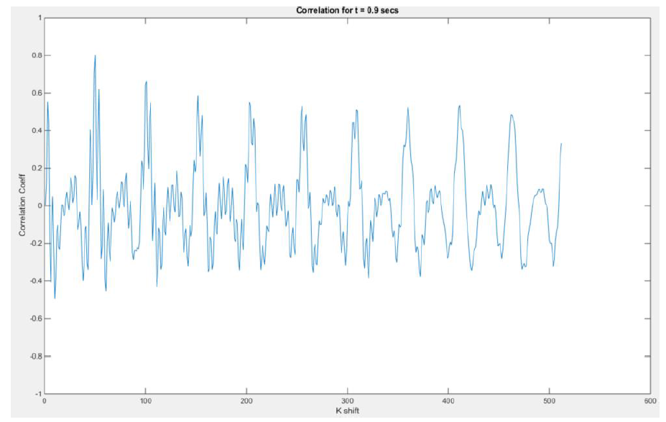Figure (4)

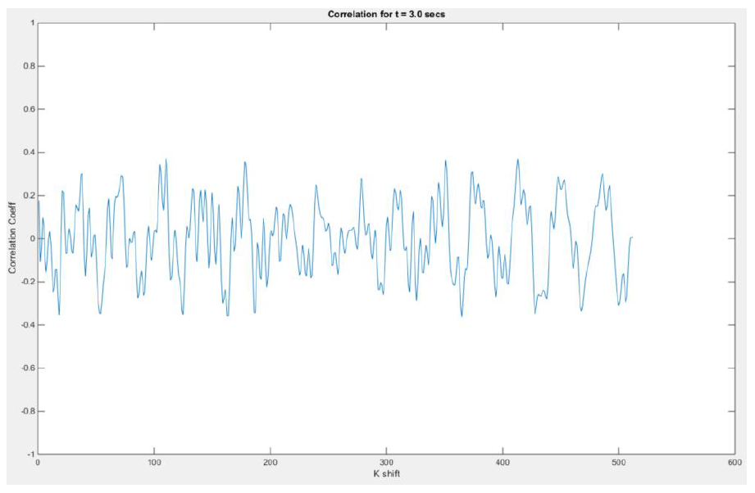Figure (5)

These two figures show the differences on time while figure (4) represent the correlation responding when time = 0.9 sec while the other on Figure (5) shows the plot of time = 3 sec.

### CAlcutions:

When T= 0.9 sec When T= 3 sec When T= 1.2 sec

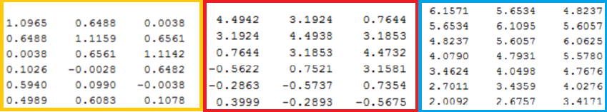

### Conclusion & Appendex:

This assignment goal was to understand the correlation respond with respect to the time difference while having two different sets of variables of the dependent correlation coefficient. As a conclusion we can end up with that correlation signals is periodic and based on sine waves signals, while the covariance is almost similar to the correlation from the results we got in the graphs.

clear; clc; close all;

% Let's first open the raw speech data file and store its values in a

% vector fn

fp=fopen('rec_01_speech.raw', 'r');

fn=fread(fp,inf,'int16');

fclose(fp);

L_speech = length(fn);

% Sample Frequency given

fs = 8000;

% Let us find the min/max val, mean, med, and var

fn_min = min(fn);

fn_max = max(fn);

fn_mean = mean(fn);

fn_median = median(fn);

fn_var = var(fn);

% Print our findings

out = sprintf('Speech data: min = %f, max = %f, mean = %f, median = %f, variance = %f\n'...

, fn_min, fn_max, fn_mean, fn_median, fn_var);

disp(out);

% ------------------ Speech ------------------

L_speech = length(fn);

timeL = L_speech/fs;

% We can find the legnth of our signal given our sample frequency

t= linspace(0, timeL,L_speech);

figure('name','[ECE 3522] CA[5]');

plot(t, fn);

title('Non-shifted portion of the signal (240 Samples)');

xlabel('time (secs)');

ylabel('Amplitude');

xlim([0.9+60/fs 0.9+(240+60)/fs]);

% Define starting points %

t_window1 = 0.9;

t_window2 = 3.0;

t_window3 = 1.1;

s_window1 = t_window1*fs;

s_window2 = t_window2*fs;

s_window3 = t_window3*fs;

% Define window size

xL = 239;

yL = 239;

kL = 512;

%Define index variable

i = 1;

% Find corelation at 0.9secs

for k = 1:kL

xSam = fn(s_window1:s_window1+xL);

ySam = fn(s_window1+k+1:s_window1+xL+k+1);

% Find correlation Coefficient.

temp = corrcoef(xSam, ySam);

corCoeff1(i) = temp(2,1);

i=i+1;

end

k = linspace(0,kL,i-1);

figure('name','[ECE 3522] Class Assignment [5]');

plot(corCoeff1);

title(sprintf('Correlation for t = %0.1f secs', t_window1));

xlabel('K shift');

ylabel('Correlation Coeff');

ylim([-1 1]);

% Resest index

i = 1;

% Find corelation at 3.0secs

for k = 1:kL

xSam = fn(s_window2:s_window2+xL);

ySam = fn(s_window2+k+1:s_window2+xL+k+1);

% Find correlation Coefficient.

temp = corrcoef(xSam, ySam);

corCoeff2(i) = temp(2,1);

i=i+1;

end

figure('name','[ECE 3522] Class Assignment [5]');

plot(corCoeff2);

xlabel('K shift');

ylabel('Correlation Coeff');

title(sprintf('Correlation for t = %0.1f secs', t_window2));

ylim([-1 1]);

% Part 2

% Covariance when t = 0.9secs

for i = 0:1:15

for j = 0:1:15

index1 = 1;

for n = s_window1:1:s_window1+xL

x1(index1) = fn(n-i)*fn(n-j);

index1 = index1 + 1;

end

coVar1(i+1, j+1) = 1/xL*sum(x1);

end

end

coVar1

% Covariance when t = 3.0secs

for i = 0:1:15

for j = 0:1:15

index1 = 1;

for n = s_window2:s_window2+xL

x2(index1) = fn(n-i)*fn(n-j);

index1 = index1 + 1;

end

coVar2(i+1, j+1) = 1/xL*sum(x2);

end

end

coVar2

% Covariance when t = 1.1secs

for i = 0:1:15

for j = 0:1:15

index1 = 1;

for n = s_window3:1:s_window3+xL

x3(index1) = fn(n-i)*fn(n-j);

index1 = index1 + 1;

end

coVar3(i+1, j+1) = 1/xL*sum(x3);

end

end