Harish Boggarapu

ECE 3522

Google Stock

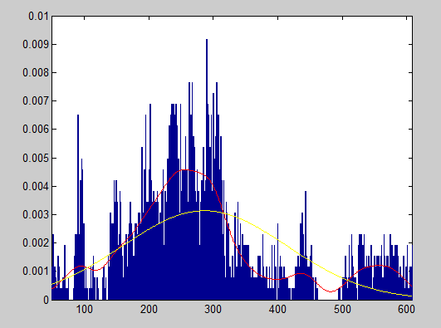

Error between PDF and Gaussian =2.1963e-06

Error between PDF and Kernel = 1.1711e-06

Speech Signal

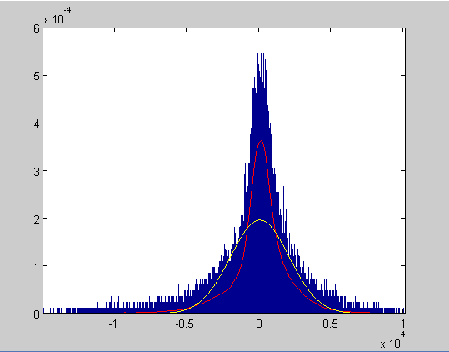

Error between PDF and Gaussian =1.8866e-09

Error between PDF and Kernel = 4.8673e-10

* As you can see, the Gaussian distribution is not a good fit for estimating the PDF of the Google stock. The kernel distribution gives us a better an approximation of the PDF. For Google stock, the kernel keeps track of the changes in the PDF much better compared to Gaussian. As a result, the mean squared error between the PDF and kernel distribution is lower than it is in between PDF and Gaussian distribution. Although the Gaussian distribution is one of the most popular used distribution, for the particular Google stock data, it is however not a good approximation is estimating the PDF. For the Speech signal, the Gaussian distribution is a good fit but the kernel distribution is a better fit.