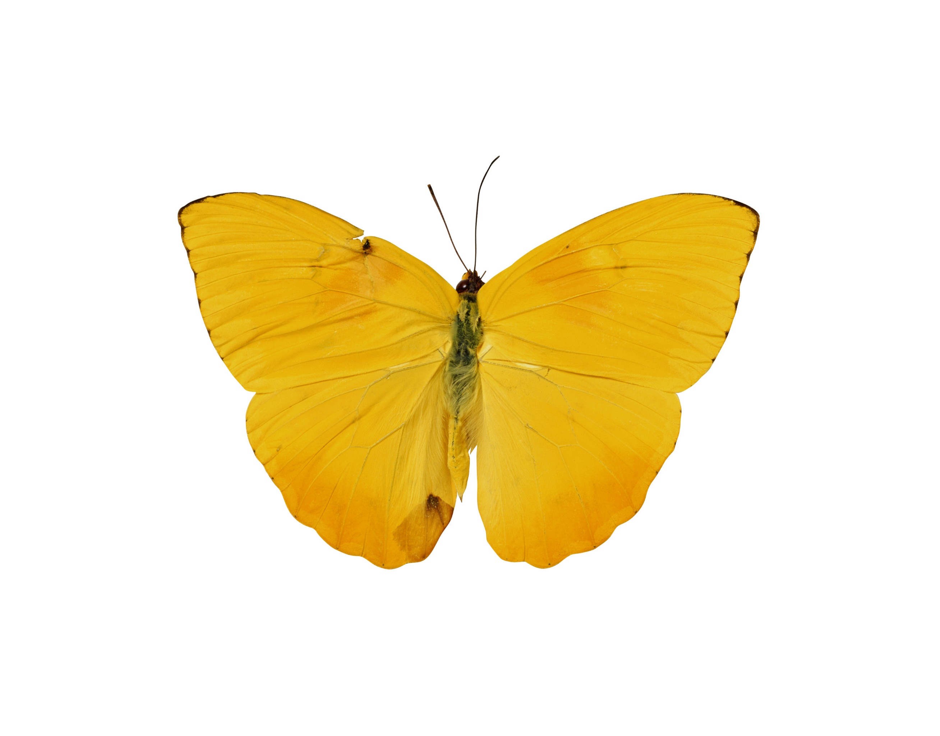

Zainab H. AlAli  
SPSS 3522  
Joseph Picone

Computer Assignment (4) Model Fitting

# Image of butterfliesIntroduction:

In this computer assignment we are going to learn more about model fitting and how to demonstrate the model using the given data from google stock of a pdf model using both (Google stock and speech data)

# Problem Statement:

The tasks to be accomplished are:

1. Compute a histogram of the amplitude of the data and normalize it by the number of samples so that it is an estimate of the pdf.
2. Fit this distribution by estimating the mean and variance. Plot the Gaussian model on top of the histogram. Compare and contrast the quality of the fits to the data.
3. In (2), you should find that the Gaussian model is not a good fit for the Google data. Select another distribution from Chapter 4 that provides a better estimate of the data. Plot this model on the same graph with the histogram and the Gaussian fit. Compute the mean-squared error between the actual data and the parametric fit. Which gives a better approximation? (Do this for both data sets.)

## Results:

Google Stock PDF

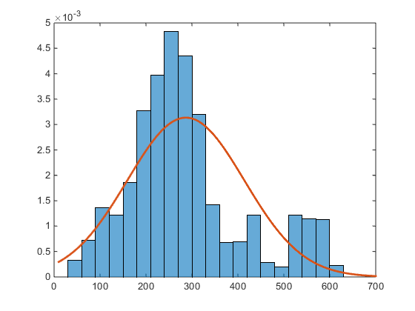 Figure (1)

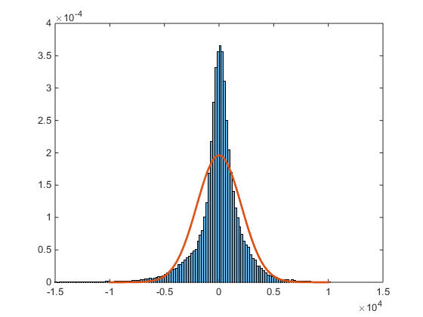Figure (2)

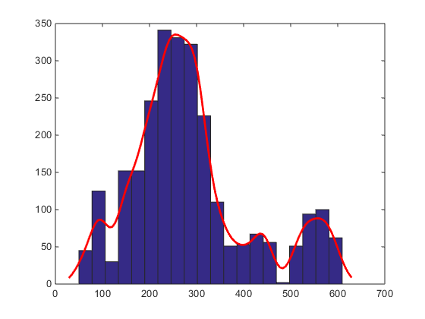Figure (3)

### Conclusion & Appendex:

This assignment goal was to understand the Model fitting where in the first part it was task to learn about histograms and understand what they present through the graph as PDF’s where the distribution line is plotting the array to present the values of the function that span the sample spaces. The first figure, represent the closing stock histogram estimate with Guassian distribution, while the second figure shows the speech signals, and finally the last figure shows the overlaid fit. So this assignment tests our ability to understand the histogram.

clear;

clc;

%Google Stocks

a = xlsread('google_v00.xlsx');

Faudio = fopen('rec_01_speech.raw','r');

b = fread(Faudio, inf, 'int16');

fclose(Faudio);

a2 = a/norm(a);

b2 = b/norm(b);

% Defining N1 and N2

N1 = length(a);

N2 = length(b2);

%Plot of For loop

figure(1)

hist(a2);

title('Google Plot');

xlabel('Google Stocks Data');

ylabel('Variance of samples');

figure(2)

histfit(a2(:),10,'normal');

title('Google Plot + Cruve fit');

xlabel('Google Stocks Data');

ylabel('Variance of samples');

%Plot of For loop

figure(3)

hist(b2)

title('Speech Plot');

xlabel('Speech File Data');

ylabel('Variance of samples');;

figure(4)

histfit(b2,10,'normal')

title('Speech Plot + Line fit');

xlabel('Speech File Data');

ylabel('Variance of samples');

This assignment has demonstrated the importance of using different distribution fits appropriately for different types of data sets.