Vaughn Wiernicki

ECE 3522: Stochastic Processes in Signals and Systems

Department of Electrical and Computer Engineering, Temple University, Philadelphia, PA 19122

# Problem Statement

For this computer assignment we were tasked with using the same two signals, Google’s stock prices and a speech signal, and computing three different types of variance on them. The first type was a global variance, where we used all the data points within the signal to get one value of variance. This was plotted as a dotted horizontal line. We then had to take a moving variance where we first used ten points of data and then included one additional data point, recalculated the variance of the new amount of points and then save that value. The final form of variance was a window frame analysis to get the variance within a small sampling of data that moved along with the signal. While the moving variance eventually converged to the same value of the global variance, the window frame analysis of the variance would not do this.

# Approach and Results

Computing the total variance of the signal was easy seeing as the signal was already read into MATLAB, “var” seemed like the appropriate tool for this job. Then using for loops I computed the variance of the first ten samples of data and plotted them in a temporary variable equally as long as the original signal. The for loop then started at 10 and went through the signal taking one extra sample each iteration. When this moving variation plot was done I plotted it next to the first global variance and received the following plot:

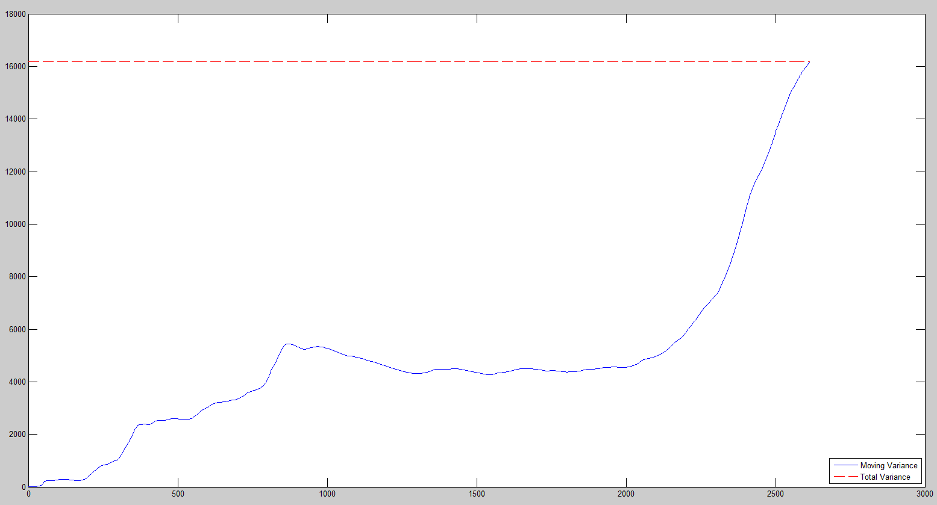

Figure 1: Global Variance and Moving Variance of Google's Stock Prices

So the variance of the stock prices changes a little before finally reaching the global variance value. It makes sense that the global variance is the same value as when the loop accounts for every data point within the signal, because they’re using the same data and all of the same data at that. The moving variance’s general shape also makes sense because the stock market is volatile and as such there are days where the price can go up or down. As we get more and more samples of data we get more of these days where the price goes down and we also get these areas in the graph where it trends downwards. Using similar techniques to the previous computer assignments it was The following plot is when I took a window frame analysis of the data and plotted that on top of the previous figure’s graph:

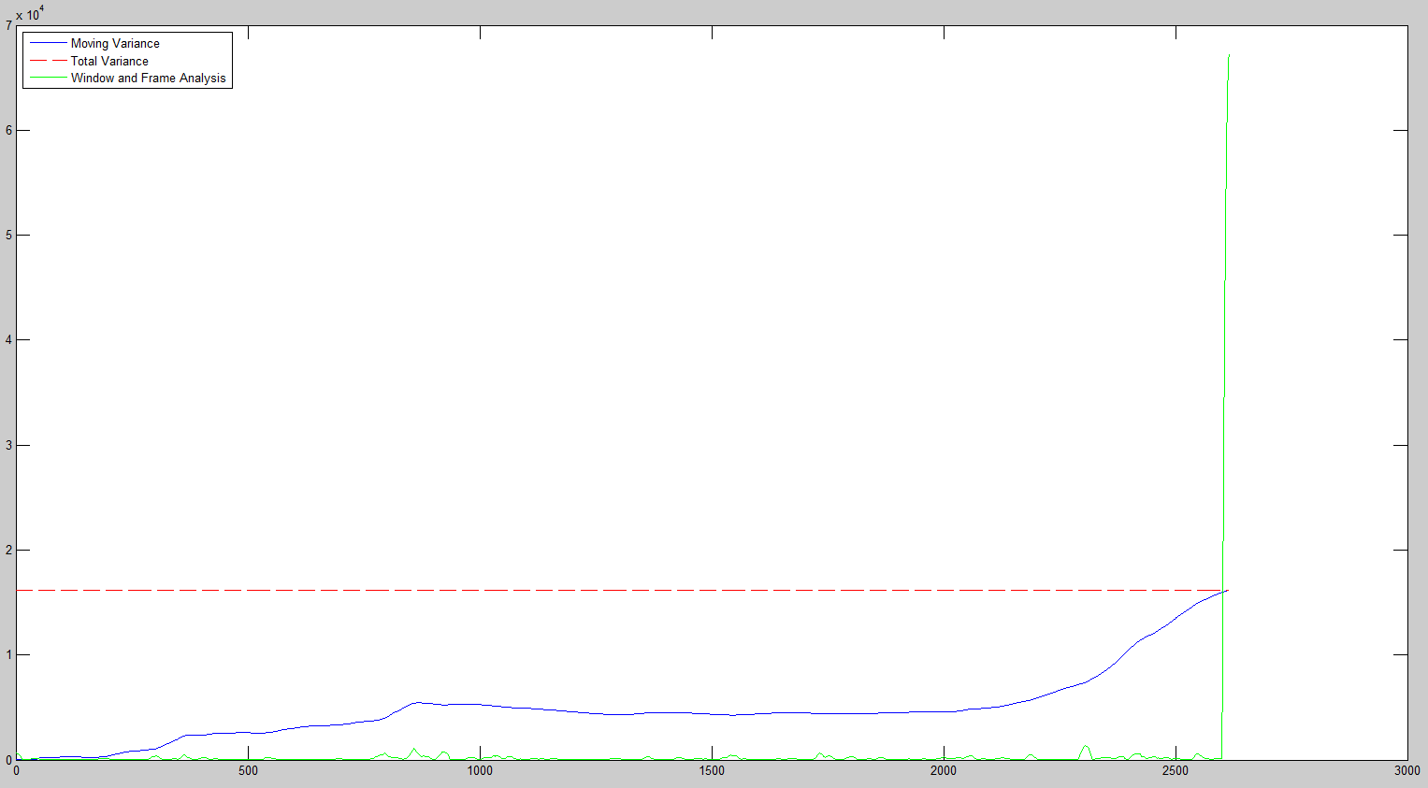

Figure 2: Global, Moving and Window Frame Analysis Plots of the Signal's Variance

We can observe that the window frame analysis plot (in green) doesn’t ever really get close to the moving variance or the global variance. This would make sense because although the stock market is a very volatile thing, in the short term of things you’re not very likely to see an explosion in price. When we use a window of 30 days, like we did, those 30 days are going to be prices within a small range as opposed to the overall range of values. AS such the variance of these values is going to be a fraction of what the global variance value looks like.

For the speech signal I repeated the same processes used for the first part of the assignment. The following is a plot of the global variance as a horizontal line and the moving variance:

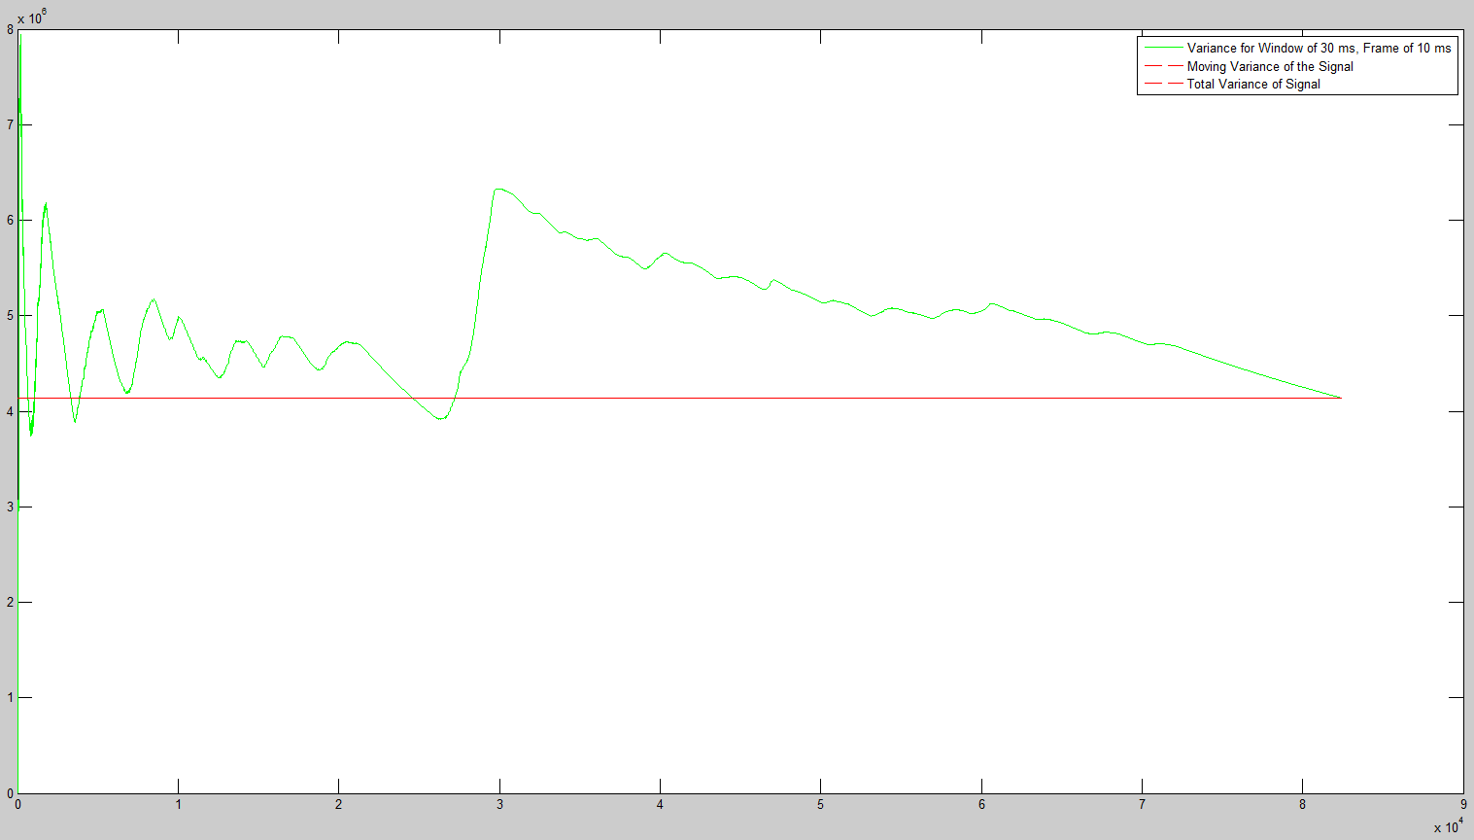

Figure 3: Global Variance and Moving Variance of the Speech Signal

The speech signal’s moving variance is shown to move around a lot in a pattern similar to oscillation, which would make sense as the speech signal is comprised of periodic functions like cosines. As the variance includes more and more of the signal we see the change in the variance value because the signal is moving closer to or further from the predefined mean of the signal. Similar to the first computation of moving variance, once the signal is complete the moving variance converges to the global variance. Below is a plot containing the signals observed in figure 3 as well as a window-frame analysis of the speech signal:

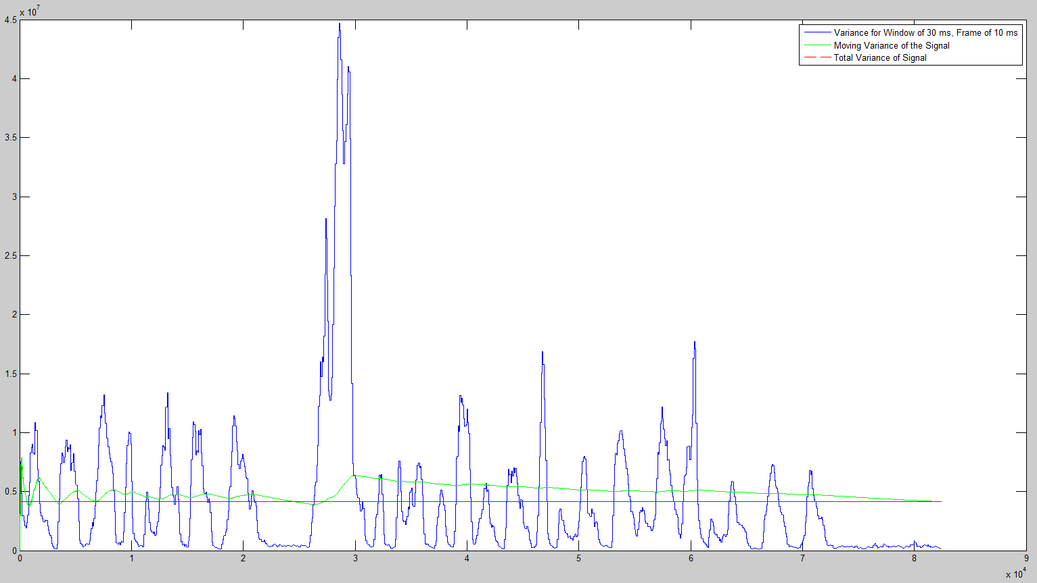

Figure 4: Global, Moving and Window-Frame Analysis of the Variance

We can see that similar to the previous signal, the window frame analysis varies in amplitude much more than the other signals do. This is also due to the fact that we’re computing the variance of a much smaller set of data. To further illustrate the point, below is a plot of the same signal, but zoomed it at the first 10,000 data points:

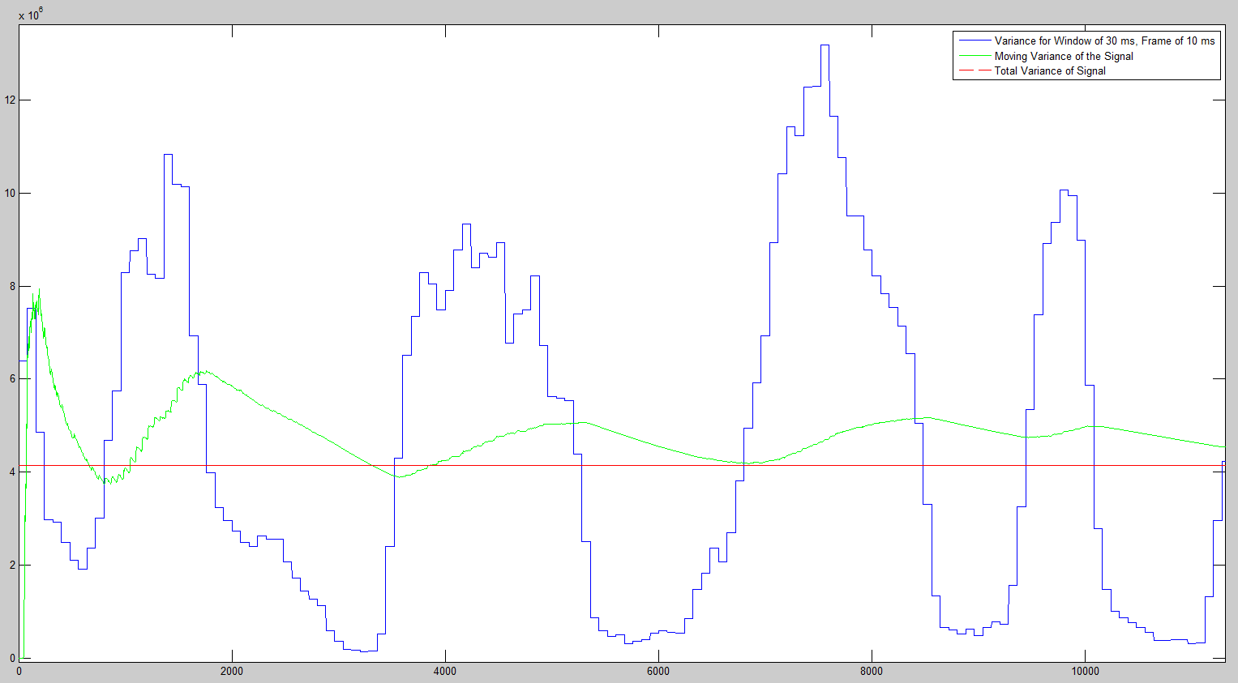

Figure 5: Zoomed In Plot of the three Variances

We can observe that the variance follows the general trend of the window frame analysis. When enough of the higher values are accumulated the moving variance goes up and then goes down with the graph as well.

# MATLAB Code

clear; clc; clf; close all;

%Reading Google Stock Prices:

GOOG = xlsread('C:\Users\Vaughn II\Desktop\CA03\google_v00.xlsx');

[R, C] = size(GOOG);

clse = zeros(1, R);

for l = 1:R

clse(1, l) = GOOG(l, 4);

end

%Total Variance:

Cvar = var(clse, 1);

TotalVar = ones(1, R);

for z = 1:1:R

TotalVar(1, z) = Cvar;

end

%Looping through for Variances:

Start = 10;

MovVar = zeros(1, R);

FirstSet = zeros(1, Start);

for l = 1:1:Start

FirstSet(1, l) = clse(1, l);

end

for m = 1:1:Start

MovVar(1, m) = var(FirstSet, 1);

end

for m = Start:1:R

WorkingSet = zeros(1, m);

for n = 1:1:m

WorkingSet(1, n) = clse(1, n);

end

MovVar(1, m) = var(WorkingSet, 1);

end

%Plotting Section 1:

t = linspace(1, R, R);

plot(t, MovVar, 'b', t, TotalVar, '--r');

legend('Moving Variance', 'Total Variance', 'Location', 'SouthEast');

%%

%Loop through Data with Window of n, Frame of m:

m = 1;

n = 30;

data = zeros(1, n);

vardata = zeros(1, round(length(clse) / m));

times = 1;

for j = 1:m:length(clse)

for k = 1:1:n

x = m - round(n/2) + k + j;

if (x < 1)

data(1, k) = 0;

end

if (x > length(clse))

data(1, k) = 0;

end

if (1 <= x && x <= length(clse))

data(1, k) = clse(1, x);

end

end

vardata(1, times) = var(data, 1);

times = times + 1;

end

%Plotting Section 2:

plot(t, MovVar, 'b', t, TotalVar, '--r', t, vardata, 'g');

legend('Moving Variance', 'Total Variance', 'Window and Frame Analysis','Location', 'NorthWest');

--------------------------------------------------------------------------------------------------------------------------------------------

clear; clc; clf; close all;

%Reading Data:

fileID = fopen('rec_01_speech.raw', 'r');

speech = fread(fileID, inf, 'int16')';

fclose(fileID);

size = length(speech);

%Total Variance:

Svar = var(speech, 1);

TotalVar = ones(1, size);

for z = 1:1:size

TotalVar(1, z) = Svar;

end

%Looping through for Variances:

Init = 10;

MovVar = zeros(1, size);

FirstSet = zeros(1, Init);

for y = 1:1:Init

FirstSet(1, y) = speech(1, y);

end

for x = 1:1:Init

MovVar(1, x) = var(FirstSet, 1);

end

for w = Init:1:size

WorkingSet = zeros(1, w);

for n = 1:1:w

WorkingSet(1, n) = speech(1, n);

end

MovVar(1, w) = var(WorkingSet, 1);

end

%Window and Frame Analysis for Variance:

m = 80; %10 ms

n = 240; %30 ms

data = zeros(1, n);

vardata = zeros(1, size);

times = 0;

for j = 1:m:size

for k = 1:1:n

x = m - round(n/2) + k + j;

if (x < 1)

data(1, k) = 0;

end

if (x > size)

data(1, k) = 0;

end

if (1 <= x && x <= size)

data(1, k) = speech(1, x);

end

end

%Plotting Variables:

start = 1 + times * m;

finish = (1+times) * m;

for l = start:1:finish

if (l > size)

break

end

vardata(1, l) = var(data, 1);

end

times = times + 1;

end

t = linspace(1, size, size);

plot(t, vardata, 'b', t, MovVar, 'g', t, Svar, '--r');

legend('Variance for Window of 30 ms, Frame of 10 ms', 'Moving Variance of the Signal', 'Total Variance of Signal');

# Conclusions

While there were some similarities between the different ways of computing variance they each explain things in a different way. The three different kinds of variance all had their quirks to them, but it’s hard to say which is best. What it really depends on is the problem at hand. In some instances you might want to look at a global variance over a moving variance or vice versa. In the case of stock the variance might help to determine an overall trend of the stock, whether it’s a good long-term investment or good for making money quickly. The window frame analysis would also be good in this case. If you wanted to look at the overall trend by a chunk of data at a time.