Joe DeMarco, CA03

This is a plot of the google data and its standard deviation.

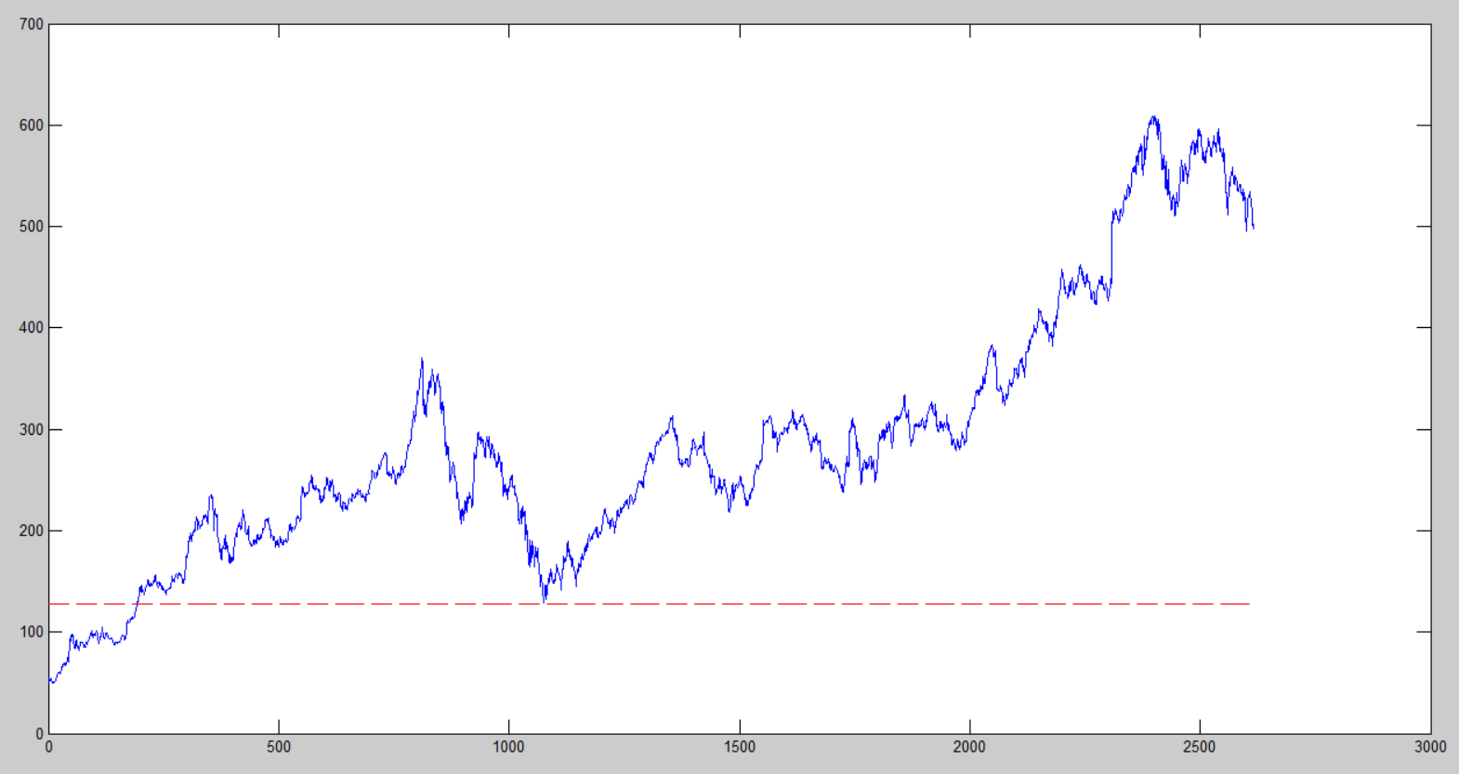

In this plot the blue line is the google data. The red line is the variance for the whole google stock data set. The magenta line is the running variance as more data is added. It makes sense that the running variance will eventually equal the total variance since the total is a summing of the distinct values.

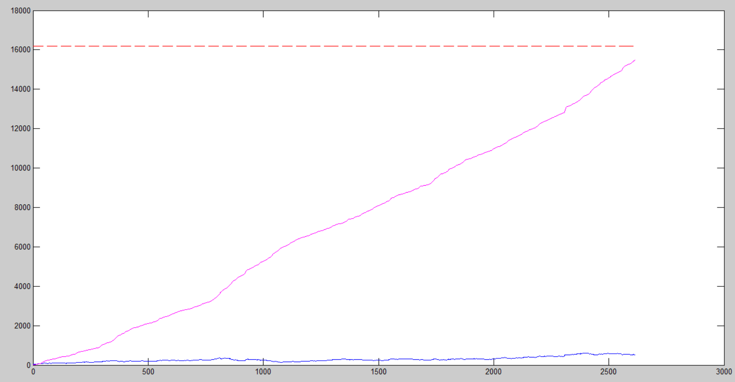

The cyan line shows a set of data where the variance is calculated every day, with a window of 30 days. It seems like this emphasizes the spots in the google data where the data is changing the fastest. So on days where there were big changes in the stock price there will be big spikes in this plot.

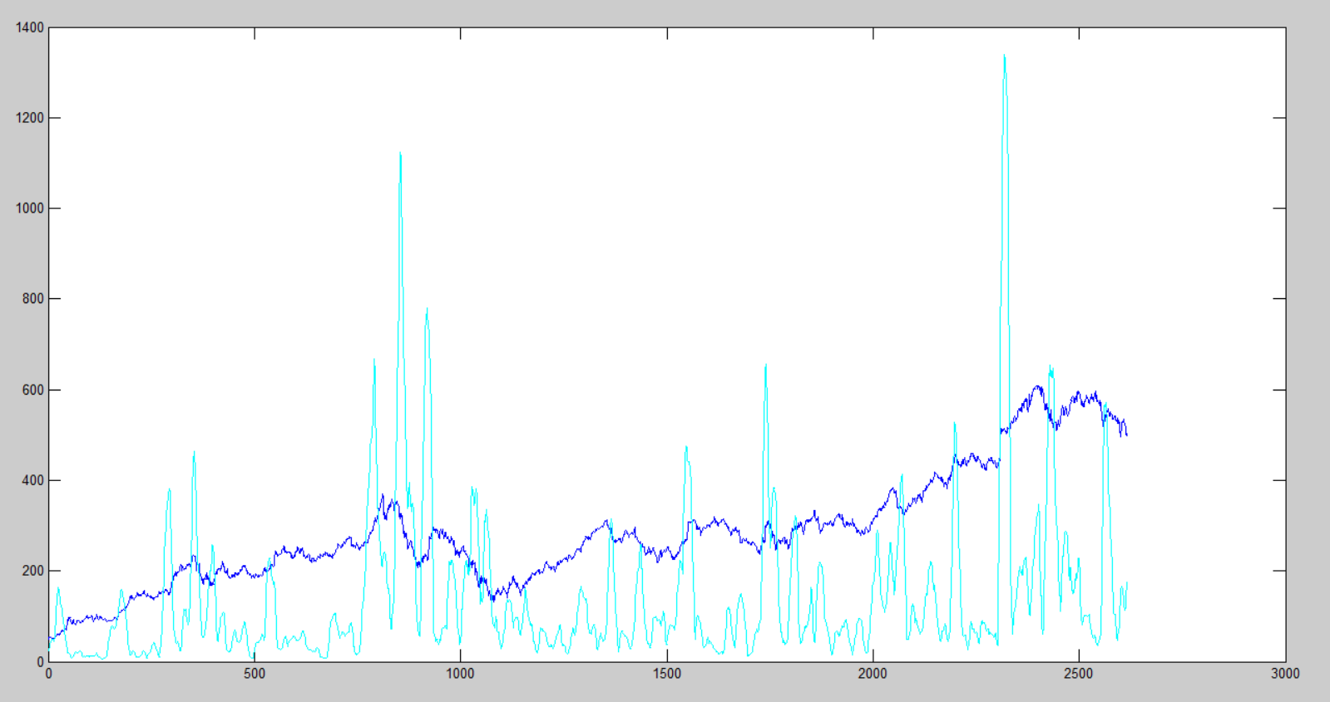

I kept getting memory errors, so I am using only the first 4000 data points from the voice file. Red line is the total variance, cyan is rolling variance, blue is the voice data.

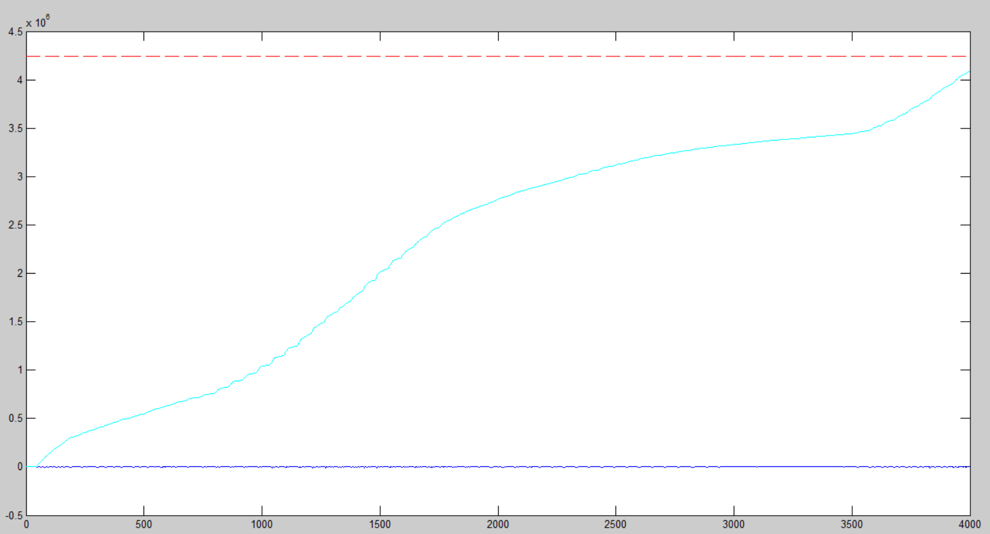

Variance with a window of 30 ms and a frame of 10 ms is in cyan. The voice data is in blue. The variance plots magnitude is so large that it drowns out the voice data. So below I plotted the voice data at a different magnitude scale, same time scale. This way you can line up the views and again see that the large variance corresponds with fast changes in the data.

