Harish Boggarapu

ECE 3522

Below is the plot of the google stock and speech signal with the blue plot representing the variance computed over the entire data, the red plot representing the varinace computed with N number of samples ranging from to with increments of 10 samples. The green plot represents the varinace computed using fram and window technique with window of 30 days and frame of 1 day for google stock and window of 30 ms and frame of 10 ms for speech signal.

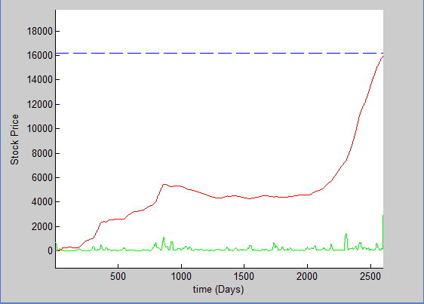

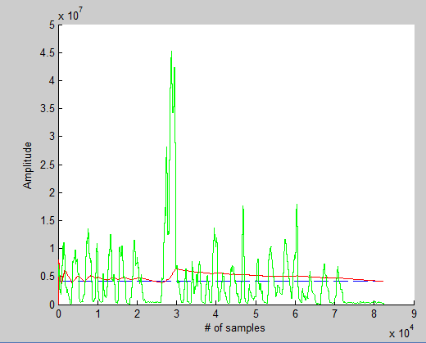

For Google stock, using the framing and windowing technique seems to give us the smallest variance, which tells us that the spread is small and the values are closer to the mean value. For the speech signal, using the framing and windowing technique gives us mixed results as there is vast change in between each window. This could be due to the moments of silence in the signal. To achieve the smallest variance, which is very important in estimating the mean value, using the windowing/frame technique is the best possible way.