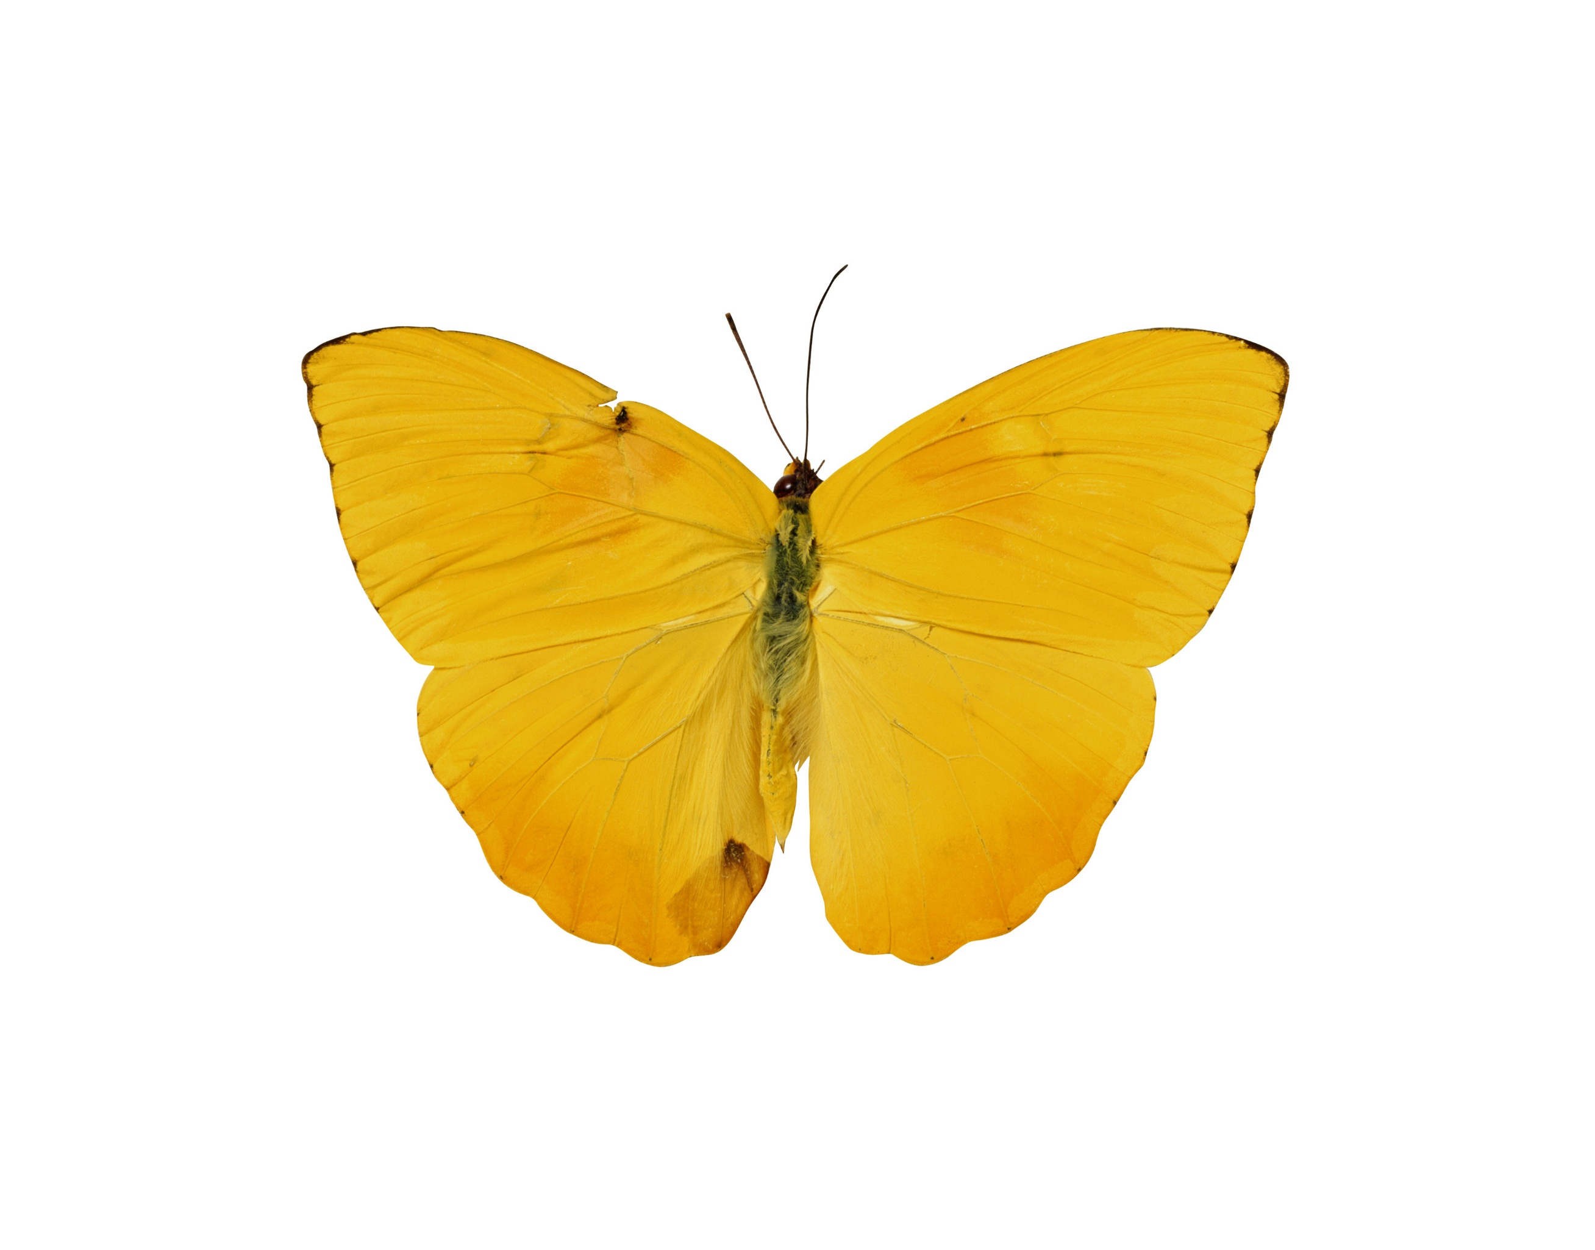

Zainab H. AlAli  
SPSS 3522  
Joseph Picone

Computer Assignment (3) Variance

# Image of butterfliesIntroduction:

In this computer assignment we are going to learn more about the variance signals, equations, and calculations. The variance is the average of the squared differences from the Mean. This computer assignment is divided into 3 tasks where the first task can be done by applying the variance equation in matlab. In the second task we need to use looping because we are going to increase the amount. “Similar to Recitation (2) code from signals.” Finally, the last task is based on replacing the RMS value using the matlab programming.

.

# Problem Statement:

The goal of this assignment is to demonstrate how you can estimate variance in real-time, which is required for streaming data. Use both data sets (Google stock and speech data) for all tasks.

The tasks to be accomplished are:

1. Estimate the variance (second central moment) from the entire data set. Plot this as a horizontal dotted line.
2. Starting with the first 10 samples, estimate the variance from the first N samples of the signal, letting N vary from 0 to a maximum of the number of samples in the file. Overlay a plot of this on the plot from (1). Describe what you observe.
3. Now estimate the variance using a frame/window approach. For the Google stock price, set the frame to 1 day and the window to 30 days. For the speech signal, set the frame duration to 10 msec and the window duration to 30 msec. Overlay this plot on the above plot and describe what you observe. Which approach makes sense?

## Results:

The mean line:

Stock variance = 1.812E+4

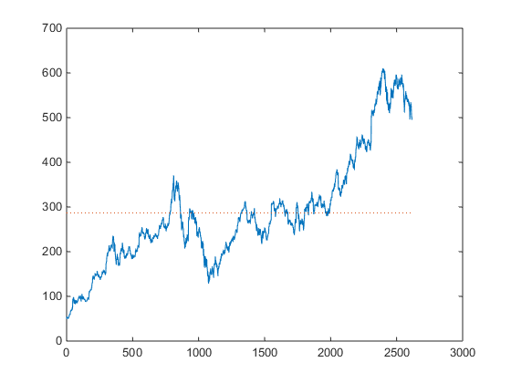 Figure (1)

Variance Function:

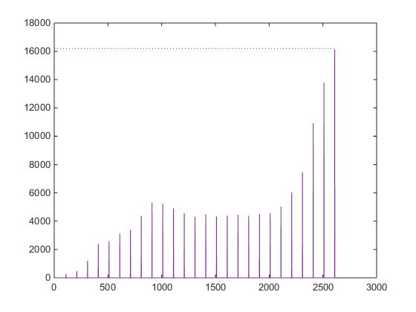Figure (2)

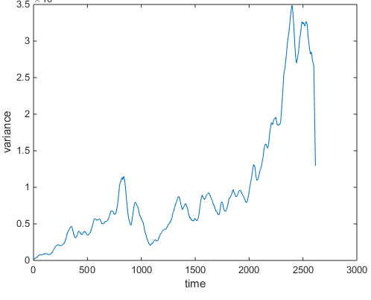Figure (3)

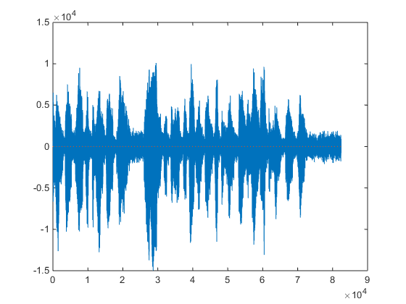Figure (4)

The Mean line is almost equal to zero.

Speech Variance = 4. 39E+06

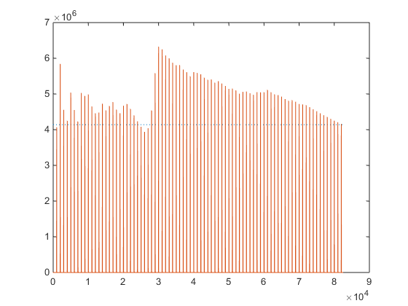Figure (5)

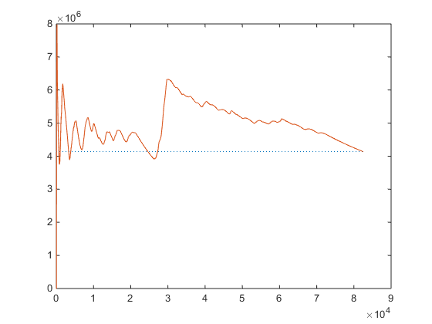 Figure (6)

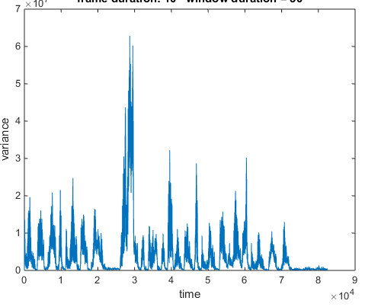 Figure (7)

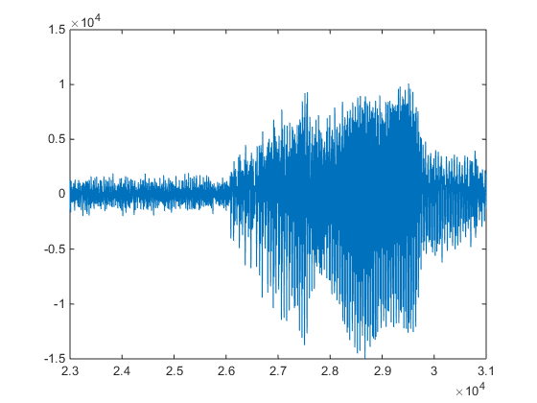Figure (8)

### Conclusion & Appendex:

This assignment goal was to understand the Variance signals and its power. Through the graphs we can notice that the graph represent the overall changing shape through the variance plot. It was difficult to explain what is going on especially in specific areas where the result was not matching the expectations.

clear;close all;clc;

% Speech Signal

fp = fopen('rec_01_speech.raw','r');

sig = fread(fp,inf,'int16');

fclose(fp);

plot(sig);

hold on

mean_s = mean(sig)

plot(ones(size(sig))*mean_s,':');

%

vari = 0;

for n=1:(length(sig))

vari = vari + (sig(n)-mean_s).^2;

end

vari=vari/(n-1)

figure(2)

%hold on

plot(ones(size(sig))*vari,':')

Nval = 1:length(sig);

vval = (1:length(sig))*0;

N = 0;

n = 0;

for N=10:1000:(length(sig))

%

mean_s = mean( sig(1:N) );

vari=0;

for n=1:N

vari = vari + (sig(n)-mean_s).^2;

end

%

vval(N)=vari/(n-1);

end

hold on

plot(vval);

function vari=rec02_v05

close all;

stock = xlsread('google_v00.xlsx');

sig = stock(:,4);

M = [ 1 ];

N = [ 30 ];

vari = zeros(length(M), length(N), length(sig));

for m = 1:length(M)

h1 = figure('name', 'vari plot', 'numbertitle', 'off');

for n = 1:length(N)

vari(m,n,:) = compute_vari(sig, M(m), N(n));

figure(h1);

str = sprintf('frame duration: %d window duration = %d', M(m),...

N(n));

plot(squeeze(vari(m,n,:)));

title(str);

xlabel('time');

ylabel('variance');

end

end

vari_out = squeeze(vari);

end

function vari_full = compute_vari(sig_a, fdur_a, wdur_a)

sig_wbuf = zeros(1, wdur_a);

num_samples = length(sig_a);

num_frames = 1+round(num_samples / fdur_a);

vari_full = zeros(length(sig_a),1);

for i = 1:num_frames

n_center = (i - 1) * fdur_a + (fdur_a / 2);

n_left = n_center - (wdur_a / 2);

n_right = n_left + wdur_a - 1;

if( (n_left < 0) || (n_right > num_samples) )

sig_wbuf = zeros(1, wdur_a);

end

for j = 1:wdur_a

index = n_left + (j - 1);

if ((round(index) > 0) && (round(index) <= num_samples))

sig_wbuf(j) = sig_a(round(index));

end

end

mean_wbuf = (sig_wbuf)/wdur_a;

vari = ( 1/(wdur_a-1) ) * sum((sig_wbuf-mean_wbuf).^2);

for j = 1:fdur_a

index = n_center + (j - 1) - (fdur_a/2);

if ((index > 0) && (index <= num_samples))

vari_full(index) = vari;

end

end

end

end