Joe DeMarco CA02

Below is a plot of the google stock price. The blue line is the closing price data with a frame of 1 and window of 10. The red line is the mean and the grey line is the linear regression.

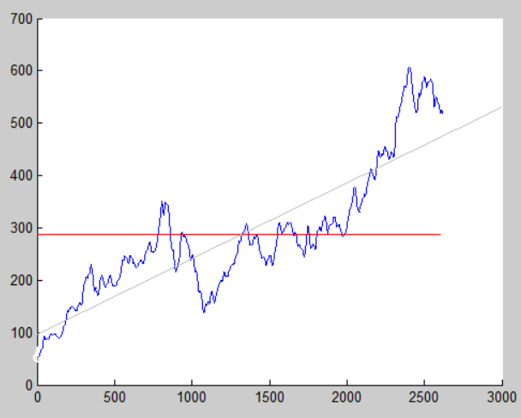

The mean value line would be a terrible predictor of the future price of the stock. The mean value will always, by its nature, lag far behind what the n+1 value will be. The linear regression line however is merely a bad predictor of the future price. It does show the direction of the general trend but it evenly weights the data from years ago, which is pretty irrelevant to the next value. It would probably be best to choose some sample of the more recent values and do a regression for them.

Here is a plot showing the same lines but with the data limited to the last 3 months.

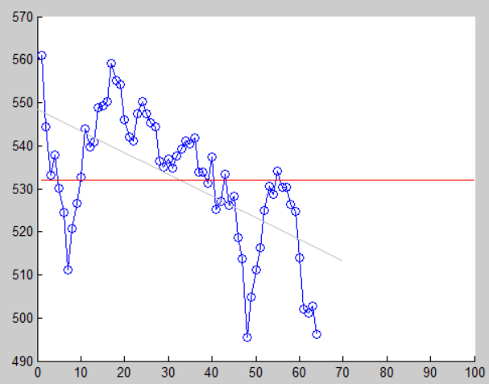

I think what I am showing here in these two plots is that:

If I am planning to buy google and hold it for 10 years I would base my expected value on the first plot. But if I am planning to buy google and hold it for 3 months I would base my expected value on the second.

This is a histogram plot of the voice signal. (bin size = 10, limits +-32767)

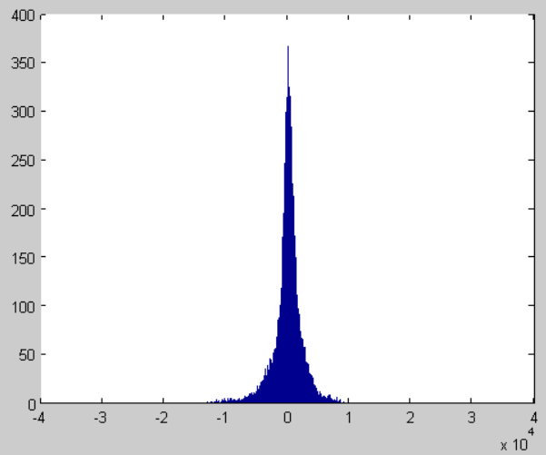

And here is the cdf.

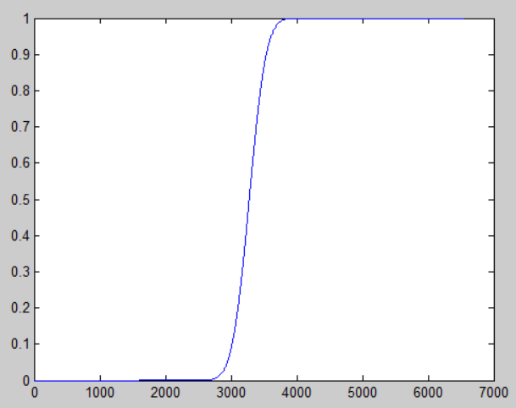

The histogram shows the magnitude of the voice signal is a normal distribution and the values are pretty closely bunched together. The cdf starts at zero and ends at one. So the plots do make sense. On the cdf the slope is pretty steep which implies that the probability will reach 1 quickly after the first data point is reached, and that agrees with what is shown in the histogram.

This seems to show that the variance is small and therefore there is not a lot of noise in the signal.