[Your Title Goes Here]

[Your Full Name Goes Here]

ECE 3512: Signals – Continuous and Discrete

Department of Electrical and Computer Engineering, Temple University, Philadelphia, PA 1912

*Summary*—State the problem and summarize your findings in 150 words or less. Filler text Filler text Filler text Filler text Filler text Filler text Filler text Filler text Filler text Filler text Filler text Filler text Filler text Filler text Filler text Filler text Filler text Filler text Filler text Filler text Filler text Filler text Filler text Filler text Filler text Filler text Filler text Filler text Filler text Filler text Filler text Filler text Filler text Filler text Filler text Filler text Filler text Filler text Filler text Filler text Filler text Filler text Filler text Filler text Filler text Filler text Filler text Filler text Filler text Filler text Filler text Filler text Filler text Filler text Filler text Filler text Filler text Filler text Filler text Filler text Filler text Filler text Filler text Filler text Filler text Filler text Filler text Filler text Filler text

*Keywords*— (three keywords from an IEEE approved list)

# Problem Statement

Summarize the problem statement in one paragraph. Section I-IV must be at least one page long following the formats in this template. References, figures and tables must appear on the second page. [...filler text filler text... -[3] [...filler text filler text... [...filler text filler text... [...filler text filler text... [...filler text filler text... [...filler text filler text... [...filler text filler text... [...filler text filler text... [...filler text filler text... [...filler text filler text... [...filler text filler text... [...filler text filler text... [...filler text filler text... [...filler text filler text... [...filler text filler text... [...filler text filler text... [...filler text filler text... [...filler text filler text... [...filler text filler text... [...filler text filler text... [...filler text filler text... [...filler text filler text... [...filler text filler text... [...filler text filler text... [...filler text filler text... [...filler text filler text... [...filler text filler text... [...filler text filler text... [...filler text filler text... [...filler text filler text... [...filler text filler text... [...filler text filler text... [...filler text filler text... [...filler text filler text... [...filler text filler text... [...filler text filler text... [...filler text filler text...

Analyze the data given to determine what you are given and what parameters you must find... [...how do the givens relate to each other? One paragraph.... filler text filler text.. filler text filler text.. filler text filler text.. filler text filler text.. filler text filler text.. filler text filler text.. filler text filler text.. filler text filler text.. filler text filler text.. filler text filler text.. filler text filler text.. filler text filler text.. filler text filler text.. filler text filler text.. filler text filler text.. filler text filler text.. filler text filler text.. filler text filler text.. filler text filler text.. filler text filler text.. filler text filler text.. filler text filler text.. filler text filler text.. filler text filler text.. filler text filler text.. filler text filler text.. filler text filler text.. filler text filler text.. filler text filler text.. filler text filler text.. filler text filler text.....]

# Methodology

Describe your approach to finding the unknowns. [...filler text filler text.. filler text filler text.. filler text filler text.. filler text filler text.. filler text filler text.. filler text filler text.. filler text filler text.. filler text filler text.. filler text filler text.. filler text filler text.. filler text filler text.. filler text filler text.. filler text filler text.. filler text filler text.. filler text filler text.. filler text filler text.. filler text filler text.. filler text filler text.. filler text filler text.. filler text filler text.. filler text filler text.. filler text filler text.. filler text filler text.. filler text filler text.. filler text filler text.. filler text filler text.. filler text filler text.. filler text filler text.. filler text filler text.. filler text filler text.. filler text filler text.....]

[...filler text filler text.. filler text filler text.. filler text filler text.. filler text filler text.. filler text filler text.. filler text filler text.. filler text filler text.. filler text filler text.. filler text filler text.. filler text filler text.. filler text filler text.. filler text filler text.. filler text filler text.. filler text filler text.. filler text filler text.. filler text filler text.. filler text filler text.. filler text filler text.. filler text filler text.. filler text filler text.. filler text filler text.. filler text filler text.. filler text filler text.. filler text filler text.. filler text filler text.. filler text filler text.. filler text filler text.. filler text filler text.. filler text filler text.. filler text filler text.. filler text filler text.....]

# Rresults

Describe your findings... include at least one graph and one table included at the end of the document on the second page... [...filler text filler text.. filler text filler text.. filler text filler text.. filler text filler text.. filler text filler text.. filler text filler text.. filler text filler text.. filler text filler text.. filler text filler text.. filler text filler text.. filler text filler text.. filler text filler text.. filler text filler text.. filler text filler text.. filler text filler text.. filler text filler text.. filler text filler text.. filler text filler text.. filler text filler text.. filler text filler text.. filler text filler text.. filler text filler text.. filler text filler text.. filler text filler text.. filler text filler text.. filler text filler text.. filler text filler text.. filler text filler text.. filler text filler text.. filler text filler text.. filler text filler text.....]

[...filler text filler text.. filler text filler text.. filler text filler text.. filler text filler text.. filler text filler text.. filler text filler text.. filler text filler text.. filler text filler text.. filler text filler text.. filler text filler text.. filler text filler text.. filler text filler text.. filler text filler text.. filler text filler text.. filler text filler text.. filler text filler text.. filler text filler text.. filler text filler text.. filler text filler text.. filler text filler text.. filler text filler text.. filler text filler text.. filler text filler text.. filler text filler text.. filler text filler text.. filler text filler text.. filler text filler text.. filler text filler text.. filler text filler text.. filler text filler text.. filler text filler text.....]

# Conclusions

Describe your conclusions... what worked, what didn’t work... in no more than 250 words..] [...filler text filler text.. filler text filler text.. filler text filler text.. filler text filler text.. filler text filler text.. filler text filler text.. filler text filler text.. filler text filler text.. filler text filler text.. filler text filler text.. filler text filler text.. filler text filler text.. filler text filler text.. filler text filler text.. filler text filler text.. filler text filler text.. filler text filler text.. filler text filler text.. filler text filler text.. filler text filler text.. filler text filler text.. filler text filler text.. filler text filler text.. filler text filler text.. filler text filler text.. filler text filler text.. filler text filler text.. filler text filler text.. filler text filler text.. filler text filler text.. filler text filler text.....].

##### References (Minimum of 3 - IEEE Format)

1. I. Arel, D. C. Rose, and T. P. Karnowski, “Deep Machine Learning - A New Frontier in Artificial Intelligence Research [Research Frontier],” *IEEE* *Computational Intelligence Mag.*, vol. 5, no. 4, pp. 13–18, 2010.
2. G. Hinton, L. Deng, D. Yu, G. Dahl, A. Mohammed, N. Jaitly, A. Senior, V. Vanhoucke, P. Nguyen, T. Sainath, and B. Kingsbury, “Deep Neural Networks for Acoustic Modeling in Speech Recognition,” *IEEE Signal Processing Magazine*, vol. 29, no. 6, pp. 83–97, Nov. 2012.
3. L. Breiman, “Random Forests,” *Machine Learning*, vol. 45, no. 1, pp. 5–32, 2001.

Table 1. Selected Fields From an EDF+ Header.

|  |  |  |
| --- | --- | --- |
| Field | Description | Example |
| 1 | Version Number | 0 |
| 2 | Patient ID | TUH123456789 |
| 4 | Gender | M |
| 6 | Date of Birth | 57 |
| 8 | Firstname_Lastname | TUH123456789 |
| 11 | Startdate | 01-MAY-2010 |
| 13 | Study Number/ Tech. ID | TUH123456789/TAS X |
| 14 | Start Date | 01.05.10 |
| 15 | Start time | 11.39.35 |
| 16 | Number of Bytes in Header | 6400 |
| 17 | Type of Signal | EDF+C |
| 19 | Number of Data Records | 207 |
| 20 | Dur. of a Data Record (Secs) | 1 |
| 21 | No. of Signals in a Record | 24 |
| 27 | Signal[1] Prefiltering | HP:1.000 Hz LP:70.0 Hz N:60.0 |
| 28 | Signal[1] No. Samples/Rec. | 250 |

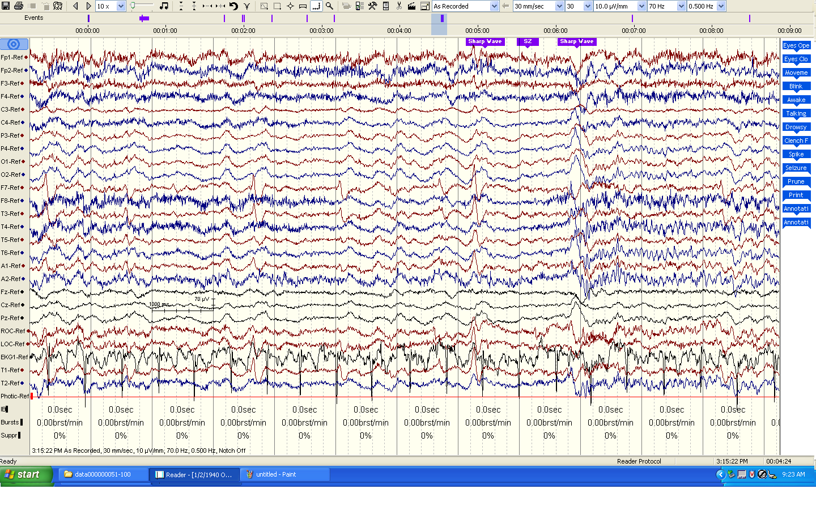

Figure . The source data, which consists of 24-channel recordings plus annotations, is displayed using Natus Medical Incorporated’s NicoletTM NicVue v5.71.4.2530).