**ECE 3512: SignalS – Continuous and Discrete**

# Recitation No. 10: Differential Equations and CiRCUITS

In this recitation, we will explore the connections between circuit analysis and the Laplace Transform.

(1) For the RC circuit shown to the right, choose values of R and C such that the 3 dB point of the frequency response is 1 kHz. Find the:

[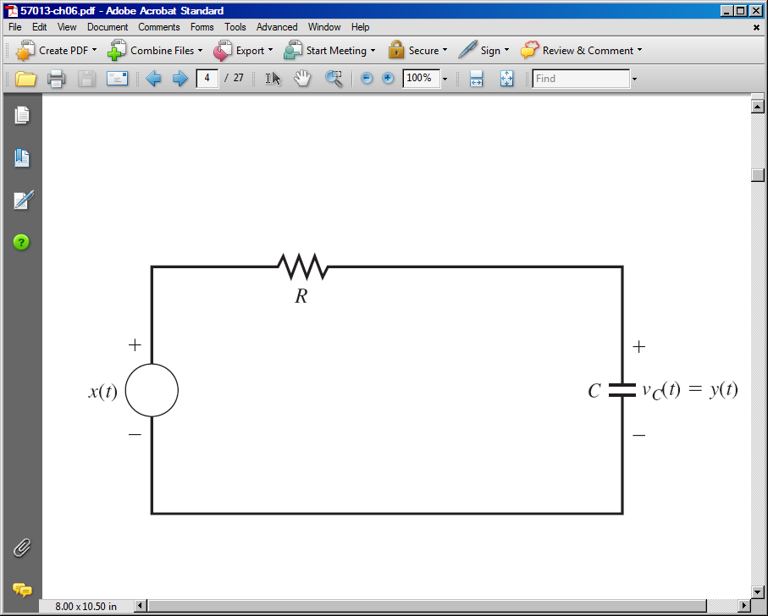](http://users.ece.gatech.edu/~bonnie/book3/)

(a) impulse response;

(b) frequency response;

(c) Bode plot for the magnitude of the transfer function.

Do this analytically and using MATLAB, and show that the results are equivalent.

(2) Repeat (1) for the RLC circuit shown. Again, design the values of R, L, and C so that the frequency response achieves a peak value at 1 kHz.

