**ECE 3512: SignalS – Continuous and Discrete**

# Recitation No. 6: Fourier Transform VS. FoURIER SERIES

Consider the signal shown to the right. In this laboratory we will compare the Fourier Transform and the Fourier Series. For the Fourier Transform, assume the signal is as shown. For the Fourier Series, assume the signal is periodic with a period of 8 secs.

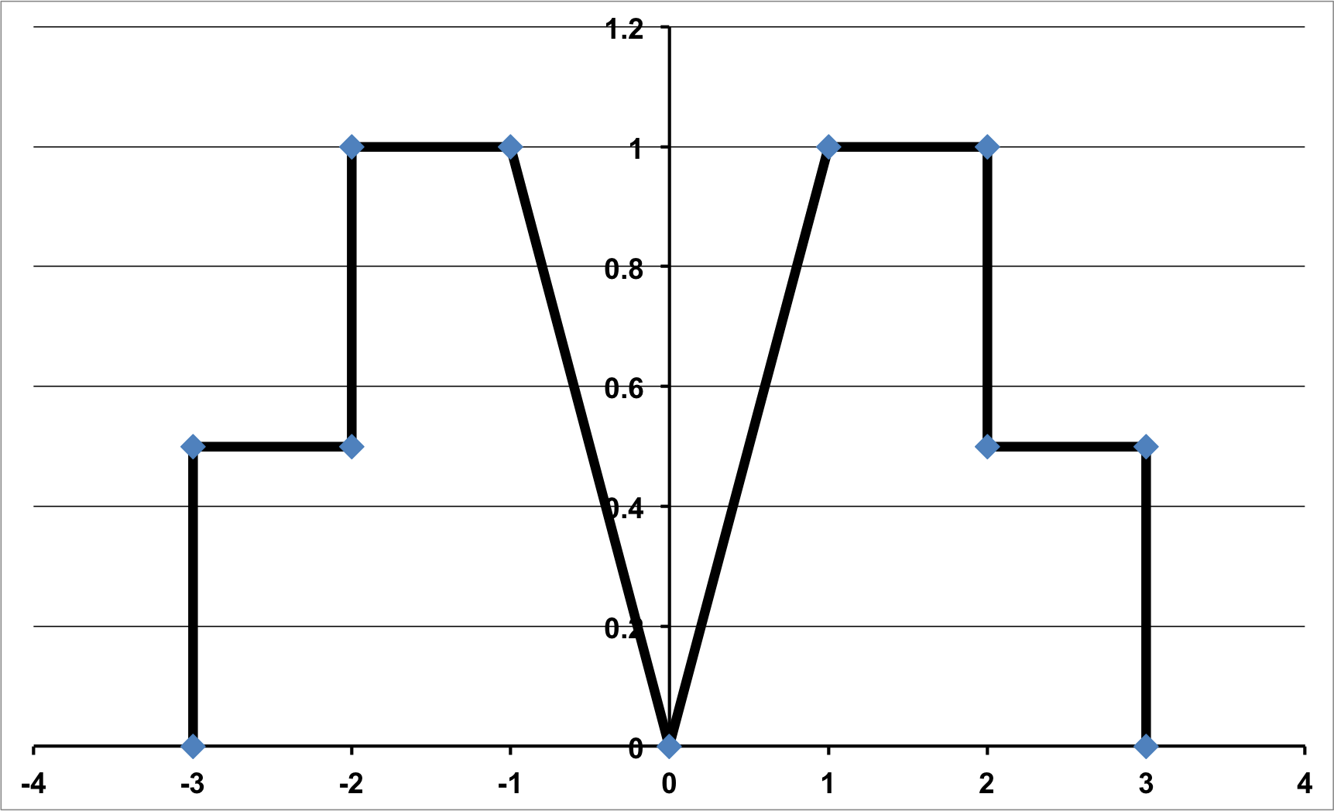

The tasks to be accomplished in this lab are:

1. Compute both the Fourier Series and Fourier Transform analytically using a direct approach in which you directly integrate the signals. (Note: the expressions will be messy, so don’t try to reduce them too much.) Plot and compare the magnitude spectrum using MATLAB. (Plot these spectra on the same plot.)
2. Compute both transforms using a superposition approach. Model the signal as the sum of a ramp function and two pulses. Compute the transform of each of these separately, and then combine them using superposition (hint: remember to deal with the time delay/phase shift). Again, plot the magnitude spectra and demonstrate that you get the same result as in prob. 1.
3. Explain the relationship between these two spectra. (Hint: think of this as a sampling problem.) How would this relationship change if the period was 16 secs instead of 8 secs? What is the period was 32 secs?