Name:

|  |  |  |
| --- | --- | --- |
| Problem | Points | Score |
| 1(a) | 15 |  |
| 1(b) | 15 |  |
| 2(a) | 20 |  |
| 2(b) | 20 |  |
| 3(a) | 15 |  |
| 3(b) | 15 |  |
| Total | 100 |  |

Notes:

1. The exam is closed books and notes except for one double-sided sheet of notes.
2. Please indicate clearly your answer to the problem.
3. If I can’t read or follow your solution, it is wrong and no partial credit will be awarded.

**Problem No. 1**: Laplace Transforms

(a) A signal consists of a single exponential function (hint: ). You are told the following:, , , and . Sketch , write a function that describes it, and compute its Laplace Transform, .

(b) Find the inverse Laplace Transform of: .

**Problem No. 2**: Circuit Analysis Using Laplace Transforms

(a) For the circuit shown, find the impulse response, :

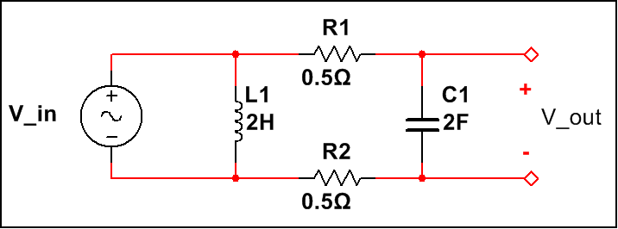

(b) Sketch the frequency response and label all critical points. Demonstrate that your solution makes sense for very small (e.g., DC) and very large (e.g., infinity) values of frequency by examining the behavior of the circuit as a function of frequency (we refer to this as the asymptotic behavior).

**Problem No. 3**: Block Diagrams

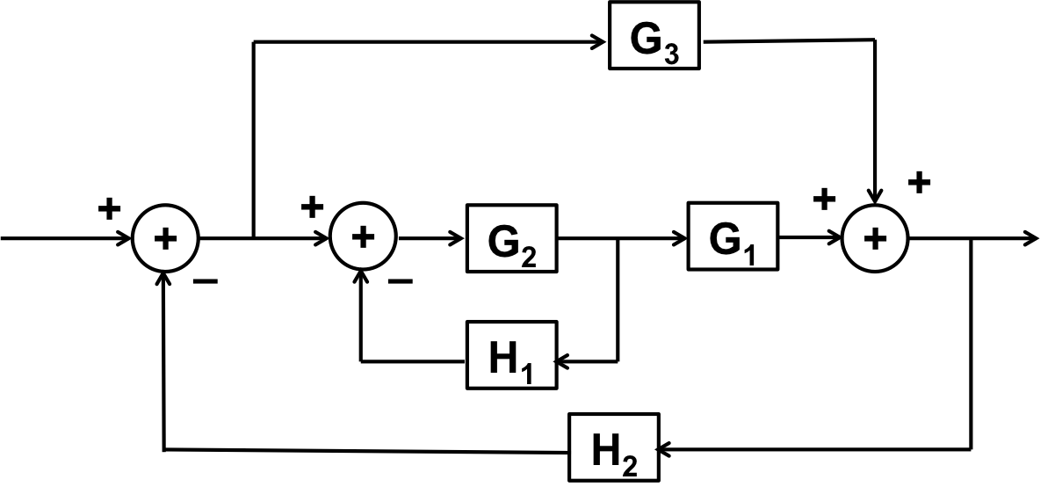

(a) Find the transfer function for the system shown to the right:

(b) Under what conditions is the system stable? Be as specific as possible.