Name:

|  |  |  |
| --- | --- | --- |
| Problem | Points | Score |
| 1(a) | 15 |  |
| 1(b) | 15 |  |
| 2(a) | 20 |  |
| 2(b) | 20 |  |
| 3(a) | 15 |  |
| 3(b) | 15 |  |
| Total | 100 |  |

Notes:

1. The exam is closed books and notes except for one double-sided sheet of notes.
2. Please indicate clearly your answer to the problem.
3. If I can’t read or follow your solution, it is wrong and no partial credit will be awarded.

**Problem No. 1**: Convolution

(a) Given a signal, , and , the impulse response of a linear time-invariant system, compute the output of the system using convolution.

(b) Suppose the input to the system is  where *x(t)* is defined in (a). The impulse response function, *h(t)*, is the same as in (a). Describe how you would compute the output using your results of (a), and sketch the output, showing all intermediate work. (Hint: you solution should consist of a series of sketches. You should not recompute the convolution integral.)

**Problem No. 2**: Fourier Transforms

(a) If *f(t)* is an even function (e.g., ), derive an expression for the Fourier Transform. (Hint: write down the general expression for a Fourier Transform and simplify it).

(b) Suppose  and . Sketch the magnitude of the Fourier Transform of the product of these two signals: . Clearly label the amplitude and frequency scales of your plot and make sure all of its critical values are **CLEARLY** identified.

**Problem No. 3**: The Sampling Theorem

(a) Compute the magnitude spectrum of the output signal for the signal processing system shown:

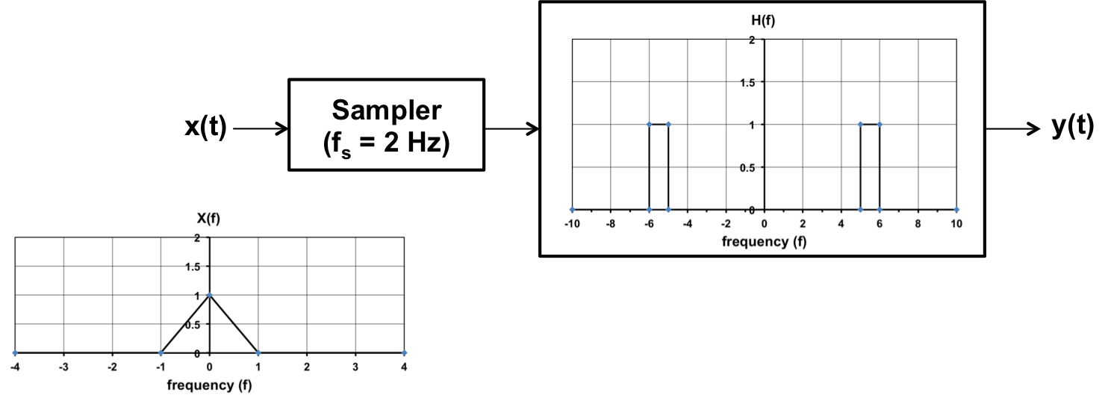

(b) Can you recover the original signal from the output signal? What are the pros and cons of this system from a communications point of view (hint: think about conservation of bandwidth)? What happens if you raise the sample frequency to 104.5MHz? Is this system physically realizable (e.g., could you implement it as a physical circuit or a real-time digital system)?