**ECE 2323: Electrical Engineering Science II**

# Laboratory No. 10: Three PHASE Power

The goal of this laboratory is to understand the basics of two-phase and three-phase power. You will need to read ahead in Chapter 10 to do some of this lab. Remember that MATLAB and Multisim must be used to verify your circuits.

**Task 1: Single-Phase Three-Wire Power**

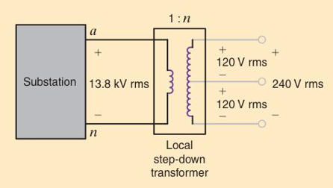

Figure 1. A schematic for a single phase three-wire power distribution system.

Using the transformer supplied in your parts kit, implement a prototype of the circuit shown in , providing a 1V RMS signal at the output. Label the three output terminals A, B and C. Measure VAB, VAC and VBC, and explain what you observe and why this makes sense.

**Task 2: Three-Phase Voltage**

Using the single-phase sinusoidal generator supplied with the Digilent board, design and implement a way of generating the three required voltages for a three-phase power distribution system. Your output voltages should be 1V RMS separated by 120o in phase. You are free to implement whatever circuit you think is necessary as long as it delivers the necessary phase shifts. Again label the output terminals A, B, and C, and neutral, and demonstrate that the voltages you measure make sense.

**Task 3: Three-Phase Power**

Using three 10 kΩ resistors (or an suitably large value), connect both a Y and Δ load to your three-phase voltage source. Measure the power dissipated in the resistors and explain what you observe.

**Summary:**

In this lab, you are learning about the basics of three-phase power distribution. This is extremely common in conventional AC power distribution systems. Later we will learn more about how you can use balanced three-phase systems to drive large industrial equipment using balanced loads.

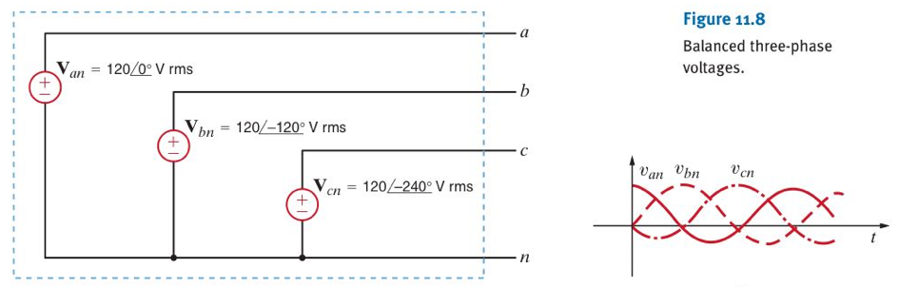

Figure 2. A schematic for three-phase voltages.