**ECE 2323: Electrical Engineering Science II**

# Laboratory No. 7: PHun with PHASE

The goal of this laboratory is to reinforce your understanding of the relationship between a system’s transfer function, frequency response, phase and time delay. As with all our labs, for every step, you are expected to compare a theoretical analysis in MATLAB, a simulation in Multisim and an implementation on the Digilent board. From the theoretical analysis, you can predict the expected outcome of the experiment. From the Multisim simulation you can validate your design and verify that your theoretical model is correct. From the Digilent implementation, you can verify that an actual prototype of the circuit behaves as predicted. Any discrepancies between the implementation and the simulation need to be explained through detailed debugging.

**Task 1: Series RC Circuit**

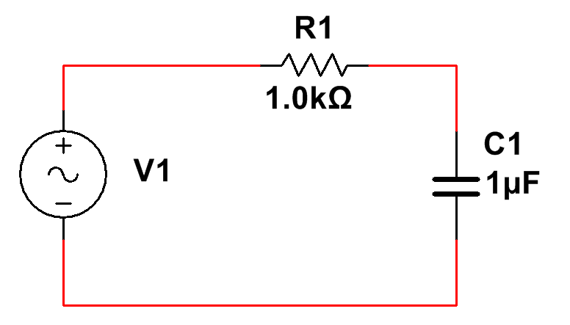

Figure 1. A series RC circuit is shown.

For the circuit shown in Figure 1, treat the voltage across C1 as the output voltage, Vo, and V1 as the input voltage, Vi. Derive an expression for the Laplace domain transfer function, H(s), and plot its frequency and phase responses using MATLAB. Similarly, construct the circuit in Multisim and plot its frequency and phase responses in Multisim. Next, prototype the circuit on the Digilent board and measure the frequency and phase responses. Plot all three on the same plot and demonstrate that they match (one plot for the frequency response and one plot for the phase response). Analyze and discuss any differences that you observe.

Set the input voltage source to a 1 kHz sinewave. Show that the predicted value of the amplitude and phase for the voltage that you measure across C1 match what is predicted from sampling the transfer function at 1 kHz. Further, and most importantly, measure the phase difference beween the input and the voltage across C1 on an oscilloscope, and show that the difference you see in the time domain (measured in units of time) matches what you predicted for the phase (measured in degrees) from the transfer function. Convert the time delay that you measure into a phase angle. Convince your TA that time delay is equivalent to phase delay by annotating screenshots of the waveforms showing the time delays that you measured, and explaining how you converted these measurements into phase angles.

Next, apply a periodic pulse train with a fundamental frequency of 1 kHz, and a duty cycle of 5%. Plot the input signal and the output that you observe in Multisim and on the Digilent board. Interpret what you see using both time domain arguments (e.g., time delay) and frequency domain arguments (e.g., phase delay). Hint: derive the Fourier series of this periodic signal and consider what happens for the first three harmonics. Use MATLAB to plot an approximation to the signal that consists of its first three harmonics.

**Task 2: Designing the Phase Response**

Set the input voltage to a 1 kHz sinewave. Adjust the values of R1 and C1 such that two conditions are satisfied: (1) The voltage across the capacitor and current through the capacitor are shifted by 90 degrees; (2) The voltage across the capacitor is 37o phase shifted with respect to the input voltage. Discuss why there is a phase shift and whether it is leading or lagging the input. Justify your designs using analytic derivations, Multisim and a Digilent prototype.

**Task 3: Maximum Power Transfer**

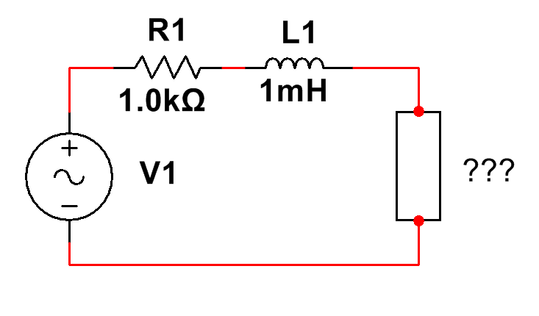

Figure 2. A series RL circuit with a mystery load.

A series RL circuit is shown in Figure 2 with a “mystery load.” Set the voltage source to a 1V peak-to-peak sinewave with a frequency equal to (1 kHz – ‘the sum of the digits in your Temple ID’). Determine the value of the load that maximizes the power dissipated in the load. Connect this load to the circuit and demonstrate that maximum power transfer is achieved, including measurement of the maximum value of the power. Calculate (and also measure) the voltage amplitude and phase for the load, and compare this to the amplitude and phase of the source. Plot the ratio of the voltage amplitudes as a function of the both the real and imaginary components of the load impedance. Where/why does it peak? Repeat this plot for the phase. Explain this.

Do the analysis in Multisim and then demonstrate the value that achieves a maximum on your Digilent board.

Repeat these plots for the current through the load. Then plot the power dissipated in the load as a function of the real and imaginary values of the load impedance. Demonstrate that the Maximum Power Transfer Theorem makes sense by explaining what you observe in these plots.

**Task 4: Buffer Amplifiers**

Insert an op amp buffer amplifier between the RL components and the mystery load. Repeat the maximum power transfer analysis of Task 3. What has changed? Why? Explain this in great detail using concepts such as the Maximum Power Transfer Theorem and the input/output impedances of an op amp circuit.

**Summary:**

In this laboratory, we have demonstrated that phase delay in the frequency domain is equivalent to delay in the time domain (time delay). Surround sound and Dolby THX audio systems are good examples of systems that exploit this relationship by adjusting the phase of the signal to produce a variety of sound effects. Radar systems also exploit these properties to digitally scan the skies for moving objects using stationary antenna arrays.

We also demonstrated the principle of maximum power transfer and how that relates to the concept of complex power. As we discussed in class, power factor plays a very important role in the efficiency of power transmission.