**ECE 2323: Electrical Engineering Science II**

# Laboratory No. 2: SYMBOLIC MANIPULATIONS IN MATLAB

The goal of this laboratory is to familiarize you with MATLAB’s ability to support symbolic manipulation. We will use this capability to compute Laplace transforms and inverse Laplace transforms. In order to complete the exercises below, you will need to do some research on how to compute Laplace transforms in MATLAB. Two important resources are the MathWorks site ([www.mathworks.com](http://www.mathworks.com)) and he corresponding help functions built into MATLAB. Of course, Google and YouTube can be very useful as well.

The tasks to be accomplished in this lab are:

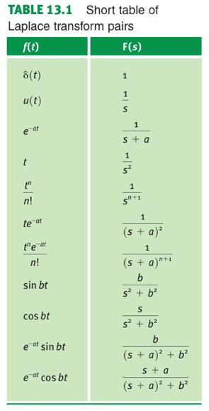

1. Verify each of the Laplace transform pairs shown in Table 13.1 by using MATLAB to compute the forward transform and the reverse transform. For the 5th and 7th entries involving the factorial function, set n=2 and n=3.
2. For the 3rd and 11th entries, set *s = j2πf* , *a = 1* and *b = 1*, and plot the magnitude of the Laplace transform (which is in general a complex number) as a function of frequency. Determine at what values of frequency the plot peaks and is 3 dB below the peak. Can you draw any conclusions about these frequencies?

Plot these on linear scales first (linear for the amplitude and frequency scales) and then repeat these plots on a log base 10 scale (for both frequency and amplitude).

1. Repeat the plots in step no. 2 for the phase, or angle of the transform. Note that this requires computing the angle of a complex number. Restrict this calculation to the range [‑π,π]. Plot the phase using a linear scale for the angle and a logarithmic scale for the frequency.
2. Now the fun part: using the parts provided in your Digilent kits, synthesize a circuit whose frequency response matches the frequency response of the third transform pair (hint: think about the transient response of a first-order circuit with a single inductor or capacitor). Use whatever value of the constant *a* that you need to based on the parts available in your kits.
3. Repeat no. 4 for the 11th transform pair. How would you describe this circuit? What uses might it have?

For steps 4 and 5, demonstrate both the transient response and frequency response (using as much of the Digilent board’s capability as possible) of your circuit. Compare these results to what Multisim predicts. Explain any discrepancies.

**Summary:**

The Laplace transform is one of the most useful mathematical tools you will learn in engineering. It allows complicated systems of differential equations to be solved using simple algebraic manipulations. Both the transient and steady-state response of a circuit or system can be obtained from a single transform.

Often, in real engineering problems, you will be given a frequency response, or a transient response, and asked to design a circuit to approximate that response. Filtering is one example of such a problem. Filters are one of the most common circuits used in most electrical engineering systems. Later in the semester we will discuss these in more detail. The shape of the Laplace transform (both magnitude and phase) determines many properties of the corresponding circuit that was synthesized. For example, in task no. 3, how many different types of circuits could you synthesize that produce the given Laplace transform?