**ECE 2323: Electrical Engineering Science II**

# Laboratory No. 12: DC/AC Inverter

For the last laboratory, we are going to introduce you to the design of a DC/AC power supply. Previously, we designed an AC/DC power supply. DC/AC conversion is a little trickier, and involves integration of concepts from ECE 2322 (Circuits II), ECE 3612 (Microprocessors) and ECE 3312 (Microelectronics). The fact that you haven’t had the last two courses shouldn’t stop us from doing this lab :)

A suggested circuit is shown to the right. It will be a bit of a challenge to build this from your parts kits that come with the Digilent boards. The ECE Shop will provide you with the additional components (e.g., the 555 Timer). You have the transistors and transformer already. Use as many parts from your Digilent kits as possible.

[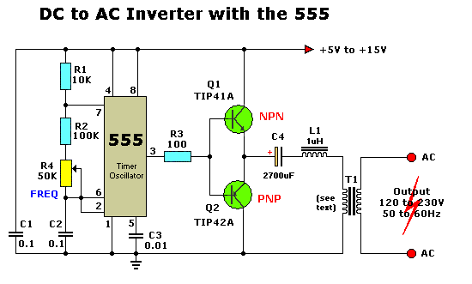](http://www.eleccircuit.com/wp-content/uploads/2008/07/dc-to-ac-inverter-by-ic-555-and-tip41-tip42.gif)

Figure 1. A suggested schematic for your power supply.

As always, prototype this in Multisim first and establish a working circuit. Google Search to learn more about how this circuit works – there is a wealth of information available. Do not attempt to wire up this circuit BEFORE you have a working Multisim simulation. Incorrect wiring could potentially damage your Digilent board.

Use a +5V power supply. With your 1:1 transformer, you will not get 120V out, which is a good thing since there are safety concerns. Shoot for a small AC output -- less than 5V peak to peak is acceptable -- and small output power. This should not be a problem given the transistors and transformers you have access to.

Once you achieve a working circuit, analyze and explain the frequency content in the output AC signal. Record a portion of the signal, transform it to Matlab, and generate the frequency response using a Fourier transform. Analyze 100 msec of the signal to produce a Fourier transform. Plot the magnitude spectrum on a linear scale. Explain this in terms of a Fourier series (since it is a periodic signal).

PLEASE REMEMBER TO USE GOOD LAB SAFETY PROCEDURES AT ALL TIMES.

**Summary:**

Modern electronics circuits most often use a combination of digital and analog components to solve real-world problems. The DC/AC converter you built, often known as an inverter, is a very useful circuit. For example, you find these in automobiles, which have a 12V DC battery. Many cars, particularly SUVs, have these circuits built in. So the next time you fire up that hair dryer on that camping trip, remember that (1) you know how to build that circuit, and (2) delivering 1500 Watts of AC power from a DC source ain’t easy :)

Good luck in your future studies as electrical and computer engineers. You have worked hard this semester and done excellent work!