**ECE 2323: Electrical Engineering Science II**

# Laboratory No. 11: Filter Fundamentals

The goal of this laboratory is to understand how to design filters. (Remember, it is the short lab descriptions that are the killers). Your task is very simple. Design and implement a filter that has the frequency response shown in . (Note that the frequency axis is linear.) The center frequency for your filter should be your Temple ID number multiplied by an integer such that this product falls between 1 kHz and 1.5 kHz. Use Multisim, MATLAB and any other resources you might have at your disposal. You will be graded on the thoroughness of your solution and the complexity of your circuit - the fewer the components, the better.

Note that you might have to make some compromises in this design. For example, can you achieve the perfectly vertical portions of the frequency response? If not, how might you best approximate them? What does it take to produce gain from your circuit?

Your task is to achieve a reasonable approximation to the frequency response shown. Start simple by designing circuits that achieve each of the three sections of the frequency response separately. Then combine these circuits and jointly optimize them.

Our university MATLAB license gives you access to several very powerful tools to help you iterate on your designs. Don’t be afraid to explore some of the advanced toolboxes.

As always, design it in MATLAB, simulate it in Multisim and then implement it on the Digilent board.

**Summary:**

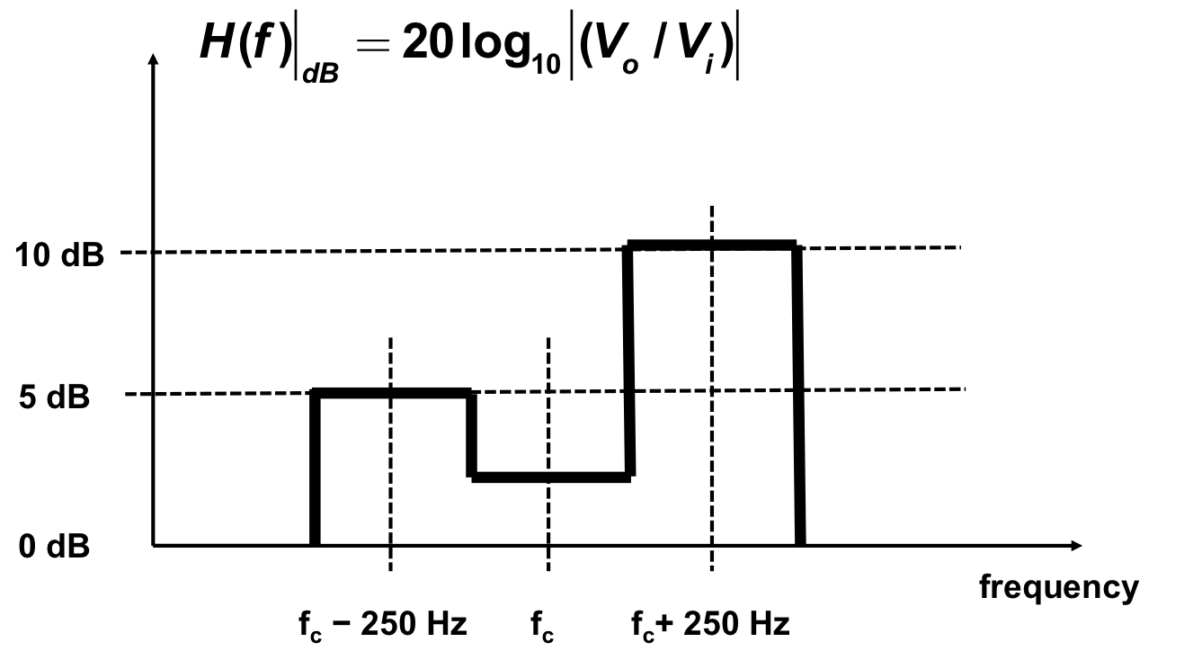

Figure 1. The desired frequency response is shown for your filter.

Your ability to design filters to a prescribed frequency response is an important engineering tool. There are certain physical limitations you will face when attempting designs, such as how much attenuation can be achieved, or how precise you can model various details of the design. It is ultimately a compromise between many competing constraints, and there are often an infinite number of solutions.