**ECE 2323: Electrical Engineering Science II**

# Laboratory No. 8: Transformers ‘R US

The goal of this laboratory is to acquaint you with the properties of a transformer. You will verify that the theory we learned in class serves as an adequate model for the transformer you received in your parts kits. As with all our labs, you are expected to do Multisim simulations of every circuit and to compare these to your measured values.

**Task 1: Data Sheets**

Locate a datasheet online for the transformer provided in your parts kit. Study its electrical properties. In your lab report, describe the pinout for the transformer. Clearly explain the purpose of each electrical connection on the device, as well as its material properties (e.g., magnetic properties, windings).

Develop a model in Multisim for this transformer based on your analysis of the datasheet. Don’t be afraid to edit the parameters of the standard model to arrive at a more precise model. Don’t be afraid to go into the lab and measure the properties of your specific device. Multisim can accept user-supplied models for devices. You can also edit the parameters of any existing device to better match your specific device.

**Task 2: Frequency Response**

Measure the frequency response of your transformer and compare it to your Multisim model. To do this, set up a simple circuit with an AC voltage source, perhaps a series and load impedance, and vary the frequency of the input signal. Be careful to use an input voltage that is clearly in the linear operating range of the transformer. Consult the data sheet for more information about this operating range. Compare your findings to your theoretical predictions.

**Task 3: Impedance**

Place a 1 kΩ resistor as a load on the output side of the transformer. Measure and plot the input impedance of the transformer as a function of frequency. Does this match Multisim? Does this match the theoretical analysis we described in class?

Repeat this measurement for the output impedance when you place a 1 kΩ resistor in series with the input side of the transformer.

**Task 4: Maximum Power**

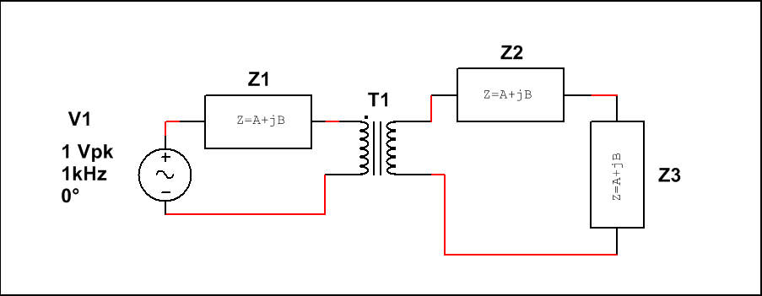

Figure 1. A simple test circuit that will be used to measure maximum power transfer.

For the circuit shown in , set Z1 = Z2 = 1 kΩ. Determine the value of Z3 that maximizes power transfer. Demonstrate that you achieve maximum power transfer on the Digilent board. Compare this value to the one obtained doing a theoretical analysis and from your Multisim simulation.

Compute the power supplied or dissipated by each component. Do these values add up to zero? If not, why not? Explain how the transformer properties influence the overall power budget for the circuit. Show this in a spreadsheet.

Set Z1 to be a 10 Ω resistor in series with a 1 mH inductor while Z2 is a 100 Ω resistor in series with a 1 μF capacitor and repeat this analysis.

**Summary:**

Transformers are very commonly used in a wide range of applications including power distribution and power supplies. Their ability to efficiently step up or step down voltage makes them ideal for such applications. In recent years, semiconductor-based circuits have begun to replace these in some applications. Why?

Power supply design involves tradeoffs between efficiency, reliability, size, weight, heat and most importantly, cost. Transformers are actually highly reliable, and have been known to operate flawlessly for 50 to 100 years (with an occasional explosion here or there). They are easy to design into circuits and can deliver a wide range of voltages and currents. They are still popular for high voltage and current applications, but are giving way to semiconductors, specifically power transistors, for low-power designs where the voltage does not need to be stepped up or down (e.g., linear regulators).