**ECE 2323: Electrical Engineering Science I**

# Laboratory No. 6: Impulse and Frequency Response

The goal of this laboratory is to reinforce your understanding of AC steady state circuit analysis, and how the impulse response and the frequency response are related. We will focus on using the Digilent board for these tasks, and compare the results to Multisim and your analytic solution.

For this lab, you will need to generate three useful signals in MATLAB and then inject them into your Digilent board. Each signal, when played out through your audio system, should have a peak amplitude that is about 25% of the full scale output of your audio system. The three signals are defined as follows:

1. Unit Pulse: generate a signal that is 10 secs in duration and changes in value from 0 to 1 at time 0, and stays at a value of 1.0 for 0.01 secs, and then returns to a value of zero. Use a 44,100 Hz sample frequency. Make sure that when you convert this signal to an audio signal and play it back using your audio system, the amplitude level has been adjusted to be about 10% of the full scale output of the audio output on your laptop.
2. Sum of Sinewaves: generate a sum of sinewaves using five frequencies - 100 Hz, 500 Hz, 1,000 Hz, 2,000 Hz and 5,000 Hz. Again, use a 44,100 Hz sample frequency.
3. White noise: use a random number generator to generate a sequence of random numbers. This is a good approximation to a signal we call white noise (to be explained shortly). Generate 10 seconds of white noise at a sample frequency of 44,100 Hz.

For each of these tasks, you will be expected to construct a simulation in Multisim, and compare the results you obtain on the Digilent board with your Multisim simulation. This should include a frequency domain analysis.

**Task 1: Understanding Frequency Response**

Using MATLAB, generate the frequency response of these signals. You can do this using a variety of MATLAB tools (e.g., <http://www.youtube.com/watch?v=dwzQnbeKnQg>). (Popular audio tools such as Audacity also have frequency response tools built into them.) Plot the frequency response of your signal from 0 to 22 kHz on a linear scale for frequency (common when dealing with digital signals) and a log scale for amplitude.

Using what we have learned about Fourier Transforms, and your transform tables, predict the frequency response for the first two signals and demonstrate that what you see in MATLAB makes sense.

**Task 1: Series RC Circuit**

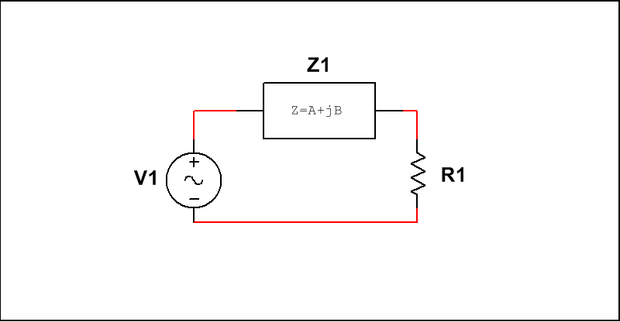

Figure 1. A simple two-component circuit.

Given the circuit shown in Figure 1, use an inductor for the load, Z1. Consider the output voltage to be the voltage across the resistor, R1. This circuit is known as a low-pass filter (why?).

Design the circuit so that the cutoff frequency is 1 kHz. Apply a sinewave input using the Digilent function generator, measure and plot the amplitude of the output votlage as you adjust the frequency from 1 Hz to 22 kHz. Plot the ratio of the output voltage to the input voltage (you can use peak voltage) as a function of frequency. Compare to your simulations and theoretical predictions.

Next, apply the unit pulse function and measure the transient response to this signal. Plot the frequency response of this signal. How does it relate to the plot you generated previously. What important characteristic of a linear system does the response to a unit pulse emulate?

Next, repeat this analysis for the remaining two signals. Again, plot the frequency response you measure and explain their relationships to the previous analyses you have generated.

**Task 2: Series RL Circuit**

Replace the inductor with a capacitor. This configuration is known as a high-pass filter. Why? Design the circuit to have a cutoff frequency of 1 kHz. Repeat all parts of Task No. 1 for the new circuit.

**Task 3: Series RLC Circuit**

Replace Z1 with and inductor and capacitor connected in series. Design the circuit so that is produces a peak amplitude output at 1 kHz. Repeat all parts of Task No. 1. Comment on your findings.

**Summary:**

In this laboratory, we are connecting two important concepts: impulse response, which is a time-domain property of a circuit, and frequency response, which describes how a circuit behaves in the frequency domain. (We are also showing you several ways to measure frequency response.) The two are related via the Fourier Transform. This lab is designed to demonstrate that.

We are also introducing the notion of the frequency response of a signal. What is the frequency response of a pulse? A sinewave? A sum of sinewaves? White noise is referred to as white noise because, similar to white light, it has energy at all frequencies. These signals are very useful as diagnostic tools when designing and building circuits.

Our next lab will focus on related concepts of phase and maximum power transfer.